Appendices
Appendix 1. RESTORE IMI-2 Eligibility Criteria
In RESTORE-IMI 2, eligible patients were aged 18 years or above and required intravenous antibacterial therapy for nonventilated HABP, ventilated HABP, or VABP. Patients with more than 24 hours of effective antibacterial therapy for the current HABP/VABP episode within 72 hours prior to randomization were not eligible for RESTORE-IMI 2, unless they failed this prior therapy (namely, persistent/worsening signs/symptoms of HABP/VABP despite more than 48 hours on the prior regimen). The MITT population included randomized patients who received 1 or more doses of study treatment and whose baseline Gram stain did not show only gram-positive cocci.

Appendix 2: US age- and sex-matched general population mortality (used in the long-term Markov model)
Age | Annual mortality rate |  | Age | Annual mortality rate
 | Male | Female |  | Male | Female
60 | 0.0115 | 0.0068 | 80 | 0.0557 | 0.0406
61 | 0.0124 | 0.0074 | 81 | 0.0617 | 0.0456
62 | 0.0133 | 0.0079 | 82 | 0.0684 | 0.0513
63 | 0.0142 | 0.0084 | 83 | 0.0757 | 0.0574
64 | 0.0151 | 0.0090 | 84 | 0.0852 | 0.0650
65 | 0.0161 | 0.0096 | 85 | 0.0945 | 0.0729
66 | 0.0172 | 0.0104 | 86 | 0.1048 | 0.0801
67 | 0.0184 | 0.0112 | 87 | 0.1175 | 0.0907
68 | 0.0197 | 0.0122 | 88 | 0.1313 | 0.1023
69 | 0.0211 | 0.0134 | 89 | 0.1464 | 0.1152
70 | 0.0225 | 0.0147 | 90 | 0.1626 | 0.1293
71 | 0.0241 | 0.0161 | 91 | 0.1801 | 0.1447
72 | 0.0264 | 0.0180 | 92 | 0.1986 | 0.1614
73 | 0.0286 | 0.0196 | 93 | 0.2182 | 0.1793
74 | 0.0314 | 0.0217 | 94 | 0.2388 | 0.1985
75 | 0.0343 | 0.0239 | 95 | 0.2602 | 0.2188
76 | 0.0380 | 0.0266 | 96 | 0.2822 | 0.2401
77 | 0.0419 | 0.0295 | 97 | 0.3047 | 0.2622
78 | 0.0459 | 0.0329 | 98 | 0.3275 | 0.2851
79 | 0.0506 | 0.0365 | 99 | 0.3503 | 0.3084
 |  |  | 100 | 1.0000 | 1.0000

Appendix 3: Model parameters with uncertainty information
Parameter |  | Mean | Distribution (95% confidence interval)
Clinical parameters
I. Susceptibility
 | IMI/REL, susceptibility coverage | 93.8% | Beta (66% to 100%)
 | PIP/TAZ, susceptibility coverage | 86.0% | Beta (65.4% to 97.9%)
II. Clinical efficacy
 | IMI/REL, clinical response at Day 28 (MITT) | 51.9% | Beta (45.9% to 57.9%)
 | PIP/TAZ, clinical response at Day 28 (MITT) | 50.6% | Beta (44.6% to 56.5%)
 | IMI/REL, all-cause mortality through Day 28 (MITT) | 15.9% | Beta (11.8% to 20.5%)
 | PIP/TAZ, all-cause mortality through Day 28 (MITT) | 21.3% | Beta (16.7% to 26.5%)
 | Subsequent CMS+IMI response rate | 40.0% | Beta (13.7% to 70.1%)
 | Subsequent CMS+IMI mortality rate | 30.0% | Beta (13.7% to 70.1%)
 | Response odds ratio (switch due to nonsusceptibility) | 4.55 | Log-normal (1.87 to 11.10)
 | Mortality odds ratio (switch due to nonsusceptibility) | 2.92 | Log-normal (1.65 to 5.18)
III. Hospital LOS
 | IMI/REL, proportion of time intubated | 84.0% | Beta (64.5% to 96.5%)
 | PIP/TAZ, proportion of time intubated | 78.2% | Beta (61.1% to 91.3%)
 | IMI/REL, average in-hospital LOS days – cured patients | 19.90 | Normal (18.56 to 21.24)
 | IMI/REL, average in-hospital LOS days – uncured patients | 23.00 | Normal (21.43 to 24.57)
 | IMI/REL, average in-hospital LOS days – death patients | 11.90 | Normal (9.66 to 14.14)
 | IMI/REL, average ICU LOS days – cured patients | 14.60 | Normal (12.73 to 16.47)
 | IMI/REL, average ICU LOS days – uncured patients | 19.20 | Normal (16.91 to 21.49)
 | IMI/REL, average ICU LOS days – death patients | 11.70 | Normal (9.10 to 14.30)
 | PIP/TAZ, average in-hospital LOS days – cured patients | 19.80 | Normal (18.40 to 21.20)
 | PIP/TAZ, average in-hospital LOS days – uncured patients | 24.60 | Normal (22.68 to 26.52)
 | PIP/TAZ, average in-hospital LOS days – death patients | 12.10 | Normal (10.36 to 13.84)
 | PIP/TAZ, average ICU LOS days – cured patients | 13.70 | Normal (12.04 to 15.36)
 | PIP/TAZ, average ICU LOS days – uncured patients | 22.50 | Normal (19.3 to 25.7)
 | PIP/TAZ, average ICU LOS days – death patients | 11.90 | Normal (9.98 to 13.82)
 | Additional LOS days due to nonsusceptibility | 6.50 | Normal (5.23 to 7.77)
IV. Adverse events
 | IMI/REL, thrombocytopenia | 0.38% | Beta (0.01% to 1.38%)
 | IMI/REL, diarrhoea | 0.00% | Beta (0.00% to 0.00%)
 | IMI/REL, alanine aminotransferase increased | 0.75% | Beta (0.09% to 2.08%)
 | IMI/REL, aspartate aminotransferase increased | 0.75% | Beta (0.09% to 2.08%)
 | IMI/REL, generalised tonic-clonic seizure | 0.00% | Beta (0.00% to 0.00%)
 | PIP/TAZ, thrombocytopenia | 0.00% | Beta (0.00% to 0.00%)
 | PIP/TAZ, diarrhoea | 0.37% | Beta (0.01% to 1.37%)
 | PIP/TAZ, alanine aminotransferase increased | 0.00% | Beta (0.00% to 0.00%)
 | PIP/TAZ, aspartate aminotransferase increased | 0.00% | Beta (0.00% to 0.00%)
 | PIP/TAZ, generalised tonic-clonic seizure | 0.37% | Beta (0.01% to 1.37%)
 | PIP/TAZ, nephrotoxicity | - | Not applicable
 | IMI/REL (RESTORE-IMI 1), nephrotoxicity | 10.4% | Beta (2.27% to 23.5%)
 | Subsequent CMS+IMI (RESTORE-IMI 1), nephrotoxicity | 56.25% | Beta (32.29% to 78.73%)
Economic parameters
I. Drug costs
 | IMI/REL, treatment duration (days) | 8.70 | Normal (6.99 to 10.41)
 | PIP/TAZ, treatment duration (days) | 8.30 | Normal (6.67 to 9.93)
 | Subsequent CMS+IMI treatment duration (days) | 6.10 | Normal (3.84 to 8.36)
 | IMI/REL, 500mg/250mg – 25 vials | $6,687.50 | None
 | PIP/TAZ, 2g/250mg - 10 vials | $30.00 | None
 | PIP/TAZ, 3g/375mg - 10 vials | $30.00 | None
 | PIP/TAZ, 4g/500mg - 10 vials | $56.10 | None
 | PIP/TAZ, 12g/1500mg - 1 vial | $39.00 | None
 | PIP/TAZ, 36g/4500mg - 1 vial | $65.00 | None
II. Resource use costs *
 | ICU cost on mechanical ventilator day 1 | $10,794 | Normal ($8,678 to $12,910)
 | ICU cost on mechanical ventilator day 2 | $4,796 | Normal ($3,856 to $5,736)
 | ICU cost on mechanical ventilator day 3+ | $3,968 | Normal ($3,190 to $4,746)
 | ICU cost off mechanical ventilator day 1 | $6,667 | Normal ($5,360 to $7,974)
 | ICU cost off mechanical ventilator day 2 | $3,496 | Normal ($2,811 to $4,181)
 | ICU cost off mechanical ventilator day 3+ | $3,182 | Normal ($1,667 to $1,810)
 | General ward unit cost per day | $2,517 | Normal ($643 to $821)
 | Outpatient visit | $183.19 | Normal ($147 to $219)
III. Adverse event costs
 | Thrombocytopenia | $17,208.03 | Normal ($12,552 to $18,672)
 | Diarrhoea | $6,936.34 | Normal ($5,060 to $7,526)
 | Alanine aminotransferase increased | $8,684.18 | Normal ($6,335 to $9,423)
 | Aspartate aminotransferase increased | $8,684.18 | Normal ($6,335 to $9,423)
 | Generalised tonic-clonic seizure | $7,770.73 | Normal ($5,668 to $8,432)
 | Nephrotoxicity | $14,051.62 | Normal ($10,250 to $15,247)
IV. Health-related quality of life
 | Utility value – ICU | 0.68 | Beta (0.54 to 0.81)
 | Utility value – general ward | 0.73 | Beta (0.58 to 0.86)
Key: CMS+IMI, colistin plus imipenem/cilastatin; ICU, intensive care unit; IMI/REL, imipenem/cilastatin/relebactam; LOS, length of stay; MITT, modified intent-to-treat; PIP/TAZ, piperacillin/tazobactam.
Note: * ICU and general ward daily costs presented in this table are the original values reported in the literature (prior to uplifting to a 2021 cost year).

Appendix 4: Probabilistic Sensitivity Analysis: Cost-effectiveness acceptability curve 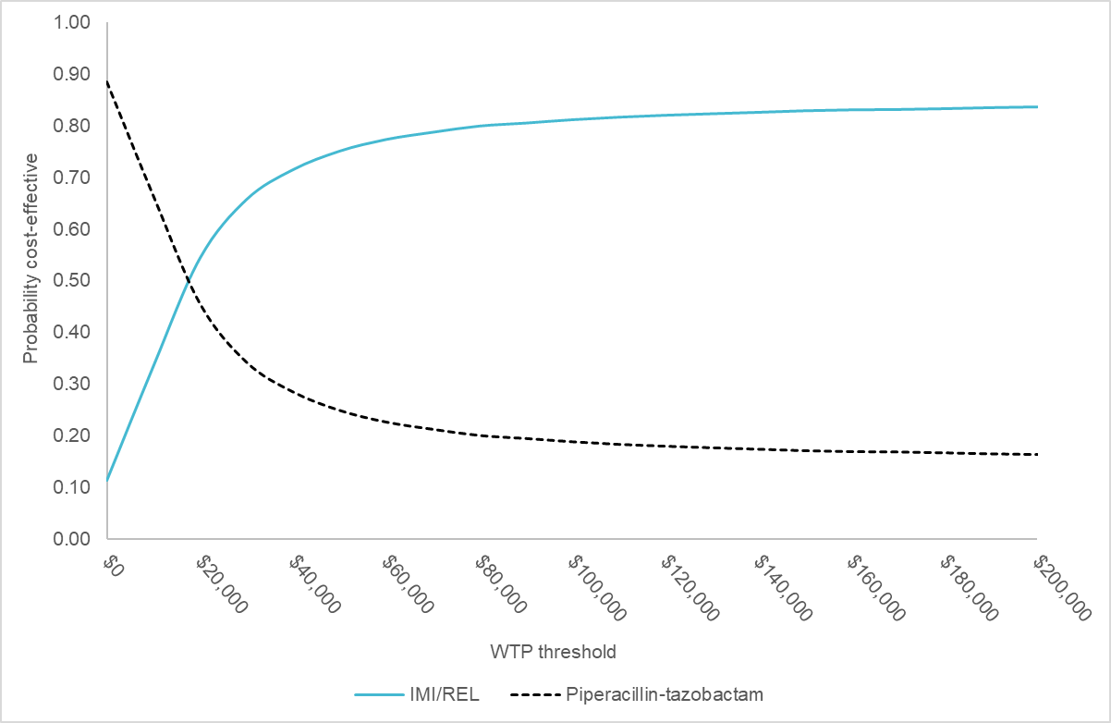
Key: IMI/REL, imipenem/cilastatin/relebactam; PIP/TAZ, piperacillin/tazobactam; WTP, willingness-to-pay.

Appendix 5: Scenario analysis
Scenario | Incremental costs | Incremental QALYs | ICER
Time horizon - 10 years | $14,741 | 0.44 | $33,819
Time horizon - 20 years | $14,741 | 0.70 | $21,041
Time horizon - 30 years | $14,741 | 0.82 | $17,997
1.5% discount rates | $14,742 | 1.01 | $14,644
6% discount rates | $14,738 | 0.82 | $23,901
MITT sub-cohort who experience prior treatment failure | -$8,186 | 1.71 | Dominant
Clinical response assessment visit: EFU | $9,773 | 1.14 | $8,544
Clinical response assessment visit: EOT | $11,975 | 1.18 | $10,122
Non-inferiority (antibacterial agents have equal response and mortality rates) | $6,252 | 0.48 | $13,003
Subsequent treatment response rate - 100% | $16,905 | 1.30 | $13,039
Key: EFU, early follow up; EOT, end of therapy; ICER, incremental cost-effectiveness ratio; MITT, modified intent-to-treat; QALY, quality-adjusted life year.

Appendix 6. Indirect Evidence’s Effect on Model Results
Indirect Evidence | Modelled Scenario | Effect on modelling | Effect on Results
RESTORE IMI-2: IMI/REL was provided empirically | IMI/REL is provided as an early adjustment during 12-48 hours after the infection onset | Delay in appropriate treatment worsens clinical outcomes. Therefore, it is expected that the patients receiving early adjustment of IMI/REL in real world will have higher mortality and a lower clinical cure rate than what is shown in the trial. | Biased in favor of IMI/REL
RESTORE IMI-2: MITT population consisted of | The target population is limited to ICU HABP/VABP patients whose condition are not improving or deteriorating 12 to 48 hours after receiving empiric treatment of PIP/TAZ | It is expected that the subset of patients considered for early adjustment treatment are in a worse pathological status than the overall ICU HABP/VABP patients, as the subset of patients may have multi-drug resistant infection. Therefore, mortality and cure rate for the subset of patients would be worse than the trial. However, due to IMI/REL's higher in vitro activity against multi-drug resistant pathogens, patients receiving continued treatment of PIP/TAZ are expected to have much worse outcomes than these receiving IMI/REL | Greatly biased in favor of PIP/TAZ
SMART data: The sample includes all lower respiratory tract specimens from ICU patients |  | It is expected that susceptibility among patients who are considered for early adjustment prescribing should be lower than the SMART data. Susceptibility to PIP/TAZ should be very low (hence the need for early adjustment); susceptibility to IMI/REL should be also lower than SMART, but of a less magnitude than PIP/TAZ. | Greatly biased in favor of PIP/TAZ
Key: HABP/VABP, hospital-acquired/ventilator-associated bacterial pneumonia; ICU, intensive care unit; IMI/REL, imipenem/cilastatin/relebactam; LOS, length of stay; MITT, modified intent-to-treat; PIP/TAZ, piperacillin/tazobactam; SMART, Study for Monitoring Antimicrobial Resistance Trends.

