Future Virology
Efficacy and safety of corticosteroid regimens for the treatment of hospitalized COVID-19 patients: A meta-analysis

Supplemental Materials

Table S1 PRISMA 2020 checklist
Section and Topic | Item # | Checklist item | Location where item is reported
TITLE
Title | 1 | Identify the report as a systematic review. | Title Page
ABSTRACT
Abstract | 2 | See the PRISMA 2020 for Abstracts checklist. | 1
INTRODUCTION
Rationale | 3 | Describe the rationale for the review in the context of existing knowledge. | 2-3
Objectives | 4 | Provide an explicit statement of the objective(s) or question(s) the review addresses. | 3
METHODS
Eligibility criteria | 5 | Specify the inclusion and exclusion criteria for the review and how studies were grouped for the syntheses. | 4
Information sources | 6 | Specify all databases, registers, websites, organisations, reference lists and other sources searched or consulted to identify studies. Specify the date when each source was last searched or consulted. | 3
Search strategy | 7 | Present the full search strategies for all databases, registers and websites, including any filters and limits used. | Table S2-S9
Selection process | 8 | Specify the methods used to decide whether a study met the inclusion criteria of the review, including how many reviewers screened each record and each report retrieved, whether they worked independently, and if applicable, details of automation tools used in the process. | 4
Data collection process | 9 | Specify the methods used to collect data from reports, including how many reviewers collected data from each report, whether they worked independently, any processes for obtaining or confirming data from study investigators, and if applicable, details of automation tools used in the process. | 4
Data items | 10a | List and define all outcomes for which data were sought. Specify whether all results that were compatible with each outcome domain in each study were sought (e.g. for all measures, time points, analyses), and if not, the methods used to decide which results to collect. | 4
 | 10b | List and define all other variables for which data were sought (e.g. participant and intervention characteristics, funding sources). Describe any assumptions made about any missing or unclear information.
Study risk of bias assessment | 11 | Specify the methods used to assess risk of bias in the included studies, including details of the tool(s) used, how many reviewers assessed each study and whether they worked independently, and if applicable, details of automation tools used in the process. | 4
Effect measures | 12 | Specify for each outcome the effect measure(s) (e.g. risk ratio, mean difference) used in the synthesis or presentation of results. | 5
Synthesis methods | 13a | Describe the processes used to decide which studies were eligible for each synthesis (e.g. tabulating the study intervention characteristics and comparing against the planned groups for each synthesis (item #5)). | 5
 | 13b | Describe any methods required to prepare the data for presentation or synthesis, such as handling of missing summary statistics, or data conversions. | 5
 | 13c | Describe any methods used to tabulate or visually display results of individual studies and syntheses. | 5
 | 13d | Describe any methods used to synthesize results and provide a rationale for the choice(s). If meta-analysis was performed, describe the model(s), method(s) to identify the presence and extent of statistical heterogeneity, and software package(s) used. | 5
 | 13e | Describe any methods used to explore possible causes of heterogeneity among study results (e.g. subgroup analysis, meta-regression). | 5
 | 13f | Describe any sensitivity analyses conducted to assess robustness of the synthesized results. | 5
Reporting bias assessment | 14 | Describe any methods used to assess risk of bias due to missing results in a synthesis (arising from reporting biases). | 5
Certainty assessment | 15 | Describe any methods used to assess certainty (or confidence) in the body of evidence for an outcome. | 5
RESULTS
Study selection | 16a | Describe the results of the search and selection process, from the number of records identified in the search to the number of studies included in the review, ideally using a flow diagram. | 6
 | 16b | Cite studies that might appear to meet the inclusion criteria, but which were excluded, and explain why they were excluded. | 6
Study characteristics | 17 | Cite each included study and present its characteristics. | 6
Risk of bias in studies | 18 | Present assessments of risk of bias for each included study. | 6-7
Results of individual studies | 19 | For all outcomes, present, for each study: (a) summary statistics for each group (where appropriate) and (b) an effect estimate and its precision (e.g. confidence/credible interval), ideally using structured tables or plots. | 6-12
Results of syntheses | 20a | For each synthesis, briefly summarise the characteristics and risk of bias among contributing studies. | 6-12
 | 20b | Present results of all statistical syntheses conducted. If meta-analysis was done, present for each the summary estimate and its precision (e.g. confidence/credible interval) and measures of statistical heterogeneity. If comparing groups, describe the direction of the effect. | 6-12, Figure 3-8
 | 20c | Present results of all investigations of possible causes of heterogeneity among study results. | 6-12, Supplementary
 | 20d | Present results of all sensitivity analyses conducted to assess the robustness of the synthesized results. | 6-12, Supplementary
Reporting biases | 21 | Present assessments of risk of bias due to missing results (arising from reporting biases) for each synthesis assessed. | 6-12
Certainty of evidence | 22 | Present assessments of certainty (or confidence) in the body of evidence for each outcome assessed. | Table 2
DISCUSSION
Discussion | 23a | Provide a general interpretation of the results in the context of other evidence. | 12-13
 | 23b | Discuss any limitations of the evidence included in the review. | 15
 | 23c | Discuss any limitations of the review processes used. | 15
 | 23d | Discuss implications of the results for practice, policy, and future research. | 12-15
OTHER INFORMATION
Registration and protocol | 24a | Provide registration information for the review, including register name and registration number, or state that the review was not registered. | 3
 | 24b | Indicate where the review protocol can be accessed, or state that a protocol was not prepared. | 3
 | 24c | Describe and explain any amendments to information provided at registration or in the protocol. | 3
Support | 25 | Describe sources of financial or non-financial support for the review, and the role of the funders or sponsors in the review. | Title Page
Competing interests | 26 | Declare any competing interests of review authors. | Title Page
Availability of data, code and other materials | 27 | Report which of the following are publicly available and where they can be found: template data collection forms; data extracted from included studies; data used for all analyses; analytic code; any other materials used in the review. | Title Page

From: Page MJ, McKenzie JE, Bossuyt PM, Boutron I, Hoffmann TC, Mulrow CD, et al. The PRISMA 2020 statement: an updated guideline for reporting systematic reviews. BMJ 2021;372:n71. doi: 10.1136/bmj.n71

Table S2 MEDLINE search strategy
Line Number | Search Phrase | Results
1 | ((("Corona virinae" or "corona virus" or Coronavirinae or coronavirus or COVID or nCoV or hCoV) adj4 ("19" or "2019" or novel or new)) or (("Corona virinae" or "corona virus" or Coronavirinae or coronavirus or COVID or nCoV or hCoV) and (wuhan or china or chinese or hubei)) or "COVID-19" or "Corona virinae19" or "Corona virinae2019" or "corona virus19" or "corona virus2019" or Coronavirinae19 or Coronavirinae2019 or coronavirus19 or coronavirus2019 or COVID19 or COVID2019 or nCOV19 or nCOV2019 or "SARS Corona virus 2" or "SARS Coronavirus 2" or "SARS-COV-2" or "Severe Acute Respiratory Syndrome Corona virus 2" or "Severe Acute Respiratory Syndrome Coronavirus 2" or sarscov*).ti,ab,hw,kw,mp. or (Severe Acute Respiratory Syndrome Coronavirus 2 or COVID-19 or COVID-19 drug treatment or COVID-19 serotherapy or COVID-19 diagnostic testing or COVID-19 vaccine or spike glycoprotein, COVID-19 virus).os,ps,rs,ox,px,rx,nm | 156,503
2 | (dexamethasone or prednisone or methylprednisolone or dexamethasone or corticoid* or corticosteroid* or corticotherap* or glucocorticoid* or prednisolone or steroid*).ab,kw,ti. | 494,340
3 | exp corticosteroid therapy/ or exp corticosteroid/ or exp glucocorticoids/ or exp adrenal cortex hormones/ or exp steroids/ | 958,350
4 | 2 or 3 | 1,185,753
5 | 1 and 4 | 4,090
6 | limit 5 to yr="2020-Current" | 4,045

Table S3 EMBASE search strategy
Line Number | Search Phrase | Results
1 | ((("Corona virinae" or "corona virus" or Coronavirinae or coronavirus or COVID or nCoV or hCoV) adj4 ("19" or "2019" or novel or new)) or (("Corona virinae" or "corona virus" or Coronavirinae or coronavirus or COVID or nCoV or hCoV) and (wuhan or china or chinese or hubei)) or "COVID-19" or "Corona virinae19" or "Corona virinae2019" or "corona virus19" or "corona virus2019" or Coronavirinae19 or Coronavirinae2019 or coronavirus19 or coronavirus2019 or COVID19 or COVID2019 or nCOV19 or nCOV2019 or "SARS Corona virus 2" or "SARS Coronavirus 2" or "SARS-COV-2" or "Severe Acute Respiratory Syndrome Corona virus 2" or "Severe Acute Respiratory Syndrome Coronavirus 2" or sarscov*).ti,ab,hw,kw,mp. | 161,344
2 | (dexamethasone or prednisone or methylprednisolone or dexamethasone or corticoid* or corticosteroid* or corticotherap* or glucocorticoid* or prednisolone or steroid*).ab,kw,ti. | 695,222
3 | exp corticosteroid therapy/ or exp corticosteroid/ or exp glucocorticoids/ or exp adrenal cortex hormones/ or exp steroids/ | 1,587,385
4 | 2 or 3 | 1,731,259
5 | 1 and 4 | 10,346
6 | limit 5 to yr="2020-Current" | 10,187

Table S4 PubMed search strategy
Line Number | Search Phrase
1 | ("COVID-19"[Supplementary Concept] OR "severe acute respiratory syndrome coronavirus 2"[Supplementary Concept] OR "COVID-19"[Title/Abstract] OR "COVID19"[Title/Abstract] OR "COVID2019"[Title/Abstract] OR "COVID-2019"[Title/Abstract] OR "SARS-CoV-2"[Title/Abstract] OR "SARSCoV2"[Title/Abstract] OR "sars coronavirus 2"[Title/Abstract] OR "2019-nCoV"[Title/Abstract] OR "2019nCoV"[Title/Abstract] OR "nCoV2019"[Title/Abstract] OR "nCoV-2019"[Title/Abstract] OR ("Wuhan"[Title/Abstract] OR "Hubei"[Title/Abstract] AND "coronavirus*"[Title/Abstract])) AND ("dexamethasone"[Title/Abstract] OR "prednisone"[Title/Abstract] OR "methylprednisolone"[Title/Abstract] OR "hydrocortisone"[Title/Abstract] OR "corticoid"[Title/Abstract] OR "corticosteroid"[Title/Abstract] OR "glucocorticoid"[Title/Abstract] OR "prednisolone"[Title/Abstract] OR "steroid"[Title/Abstract])
Search Date Range Restriction: 2020-2021

Table S5 CNKI search strategy
Line Number | Search Phrase
1 | (SU='疫情'+'新冠'+'冠状'+'武汉'+'COVID-19' + '2019-nCoV' + 'coronavirus' + '2019nCoV' + 'SARS-CoV-2'+'COVID19'+'COVID'+'SARS-CoV'+'SARS' OR TI='疫情'+'新冠'+'冠状'+'武汉'+'COVID-19' + '2019-nCoV' + 'coronavirus' + '2019nCoV' + 'SARS-CoV-2'+'COVID19'+'COVID'+'SARS-CoV'+'SARS' OR KY='疫情'+'新冠'+'冠状'+'武汉'+'COVID-19' + '2019-nCoV' + 'coronavirus' + '2019nCoV' + 'SARS-CoV-2'+'COVID19'+'COVID'+'SARS-CoV'+'SARS') AND (SU='糖皮质'+'糖皮质素'+'糖皮质激素'+'激素'+'肾上腺'+'肾上腺激素'+'prednisone'+'prednisolone'+'泼尼松'+'泼尼松龙'+'dexamethasone'+'地塞米松'+'地噻米松'+'类固醇'+'氟美松'+'德沙美松'+'氟甲强的松龙'+'肾上腺素'+'强的松'+'methylprednisolone'+'甲泼尼龙'+'甲基泼尼松龙'+'甲基强的松龙'+'甲泼尼松龙'+'甲强龙'+'去氢可的松'+'hydrocortisone'+'氢化可的松'+'皮质醇' OR TI='糖皮质'+'糖皮质素'+'糖皮质激素'+'激素'+'肾上腺'+'肾上腺激素'+'prednisone'+'prednisolone'+'泼尼松'+'泼尼松龙'+'dexamethasone'+'地塞米松'+'地噻米松'+'类固醇'+'氟美松'+'德沙美松'+'氟甲强的松龙'+'肾上腺素'+'强的松'+'methylprednisolone'+'甲泼尼龙'+'甲基泼尼松龙'+'甲基强的松龙'+'甲泼尼松龙'+'甲强龙'+'去氢可的松'+'hydrocortisone'+'氢化可的松'+'皮质醇' OR KY='糖皮质'+'糖皮质素'+'糖皮质激素'+'激素'+'肾上腺'+'肾上腺激素'+'prednisone'+'prednisolone'+'泼尼松'+'泼尼松龙'+'dexamethasone'+'地塞米松'+'地噻米松'+'类固醇'+'氟美松'+'德沙美松'+'氟甲强的松龙'+'肾上腺素'+'强的松'+'methylprednisolone'+'甲泼尼龙'+'甲基泼尼松龙'+'甲基强的松龙'+'甲泼尼松龙'+'甲强龙'+'去氢可的松'+'hydrocortisone'+'氢化可的松'+'皮质醇')
Search Date Range Restriction: 1/1/2020-4/26/2021

Table S6 Wanfang search strategy
Line Number | Search Phrase
1 | （主题:(疫情 OR 新冠 OR 冠状 OR 武汉 OR COVID-19 OR 2019-nCoV OR coronavirus OR 2019nCoV OR SARS-CoV-2 OR COVID19 OR COVID OR SARS-CoV OR SARS) OR 题名或关键词:(疫情 OR 新冠 OR 冠状 OR 武汉 OR COVID-19 OR 2019-nCoV OR coronavirus OR 2019nCoV OR SARS-CoV-2 OR COVID19 OR COVID OR SARS-CoV OR SARS)）AND（主题:（糖皮质 OR 糖皮质素 OR 糖皮质激素 OR 激素 OR 肾上腺 OR 肾上腺激素 OR prednisone OR prednisolone OR 泼尼松 OR 泼尼松龙 OR dexamethasone OR 地塞米松 OR 地噻米松 OR 类固醇 OR 氟美松 OR 德沙美松 OR 氟甲强的松龙 OR 肾上腺素 OR 强的松 OR methylprednisolone OR 甲泼尼龙 OR 甲基泼尼松龙 OR 甲基强的松龙 OR 甲泼尼松龙 OR 甲强龙 OR 去氢可的松 OR hydrocortisone OR 氢化可的松 OR 皮质醇) OR 题名或关键词:（糖皮质 OR 糖皮质素 OR 糖皮质激素 OR 激素 OR 肾上腺 OR 肾上腺激素 OR prednisone OR prednisolone OR 泼尼松 OR 泼尼松龙 OR dexamethasone OR 地塞米松 OR 地噻米松 OR 类固醇 OR 氟美松 OR 德沙美松 OR 氟甲强的松龙 OR 肾上腺素 OR 强的松 OR methylprednisolone OR 甲泼尼龙 OR 甲基泼尼松龙 OR 甲基强的松龙 OR 甲泼尼松龙 OR 甲强龙 OR 去氢可的松 OR hydrocortisone OR 氢化可的松 OR 皮质醇)）
Search Date Range Restriction: 1/1/2020-4/26/2021

Table S7 Wanfang Med Online search strategy
Line Number | Search Phrase
1 | (TI=(疫情 OR 新冠 OR 冠状 OR 武汉 OR COVID-19 OR 2019-nCoV OR coronavirus OR 2019nCoV OR SARS-CoV-2 OR COVID19 OR COVID OR SARS-CoV OR SARS) OR KW=(疫情 OR 新冠 OR 冠状 OR 武汉 OR COVID-19 OR 2019-nCoV OR coronavirus OR 2019nCoV OR SARS-CoV-2 OR COVID19 OR COVID OR SARS-CoV OR SARS)) AND (TI=(糖皮质 OR 糖皮质素 OR 糖皮质激素 OR 激素 OR 肾上腺 OR 肾上腺激素 OR prednisone OR prednisolone OR 泼尼松 OR 泼尼松龙 OR dexamethasone OR 地塞米松 OR 地噻米松 OR 类固醇 OR 氟美松 OR 德沙美松 OR 氟甲强的松龙 OR 肾上腺素 OR 强的松 OR methylprednisolone OR 甲泼尼龙 OR 甲基泼尼松龙 OR 甲基强的松龙 OR 甲泼尼松龙 OR 甲强龙 OR 去氢可的松 OR hydrocortisone OR 氢化可的松 OR 皮质醇))
Search Date Range Restriction: 1/1/2020-4/26/2021

Table S8 SinoMed search strategy
Line Number | Search Phrase
1 | ("疫情"[标题:智能] OR "新冠"[标题:智能] OR "冠状"[标题:智能] OR "武汉"[标题:智能] OR "COVID-19"[标题:智能] OR "2019-nCoV"[标题:智能] OR "coronavirus"[标题:智能] OR "2019nCoV"[标题:智能] OR "SARS-CoV-2"[标题:智能] OR "COVID19"[标题:智能] OR "COVID"[标题:智能] OR "SARS-CoV"[标题:智能] OR "SARS"[标题:智能]) AND ("糖皮质"[常用字段:智能] OR "糖皮质素"[常用字段:智能] OR "糖皮质激素"[常用字段:智能] OR "激素"[常用字段:智能] OR "肾上腺"[常用字段:智能] OR "肾上腺激素"[常用字段:智能] OR "prednisone"[常用字段:智能] OR "prednisolone"[常用字段:智能] OR "泼尼松"[常用字段:智能] OR "泼尼松龙"[常用字段:智能] OR "dexamethasone"[常用字段:智能] OR "地塞米松"[常用字段:智能] OR "地噻米松"[常用字段:智能] OR "类固醇"[常用字段:智能] OR "氟美松"[常用字段:智能] OR "德沙美松"[常用字段:智能] OR "氟甲强的松龙"[常用字段:智能] OR "肾上腺素"[常用字段:智能] OR "强的松"[常用字段:智能] OR "methylprednisolone"[常用字段:智能] OR "甲泼尼龙"[常用字段:智能] OR "甲基泼尼松龙"[常用字段:智能] OR "甲基强的松龙"[常用字段:智能] OR "甲泼尼松龙"[常用字段:智能] OR "甲强龙"[常用字段:智能] OR "去氢可的松"[常用字段:智能] OR "hydrocortisone"[常用字段:智能] OR "氢化可的松"[常用字段:智能] OR "皮质醇"[常用字段:智能])
Search Date Range Restriction: 1/1/2020-4/26/2021

Table S9 CQVIP search strategy
Line Number | Search Phrase
1 | M=(疫情 OR 新冠 OR 冠状 OR 武汉 OR COVID-19 OR 2019-nCoV OR coronavirus OR 2019nCoV OR SARS-CoV-2 OR COVID19 OR COVID OR SARS-CoV OR SARS) AND M=(糖皮质 OR 糖皮质素 OR 糖皮质激素 OR 激素 OR 肾上腺 OR 肾上腺激素 OR prednisone OR prednisolone OR 泼尼松 OR 泼尼松龙 OR dexamethasone OR 地塞米松 OR 地噻米松 OR 类固醇 OR 氟美松 OR 德沙美松 OR 氟甲强的松龙 OR 肾上腺素 OR 强的松 OR methylprednisolone OR 甲泼尼龙 OR 甲基泼尼松龙 OR 甲基强的松龙 OR 甲泼尼松龙 OR 甲强龙 OR 去氢可的松 OR hydrocortisone OR 氢化可的松 OR 皮质醇)
Search Date Range Restriction: 1/1/2020-4/26/2021

Table S10 Risk of bias, randomized controlled trials (RoB2)
Study | Randomization | Deviation from Intended Intervention | Missing Data | Outcome Measurement | Selection of Reported Result | Overall Rating
Corral-Gudino et al. 2021 | L | S | L | L | L | S
Dequin et al. 2020 | L | S | S | L | L | S
Edalatifard et al. 2020 | L | L | S | S | L | S
Jamaati et al. 2021 | S | S | L | L | L | S
Jeronimo et al. 2021 | L | L | L | L | L | L
Munch et al. 2021 | L | L | L | L | L | L
RECOVERY 2021 | L | L | L | L | L | L
REMAP-CAP 2020 | L | S | L | L | L | S
Tang et al. 2021 | L | L | L | L | S | S
Tomazini et al. 2020 | L | S | L | L | L | S

Table S11 Risk of bias, observational studies (ROBINS-I)
Study | Bias due to confounding | Bias in selection of participants into the study | Bias in classification of interventions | Bias due to deviations from intended intervention | Bias due to missing data | Bias in measurement of outcomes | Bias in selection of the reported result | Overall risk of bias
Albani et al. 2021 | S | L | S | S | L | L | M | S
Almas et al. 2021 | C | L | M | NI | L | L | NI | C
Aomar-Millán et al. 2021 | M | L | L | L | NI | L | L | M
Badr et al. 2021 | S | L | S | NI | L | L | M | S
Bahl et al. 2021 | M | M | NI | NI | C | L | NI | C
Balena et al. 2020 | M | C | S | NI | S | S | NI | C
Bartoletti et al. 2020 | M | M | S | NI | L | L | M | S
Batirel et al. 2021 | C | L | S | S | L | L | L | C
Borie et al. 2020 | C | L | S | S | L | L | NI | C
Chaudhry et al. 2021 | S | L | S | L | NI | L | L | S
Chen et al. 2020 A | S | L | L | L | NI | L | L | S
Chen et al. 2020 B | L | L | M | L | L | L | L | M
Chen et al. 2021 | C | L | S | L | NI | L | L | C
Cusacovich et al. 2021 | L | L | L | L | NI | L | L | M
De Greef et al. 2020 | S | S | C | M | NI | M | NI | C
Ding et al. 2020 | S | M | S | S | NI | M | NI | C
Espinosa-Solano et al. 2021 | S | S | M | M | S | M | NI | C
Fernández-Cruz et al. 2020 | M | M | S | M | NI | L | NI | S
Fu et al. 2021 | S | S | S | M | NI | S | NI | C
Fusina et al. 2021 | M | M | S | S | M | M | NI | S
Gallay et al. 2021 | M | L | L | L | L | L | L | M
Gong et al. 2020 | C | L | L | L | NI | L | L | C
González-Castro et al. 2021 | M | L | M | L | M | L | L | M
Gragueb-Chatti et al. 2021 | M | L | S | L | NI | L | L | S
He et al. 2021 | NI | L | C | L | NI | L | L | C
Ho et al. 2021 | M | L | M | L | L | L | NI | M
Hoertel et al. 2021 | L | L | M | NI | L | L | NI | S
Hong et al. 2020 | C | NI | NI | NI | L | L | NI | C
Hu et al. 2020 A | S | L | M | M | L | L | NI | S
Hu et al. 2020 B | S | L | M | NI | L | L | NI | C
Huang et al. 2020 | S | L | S | M | L | L | NI | C
Ikeda et al. 2021 | L | L | M | M | L | L | L | M
Jung et al. 2021 | NI | NI | NI | NI | NI | L | NI | NI
Keller et al. 2020 | M | S | NI | NI | L | L | NI | S
Ko et al. 2021 | M | L | M | M | L | L | NI | S
Kocakaya et al. 2021 | C | L | M | NI | L | L | NI | C
Lambermont et al. 2020 | NI | L | NI | NI | L | L | NI | NI
Li et al. 2020 A | L | L | M | S | L | L | NI | S
Li et al. 2020 B | S | L | M | NI | L | L | NI | S
Li et al. 2020 C | M | S | M | NI | L | L | NI | S
Li et al. 2021 | L | L | S | M | L | L | NI | S
Liang et al. 2021 | L | L | S | L | L | L | NI | S
Liu et al. 2020 A | S | L | S | L | L | L | NI | C
Liu et al. 2020 B | M | L | M | S | L | L | NI | S
López Zúñiga et al. 2021 | NI | S | M | NI | L | L | NI | NI
Lu et al. 2021 | S | L | M | S | L | L | L | C
Luo et al. 2020 | S | L | M | NI | L | L | NI | S
Ma et al. 2020 A | L | L | M | M | L | L | NI | M
Ma et al. 2020 B | L | L | S | L | L | L | NI | S
Majmundar et al. 2020 | S | L | M | S | L | L | NI | C
Monedero et al. 2021 | M | L | M | S | L | L | NI | S
Mühlemann et al. 2021 | L | L | L | M | L | L | S | S
Nelson et al. 2021 | L | L | M | M | L | L | NI | M
Ni et al. 2020 | S | L | M | NI | L | L | S | C
Obata et al. 2021 | M | L | M | S | L | L | NI | S
Ooi et al. 2020 | M | L | M | M | L | L | NI | S
Papamanoli et al. 2021 | M | L | M | M | L | L | NI | S
Piniella-Ruiz et al. 2021 | M | L | M | S | L | L | NI | S
Rahman et al. 2021 | L | NI | NI | NI | L | L | NI | NI
Ritter et al. 2021 | S | L | M | NI | L | L | NI | C
Rodríguez-Baño et al. 2021 | M | L | S | M | L | L | L | C
Rodríguez-Molinero et al. 2021 | L | L | M | L | L | L | NI | M
Ruiz-Irastorza et al. 2020 | S | L | S | S | L | L | L | C
Russo et al. 2020 | NI | NI | M | NI | L | L | NI | NI
Saggi et al. 2020 | M | L | M | L | L | L | NI | M
Salton et al. 2020 | L | L | L | M | L | L | L | M
Spagnuolo et al. 2020 | S | L | M | NI | L | L | NI | C
Tortajada et al. 2021 | M | L | L | M | L | L | NI | M
Tran et al. 2021 | M | S | M | L | L | L | L | S
Urendes et al. 2020 | NI | L | M | NI | NI | L | NI | NI
Van den Eynde et al. 2021 | S | L | M | NI | L | L | S | C
Wang & Guerra 2021 | M | L | S | L | L | L | NI | S
Wang et al. 2020 | L | L | M | L | L | L | NI | M
Wu et al. 2020 A | S | L | M | NI | L | L | NI | S
Wu et al. 2020 B | M | L | M | L | L | L | NI | S
Xia et al. 2021 | NI | L | L | NI | L | L | NI | C
Xiong et al. 2021 A | S | S | NI | NI | L | L | NI | C
Xiong et al. 2021 B | L | L | M | S | L | L | NI | S
Xue et al. 2020 | S | L | L | L | L | L | NI | S
You et al. 2020 | M | L | S | M | L | L | NI | S
Yuan et al. 2020 | L | S | S | L | L | L | NI | C
Zawaydeh et al. 2021 | NI | NI | NI | NI | L | L | NI | NI
Zha et al. 2020 | S | L | M | M | L | L | NI | C
Zhan et al. 2021 | S | L | S | S | L | L | NI | C
Zhu et al. 2020 | C | L | S | L | L | L | NI | C

Table S12: Characteristics of included studies and patients

Study | Design | Country | Population | Treatment Arms | Treatment Description | Treatment Duration (Days)ª | Time from Hospitalization to Randomization/Administration (Days)ª | Sample Size | Patients with Severe Disease N (%) | Severity Criteria | Baseline SOFA Score | F/M | Age (Years) | Reference
Albani et al. 2021 | RC | Italy | Hospitalized COVID-19 patients | SOC | - | - | - | 844 | - | - | - | 193/651 | 68.5±15.1 | [91]
 |  |  |  | CS | DXM EQV median dose 10 (IQR 4.5-20) mg/d | - | - | 559 | - |  | - | 286/273 | 68.7±11.5
Almas et al. 2021 | RC | - | Hospitalized COVID-19 patients without severe disease | SOC | AZM 500 mg q.d., acetaminophen 500 mg b.i.d., cetirizine 10 mg q.d., medication for controlling co-morbidities (e.g. hypertension medications) | 7 | - | 13 | 0 (0) | Persistent saturation levels below 94% | - | - | - | [92]
 |  |  |  | PRED | PRED 5 mg q.d. + SOC treatment | 7 | - | 12 | 0 (0) |  | - | - | -
Aomar-Millán et al. 2021 | RC | Spain | Hospitalized COVID-19 patients with severe disease | MPS* | MPS 2 mg/kg/d | - | - | 80 | 80 (100) | A baseline oxygen saturation <93% or a partial pressure of oxygen <65 mmHg with radiological evidence of uni or multilobar involvement compatible with COVID-19 | - | 35/45 | - | [93]
 |  |  |  | TCZ | TCZ 400-600 mg (weight adjusted) | - | - | 14 | 14 (100) |  | - | 4/10 | -
 |  |  |  | MPS+TCZ | Combined MPS and TCZ regimens | - | - | 48 | 48 (100) |  | - | 14/34 | -
Badr et al. 2021 | RC | UAE | ICU Hospitalized COVID-19 patients | SOC | Vasopressor support, renal replacement therapy, neuromuscular blocker agents, TCZ, HCQ, favipravir, LPV/r | - | - | 45 | - | - | 7 (4-10) | 3/42 | 51 (41-61) | [94]
 |  |  |  | MPS | MPS median dose 1 (IQR 1-1.3) mg/kg/d + SOC treatment | 5 (5-7) | - | 32 | - |  | 7 (4-9) | 2/30 | 49 (41-55)
Bahl et al. 2021 | Matched RC | US | Hospitalized COVID-19 patients | SOC | Oxygen therapy, HCQ, AZM, vitamin C, zinc, ace inhibitors/ARB/sartanics | - | - | 385 | - | - | - | 185/200 | - | [95]
 |  |  |  | CS | - | - | - | 385 | - |  | - | 184/201 | -
Balena et al. 2020 | RC | Italy | Hospitalized COVID-19 patients | SOC | Supportive care, antivirals (including LPV/r and HCQ), antibiotics | - | - | 148 | - | - | - | 83/65 | 80 (72-86) | [96]
 |  |  |  | TCZ* | Single dose TCZ 8 mg/kg + SOC treatment | - | - | 16 | - |  | - | 5/11 | 75 (70-85)
 |  |  |  | CS | Most patients received DXM ≥10 mg/d + SOC treatment | 5 | - | 42 | - |  | - | 20/22 | 81 (72-86)
Bartoletti et al. 2020 | RC | Italy | Hospitalized COVID-19 patients with severe disease | SOC | HCQ, LPV/r, darunavir/ritonavir, darunavir/cobicistat, remdesivir, LMWH, antibiotics, NIMV | - | - | 343 | 343 (100) | Defined as radiologically confirmed pneumonia and respiratory rate 30 breaths per minute, oxygen saturation 93% on ambient air or partial arterial O2 pressure to fraction of inspired O2 (P/F ratio) 300 mm Hg | - | 118/225 | 69±16 | [97]
 |  |  |  | CS | PRED EQV 0.5 mg/kg/d + SOC treatment | - | ≤3 | 170 | 170 (100) |  | - | 58/112 | 74±12
Batirel et al. 2021 | Matched RC | Turkey | Hospitalized COVID-19 patients | SOC | - | - | - | 150 | 63 (42) | Definited as high on the NEWS-2 Score | - | 50/100 | 60 (48.7-71.0) | [98]
 |  |  |  | CS | DXM EQV 6 mg/d | 6 (4-9) | - | 150 | 63 (42) |  | - | 50/100 | 59.5 (49.0-71.2)
 |  |  |  | CS Pulse | MPS 250 mg pulse for 3 days followed by DXM EQV 6 mg/d maintenance dose | 7 (5-9) | - | 150 | 63 (42) |  | - | 50/100 | 59.5 (48.0-70.7)
Borie et al. 2020 | Matched RC | France | Hospitalized COVID-19 patients with severe disease | SOC | - | - | - | 63 | 63 (100) | Symptom duration ≥5 days; bilateral pneumonia based on non-injected thoracic CT scan, need for ≥3 L/min oxygen supply in view of ≥94% oxygen saturation measured by pulse oximetry; hyper-inflammation assessed by C-reactive protein (CRP) blood levels ≥50mg/L, or CRP between 20 and 50mg/L and increased blood ferritin (>500 μg/L) or Ddimers levels (>500 ng/mL) | - | 21/42 | 66.3 (55.9-78.1) | [99]
 |  |  |  | MPS | MPS 120 mg/d with tapering | - | - | 108 | 108 (100) |  | - | 27/81 | 67.9 (56.7-77.7)
Chaudhry et al. 2021 | RC | UK | Hospitalized COVID-19 patients | SOC | - | - | - | 72 | - | - | - | 35/37 | 61 (49-78) | [100]
 |  |  |  | DXM (1-3 Days) | - | 1-3 | - | 40 | - |  | - | 17/23 | 51 (41-65)
 |  |  |  | DXM (4-5 Days) | - | 4-5 | - | 26 | - |  | - | 14/12 | 56 (40-66)
 |  |  |  | DXM (6-8 Days) | - | 6-8 | - | 32 | - |  | - | 17/15 | 64 (48-70)
 |  |  |  | DXM (≥9 Days) | - | >=9 | - | 26 | - |  | - | 11/15 | 55 (49-67)
Chen et al. 2020 A | RC | China | Hospitalized COVID-19 patients | SOC | - | - | - | 49 | 5 (10.2) | - | - | 25/24 | 47 (36-58) | [101]
 |  |  |  | Low Dose MPS | MPS 0.5-1 mg/kg/d | ~21 | - | 21 | 8 (38.1) |  | - | 10/11 | 51 (38-61)
 |  |  |  | Medium Dose MPS | MPS 1-2 mg/kg/d | ~21 | - | 19 | 11 (57.9) |  | - | 5/14 | 51 (45-62.5)
 |  |  |  | High Dose MPS | MPS pulse 200-400 mg/d for 3 days followed by taper to lower dosages | ~24 | - | 24 | 7 (29.2) |  | - | 7/17 | 64 (59-67.5)
Chen et al. 2020 B | Matched RC | China | Hospitalized COVID-19 patients with severe disease | SOC | - | - | - | 162 | 162 (100) | National Health Comission of China COVID-19 Diagnosis and Treatment Protocol (Version 7) | - | 75/87 | 63.00 (55.00-71.00) | [102]
 |  |  |  | CS | Max dosage was MPS EQV 63.8±41.8 mg/d | 9.1±7.5 | 4.8±4.8 | 209 | 209 (100) |  | - | 76/133 | 65.00 (54.00-72.00)
Chen et al. 2021 | RC | China | Hospitalized COVID-19 patients with severe disease | SOC | - | - | - | 148 | 148 (100) | WHO COVID-19 Interim Guidence | 2.0 (1.0-4.0) | 72/76 | 61.5 (49.0-71.0) | [103]
 |  |  |  | CS | Max dosage was MPS EQV 40 (40-80) mg/d | 6.5 (3-11) | 2 (1-4) | 280 | 280 (100) |  | 5.0 (2.0-8.0) | 129/151 | 66.0 (55.0-73.0)
Corral-Gudino et al. 2021 | RCT | Spain | Hospitalized COVID-19 patients | SOC | Symptomatic treatment using acetaminophen, oxygen therapy, LMWH, antibiotics, azithromycin, HCQ, LPV/r | - | - | 29 | - | - | - | 13/16 | 66±12 | [90]
 |  |  |  | MPS | MPS 40 mg b.i.d. for 3 days followed by taper to 20 mg b.i.d. + SOC treatment | 6 | 0 | 35 | - |  | - | 12/23 | 73±11
Cusacovich et al. 2021 | Matched RC | Spain | Hospitalized COVID-19 patients | SOC | HCQ, AZM, remdesivir, LPV/r, colchicine | - | - | 88 | - | - | - | 43/45 | 76 (66-83) | [104]
 |  |  |  | MPS | MPS 125-500 mg pulse for 2-5 days + SOC treatment | - | - | 117 | - |  | - | 43/74 | 75 (60-83)
De Greef et al. 2020 | RC | Belgium | ICU hospitalized COVID-19 patients | SOC | HCQ, AZM, TCZ, remdesivir | - | - | 29 | - | - | - | 11/18 | 70 (62-78) | [105]
 |  |  |  | DXM | - | - | - | 18 | - |  | - | 5/13 | 63 (54-71)
Dequin et al. 2020 | Placebo Controlled RCT | France | ICU hospitalized COVID-19 patients | SOC | - | 12.8 (8-13) | - | 73 | 57 (78.1) | IMV at baseline | 6 (4-7.5) | 23/50 | 66.3 (53.5-72.7) | [85]
 |  |  |  | HCT | HCT 200 mg/d with taper to discontinuation | 10.5 (6-14) | - | 76 | 60 (78.9) |  | 6 (4-8) | 22/54 | 63.1 (51.5-70.8)
Ding et al. 2020 | RC | China | Hospitalized COVID-19 patients without severe disease | SOC | - | - | 5 (3-7) | 46 | 0 (0) | - | - | 25/21 | 45 (34-55) | [106]
 |  |  |  | MPS | MPS median 40 (IQR 28-50) mg/d | 7.5 (5-13) | 8 (6-9) | 36 | 0 (0) |  | - | 17/19 | 59 (45-65.5)
Edalatifard et al. 2020 | RCT | Iran | ICU hospitalized COVID-19 patients | SOC | HCQ, LPV/r, naproxen | - | - | 28 | - | - | - | 13/15 | 61.7±16.6 | [89]
 |  |  |  | MPS | MPS 250 mg/d + SOC treatment | 3 | 1-2 | 34 | - |  | - | 10/24 | 55.8±16.4
Espinosa-Solano et al. 2021 | RC | Spain | Hospitalized COVID-19 patients | SOC | High flow nasal cannula, antivirals | - | - | 14 | - | - | - | 4/10 | 62 (56-74.3) | [107]
 |  |  |  | MPS | MPS 250 mg/d pulse(s), followed by MPS 40 mg b.i.d. + SOC treatment | 5 | - | 10 | - |  | - | 0/10 | 65.5 (60.1-68.8)
Fernández-Cruz et al. 2020 | Matched RC | Spain | Hospitalized COVID-19 patients | SOC | - | - | - | 67 | 0 (0) | Direct admission to ICU | - | 26/41 | 68.1±15.7 | [108]
 |  |  |  | CS | MPS EQV 1 mg/kg/d | - | 10 (8-13) | 396 | 30 (7.6) |  | - | 120/276 | 65.4±12.9
Fu et al. 2021 | RC | China | Hospitalized COVID-19 patients | SOC (≤3 Weeks Disease Duration) | - | - | 14 (3-20) | 45 | 2 (0.4) | - | - | 19/26 | 62.5 (RANGE 29-81) | [109]
 |  |  |  | CS (≤3 Weeks Disease Duration) | MPS 40-80 mg/d with taper to discontinuation | 3-7 | 16 (7-20) | 47 | 13 (27.7) |  | - | 20/27 | 63.5 (RANGE 25-82)
 |  |  |  | SOC (>3 Weeks Disease Duration) | - | - | 32.5 (22-64) | 56 | 7 (12.5) |  | - | 21/35 | 60.5 (RANGE 26-79)
 |  |  |  | CS (>3 Weeks Disease Duration) | PRED 15-20 mg/d with taper to discontinuation | 3-7 | 34 (21-61) | 25 | 5 (20.0) |  | - | 10/15 | 66 (RANGE 33-79)
Fusina et al. 2021 | RC | Italy | Hospitalized COVID-19 patients | SOC | - | - | - | 831 | - | - | - | 282/549 | 69±15 | [110]
 |  |  |  | CS | - | 5 (3-9) | 2 (2-5) | 480 | - |  | - | 175/305 | 69±12
Gallay et al. 2021 | RC | France | Hospitalized COVID-19 patients without severe disease | SOC | - | - | - | 169 | 169 (100.0) | Oxygen requirement 3 L/min (regardless of its duration) and C-reactive protein 40 mg/L | - | 84/85 | 87 (83-90) | [111]
 |  |  |  | CS | PRED EQV ≥0.4 mg/kg/d, median 1.1 (IQR 0.9-1.6) mg/kg/d | 5 (3-11) | ≤3 | 98 | 98 (100.0) |  | - | 50/48 | 86 (83-89)
Gong et al. 2020 | RC | China | Hospitalized COVID-19 patients | SOC | Antiviral (ARB 200 mg/d, LPV/r 500 mg b.i.d.) | 7-10 | - | 16 | 4 (25) | At least one of the following criteria: respiratory rate ≥30 breaths/min; oxygen saturation ≤93% at a rest state; arterial partial pressure of oxygen (PaO2)/oxygen concentration (FiO2) ≤300 mm Hg; patients with >50% lesions progression within 24 to 48 h in lung imaging | - | 5/11 | 33.75±7.8 | [112]
 |  |  |  | MPS | MPS 1-2 mg/kg/d with taper + SOC treatment | 5-10 | - | 18 | 12 (66.7) |  | - | 7/11 | 38.22±8.95
González-Castro et al. 2021 | RC | Spain | ICU hospitalized COVID-19 patients | SOC | - | - | - | 72 | - | - | 5±3 | 19/53 | 64±13 | [113]
 |  |  |  | CS | MPS EQV ≥40 mg/d | ≥3 | - | 58 | - |  | 4±2 | 8/50 | 65±8
 |  |  |  | TCZ | TCZ 400-600 mg (weight adjusted) | - | - | 29 | - |  | 7±3 | 9/20 | 57±18
 |  |  |  | CS+TCZ | Combination of CS and TCZ regimens | - | - | 49 | - |  | 5±4 | 11/38 | 67±11
Gragueb-Chatti et al. 2021 | RC | France | ICU hospitalized COVID-19 patients with severe disease | SOC | - | - | - | 67 | 67 (100.0) | Requirement for IMV ≥48h | 6±3 | 12/55 | 62±13 | [114]
 |  |  |  | DXM | - | - | - | 84 | 84 (100.0) |  | 5±4 | 19/65 | 66±11
He et al. 2021 | RC | China | Hospitalized COVID-19 patients | SOC | Antiviral therapy, oxygen support, electrolyte balance | - | - | 124 | 0 (0) | National Health Comission of China COVID-19 Diagnosis and Treatment Protocol (Version 6) | - | 58/66 | 50 (33-61) | [115]
 |  |  |  | MPS | MPS 2 mg/kg/d + SOC treatment | 3 | - | 38 | 0 (0) |  | - | 17/21 | 56 (39-67)
 |  |  |  | SOC (Severe Patients) | Antiviral therapy, oxygen support, electrolyte balance | - | - | 11 | 11 (100.0) |  | - | 5/6 | 64 (56-74)
 |  |  |  | MPS (Severe Patients) | MPS 2 mg/kg/d + SOC treatment | - | - | 40 | 40 (100.0) |  | - | 17/23 | 67 (59-76)
 |  |  |  | SOC (Critical Patients) | Antiviral therapy, oxygen support, electrolyte balance | - | - | 10 | 10 (100.0) |  | - | 3/7 | 70 (61-80)
 |  |  |  | MPS (Critical Patients) | MPS 2 mg/kg/d + SOC treatment | - | - | 25 | 25 (100.0) |  | - | 8/17 | 75 (69-86)
Ho et al. 2021 | RC | US | Hospitalized COVID-19 patients | SOC | HCQ, AZM, TCZ, and anticoagulation (heparin, enoxaparin, apixaban, rivaroxaban). | - | - | 3739 | 486 (13) | Respiratory failure requiring IMV | - | 3739/2115 | 65.2±16.9 | [116]
 |  |  |  | CS | - | - | 5.96 (3.08-10.62) | 574 | 84 (14.6) |  | - | 574/326 | 64.5±16.1
Hoertel et al. 2021 | Matched RC | France | Hospitalized COVID-19 patients | SOC | - | - | - | 1080 | 170 (15.7) | At least one of 1) respiratory rate >24 breaths/min or <12 breaths/min, 2) resting peripheral capillary oxygen saturation in ambient air <90%, 3) temperature >40°C, or 4) systolic blood pressure <100 mmHg | - | 1080/743 | - | [117]
 |  |  |  | DXM | DXM cumulative mean dose 107.8±63.5 mg | - | - | 108 | 17 (15.7) |  | - | 108/76 | -
 |  |  |  | SOC + Respiratory Support | - | - | - | 630 | 278 (44.1) |  | - | 630/476 | -
 |  |  |  | DXM + Respiratory Support | DXM cumulative mean dose 101.8±89.8 mg | - | - | 63 | 33 (52.4) |  | - | 63/46 | -
Hong et al. 2020 | RC | US | ICU hospitalized COVID-19 patients with severe disease | SOC | - | - | - | 84 | 84 (100) | ICU admission | - | - | - | [118]
 |  |  |  | CS | PRED 10-60 mg b.i.d. with/without a loading dose (unspecified) of IV MPS | Mean 5 | - | 93 | 93 (100) |  | - | - | -
Hu et al. 2020 A | RC | China | Hospitalized COVID-19 patients without severe disease | SOC | IV immunoglobulin 20 g/d for 3-5 days, aerosol IFN α, ARB, LPV/r, darunavir/cobicistat, antibiotics, oxygenation support, NIMV/IMV | - | - | 44 | 0 (0) | National Health Comission of China COVID-19 Diagnosis and Treatment Protocol (Version 7) | - | 44/28 | 38 (31-53) | [119]
 |  |  |  | MPS | MPS 40 mg/d, median cumulative dose 140 (IQR 120-200) mg + SOC treatment | 4.5 (3-5) | - | 28 | 0 (0) |  | - | 28/12 | 53 (43-63)
Hu et al. 2020 B | RC | China | Hospitalized COVID-19 patients | SOC | - | - | - | 92 | - | - | - | 92/43 | 48 (39-60) | [120]
 |  |  |  | CS | MPS EQV 0.75-1.5 mg/kg/d | 6 (4-8) | - | 216 | - |  | - | 216/102 | 54 (44-63)
Huang et al. 2020 | RC | China | Hospitalized COVID-19 patients | SOC | IFN α2b, LPV/r, ARB | - | - | 220 | 4 (1.8) | - | - | 220/110 | 41 (32-54) | [121]
 |  |  |  | MPS | MPS 40-160 mg/d + SOC treatment | - | - | 89 | 31 (34.8) |  | - | 89/57 | 48 (36-57)
Ikeda et al. 2021 | Matched RC | Japan | Hospitalized COVID-19 patients | SOC | Favipiravir, LPV/r, CQ, ciclesonide, TCZ, macrolide antibiotics, immunoglobulin, etc. | - | - | 118 | 69 (58.5) | Critical is defined as a score of 2 or 3 on the 7-point ordinal scale. Severe is defined as a score of 4. The ordinal scale definition is as follows: 1-point, death; 2-points, hospitalized, on IMV or ECMO; 3-points, hospitalized, on noninvasive positive pressure ventilation or high-flow nasal cannula; 4-points, hospitalized, requiring low flow supplemental oxygen; 5-points, hospitalized, not requiring supplemental oxygen, requiring ongoing medical care; 6-points, hospitalized, not requiring supplemental oxygen, no longer required ongoing medical care; and 7-points, discharged/not hospitalized | - | 118/80 | - | [122]
 |  |  |  | CS | MPS median 80 (range 12-1000) mg/d, PRDL median 40 (range 30-55) mg/d, DXM 80 mg/d or equivalent + SOC treatment | - | - | 118 | 68 (57.6) |  | - | 118/84
Jamaati et al. 2021 | RCT | Iran | Hospitalized COVID-19 patients without severe disease | SOC | According to National Iranian Guidelines, oxygen support, fluid support, and LPV/r 200/50 mg x2 b.i.d. | - | - | 25 | 0 (0) | - | 4.56±1.36 | 25/18 | 62 (54-68) | [88]
 |  |  |  | DXM | DXM 20 mg/d from day 1-5, then tapered 10 mg/d from day 6-10 + SOC treatment | 10 | - | 25 | 0 (0) |  | 4.68±1.38 | 25/18 | 62 (52-71)
Jeronimo et al. 2021 | Placebo Controlled RCT | Brazil | Hospitalized COVID-19 patients | Placebo + SOC | IV ceftriaxone 1 g b.i.d., AZM 500 mg q.d., clarithromycin 500 mg b.i.d. | 5-7 | - | 207 | 65 (35.1) | ICU admission | - | 207/134 | 56±15.5 | [84]
 |  |  |  | MPS | MPS 0.5 mg/kg b.i.d. + SOC treatment | 5 | - | 209 | 66 (35.7) |  | - | 71/137 | 54±14.9
Jung et al. 2021 | PC | Multinational | ICU hospitalized COVID-19 patients with severe disease | SOC | - | - | - | 2115 | - | - | 5 (3-8) | - | 75 (72-79) | [123]
 |  |  |  | CS | - | - | - | 967 | - |  | 5 (3-8) | - | 75 (72-79)
Keller et al. 2020 | RC | US | Hospitalized COVID-19 patients | SOC | - | - | - | 1666 | - | - | - | 772/894 | 62.3±17.9 | [124]
 |  |  |  | CS | - | - | ≤2 | 140 | - |  | - | 69/71 | 61.7±15.9
Ko et al. 2021 | RC | US | ICU hospitalized COVID-19 patients with severe disease | SOC | Anticoagulation based on D-dimer levels, oxygen support, antibiotics, remdesivir, covalescent plasma, HCQ, and TCZ | - | - | 75 | 75 (100) | ICU admission, oxygen requirement of ≥ 40 L/min and FiO2 of ≥ 50% | - | 19/56 | 60.5±15.3 | [125]
 |  |  |  | DXM | DXM 6 mg/d + SOC treatment | 8.12±3.29 | - | 83 | 83 (100) |  | - | 21/62 | 57.8±14.9
 |  |  |  | MPS | MPS 1 mg/kg/d + SOC treatment | 5.25±3.57 | - | 104 | 104 (100) |  | - | 25/79 | 56.2±14.1
Kocakaya et al. 2021 | RC | Turkey | Hospitalized COVID-19 patients with severe disease | SOC | HCQ 400 mg b.i.d. loading dose + HCQ 200 mg b.i.d. maintenance dose for 7-10 days (for patients without QT prolongations), AZM 500 mg/d loading dose + AZM 250 mg/d maintenance dose, favipiravir 1600 mg loading dose + favipiravir 600 mg b.i.d. for 5 days (for patients with respiratory distress), heparin according to D-dimer levels | - | - | 12 | 12 (100) | Fever, cough, and dyspnea, tachypnea, hypoxemia, hypotension, widespread radiologic findings, and confusion | - | 2/10 | 48.3±12.8 | [126]
 |  |  |  | MPS | MPS 0.5-1 mg/kg/d and tapering according to need for oxygenation in 7-10 days, mean cumulative dose 306±119.8 mg + SOC treatment | 6.38±3.6 | - | 13 | 13 (100) |  | - | 5/8 | 64.8±13.9
Lambermont et al. 2020 | RC | Belgium | ICU hospitalized COVID-19 patients | SOC | - | - | - | 189 | - | - | - | - | - | [127]
 |  |  |  | CS | - | - | - | 58 | - |  | - | - | -
Li et al. 2020 A | Matched RC | China | Hospitalized COVID-19 patients without severe disease | SOC | Antiviral therapy (thymosin α, HCQ, ARB, LPV/r, emtricitabine/tenofovir) | - | - | 55 | 0 (0) | National Health Comission of China COVID-19 Diagnosis and Treatment Protocol (Version 5) | - | - | 58 (43-70) | [128]
 |  |  |  | CS | MPS 20 mg/d or 40 mg/d, or PRED at MPS EQV 20 mg/d + SOC treatment | ≤5 | - | 55 | 0 (0) |  | - | 22/33 | 59 (46-68)
Li et al. 2020 B | RC | China | ICU hospitalized COVID-19 patients with severe disease | SOC | - | - | - | 111 | 111 (100) | WHO COVID-19 Interim Guidence | 3 (2-5) | 38/73 | 67 (56-78.5) | [129]
 |  |  |  | CS | HCT EQV median 200 (IQR 100-320.9) mg/d | 9 (5-14) | ≤1 | 183 | 183 (100) |  | 4 (3-6) | 32/151 | 65 (56-73)
Li et al. 2020 C | RC | China | Hospitalized COVID-19 patients | SOC | - | - | - | 21 | - | - | - | 9/12 | 59±18.3 | [130]
 |  |  |  | MPS | MPS 40-80 mg/d (or MPS 0.75-1.5 mg/kg/d) for 3 days, then tapered to 20 mg/d | ≤7 | - | 47 | - |  | - | 17/30 | 57.6±15.5
Li et al. 2021 | RC | China | Hospitalized COVID-19 patients with severe disease | SOC | National Health Comission of China COVID-19 Diagnosis and Treatment Protocol (Version 5), including oxygen supplementation and respiratory support (IMV, NIMV and ECMO), antibiotics (moxifloxacin), antivirals (LPV/r), albumin, thymosin α1 and IFN | - | - | 28 | 28 (100) | ICU admission, MV, or FiO2 ≥60% | - | 10/18 | - | [131]
 |  |  |  | CS | MPS EQV ≤2 mg/kg/d + SOC treatment | 3-5 | - | 68 | 68 (100) |  | - | 30/38 | -
Liang et al. 2021 | Matched RC | China | Hospitalized COVID-19 patients | SOC | Oxygen support, immunoglobulin, antibiotics | - | - | 200 | 59 (29.5) | - | - | 97/103 | 61 (50-67) | [132]
 |  |  |  | CS | MPS EQV ≤2 mg/kg/d + SOC treatment | ≥3 | - | 200 | 58 (29) |  | - | 101/99 | 62 (47-71)
Liu et al. 2020 A | RC | China | Hospitalized COVID-19 patients with severe disease | SOC | - | - | - | 123 | 123 (100) | National Health Comission of China COVID-19 Diagnosis and Treatment Protocol (Version 6) | - | 60/63 | 62.2±14.26 | [133]
 |  |  |  | CS | - | - | - | 72 | 72 (100) |  | - | 24/48 | 63.01±11.93
Liu et al. 2020 B | RC | China | Hospitalized COVID-19 patients with severe disease | SOC | Respiratory support (lung-protective ventilation if needed), antiviral therapy (LPV/r 100 mg b.i.d., ARB 200 mg t.i.d., ganciclovir, IFN, oseltamivir, ribavirin, etc.), antibiotics, antifungals, organ support | - | - | 365 | 365 (100) | National Health Comission of China COVID-19 Diagnosis and Treatment Protocol (Version 6) | 7 (6-9) | 162/203 | 63 (54-72) | [134]
 |  |  |  | CS | HCT EQV 200-400 mg/d + SOC treatment | 6 (4-10) | 1 (0-3) | 409 | 409 (100) |  | 7 (6-8) | 160/249 | 65 (55-74)
López Zúñiga et al. 2021 | PC | Spain | Hospitalized COVID-19 patients | SOC | HCQ, LPV/r, immunoglobulin, TCZ, anakinra, azytromycin, IFN, vitamin D supplementation, anticoagulation (LMWH or direct-acting oral anticoagulants) | - | - | 186 | - | - | - | - | - | [83]
 |  |  |  | Low Dose CS | MPS EQV <1.5/kg/d + SOC treatment | 3-5 | - | 68 | - |  | - | - | -
 |  |  |  | High Dose CS | MPS EQV ≥1.5/kg/d + SOC treatment | 3-5 | - | 64 | - |  | - | - | -
Lu et al. 2021 | RC | China | Hospitalized COVID-19 patients | SOC + Early IFN α2b | IFN α2b administered within the first 5 days of hospitalization for at least 3 days | - | - | 87 | 3 (3.4) | National Health Comission of China COVID-19 Diagnosis and Treatment Protocol (unspecified version) | - | 38/49 | 48 (34-54) | [135]
 |  |  |  | CS + Early IFN α2b | MPS EQV ≥40 mg/d + IFN α2b 5 MU b.i.d. | 4 (3-7) | 2 (1-4) | 116 | 43 (37.1) |  | - | 49/67 | 51 (42.5-58.5)
 |  |  |  | SOC | LPV/r, ARB, oseltamivir, human immune globulins, antibiotics | - | - | 87 | 12 (13.8) |  | - | 41/46 | 47 (35-56)
 |  |  |  | CS | MPS EQV ≥40 mg/d (all received < 80 mg/d) + SOC treatment | 4 (3-6) | 4 (2-6) | 84 | 30 (35.7) |  | - | 45/39 | 51 (42.5-62.5)
Luo et al. 2020 | RC | China | Hospitalized COVID-19 patients with severe disease | SOC | IFN α 500 MU b.i.d., ARB 500 mg b.i.d., ribavirin 500 mg b.i.d., antiviral therapy (vitamin C 2 g q.d., ambroxol hydrochloride 30 mg .b.i.d., or acetylcysteine 0.2 g t.i.d.), anti-fibrosis treatment, antioxidation treatment, and 3-4 L/min mask or nasal cannula | - | - | 15 | 15 (100) | One of 1) to 6), and 7), or ≥4 of: 1) ≥65 years old, 2) repeated fever above 38.0°C, 3) respiratory rate between 24 to 30, 4) stubborn cough, chest tightness or difficulty breathing after activity, 5) oxygen saturation during oxygen support <93%, 6) increased total number of white blood cell, neutrophil count, lactate dehydrogenase, D-dimer, C-reactive protein, creatine kinase isoenzyme or erythrocyte sedimentation rate, or significantly decreased lymphocyte count, or 7) consolidation or ground glass shadow on chest radiograph is distributed in the outer band, involving multiple lung lobes; CT single-lobe segment of the lung has large consolidation shadow, ground glass shadow or ground glass + consolidation shadow, and multiple leaf segments are scattered ground glass shadow, consolidation shadow, or ground glass+consolidation shadow; or the lung infiltrates within 48 hours are enlarged by ≥50% compared with admission | - | 7/8 | 48.88±15.33 | [136]
 |  |  |  | MPS | MPS 1-2 mg/kg b.i.d. or t.i.d. + SOC treatment | ≤10 | - | 17 | 17 (100) |  | - | 11/6 | 47.26±11.74
Ma et al. 2020 A | Matched RC | China | Hospitalized COVID-19 patients | SOC | Antiviral agents (IFN, LPV/r, ribavirin, chloroquine), antibiotics (quinolones, cephalosporins, carbapenems, macrolides, penicilins, linezolid, polymyxin, teicoplanin), antifungal agents (voriconazole), oxygen support, renal replacement therapy | - | - | 324 | 20 (6.2) | National Health Comission of China COVID-19 Diagnosis and Treatment Protocol (Version 6) | - | 161/163 | 49.5 (39-61) for non-severe patients, 54.5±15.3 for severe patients | [137]
 |  |  |  | CS | MPS EQV median 56.6 (IQR 40-78.4) mg/d + SOC treatment | 5 (3-7) | 2 (1-5) | 126 | 62 (49.2) |  | - | 56/70 | 41 (32-50) for non-severe patients, 64.5±14.1 for severe patients
Ma et al. 2020 B | RC | China | Hospitalized COVID-19 patients with severe disease | SOC | Oxygen therapy, antibiotics, antivirals, IV immunoglobin | - | - | 25 | 25 (100.0) | National Health Comission of China COVID-19 Diagnosis and Treatment Protocol (Version 7) | 4.3±1.2 | 10/15 | 60±12.3 | [138]
 |  |  |  | MPS | MPS 80 mg/d for patients with shock, 40 mg/d for other patients + SOC treatment | 3 | - | 47 | 47 (100.0) |  | 3.5±1.1 | 22/25 | 61±14.7
Majmundar et al. 2020 | RC | US | Hospitalized COVID-19 patients | SOC | HCQ, TCZ, enoxaparin | - | - | 145 | - | - | - | 44/101 | 57.18±16.81 | [139]
 |  |  |  | CS | MPS EQV median 80 (60-107) mg/d + SOC treatment | 5 (4-7) | 2 (1-5) | 60 | - |  | - | 8/52 | 58.67±13.35
Monedero et al. 2021 | RC | Spain and Andorra | ICU hospitalized COVID-19 patients | SOC | Oxygen support, TCZ | - | - | 191 | - | - | 5.9±3.2 | 66/125 | 60.1±13.9 | [140]
 |  |  |  | Early CS | Varied CS at low, moderate or high doses + SOC treatment | 7 (5-11) | 0 (0-0) | 485 | - |  | 5.6±3.0 | 153/332 | 62.9±10.6
 |  |  |  | Delayed CS | Varied CS at low, moderate or high doses + SOC treatment | 6 (4-8) | 6 (3-10) | 206 | - |  | 5.6±2.7 | 72/132 | 63±10.8
Mühlemann et al. 2021 | PC | Germany | Hospitalized COVID-19 patients | SOC | Remdesivir, LPV/r, HCQ | - | - | 93 | - | - | - | 30/63 | 62 (51-73) | [141]
 |  |  |  | DXM | DXM 6 mg/d + SOC treatment | 10 (8.5-11) | 1 (0-2) | 101 | - |  | - | 23/78 | 58 (51-68)
Munch et al. 2021 | RCT | Denmark, Sweden, Switzerland, and India | Hospitalized COVID-19 patients with severe disease | SOC | Oxygen support, remdesivir, HCQ, convalescent plasma and/or other antiviral and antibiotic agents | 7 (6-7) | 6 (1-8) | 14 | 14 (100.0) | Defined as either: 1) Receiving IMV, 2) receiving NIMV, 3) Use of continuous positive airway pressure, 4) oxygen supplementation with an oxygen flow of at least 10 L/min independent of delivery system. | - | 4/10 | 62 (55-71) | [87]
 |  |  |  | HCT | HCT 200 mg/d (continuous injection or 50 mg bolus q.6.h.) + SOC treatment | 7 (6-7) | 4 (1-7) | 16 | 16 (100.0) |  | - | 2/14 | 59 (52-74)
Nelson et al. 2021 | Matched RC | US | Hospitalized COVID-19 patients with severe disease | SOC | HCQ, AZM and vasopressors | - | - | 42 | 42 (100.0) | Receiving MV | - | 12/30 | 62 (55-70) | [142]
 |  |  |  | MPS | MPS 1 mg/kg/d (max 80 mg/kg/d) + SOC treatment | 5 (4-6) | ≤14 | 42 | 42 (100.0) |  | - | 14/28 | 60 (46-68)
Ni et al. 2020 | RC | China | Hospitalized COVID-19 patients | SOC | Antiviral and symptomatic supportive treatment, ARB, LPV/r, darunavir/cobicistat | - | - | 21 | 4 (19.0) | National Health Comission of China COVID-19 Diagnosis and Treatment Protocol (Version 6) | - | 9/12 | 46 (32-56) | [143]
 |  |  |  | MPS | MPS 0.75-1.5 mg/kg/d + SOC treatment | - | - | 51 | 38 (74.5) |  | - | 22/29 | 52 (45-62)
Obata et al. 2021 | RC | US | Hospitalized COVID-19 patients | SOC | HCQ, TCZ, AZM, vasopressors, oxygen therapy | - | - | 169 | - | - | - | 69/100 | 64 (51-76) | [144]
 |  |  |  | CS | - | - | - | 57 | - |  | - | 28/29 | 70 (59.5-79)
Ooi et al. 2020 | RC | Singapore | Hospitalized COVID-19 patients | SOC | LPV/r, HCQ, TCZ, and/or antibiotics, inotropes, TCZ | 7 (5-7) | - | 57 | - | - | - | 12/45 | 50 (36-58) | [145]
 |  |  |  | PRDL | PRDL 30-80 mg/d depending on severity and weight + SOC treatment | 5 (5-7) | - | 35 | - |  | - | 4/31 | 48 (41-57)
Papamanoli et al. 2021 | RC | USA | Hospitalized COVID-19 patients with severe disease | SOC | TCZ, HCQ, AZM, remdesivir | - | - | 294 | 294 (100.0) | Respiratory rate >30 breaths/min, severe respiratory distress, or oxygen saturation <93% on room air who required high-flow oxygen | - | 107/187 | 61 (48-74) | [146]
 |  |  |  | MPS | MPS median 160 (IQR 120-180) mg/d, or median 1.78 (IQR 1.33-2.33) mg/kg/d + SOC treatment | 10 (5-14) | 2 (1-4) | 153 | 153 (100.0) |  | - | 49/104 | 62 (53-72)
Piniella-Ruiz et al. 2021 | RC | Spain | Hospitalized COVID-19 patients with severe disease | SOC | Oxygen support, LPV/r, HCQ, ceftriaxone, AZM, IFN β-1b, and/or TCZ | - | - | 55 | 55 (100.0) | WHO COVID-19 Interim Guidence | - | 20/35 | 85 (83-89) | [147]
 |  |  |  | MPS | MPS 125-250 mg/d for 1-3 days, followed by 0.5-1 mg/kg/d for 5 days + SOC treatment | 6 (3-9) | 6 (3-8) | 88 | 88 (100.0) |  | - | 35/53 | 85 (81-89)
Rahman et al. 2021 | PC | US | ICU hospitalized COVID-19 patients | SOC | - | - | - | 64 | - | - | 5.5 (mean) | 25/30 | 65 (mean) | [148]
 |  |  |  | CS | - | - | - | 72 | - |  | 8 (mean) | 38/34 | 60.5 (mean)
RECOVERY 2021 | RCT | UK | Hospitalized COVID-19 patients | SOC | AZM or other microlide antibiotics if required | - | - | 4321 | - | - | - | 1572/2749 | 65.8±15.8 | [28]
 |  |  |  | DXM | DXM 6 mg q.d. + SOC treatment | 7 (3-10) | 2 (1-5) | 2104 | - |  | - | 766/1338 | 66.9±15.4
REMAP-CAP 2020 | RCT | Australia, Canada, France, Ireland, Netherlands, New Zealand, UK, US | ICU hospitalized COVID-19 patients with severe disease | SOC | - | - | 1.1 (0.7-2) | 101 | 101 (100.0) | Receiving respiratory or cardiovascular organ failure support in an ICU | - | 29/72 | 59.9±14.6 | [29]
 |  |  |  | Fixed Dose HCT | HCT 50 mg q.6.h. | 7 (6-8) | 1.2 (0.8-2.6) | 137 | 137 (100.0) |  | - | 39/98 | 60.4±11.6
Ritter et al. 2021 | RC | US | ICU hospitalized COVID-19 patients with severe disease | SOC | - | - | - | 61 | 61 (100.0) | - | - | 24/37 | 54.2±20.9 | [149]
 |  |  |  | CS | MPS EQV 2 mg/kg/d | Mean 12.9 | 5.33±5.82 | 74 | 74 (100.0) |  | - | 16/58 | 49.2±14.7
Rodríguez-Baño et al. 2021 | RC | Spain | Hospitalized COVID-19 patients | SOC | - | - | 1 (0-4) | 344 | - | - | - | 106/237 | 69 (59-76) | [150]
 |  |  |  | High Dose CS | MPS EQV <250 mg/d | - | 3 (1-5) | 117 | - |  | - | 33/83 | 71 (62-76)
 |  |  |  | Pulse Dose CS | MPS EQV ≥250 mg/d | - | 2 (1-4) | 78 | - |  | - | 21/57 | 71 (60-76)
 |  |  |  | TCZ | - | - | 2 (1-5) | 88 | - |  | - | 24/40 | 66 (56-72)
 |  |  |  | CS + TCZ | - | - | 3 (1-5) | 151 | - |  | - | 42/107 | 65 (58-74)
Rodríguez-Molinero et al. 2021 | Matched RC | Spain | Hospitalized COVID-19 patients | SOC | HCQ, LPV/r, IFN, AZM, TCZ | - | - | 25 | - | - | - | 5/20 | 69.8 (mean) | [151]
 |  |  |  | CS | MPS 1-2 mg/kg/d or DXM bolus 20-40 mg/d + SOC treatment | 3-5 | - | 25 | - |  | - | 5/20 | 68.8 (mean
Ruiz-Irastorza et al. 2020 | RC | Spain | Hospitalized COVID-19 patients with severe disease | SOC | Supportive therapy with or without HCQ, LPV/r, remdesivir and/or heparin | - | - | 181 | 181 (100.0) | CURB-65 ≥2 | - | 71/110 | 64.2±15 | [152]
 |  |  |  | MPS | MPS 1 mg/kg/d with 125-250 mg/d pulse therapy for 3 days | - | - | 61 | 61 (100.0) |  | - | 21/40 | 65±12.1
Russo et al. 2020 | RC | Italy | ICU hospitalized COVID-19 patients | SOC | - | - | - | 67 | - | - | 6±2 | - | 60±11 | [153]
 |  |  |  | MPS | MPS 1 mg/kg/d or (up to) 3x 1000 mg boluses | 10 | ≤14 | 63 | - |  | 6±2 | - | 61±12
Saggi et al. 2020 | RC | US | Hospitalized COVID-19 patients | SOC | Anticoagulants, HCQ, AZM | - | - | 38 | - | - | - | 17/21 | 72.5 (34-92) | [154]
 |  |  |  | MPS | MPS 1-2 mg/kg/d + SOC treatment | ≥3 | - | 37 | - |  | - | 14/23 | 73 (48-93)
Salton et al. 2020 | PC | Italy | Hospitalized COVID-19 patients with severe disease | SOC | Resiratory support, antibiotics, antivirals, vasopressors, and renal replacement therapy | - | 0.6 (1.5) | 90 | 90 (100.0) | P/F ratio < 200 mmHg, bilateral infiltrations, CRP >100 mg/L and/or ARDS diagnosis according to the Berlin Definition Criteria | 3 (2-4) | 24/66 | 67.1±8.2 | [155]
 |  |  |  | MPS | MPS 80 mg/d + SOC treatment | 9.1±2.4 | 0.8 (2.0) | 83 | 83 (100.0) |  | 3 (2-4) | 29/54 | 64.4±10.7
Spagnuolo et al. 2020 | RC | Italy | Hospitalized COVID-19 patients | SOC | Immunomodulatory agents (TCZ, sarilumab, mavrilimumab, and anakinra), HCQ, and antiretrovirals (LPV/r and darunavir/cobicistat) | - | - | 221 | - | - | - | 50/171 | 62 (53-73) | [156]
 |  |  |  | CS | MPS EQV median 0.87 (IQR 0.51-1) mg/kg/d with tapering + SOC treatment | 9 (7-16) | 1 (0-2) | 59 | - |  | - | 13/46 | 67 (54-77)
Tang et al. 2021 | RCT | China | Hospitalized COVID-19 patients | SOC | According to the National Health Comission of China COVID-19 Diagnosis and Treatment Protocol (Version 6) | - | - | 43 | - | - | 1 (0-2) | 23/20 | 55 (38-65) | [86]
 |  |  |  | MPS | MPS 1 mg/kg/d + SOC treatment | 7 | - | 43 | - |  | 2 (1-2) | 22/21 | 57 (49-67)
Tomazini et al. 2020 | RCT | Brazil | ICU hospitalized COVID-19 patients with ARDS | SOC | Antibiotics, ventilation, hemodynamic management | - | - | 148 | 148 (100.0) | ARDS diagnosis according to the Berlin Definition Criteria | 8 (7-11) | 51/97 | 62.7±13.1 | [30]
 |  |  |  | DXM | DXM 20 mg q.d. for 5 days followed by 10 mg q.d. for 5 days or until ICU discharge + SOC treatment | 10 (6-10) | - | 151 | 151 (100.0) |  | 9 (7-10.5) | 61/90 | 60.1±15.8
Tortajada et al. 2021 | RC | Spain | Hospitalized COVID-19 patients | SOC | TCZ, IFN β, HCQ, AZM, and LPV/r, oxygen therapy | - | - | 77 | - | - | - | 25/52 | 72 (60-79) | [157]
 |  |  |  | CS | MPS 250 mg loading dose followed by 40 mg b.i.d. for 4 days, or DXM 20 mg/d q.d. for 5 days followed by 10 mg q.d. for 5 more days + SOC treatment | 5-10 | - | 38 | - |  | - | 18/20 | 76 (64-87)
Tran et al. 2021 | RC | France and Luxembourg | Hospitalized COVID-19 patients | SOC | Supportive therapy and symptom treatment, with or without LPV/r | - | - | 688 | - | - | - | 241/447 | 62 (52-70) | [158]
 |  |  |  | CS | ≥1 dose of PRED EQV 0.8 mg/kg/d or ≥1 dose of PRED EQV 0.4 mg/kg/d with LPV/r + SOC treatment | 7 (6-11) | ≤5 | 203 | - |  | - | 58/145 | 64 (56-72)
Urendes et al. 2020 | RC | Spain | ICU hospitalized COVID-19 patients | SOC | LPV/r, HCQ. AZM, and/or TCZ, IFN | - | - | 95 | - | - | - | - | - | [159]
 |  |  |  | CS | Institutional protocol + SOC treatment | - | - | 55 | - |  | - | - | -
Van den Eynde et al. 2021 | RC | Spain | Hospitalized COVID-19 patients with severe disease | SOC | Antibiotic and antiviral agents (HCQ, LPV/r, IFN β-1b, remdesivir), oxygen support, IMV/NIMV, vasopressors, renal-replacement therapy | - | - | 118 | 118 (100.0) | Multilobar or bilateral pneumonia in patients who presented a ratio of oxygen saturation by non-invasive pulse oximetry to the fraction of inspired oxygen (SpFi) below 315 | - | 41/77 | 73.7 (60.5-82.1) | [160]
 |  |  |  | CS | MPS EQV ≥60 mg/d + SOC treatment | - | - | 38 | 38 (100.0) |  | - | 11/27 | 75.6 (67.3-83.8)
 |  |  |  | TCZ | TCZ 400 mg q.d. for patients <75 kg, 600 mg q.d. or b.i.d. for patients ≥75 kg + SOC treatment | - | - | 21 | 21 (100.0) |  | - | 5/16 | 61.5 (51.2-71.4)
 |  |  |  | CS + TCZ | CS + TCZ + SOC treatment | - | - | 78 | 78 (100.0) |  | - | 26/52 | 73.3 (63.3-76.8)
Wang & Guerra 2021 | RC | US | ICU hospitalized COVID-19 patients with severe disease | SOC | HCQ, AZM and zinc | - | - | 11 | 11 (100.0) | Intubated, admitted to ICU, with acute hypoxic respiratory failure, ARDS, acute renal failure, hypoxic and/or encephalopathy | 8 (7-8) | 4/7 | 65±17 | [161]
 |  |  |  | MPS | MPS 250 mg for day 1 and 1mg/kg/d for 3-5 days + SOC treatment | 4-6 | - | 18 | 18 (100.0) |  | 7 (6-7) | 9/9 | 63±14
Wang et al. 2020 | RC | China | ICU hospitalized COVID-19 patients with severe disease | SOC | Oxygen therapy, antiviral therapy (IFN α and/or LPV/r), thymosin, antibiotics, symptom relief and nutritional support | - | - | 20 | 20 (100.0) | National Health Comission of China COVID-19 Diagnosis and Treatment Protocol (Version 5) | - | 10/10 | 53 (48-63) | [162]
 |  |  |  | MPS | MPS 1-2 mg/kg/d + SOC treatment | 5-7 | - | 26 | 26 (100.0) |  | - | 10/16 | 54 (48-63)
Wu et al. 2020 A | RC | China | Hospitalized COVID-19 patients with severe disease | SOC | - | - | - | 983 | 983 (100.0) | National Health Comission of China COVID-19 Diagnosis and Treatment Protocol (Version 7) | - | 550/433 | 60 (50-69) | [163]
 |  |  |  | CS | MPS EQV median 40 (IQR 37.3-57.1) mg/d | 6 (3-10) | 2.2 hours (0.1-41.5 hours) | 531 | 531 (100.0) |  | - | 240/291 | 63 (53-71)
Wu et al. 2020 B | RC | China | Hospitalized COVID-19 patients | SOC | - | - | - | 156 | 38 (24.4) | WHO COVID-19 Interim Guidence | 2 (2-3) | 72/84 | 63±14 | [164]
 |  |  |  | CS | MPS EQV median 80 (IQR 40-80) mg/d | 7 (4-12) | 1 (0-3) | 226 | 67 (29.6) |  | 2 (2-3) | 76/150 | 59.1±14
Xia et al. 2021 | PC | China | Hospitalized COVID-19 patients | SOC | LPV/r + ARB | - | - | 19 | 3 (15.8) | National Health Comission of China COVID-19 Diagnosis and Treatment Protocol | - | - | - | [165]
 |  |  |  | MPS | MPS 0.75 mg/kg q.d. or b.i.d. + SOC treatment | - | - | 56 | 46 (82.1) |  | - | - | -
Xiong et al. 2021 A | RC | China | Hospitalized COVID-19 patients receiving IMV/NIMV | SOC | - | - | - | 1019 | 398 (39.1) | National Health Comission of China COVID-19 Diagnosis and Treatment Protocol (Version 8) | - | 578/441 | 63 (50-70) | [166]
 |  |  |  | CS | - | - | - | 428 | 254 (59.3) |  | - | 213/215 | 62 (51-69)
Xiong et al. 2021 B | RC | China | ICU hospitalized COVID-19 patients with severe disease | SOC | According to the National Health Comission of China COVID-19 Diagnosis and Treatment Protocol (Version 5) | - | - | 28 | 28 (100.0) | National Health Comission of China COVID-19 Diagnosis and Treatment Protocol | - | 14/14 | 62.0±14.9 | [167]
 |  |  |  | MPS | MPS 1-2 mg/kg/d + SOC treatment | 3-5 | ≤3 | 47 | 47 (100.0) |  | - | 22/25 | 57.1±13.7
Xue et al. 2020 | PC | China | Hospitalized COVID-19 patients | SOC | Nutrition support, oxygen therapy, symptom relief, immunoenhancement therapy, antiviral and antibacterial treatment (IFN α, moxifloxacin, immunoglobulin, ambroxol, doxofylline) | - | - | 60 | - | - | - | 27/33 | 72.5±9.7 | [168]
 |  |  |  | MPS | MPS 40 mg q.d. or b.i.d. with tapering to half-dose after 2-3 days + SOC treatment | 5-7 | - | 60 | - |  | - | 24/36 | 74.2±10.8
You et al. 2020 | Matched RC | China | Hospitalized COVID-19 patients | SOC | - | - | - | 44 | 6 (13.7) | National Health Comission of China COVID-19 Diagnosis and Treatment Protocol (Version 7) | - | 29/15 | 56.8±17.3 | [169]
 |  |  |  | MPS | MPS 40 mg q.d. or b.i.d. | 5 (3-6) | ≤2 | 44 | 6 (13.7) |  | - | 26/18 | 54.3±15.3
Yuan et al. 2020 | Matched RC | China | Hospitalized COVID-19 patients | SOC | - | - | - | 35 | 1 (2.9) | National Health Comission of China COVID-19 Diagnosis and Treatment Protocol (Version 7) | - | 21/14 | 47.7 (31-67) | [170]
 |  |  |  | MPS | MPS 40-50 mg/d | 10.7 (8-12.3) | 1.9 (0-2.25) | 35 | 4 (11.4) |  | - | 18/17 | 48.1 (33-64)
Zawaydeh et al. 2021 | RC | US | ICU hospitalized COVID-19 patients | SOC | - | - | - | 89 | - | - | - | - | - | [171]
 |  |  |  | DXM | - | - | - | 41 | - |  | - | - | -
Zha et al. 2020 | RC | China | Hospitalized COVID-19 patients | SOC | LPV/r + IFN α, with some patients receiving moxifloxacin and/or ARB | - | - | 20 | - | - | - | 8/12 | 37 (27-52) | [172]
 |  |  |  | MPS | MPS 40 mg q.d. or b.i.d. + SOC treatment | 5 (4.5-5) | ≤1 | 11 | - |  | - | 3/8 | 53 (36-57)
Zhan et al. 2021 | RC | China | Hospitalized COVID-19 patients | SOC | - | - | - | 286 | 90 (31.5) | WHO COVID-19 Interim Guidence | - | 161/125 | 44 (32-56) for non-severe patients, 56 (40-67) for severe patients | [173]
 |  |  |  | CS | MPS EQV median 40 (IQR 33.3-40) mg/d for non-severe patients, MPS EQV median 40 (IQR 31.4-52.1) mg/d for severe patients | 6 (4-9) for non-severe patients, 8 (5-10) for severe patients | ≤3 | 257 | 178 (69.3) |  | - | 138/119 | 48 (32-58) for non-severe patients, 55 (45-64) for severe patients
Zhu et al. 2020 | RC | China | Hospitalized COVID-19 patients with severe disease | SOC | Symptomatic treatment, organ function support, respiratory support, antiviral treatment, infection/complication prevention | - | - | 33 | 33 (100.0) | National Health Comission of China COVID-19 Diagnosis and Treatment Protocol (Version 7) | - | 14/19 | - | [174]
 |  |  |  | MPS | MPS 0.75-1.5 mg/kg/d + SOC treatment | ≤14 | - | 69 | 69 (100.0) |  | - | 35/34 | -

Abbreviations: MPS methylprednisolone, EQV equivalent, IQR interquartile range, RC retrospective cohort, SOC standard of care, LPV/r lopinavir-ritonavir combination therapy, IFN interferon, DXM dexamethasone, IMV invasive mechanical ventilation, NIMV non-invasive mechanical ventilation, TCZ tocilizumab, HCQ hydroxychloroquine, AZM azithromycin, ARDS acute respiratory distress syndrome, HCT hydrocortisone, ARB arbidol, LMWH low-molecular-weight heparin, CQ chloroquine, MV mechanical ventilation, ECMO extracorporeal membrane oxygenation, PRED prednisone, PRDL prednisolone.
Cells with “-“ indicates no applicable or available data.
* indicates treatment arms that were not included in the systematic review.
All numerical data is presented as mean (SD) or median (IQR), unless otherwise specified.
ª Data presented without variance indicates planned durations.

Figure S1 Funnel plot, time to negative test conversion
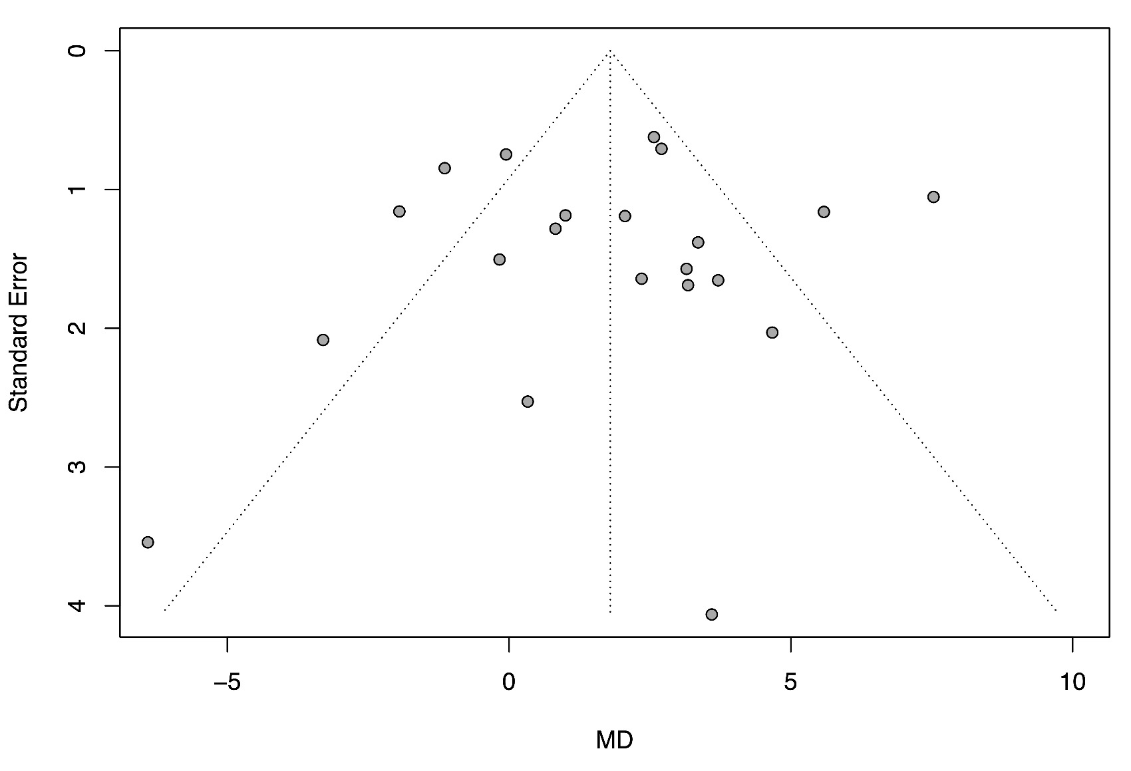
Figure S2 Forest plot for subgroup analysis by study design, time to negative test conversion
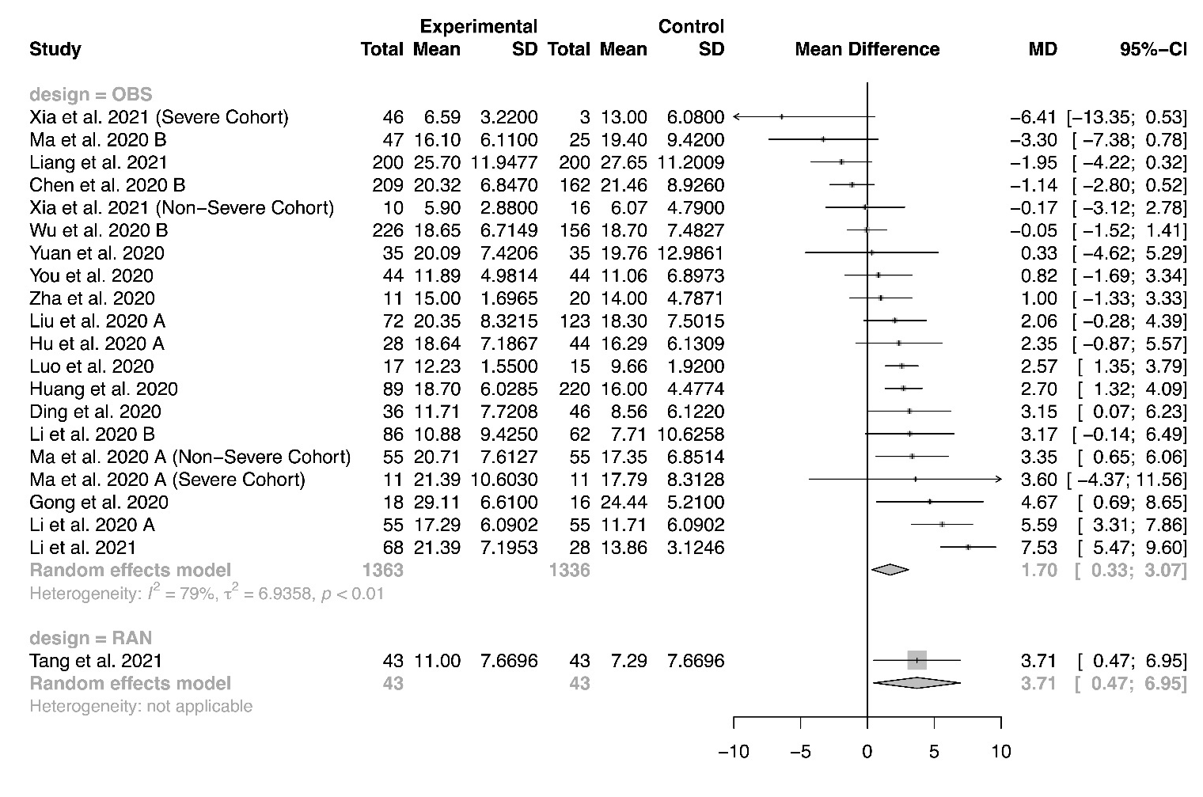
Figure S3 Forest plot for subgroup analysis by risk of bias, time to negative test conversion
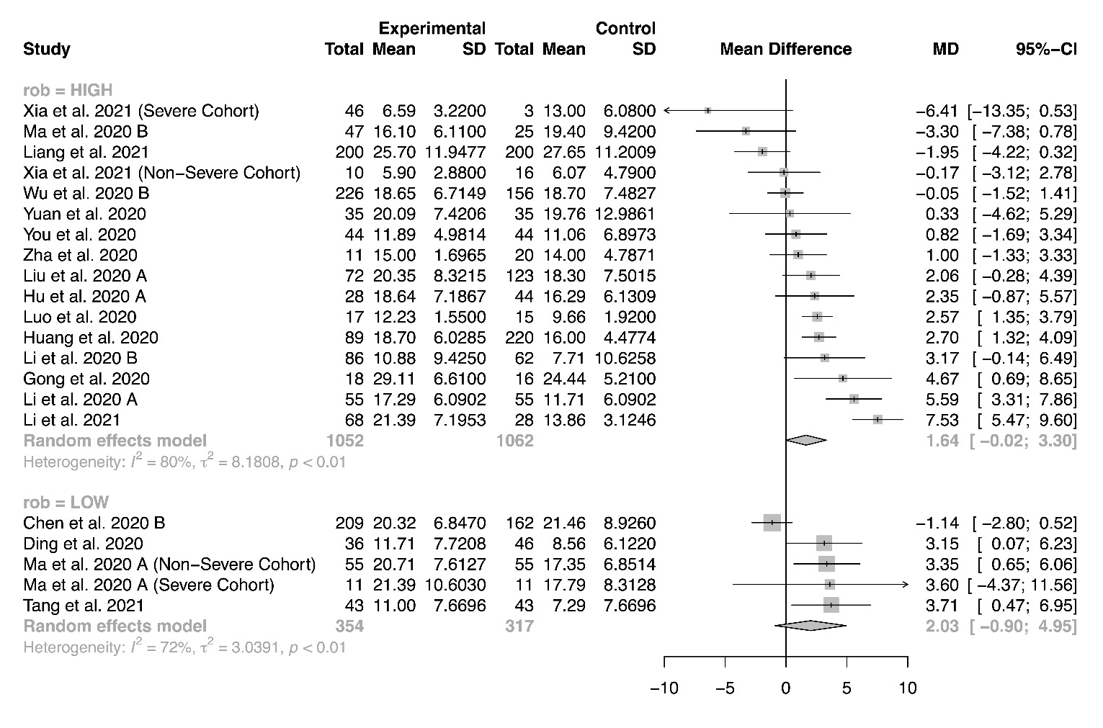
Figure S4 Forest plot for subgroup analysis by corticosteroid regimen, time to negative test conversion
Figure S5 Forest plot for subgroup analysis by corticosteroid dose, time to negative test conversion
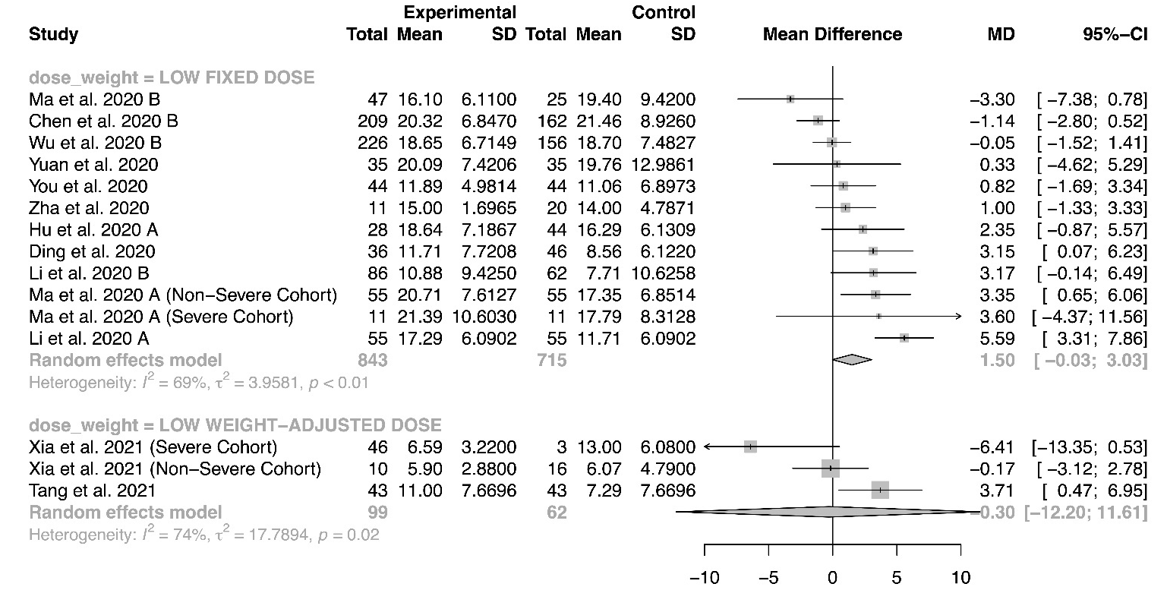
Figure S6 Forest plot for subgroup analysis by time to administration, time to negative test conversion

Figure S7 Meta-regression for proportion of severe patients, time to negative test conversion
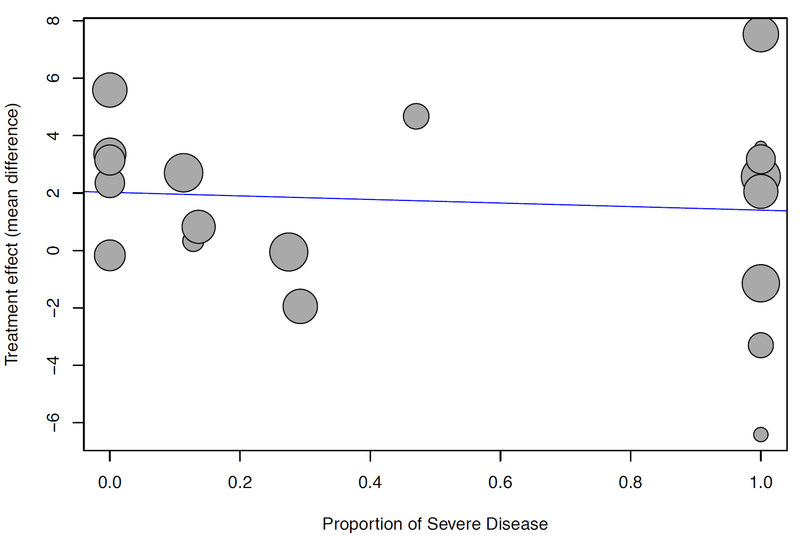
Figure S8 Meta-regression for baseline mean SOFA score, time to negative test conversion
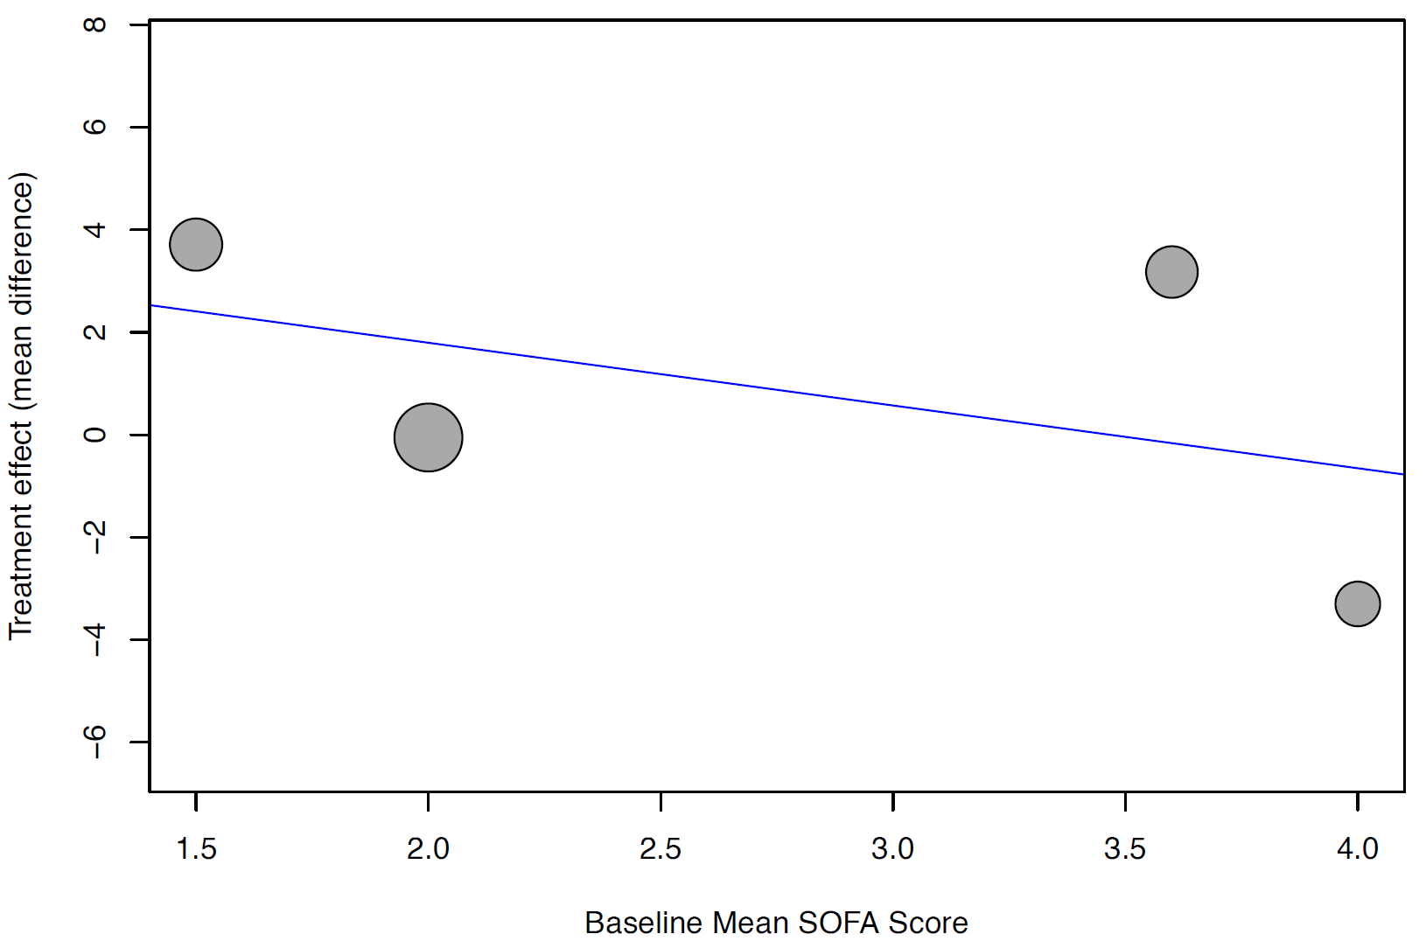
Figure S9 Funnel plot, length of stay

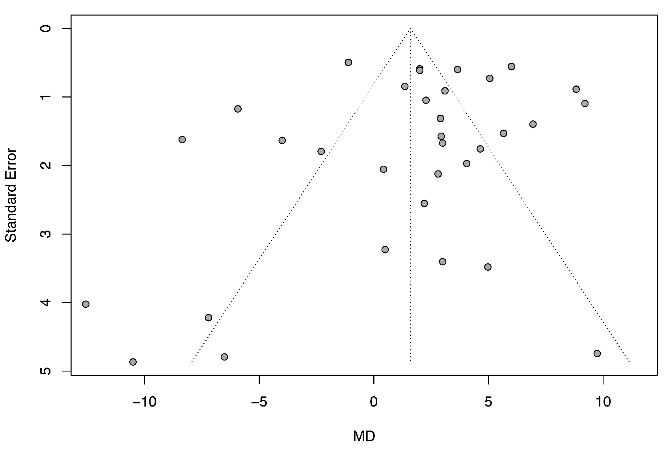
Figure S10 Forest plot for subgroup analysis by study design, length of stay

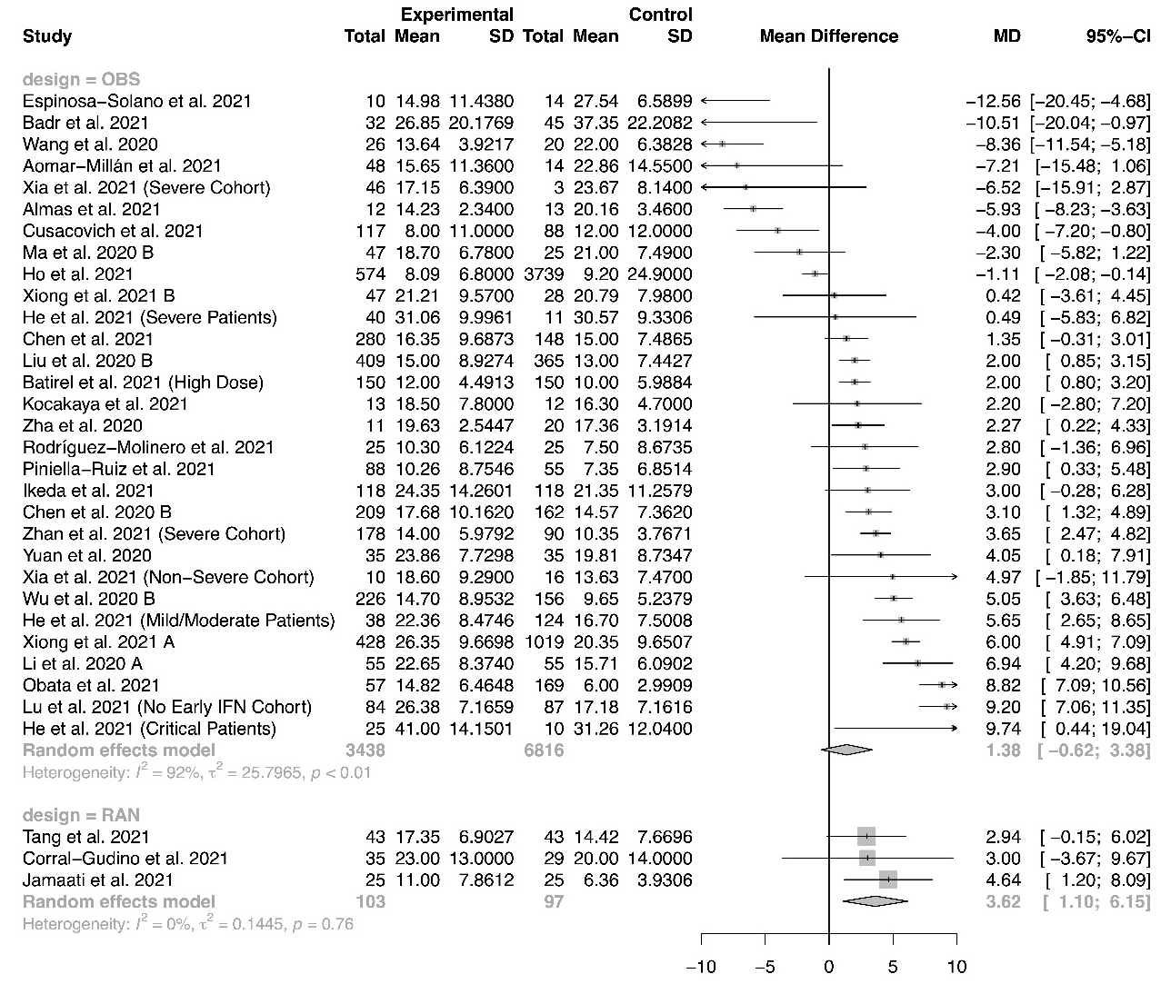
Figure S11 Forest plot for subgroup analysis by risk of bias, length of stay

Figure S12 Forest plot for subgroup analysis by corticosteroid regimen, length of stay

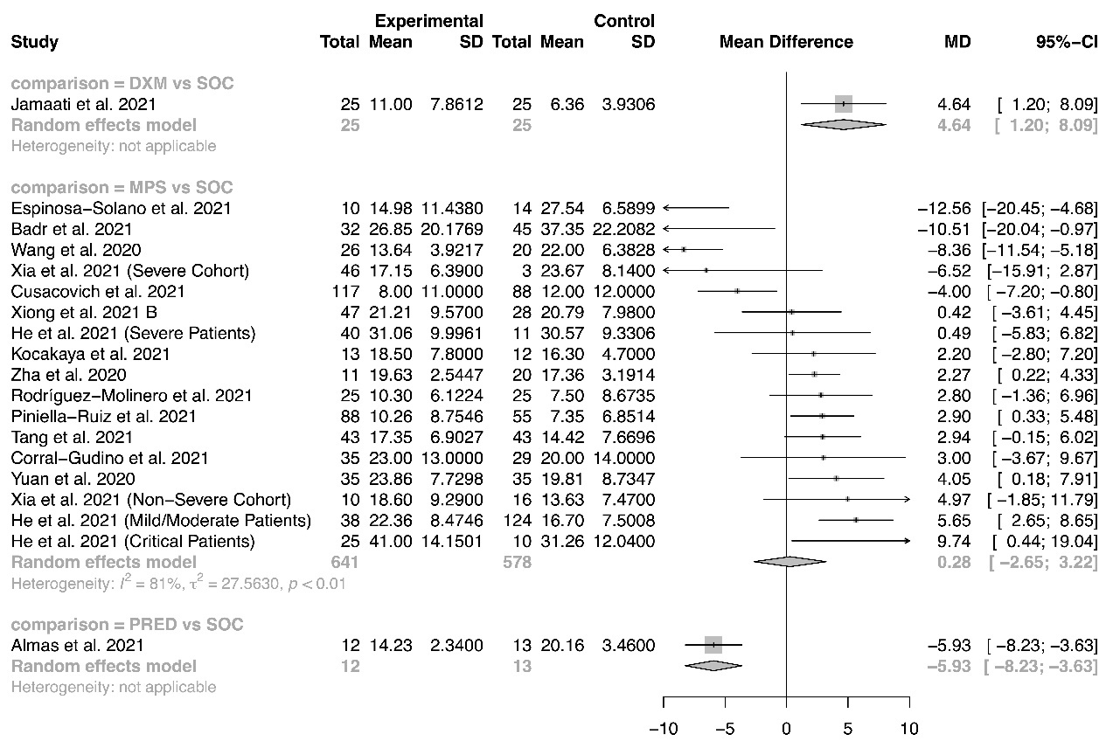
Figure S13 Forest plot for subgroup analysis by corticosteroid dose, length of stay

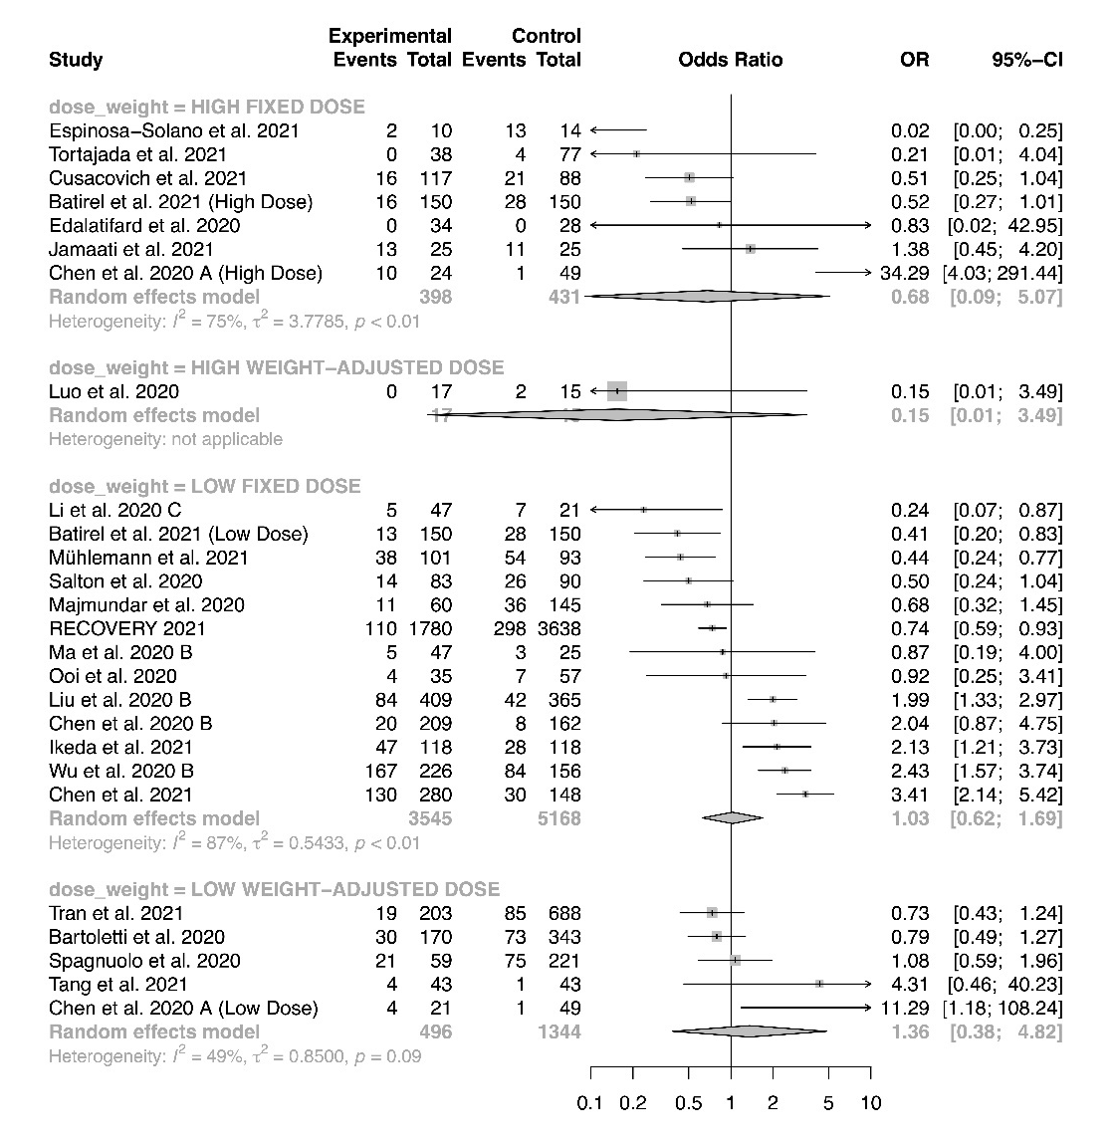
Figure S14 Forest plot for subgroup analysis by time to administration, length of stay

Figure S15 Meta-regression for proportion of severe patients, length of stay

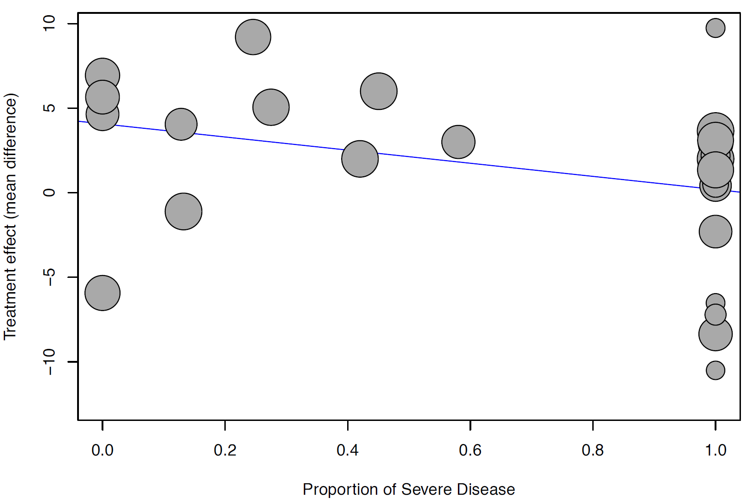
Figure S16 Meta-regression for baseline mean SOFA score, length of stay

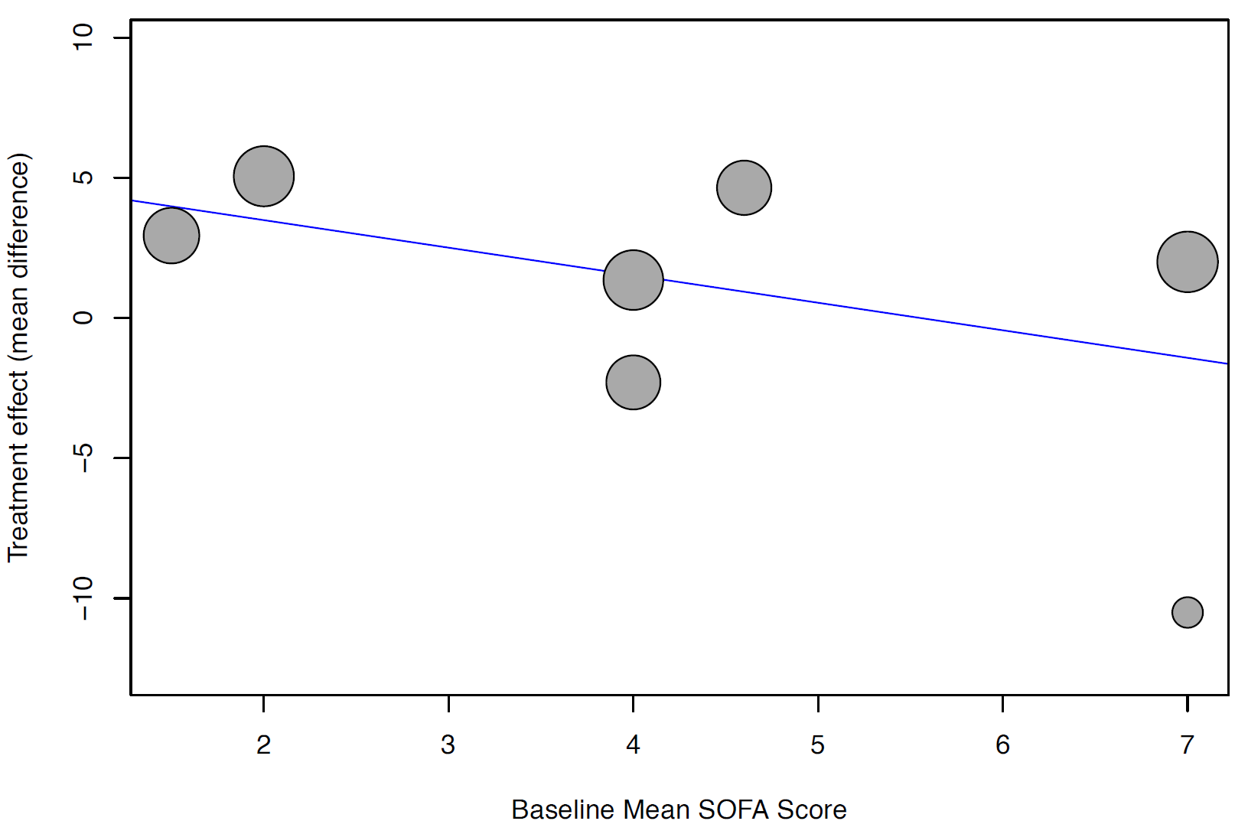
Figure S17 Forest plot for subgroup analysis by study design, ICU length of stay
Figure S18 Forest plot for subgroup analysis by risk of bias, ICU length of stay
Figure S19 Forest plot for subgroup analysis by corticosteroid regimen, ICU length of stay
Figure S20 Forest plot for subgroup analysis by corticosteroid dose, ICU length of stay
Figure S21 Forest plot for subgroup analysis by time to administration, ICU length of stay

Figure S22 Meta-regression for proportion of severe patients, ICU length of stay
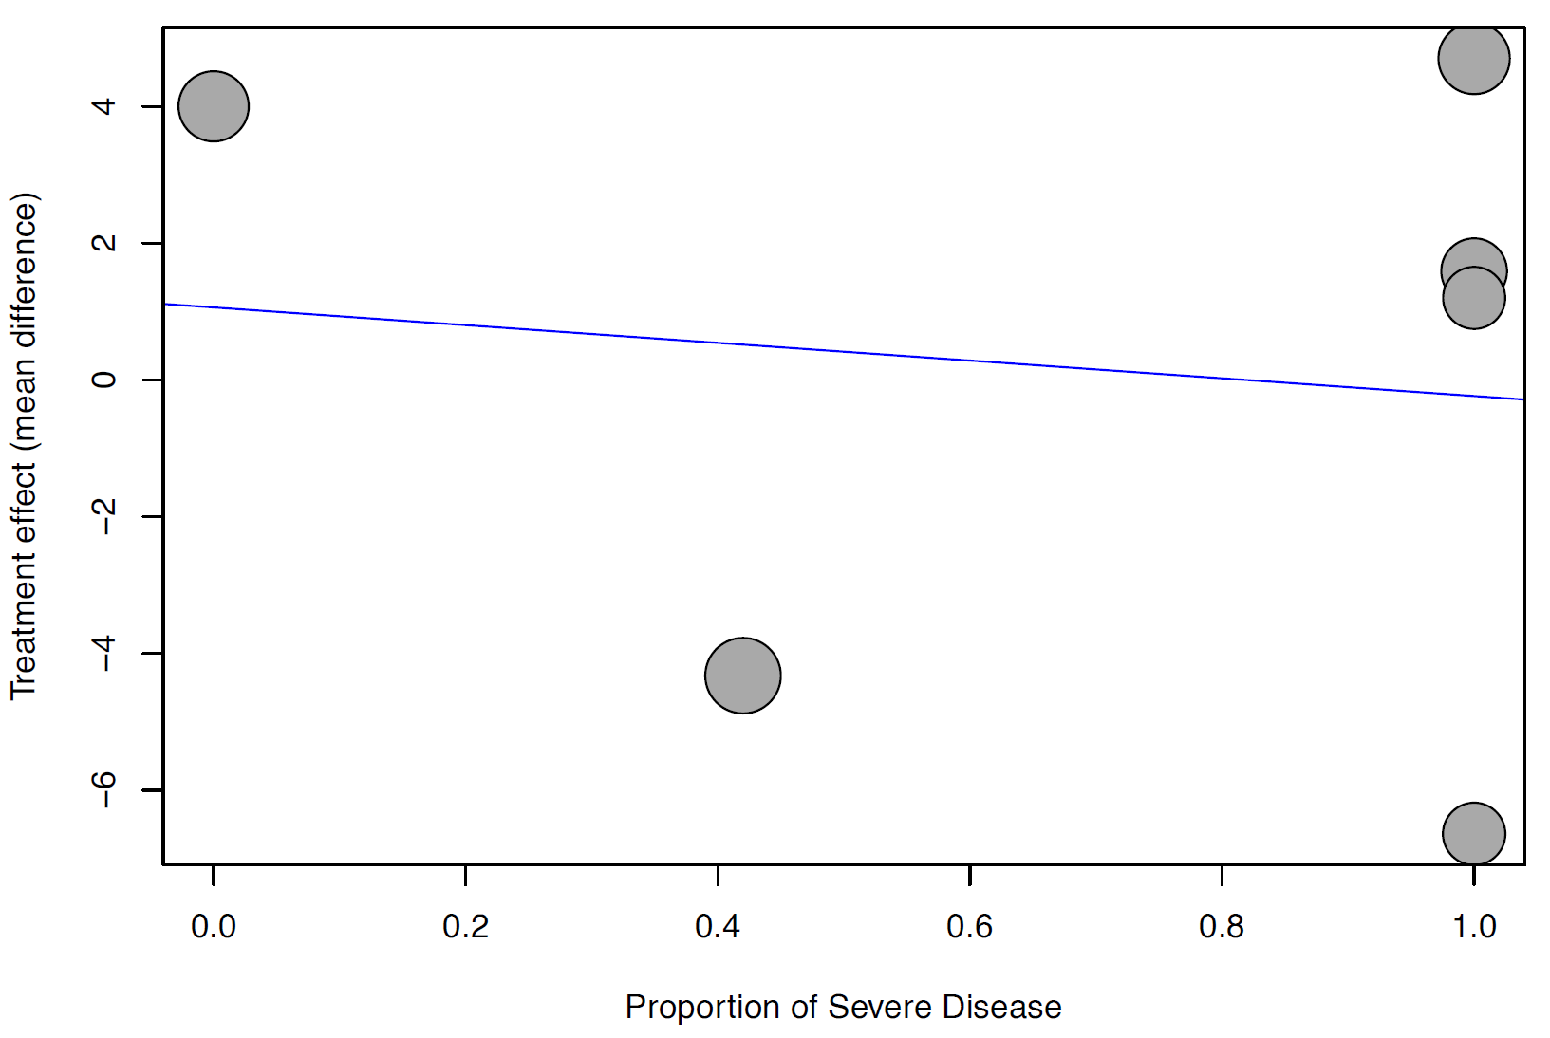

Figure S23 Meta-regression for baseline mean SOFA score, ICU length of stay
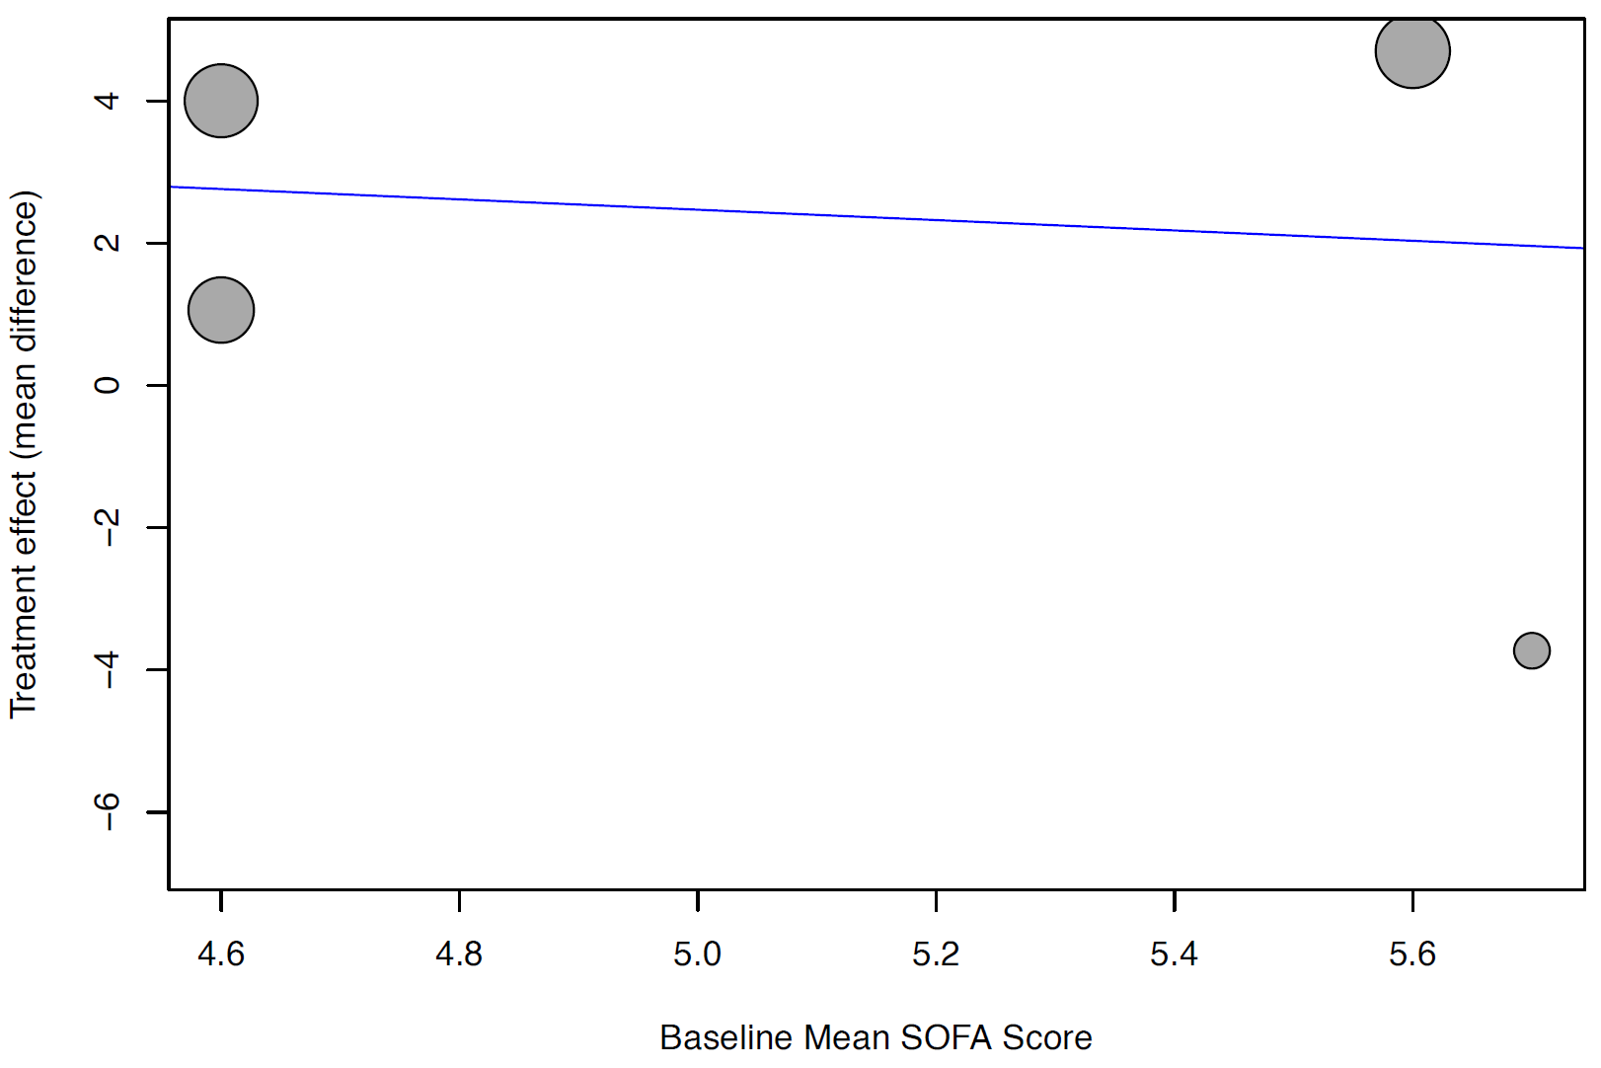
Figure S24 Funnel plot, incidence of ICU admission
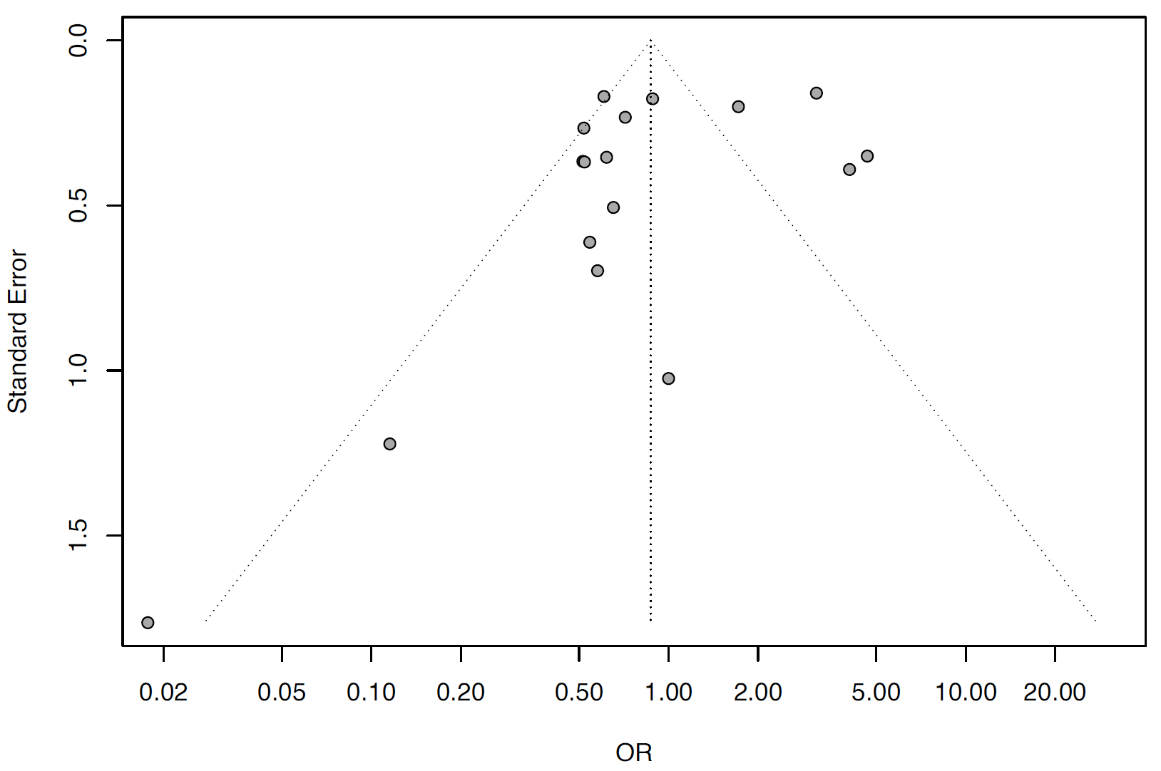
Figure S25 Forest plot for subgroup analysis by study design, incidence of ICU admission
Figure S26 Forest plot for subgroup analysis by risk of bias, incidence of ICU admission
Figure S27 Forest plot for subgroup analysis by corticosteroid regimen, incidence of ICU admission
Figure S28 Forest plot for subgroup analysis by corticosteroid dose, incidence of ICU admission
Figure S29 Forest plot for subgroup analysis by time to administration, incidence of ICU admission

Figure S30 Meta-regression for proportion of severe patients, incidence of ICU admission
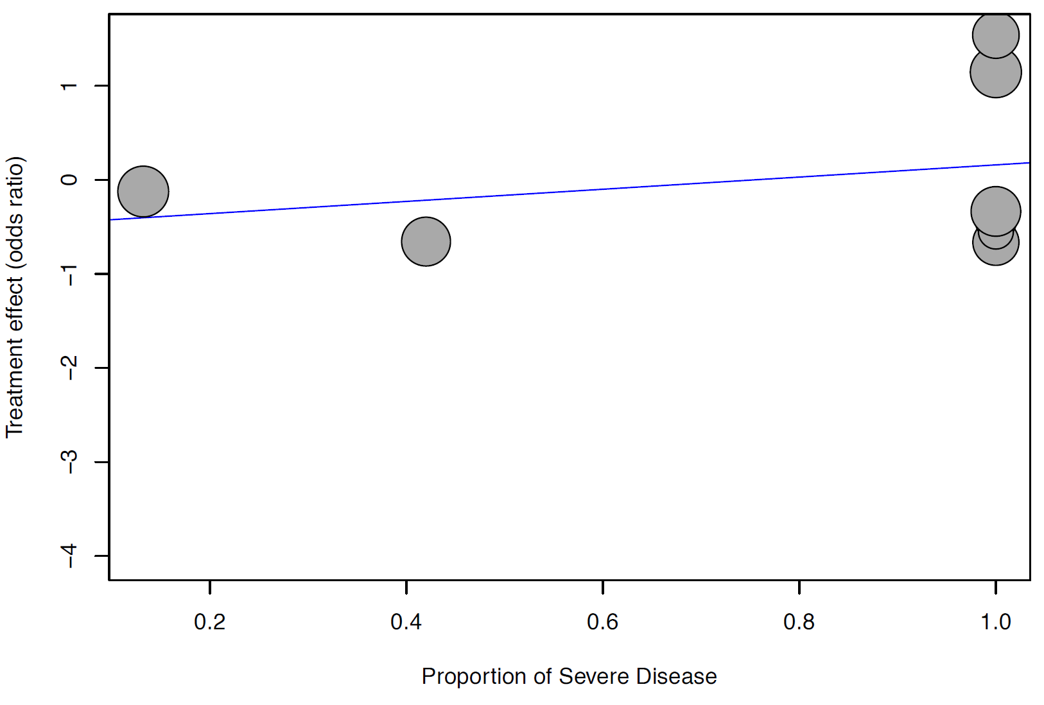

Figure S31 Meta-regression for baseline mean SOFA score, incidence of ICU admission
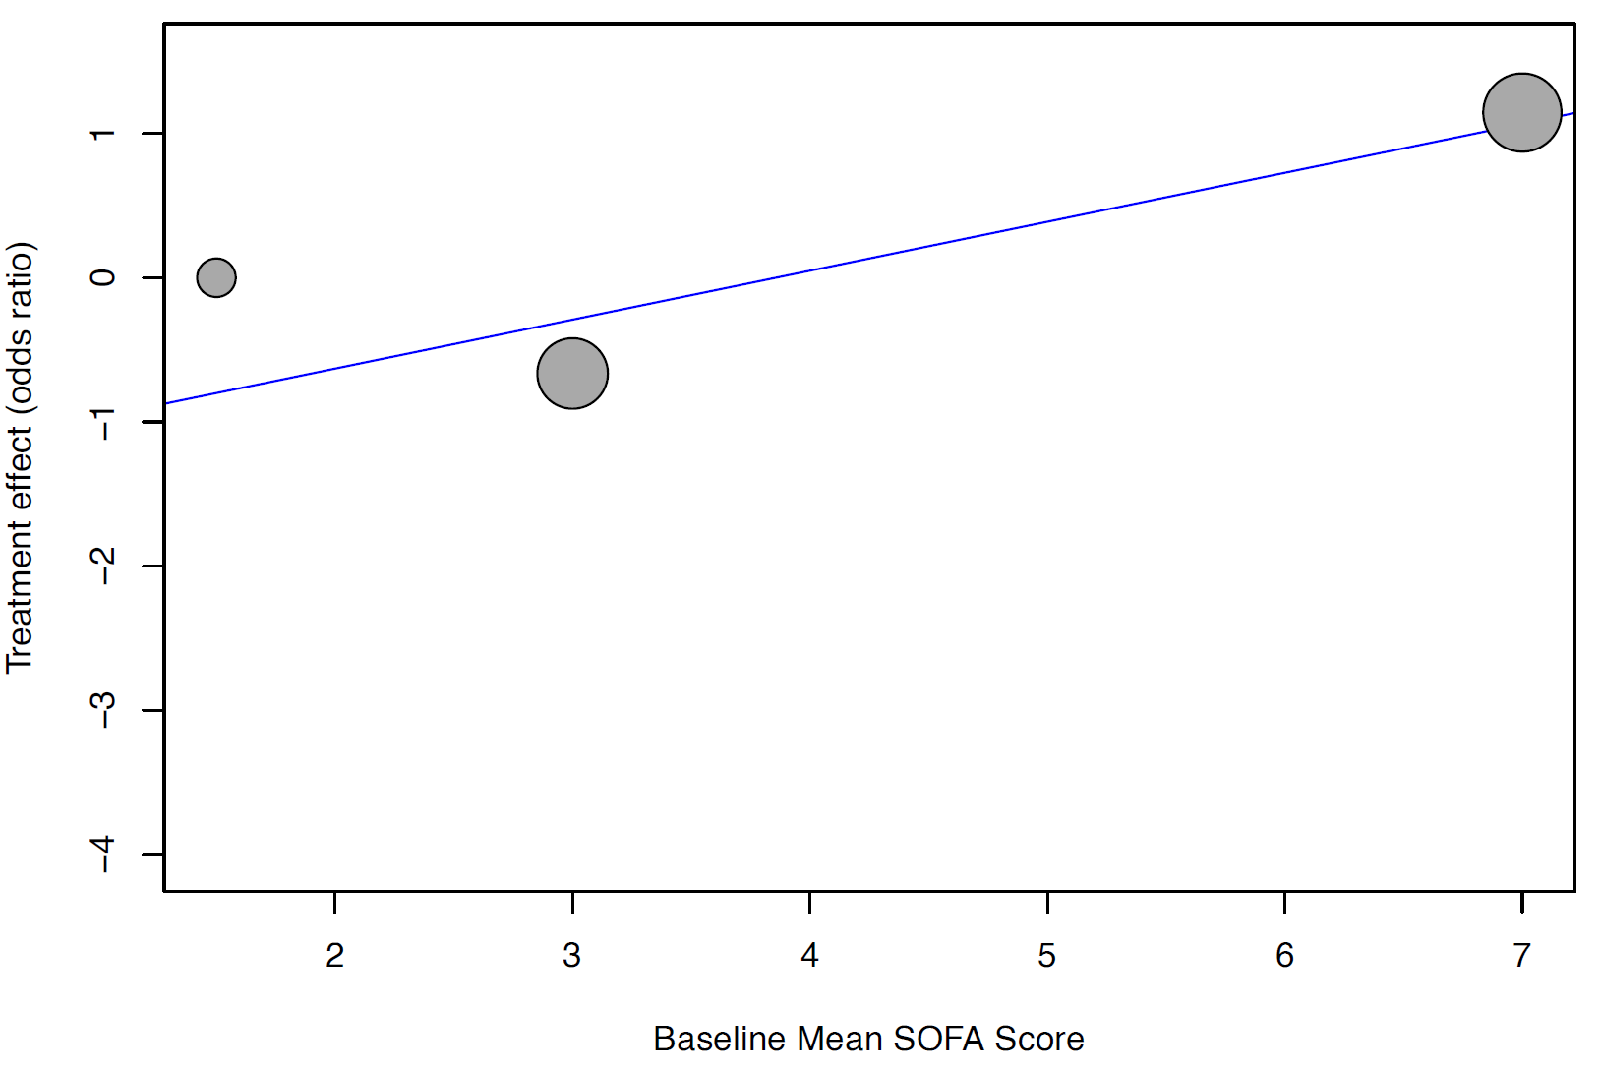
Figure S32 Funnel plot, mortality
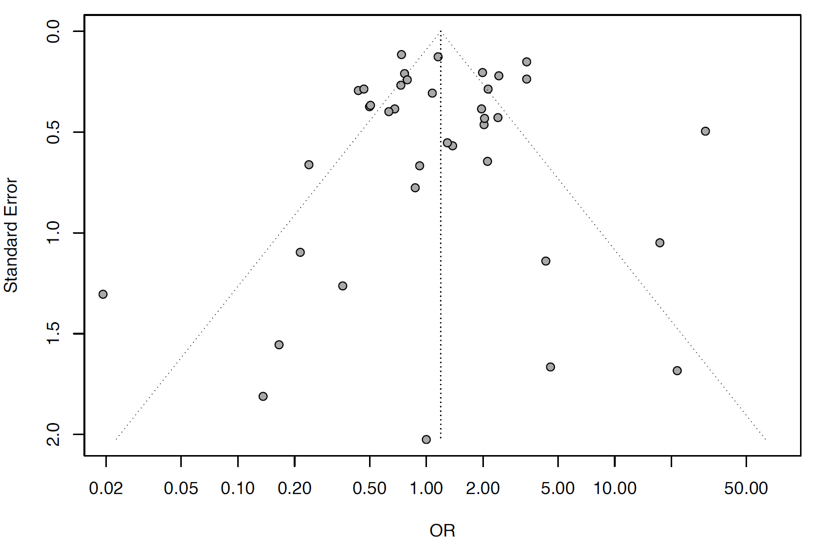

Figure S33 Forest plot for subgroup analysis by study design, mortality
Figure S34 Forest plot for subgroup analysis by risk of bias, mortality

Figure S35 Forest plot for subgroup analysis by corticosteroid regimen, mortality
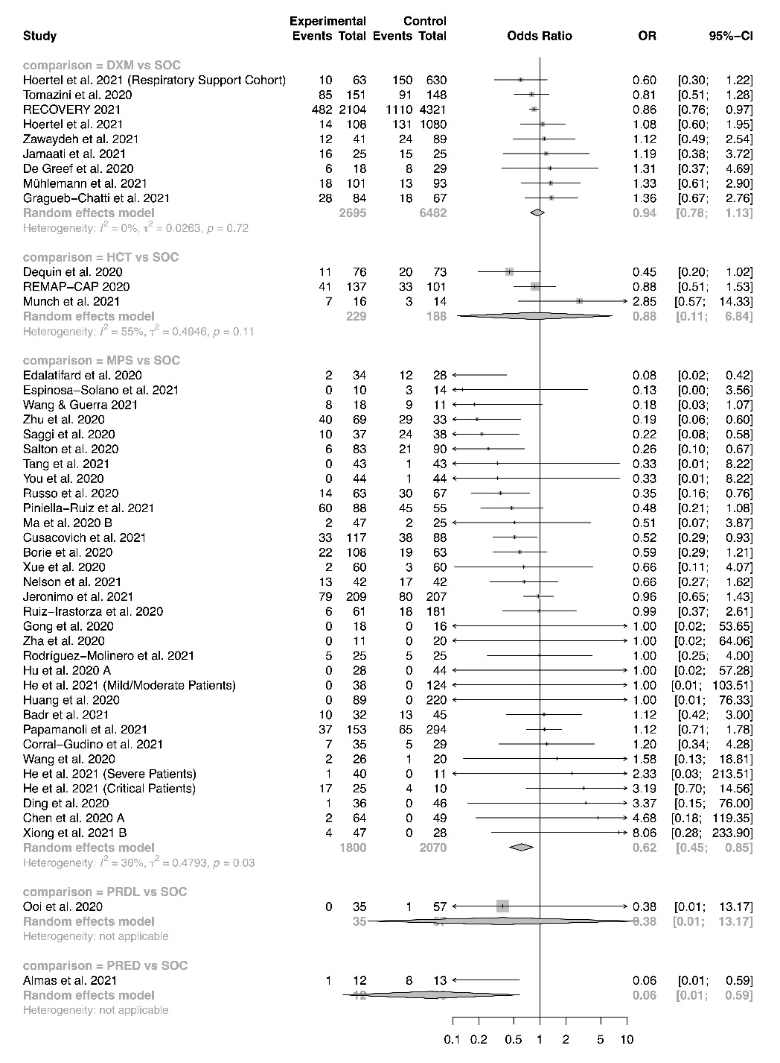
Figure S36 Forest plot for subgroup analysis by corticosteroid dose, mortality
Figure S37 Forest plot for subgroup analysis by time to administration, mortality
Figure S38 Meta-regression for proportion of severe patients, mortality
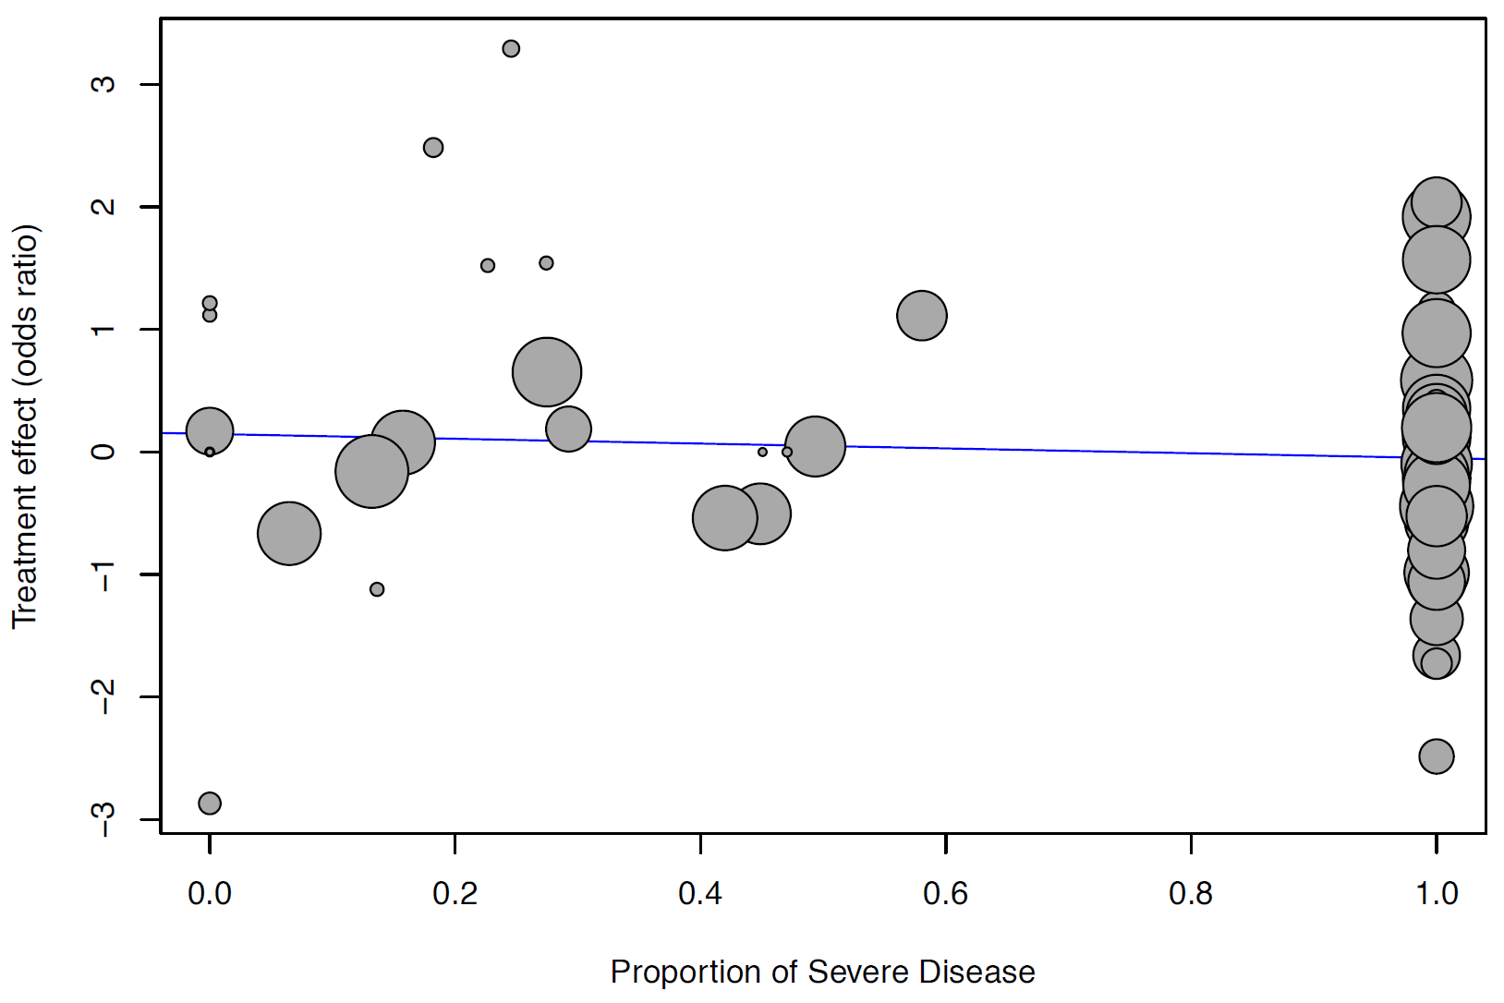

Figure S39 Meta-regression for baseline mean SOFA score, mortality
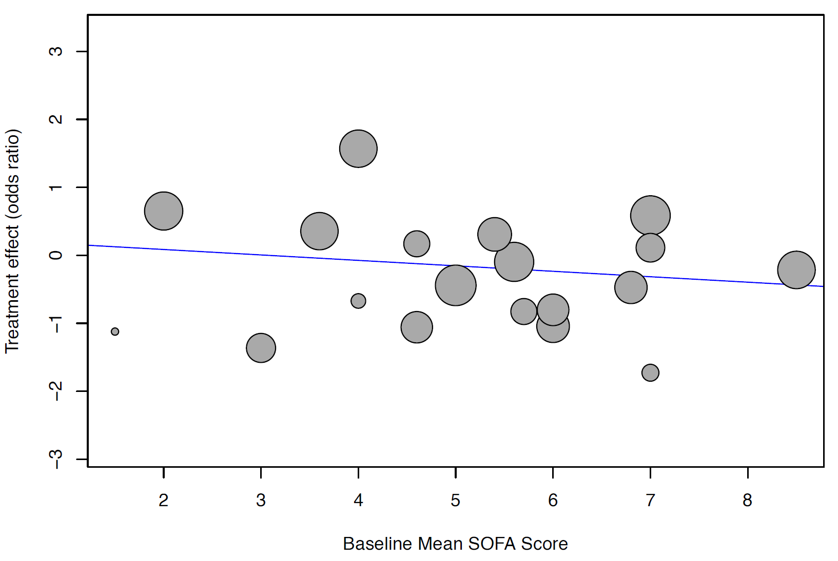

Figure S40 Meta-regression for follow-up duration, mortality
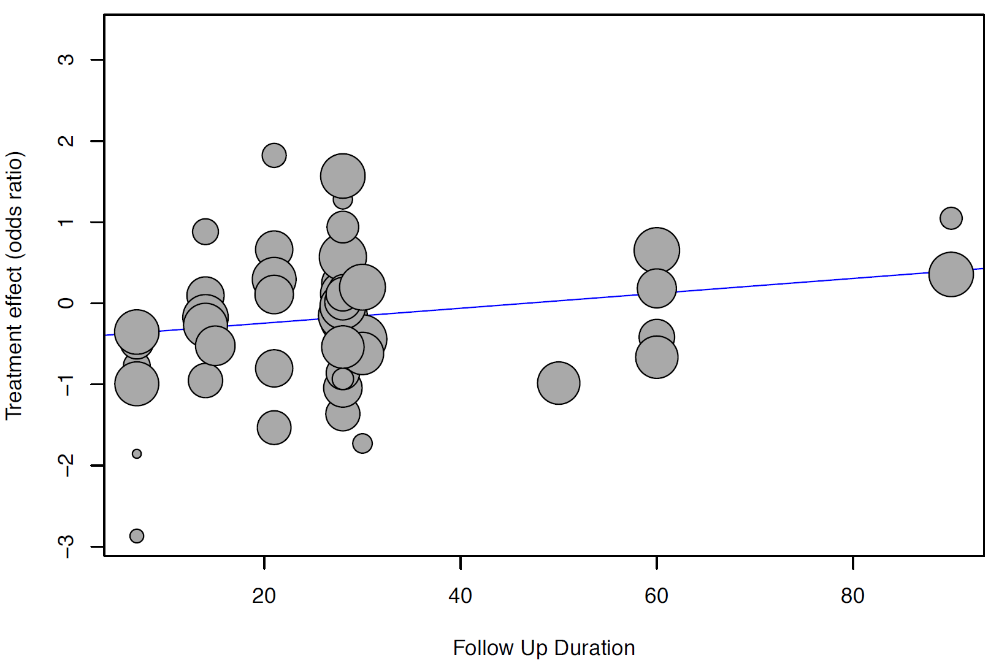
Figure S41 Funnel plot, incidence of mechanical ventilation
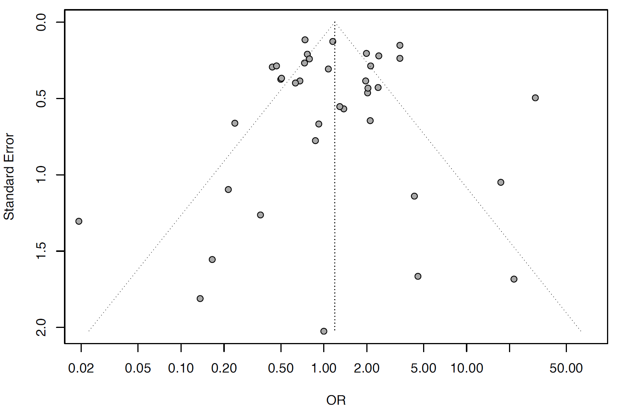
Figure S42 Forest plot for subgroup analysis by study design, incidence of mechanical ventilation
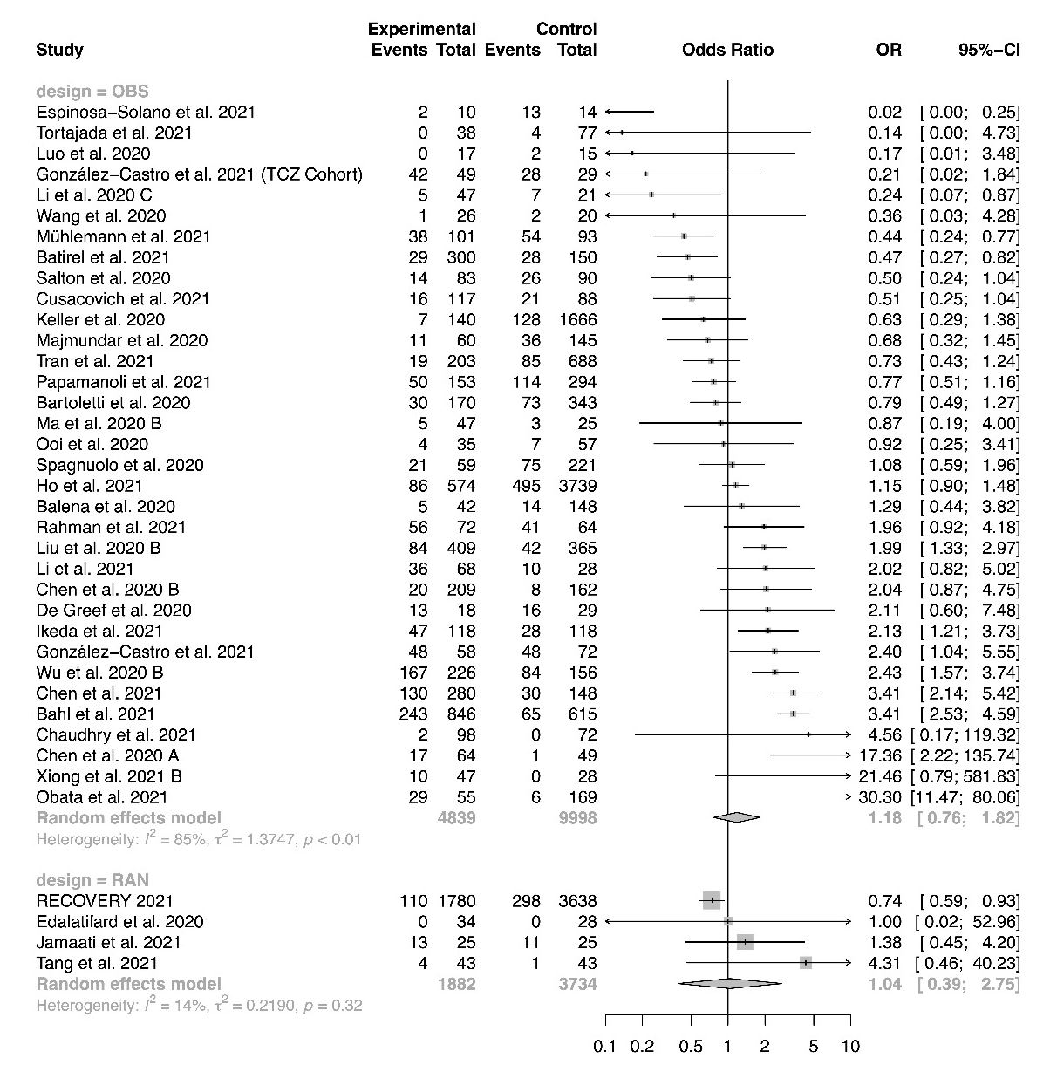
Figure S43 Forest plot for subgroup analysis by risk of bias, incidence of mechanical ventilation
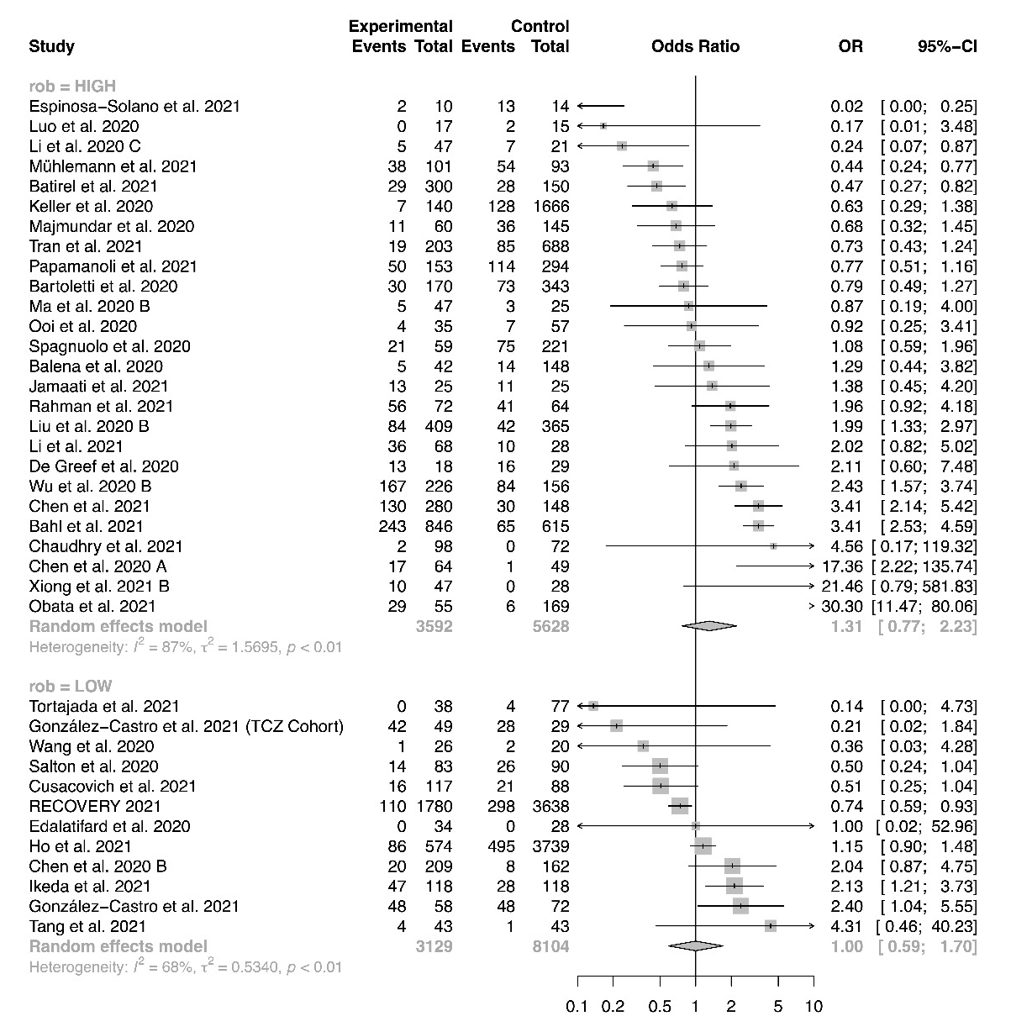
Figure S44 Forest plot for subgroup analysis by corticosteroid regimen, incidence of mechanical ventilation
Figure S45 Forest plot for subgroup analysis by corticosteroid dose, incidence of mechanical ventilation
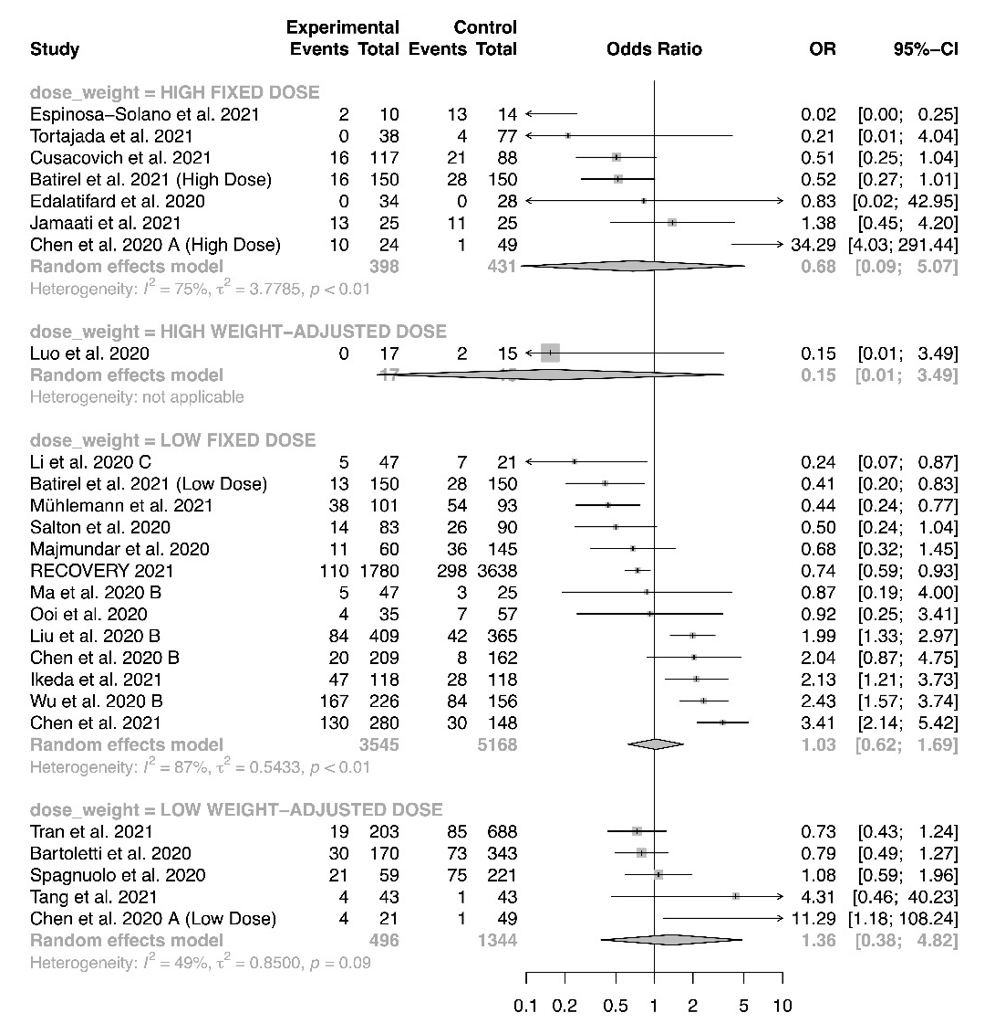
Figure S46 Forest plot for subgroup analysis by time to administration, incidence of mechanical ventilation

Figure S47 Meta-regression for proportion of severe patients, incidence of mechanical ventilation
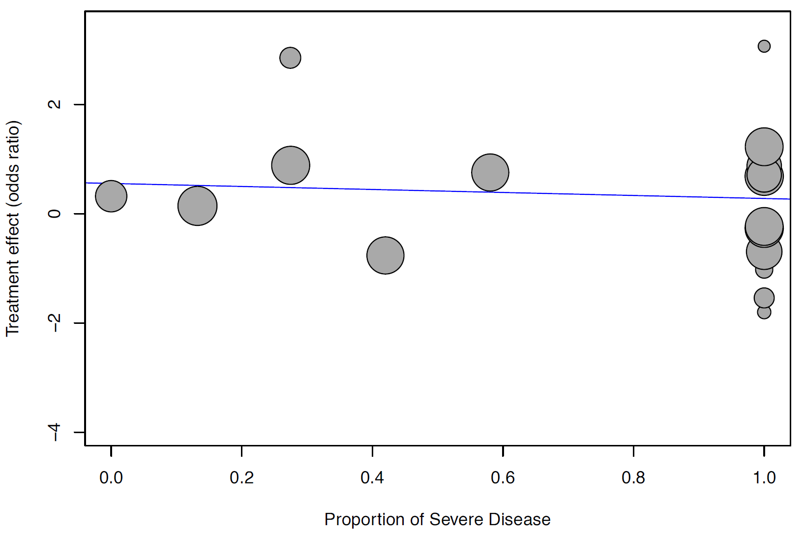

Figure S48 Meta-regression for baseline mean SOFA score, incidence of mechanical ventilation
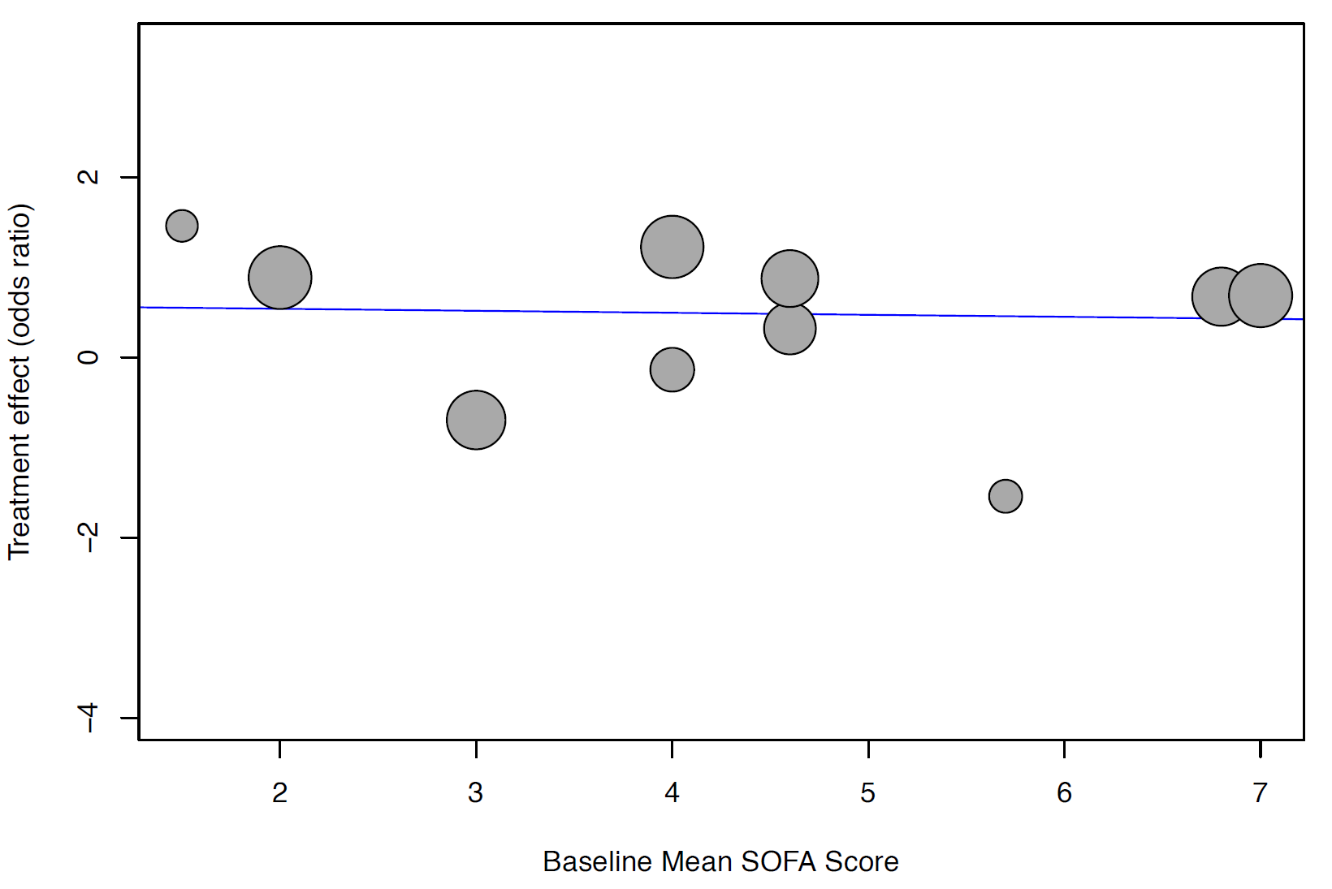
Figure S49 Forest plot for subgroup analysis by study design, length of mechanical ventilation
Figure S50 Forest plot for subgroup analysis by risk of bias, length of mechanical ventilation
Figure S51 Forest plot for subgroup analysis by corticosteroid regimen, length of mechanical ventilation
Figure S52 Forest plot for subgroup analysis by corticosteroid dose, length of mechanical ventilation

Figure S53 Meta-regression for proportion of severe patients, length of mechanical ventilation
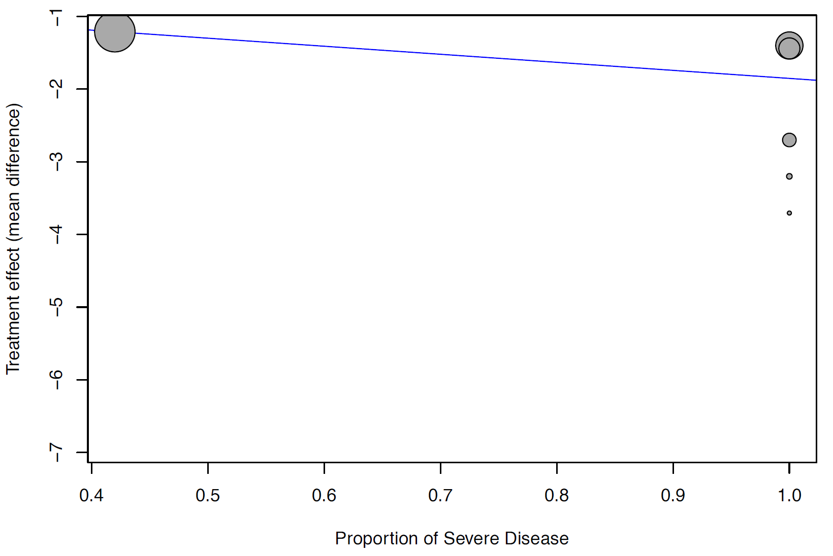

Figure S54 Meta-regression for baseline mean SOFA score, length of mechanical ventilation
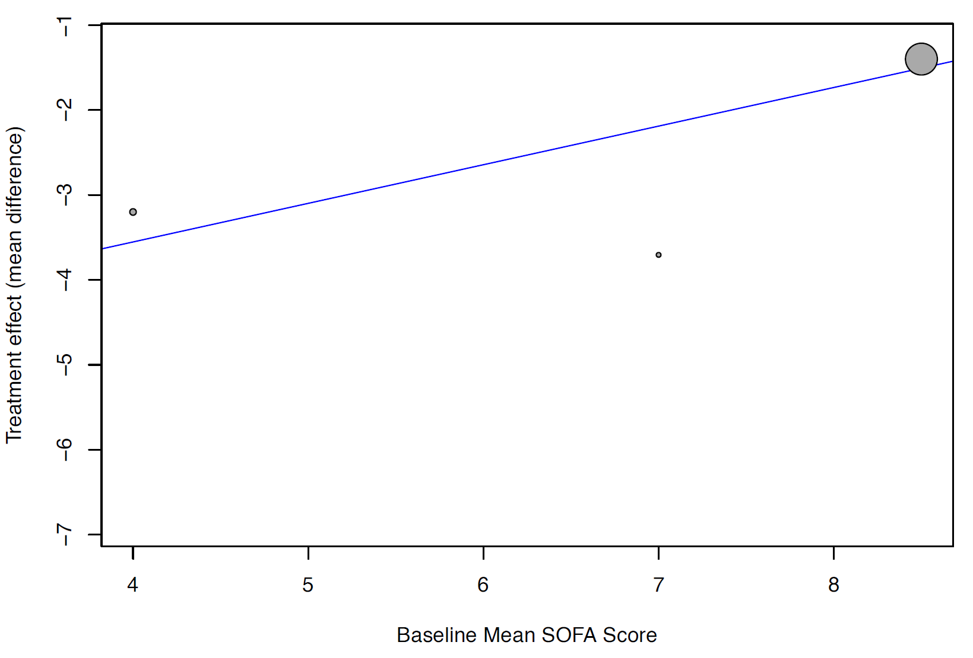
Figure S55 Forest plot for subgroup analysis by study design, incidence of adverse events
Figure S56 Forest plot for subgroup analysis by risk of bias, incidence of adverse events
Figure S57 Forest plot for subgroup analysis by corticosteroid regimen, incidence of adverse events
Figure S58 Forest plot for subgroup analysis by corticosteroid dose, incidence of adverse events
Figure S59 Forest plot for subgroup analysis by time to administration, incidence of adverse events

Figure S60 Meta-regression for proportion of severe patients, incidence of adverse events
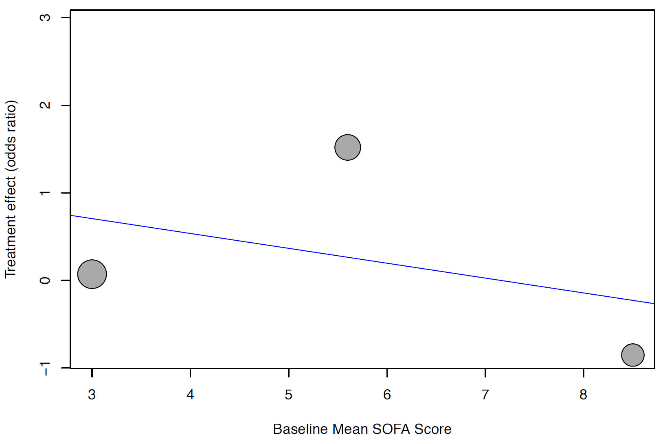

Figure S61 Forest plot for subgroup analysis by study design, incidence of severe adverse events
Figure S62 Forest plot for subgroup analysis by risk of bias, incidence of severe adverse events
Figure S63 Forest plot for subgroup analysis by corticosteroid regimen, incidence of severe adverse events

Figure S64 Forest plot for subgroup analysis by corticosteroid dose, incidence of severe adverse events

Figure S65 Forest plot for subgroup analysis by time to administration, incidence of severe adverse events

Figure S66 Funnel plot, incidence of hyperglycemia
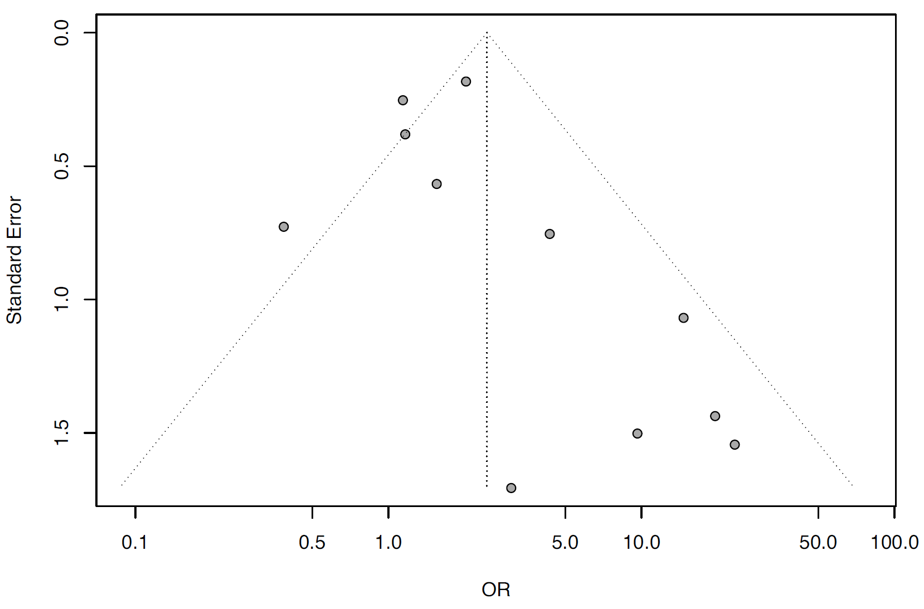

Figure S67 Forest plot for subgroup analysis by study design, incidence of hyperglycemia
Figure S68 Forest plot for subgroup analysis by risk of bias, incidence of hyperglycemia
Figure S69 Forest plot for subgroup analysis by corticosteroid regimen, incidence of hyperglycemia
Figure S70 Forest plot for subgroup analysis by corticosteroid dose, incidence of hyperglycemia
Figure S71 Forest plot for subgroup analysis by time to administration, incidence of hyperglycemia

Figure S72 Meta-regression for proportion of severe patients, incidence of hyperglycemia
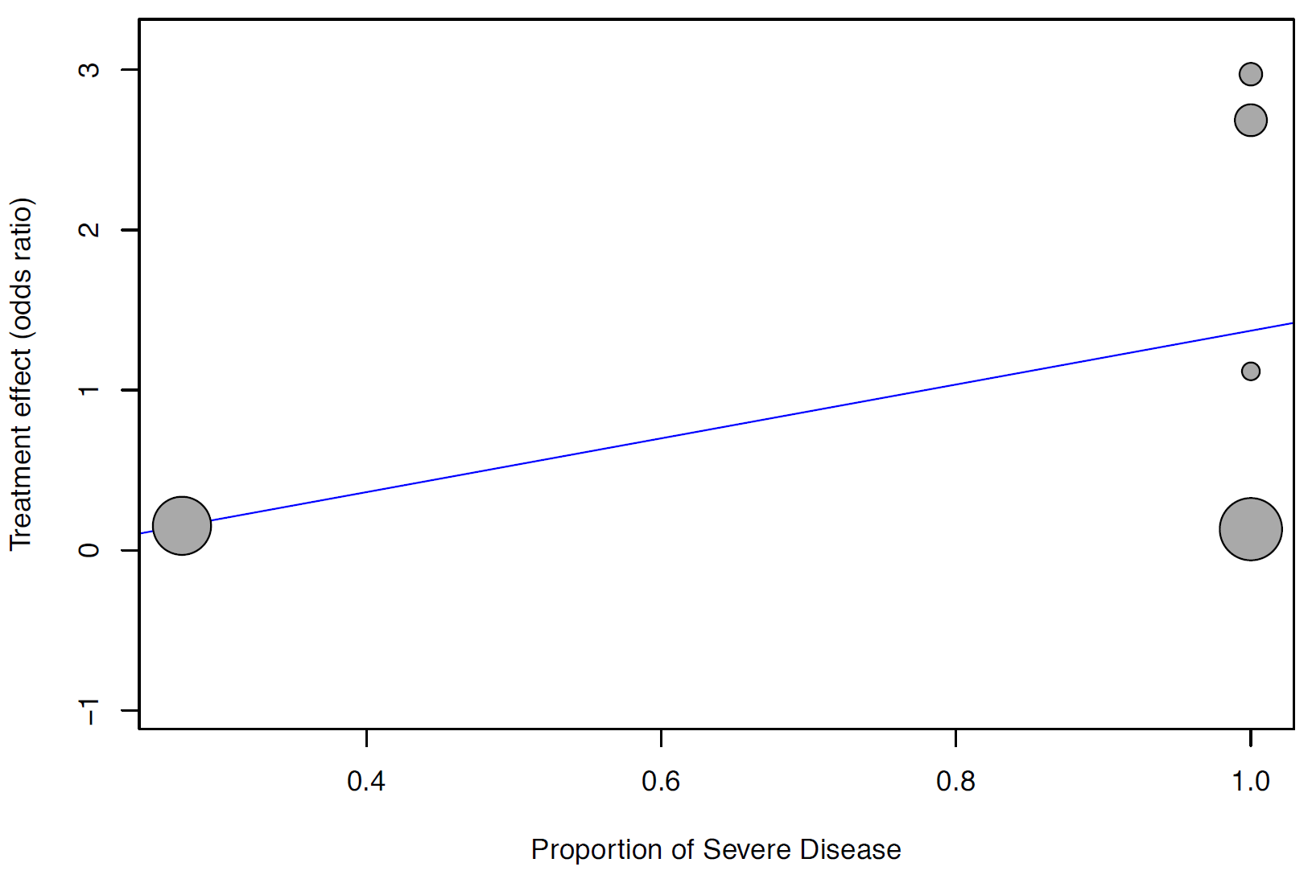

Figure S73 Meta-regression for baseline mean SOFA score, incidence of hyperglycemia
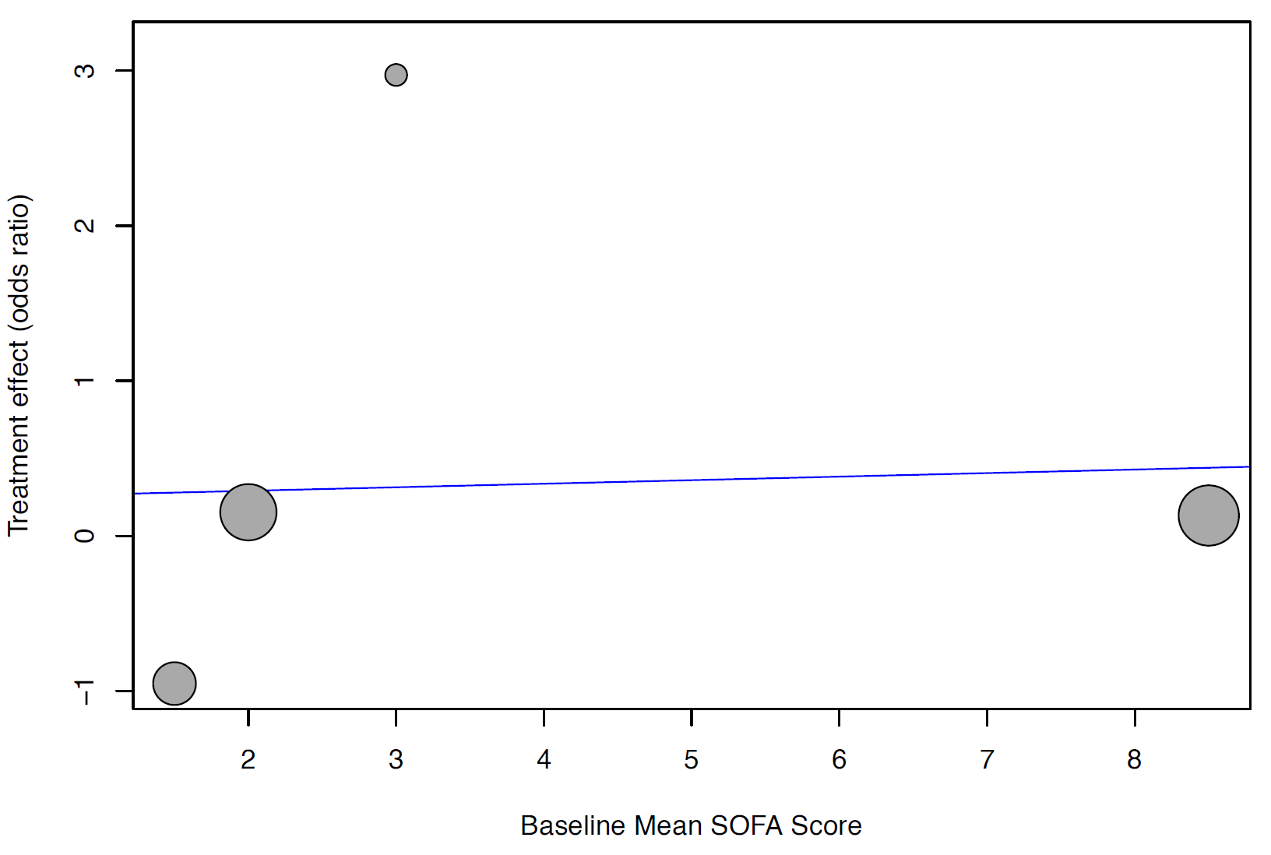
Figure S74 Funnel plot, incidence of nosocomial infection
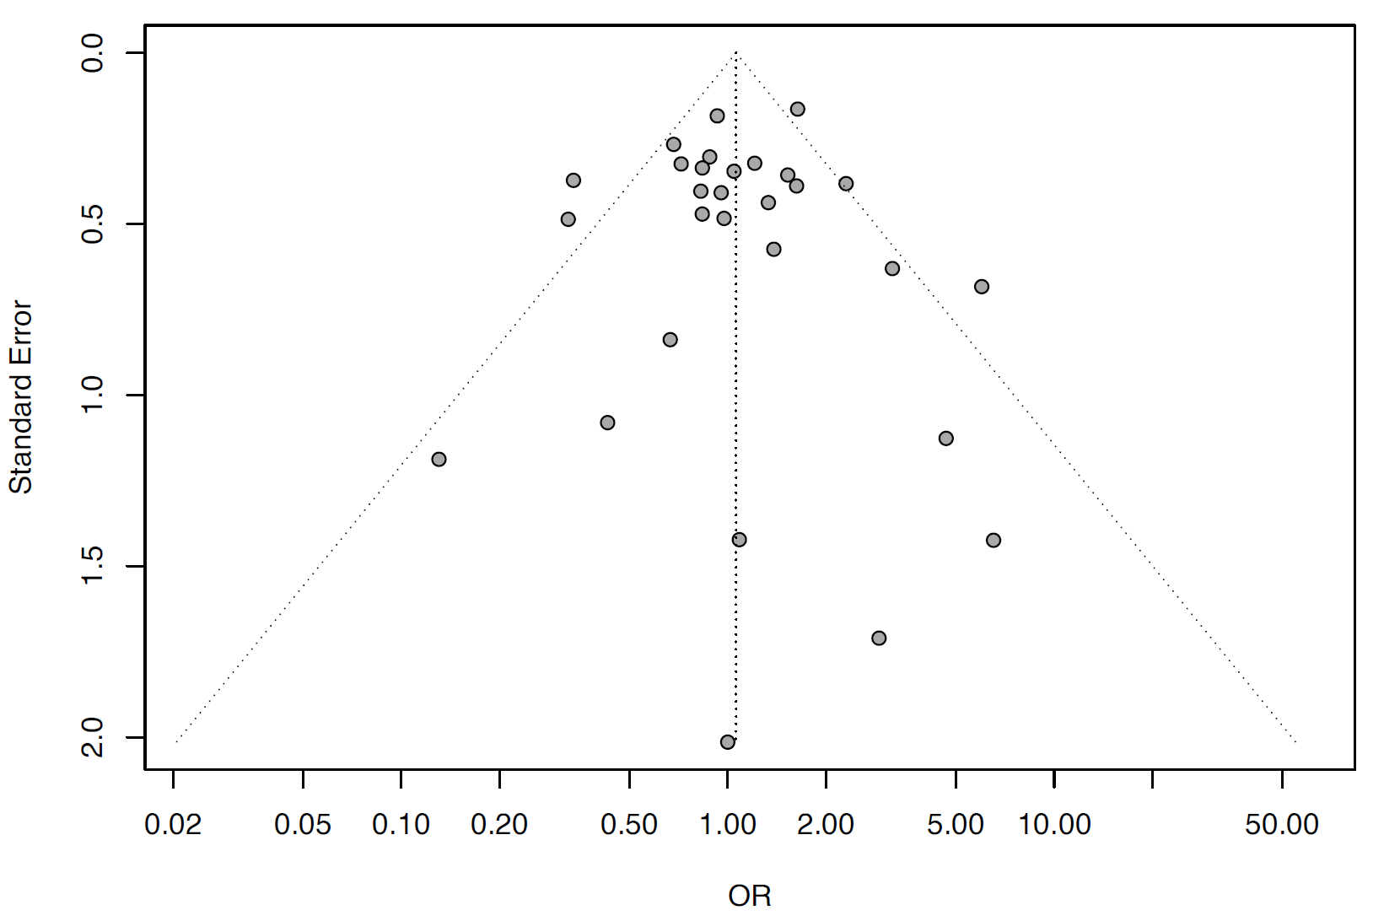
Figure S75 Forest plot for subgroup analysis by study design, incidence of nosocomial infection
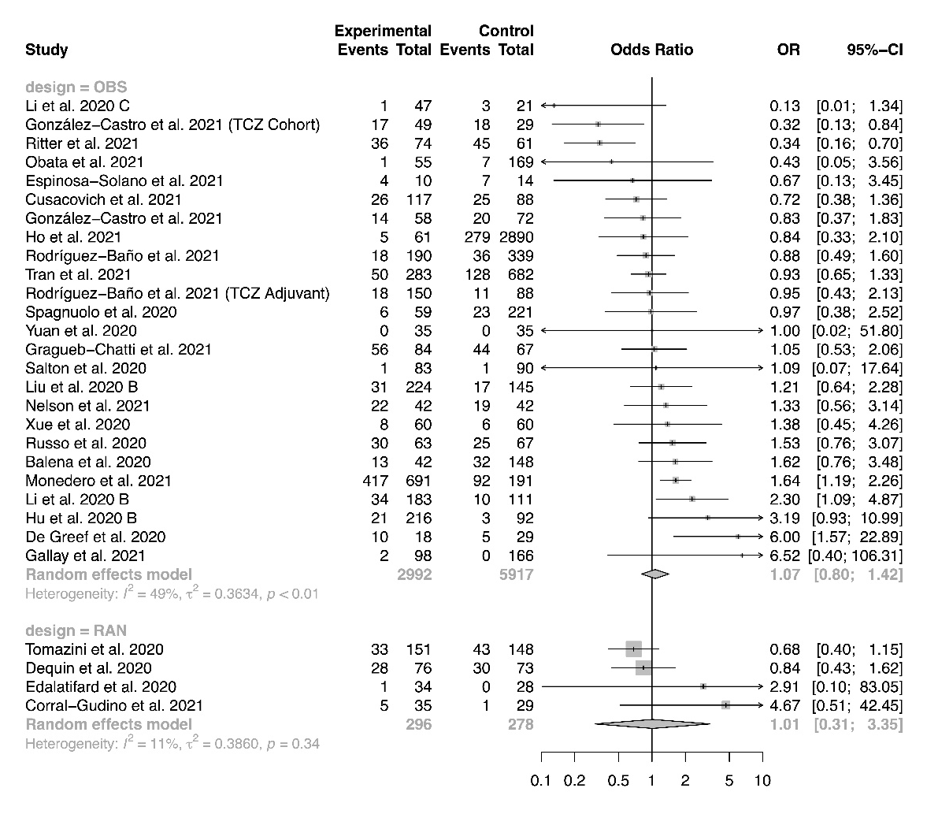
Figure S76 Forest plot for subgroup analysis by risk of bias, incidence of nosocomial infection
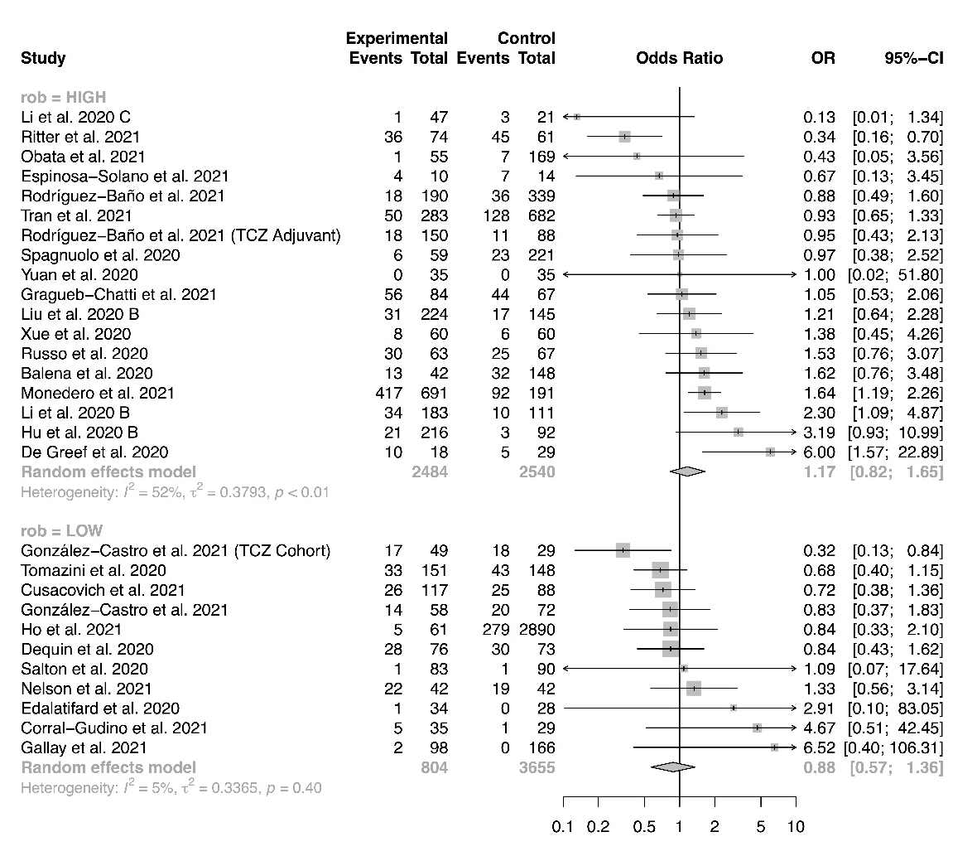
Figure S77 Forest plot for subgroup analysis by corticosteroid regimen, incidence of nosocomial infection
Figure S78 Forest plot for subgroup analysis by corticosteroid dose, incidence of nosocomial infection
Figure S79 Forest plot for subgroup analysis by time to administration, incidence of nosocomial infection

Figure S80 Meta-regression for proportion of severe patients, incidence of nosocomial infection
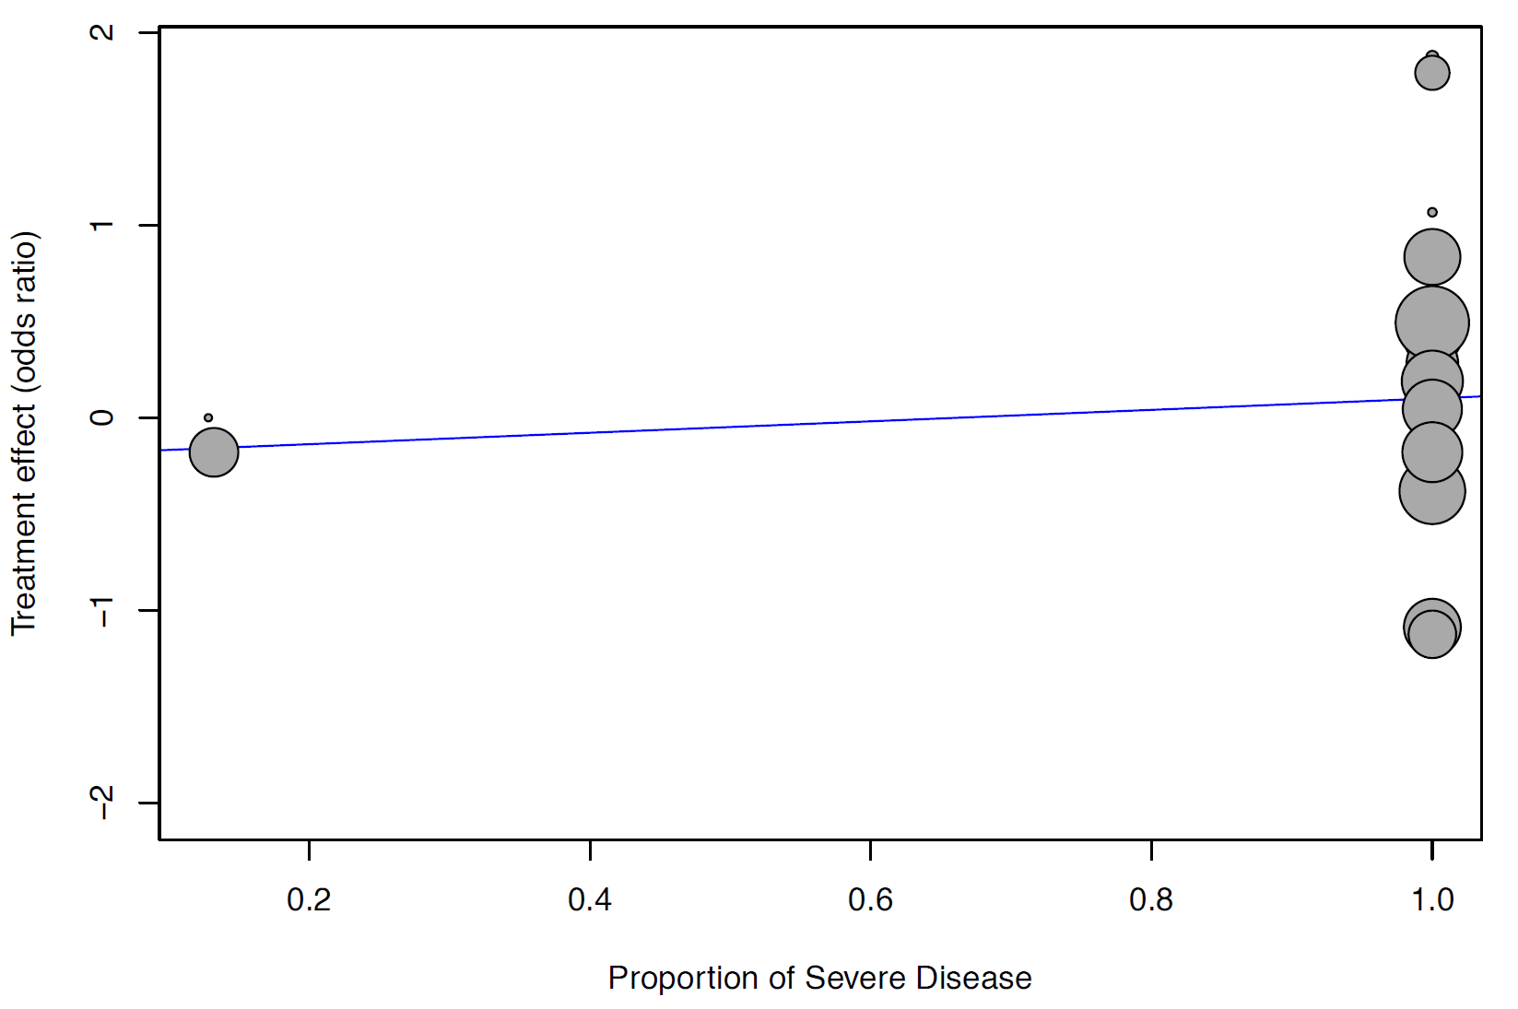

Figure S81 Meta-regression for baseline mean SOFA score, incidence of nosocomial infection
