Nanoscale cell-matrix adhesions modulate gap junction intercellular communication of mesenchymal cell condensates during chondrogenesis (Supplementary Files)

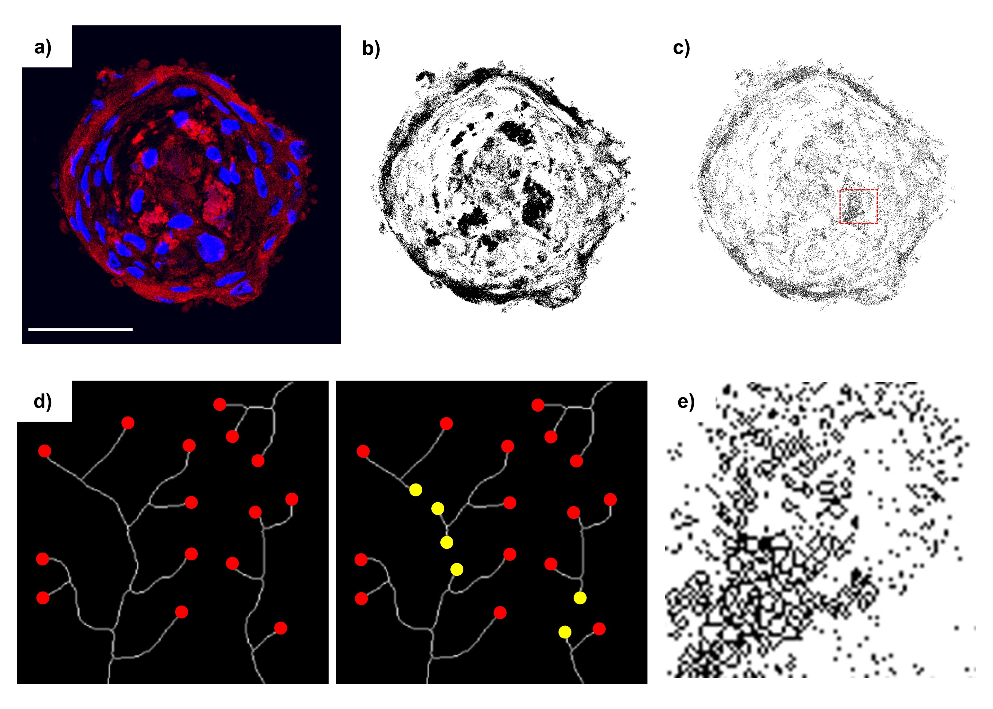

Fig. S1: Analysis of Cx43 expression and intercellular communication network architecture. a) Representative chondrogenic cell condensate stained for Cx43 (red) and cell nuclei (blue). b) Threshold selecting Cx43 expression. c) Skeletonizing of the Cx43 network, from which end-point voxels and mean branch length were quantified. a-c) Scale bar = 50 μm. d) Schematic of network connectivity quantification as the inverse of the amount of end-point voxels. White lines represent theoretical networks, red dots indicate end-point voxels, yellow dots indicate new end-point voxels as a results of network splitting. The network on the left is more extensively connected than the one on the right, and thus contains fewer end-point voxels. e) Zoomed-in section from the red square in c.

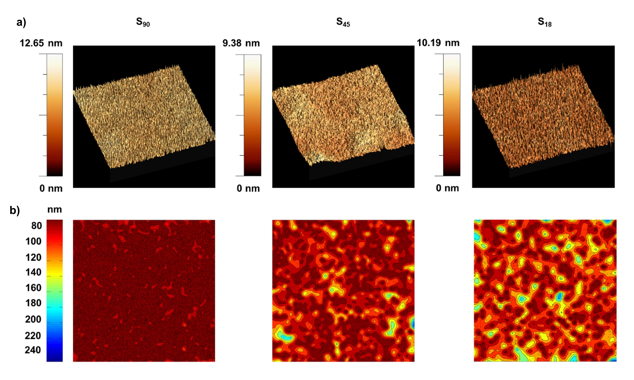
Fig. S2: Substrates of tunable local surface adhesiveness obtained by nanopatterning RGD-functionalized dendrimers on PLLA. a) Representative 3D AFM images (5x5 µm) of the nanopatterns’ topography. b) Corresponding d_{min} probability contour plots showing high-density RGD regions (d_{min} < 70 nm) in dark red (dendrimer positions are superimposed in black for clarity). Adapted with permission from [30] © Tsinghua University Press and Springer-Verlag Berlin Heidelberg (2016).

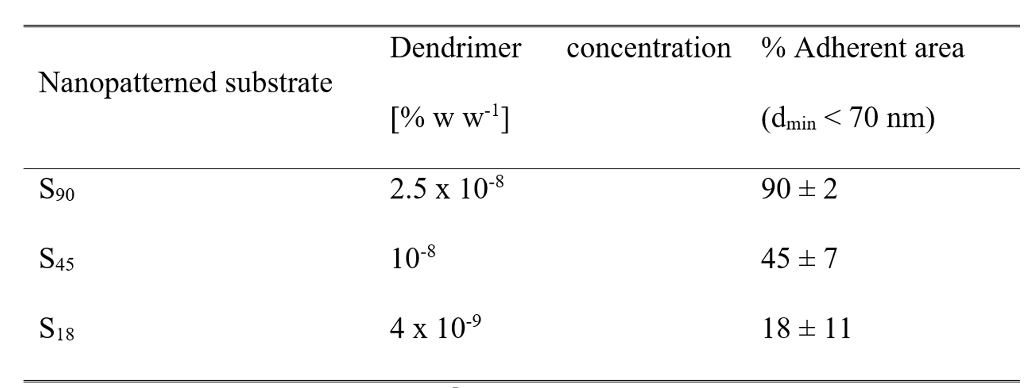
Table S1: Nanopatterns adherent area

Fig. S3: Representative confocal z-projections of Cx43 immunostaining at day 6, scale bar = 40 µm.

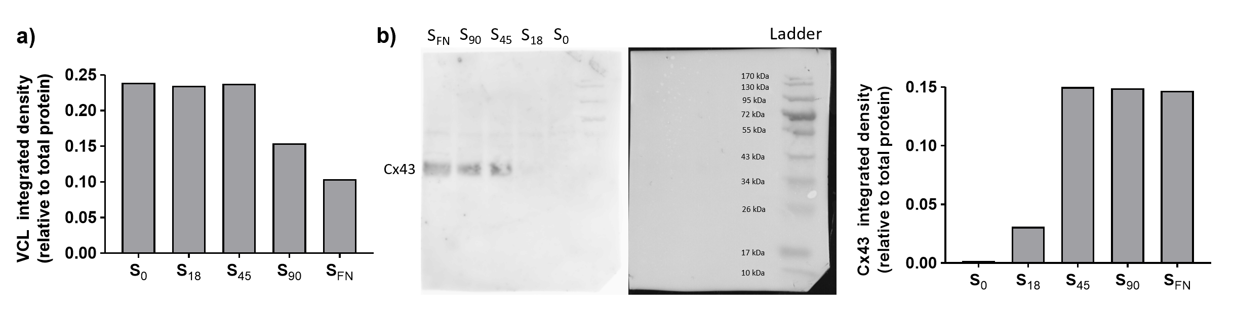
Fig. S4: a) Western blot quantification for vinculin at day 6 of chondrogenesis. b) Western blot and corresponding quantification for Cx43 at day 6 of chondrogenesis.

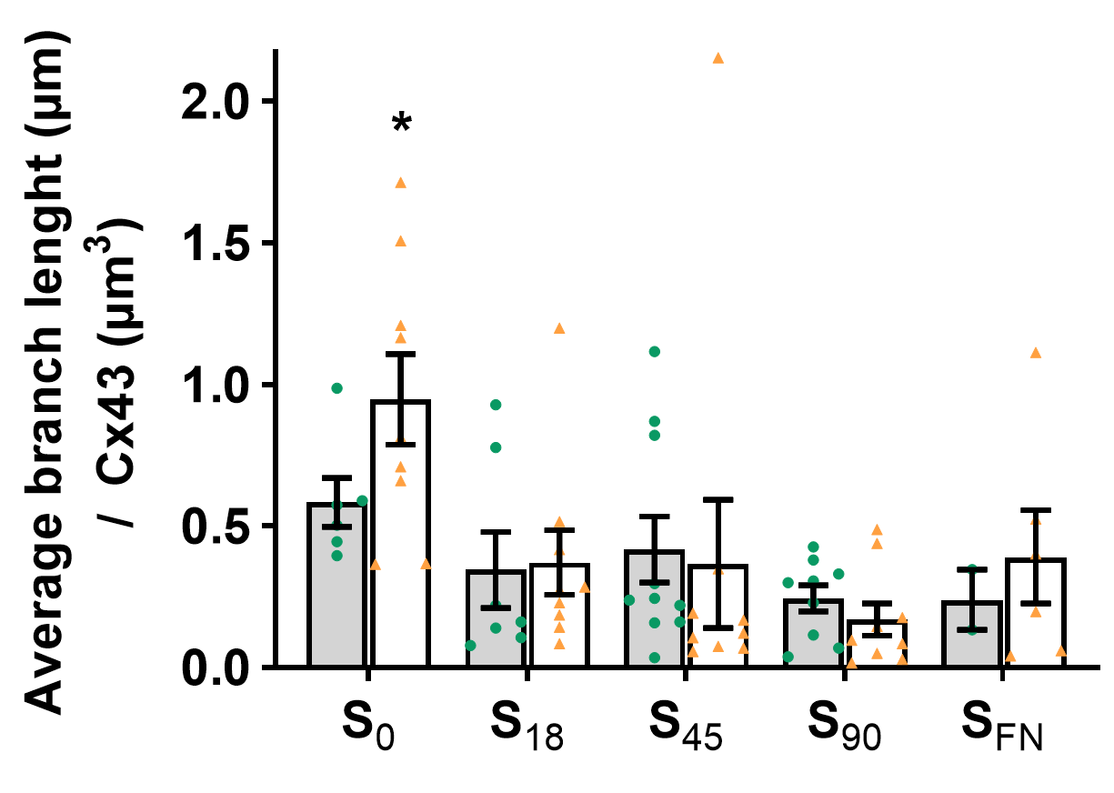

Fig. S5: Average length of Cx43 network branches in chondrogenic cell condensates (n≥2). Gray and white bars correspond to 6 and 9 days of chondrogenic induction, respectively. Green dots and orange triangles correspond to individual sample values at day 6 and day 9, respectively. Results given as the mean ± SEM., *p < 0.05

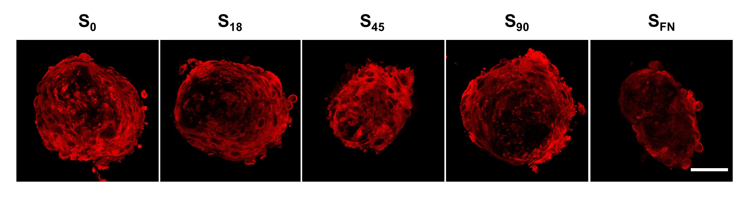
Fig. S6: Confocal z-projections showing neurobiotin tracer (red) after 10 min of exposure at day 6 of chondrogenic induction. Scale bar = 80 µm.

