Supporting information
Detection of Adenosine Triphosphate in Cancer Cells with a label-free fluorescent aptasensor

Characterization of SWCNHs
Transmission electron microscopy (TEM) measurements were performed on a Hitachi H600 transmission electron microscope operated at an accelerating voltage of 100 KV. Scanning electron microscopy (SEM) measurements were performed using a Hitachi SU8010 Scanning electron microscope operating at an accelerating voltage of 5 KV. Figure S1 show the TEM and SEM images of SWCNHs. The images indicate that the SWCNHs particles are spherical aggregates with diameters between 50 to 100 nm, which is similar to the report of Nan Li and Shuyun Zhu [1,2].
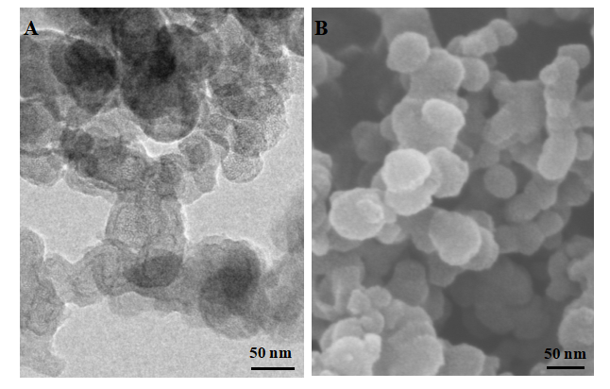
Figure S1. (A) TEM image of SWCNHs; (B) SEM image of SWCNHs

Optimization of SYBR Gold concentration
To specify the optimum concentration of SYBR Gold for complete reaction with aptamer, we determined the fluorescence spectrums of aptamer reacted with different concentrations of SYBR Gold. First, 100 µl of 200 nM aptamer reacted with 100 µl of different concentrations of SYBR Gold (5×, 10×, 15×, 20×, 25× and 30×) Then, each of the mixtures was added with 300 μL buffer solution until a total final volume of 500 μL was obtained. After 30 min incubation in the dark at room temperature, the fluorescence intensity was measured. The fluorescence intensity first increased then decreased with the increase of SYBR Gold concentrations, with the maximum fluorescence intensity obtained at 20× SYBR Gold concentration. Higher concentrations of SYBR Gold will lead to aggregation-caused quenching (ACQ). Therefore, we chose 20× of SYBR Gold as the optimal concentration and used it in the subsequent experiments.
Optimization of SWCNHs concentration
To determine an optimal SWCNHs concentration for the detection system, we investigated the effects of SWCNHs concentrations in the fluorescence intensity. First, 100 µl solution containing 200 nM aptamer and 100 µl solution of 20× of SYBR Gold were mixed and incubated at room temperature (30 min). Then, 100 µl of different concentrations of SWCNHs (0, 0.1, 0.2, 0.3, 0.4, and 0.5 g/L) was added. Finally, each of the mixtures was added with 200 μL buffer solution until a total final volume of 500 μL was obtained. After 30 min incubation in the dark at room temperature, the fluorescence intensity was measured. As shown in Figure S2, the maximum peak intensity of fluorescence spectra decreased along with increasing the concentration of SWCNHs. When the added SWCNHs concentration reached 0.2 g/L, approximately 90% of the fluorescence intensity was quenched. Since a higher concentration of SWCNHs cannot quench the ﬂuorescence intensity more efﬁciently and will affect the sensitivity of the sensor, a higher concentration than 0.2 g/L was not necessary. Therefore, we chose 0.2 g/L of SWCNHs as the optimum concentration and used it in the subsequent experiments.
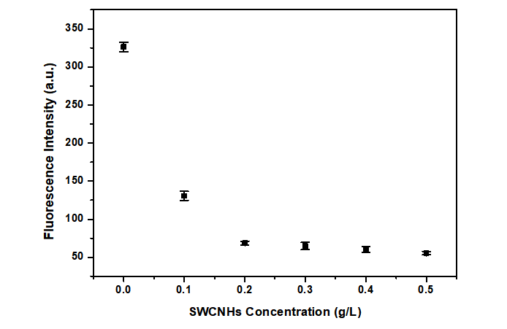
Figure S2. Effect of SWCNHs concentration on the quenching efficiency toward SYBR Gold-bound aptamer (error bars were obtained from three experiments).
Optimization of PVP concentration
To determine an optimal PVP concentration for the detection system, we investigated the effects of PVP concentrations on fluorescence intensity. First, 100 µl solution containing 200 nM aptamer and 100 µl solution of 20× of SYBR Gold were mixed and incubated at room temperature (30 min). Then, 100 µl of 0.2 g/L SWCNHs and 100 µl solution of different concentrations of PVP (0, 50, 100, 200, 300, 400, 500 nM) were added. Finally, each of the mixtures was added with 100 μL buffer solution until a total final volume of 500 μL was obtained. After 30 min incubation in the dark at room temperature, the fluorescence intensity was measured. As shown in Figure S3, the peak intensity of fluorescence spectra increased along with increasing the concentration of PVP. When the concentration of PVP reached 200 nM, there was no significant increase in fluorescence intensity. Since a higher concentration of PVP will result in high blank background and affect the sensitivity of the sensor, a higher concentration than 200 nM was not necessary. Therefore, we chose 200 nM of PVP as the optimum concentration and used it in the following tests.
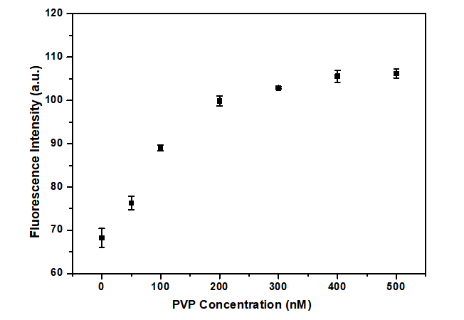
Figure S3. Effect of PVP concentration on the fluorescence intensity of SWCNHs/SYBR Gold-bound aptamer. Error bars were based on three experiments.

Optimization of incubation time
To determine an optimal incubation time for aptamer (ssDNA) being adsorbed onto SWCNHs, the effects of incubation time on the fluorescence intensity were investigated. First, 100 µL solution containing 200 nM aptamer and 100 µL solution of 20× of SYBR Gold were mixed and incubated at room temperature (30 min). Then, 100 µL of 0.2 g/L SWCNHs and 100 µL solution of 200 nM of PVP were added. Finally, each of the mixtures was added with 100 μL buffer solution until a total final volume of 500 μL was obtained. Then the profile of SYBR Gold emission was monitored at 0, 10, 20, 30, 40, 50, and 60 min. As shown in Figure S4, the fluorescence intensity decreased as the incubation time increased and reached a minimum of 30 min, showing the maximum time required for adsorption of all ssDNA. Therefore, 30 min has been chosen as the optimum incubation time and used in the subsequent experiments.
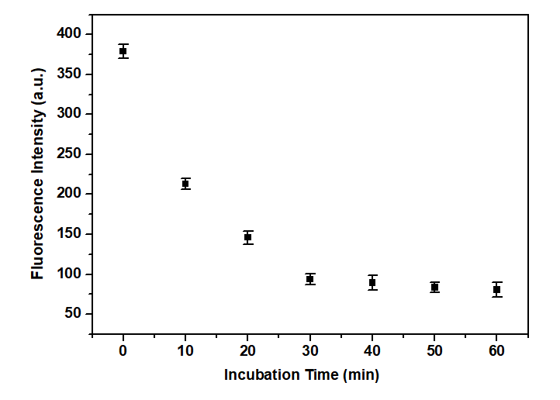
Figure S4. Effect of incubation time on the fluorescence intensity of SWCNHs/PVP/SYBR Gold-bound aptamer. Error bars were based on three experiments.

Reference
1. Li N, Wang Z, Zhao K, Shi Z, Gu Z, Xu S. Synthesis of single-wall carbon nanohorns by arc-discharge in air and their formation mechanism. Carbon 48 (5):1580-1585 (2010).
2. Zhu SY, Liu Z, Zhang W, Han S, Hu L, Xu GB. Nucleic acid detection using single-walled carbon nanohorns as a fluorescent sensing platform. Chem. Commun. 47 (21):6099-6101 (2011).

