Design, Synthesis and Evaluation of Novel Phenanthridine Triazole Analogs as Potential Antileishmanial Agents
Adinarayana Nandikolla,ª Singireddi Srinivasarao,ª Banoth Karan Kumar,^{b} Sankaranarayanan Murugesan,^{b} Himanshu Aggarwal,ª Rafael Balaña-Fouce,^{c} Estela Melcón-Fernandez^{c} and Kondapalli Venkata Gowri Chandra Sekhar∗ª

ªDepartment of Chemistry, Birla Institute of Technology and Science, Pilani, Hyderabad Campus, Jawahar Nagar, Kapra Mandal, Hyderabad – 500078, Telangana, India.
^{b}Medicinal Chemistry Research Laboratory, Department of Pharmacy, Birla Institute of Technology and Science Pilani, Pilani Campus, Pilani-333031, Rajasthan. India.
^{c}Department of Biomedical Sciences, University of Leon, 24071 Leon, Spain.

Contents: Page
- Materials and methods 02-05
- Biological procedures 05-06
- Computation studies 06-09
- ¹HNMR spectra 09-19
- ¹³C NMR spectra 20-29
- Mass spectra 30-43
- References 44

Experimental section

1. Materials and methods
All chemical reagents and solvents are purchased from Aldrich, Alfa Aesar, Finar. The solvents and reagents were of LR grade. All the solvents were dried and distilled before use. Thin-layer chromatography (TLC) was carried out on aluminium-supported silica gel plates (Merck 60 F254) with visualization of components by UV light (254 nm). Column chromatography was carried out on silica gel (Merck 100-200 mesh). ¹H NMR and ¹³C NMR spectra were recorded at 400 MHz and 101 MHz respectively using a Bruker AV 400 spectrometer (Bruker CO., Switzerland) in CDCl₃ and DMSO-d₆ solution with tetramethylsilane as the internal standard and chemical shift values (δ) were given in ppm. ¹H NMR spectra were recorded in CDCl₃ or DMSO-d₆. The following abbreviations are used to designate multiplicities: s = singlet, d = doublet, t = triplet, m = multiplet, br = broad. Melting points were determined on an electro thermal melting point apparatus (Stuart-SMP30) in open capillary tubes and are uncorrected. Elemental analyses were performed by ElementarAnalysensysteme GmbH vario MICRO cube CHN Analyzer. Mass spectra (ESI-MS) were recorded on Schimadzu MS/ESI mass spectrometer.
1.1 General procedure for synthesis of compounds T01-T14
Synthesis of compound T02:
Compound T01 (1 eq.) was taken in dioxane then added ethyl 2-chloroacetoacetate (3 eq.) at rt. The reaction mixture was heated to 100 ℃ and allowed for stirring overnight. The reaction was monitored by TLC. After completion of reaction, the total reaction mixture was extracted with excess ethyl acetate. The organic layers were washed with brine solution, separated and dried over anhydrous sodium sulphate and evaporated under reduced pressure. The crude product was purified with silica gel column chromatography by eluting with 0- 20% ethyl acetate and petroleum ether. The compound T02 was obtained in 79% yield. Structure of T02 was confirmed with mass and NMR spectras.
Synthesis of compound T03:
Compound T02 (1 eq.) was taken in ethanolic water mixture then LiOH (5 eq.) was added at rt. The total reaction mixture was heated to 80 ℃ and stirred for 5 h. The reaction was monitored by TLC. After completion of reaction, the reaction mixture was evaporated under reduced pressure. The crude product was washed with ethyl acetate (2X). The obtained compound was dissolved in water, and pH was adjusted to 7 by the addition of saturated citric acid. The precipitated compound was filtered under vacuum. The compound T03 was obtained in 75% yield confirmed with mass and NMR spectras.
Synthesis of compound T04:
Compound T03 (1 eq.) was taken in DMF then DIPEA (3 eq.) was added at rt. To this reaction mixture HOBT (1.5 eq.), EDC.HCl (1.5 eq.) and then propargylamine (1.1 eq.) was added. The mixture was stirred at rt for 5 h. The reaction was monitored by TLC. After completion of reaction, the reaction mixture was extracted with ethyl acetate. The organic layer was dried over anhydrous sodium sulphate and evaporated under reduced pressure. The crude product was purified with silica gel column chromatography by eluting with 0-50% ethylacetae: petroleum ether. The compound T04 is obtained in 80% yield and confirmed with mass and NMR spectras.
Synthesis of Compounds T05-T14:
Compound T04 (1 eq.) was taken in DMF: t-BuOH: water then CuSO₄ (5 mol %), CuI (5 mol %), sodium ascorbate (1.5 eq.) was added at rt. To this reaction mixture substituted azides (1.1 eq.) were added and stirred at rt for 5 h. The reaction was monitored by TLC. After completion of reaction, the total reaction mixture was extracted with ethyl acetate. The organic layer was dried over anhydrous sodium sulphate and evaporated under reduced pressure. The crude product was purified with silica gel column chromatography by eluting with 0-100% ethylacetae: pet ether. The triazoles T05-T14 were confirmed with mass and NMR data.

Table S1. Crystal data and refinement parameters for compounds T01 and T09
Identification Code | T01 | T09
Empirical formula | C₁₃H₁₀N₂ | C₂₈H₂₃Cl₂N₇O₄
Formula weight | 194.238 | 592.444
Temperature/K | 100 | 100
Crystal system | monoclinic | triclinic
Space group | P2₁/n | P-1
a/Å | 13.2447(10) | 9.5639(2)
b/Å | 5.0841(4) | 11.4740(2)
c/Å | 14.1024(11) | 14.1042(3)
α/° | 90 | 103.5137(16)
β/° | 99.197(7) | 104.7417(17)
γ/° | 90 | 108.6692(18)
Volume/Å³ | 937.41(13) | 1331.51(5)
Z | 4 | 2
ρ calc g/cm³ | 1.376 | 1.478
μ/mm^{‑1} | 0.649 | 2.620
F(000) | 409.2 | 615.4
Crystal size/mm³ | 0.1 × 0.05 × 0.03 | 0.1 × 0.08 × 0.05
Radiation | Cu Kα (λ = 1.54184) | Cu Kα (λ = 1.54184)
2Θ range for data collection/° | 8.5 to 159.3 | 8.66 to 159.22
Index ranges | -15 ≤ h ≤ 16, -6 ≤ k ≤ 4, -17 ≤ l ≤ 17 | -11 ≤ h ≤ 11, -10 ≤ k ≤ 14, -17 ≤ l ≤ 16
Reflections collected | 4175 | 15114
Independent reflections | 1975 [R_{int} = 0.0429, R_{sigma} = 0.0588] | 5599 [R_{int} = 0.0306, R_{sigma} = 0.0357]
Data/restraints/parameters | 1975/0/137 | 5599/0/372
Goodness-of-fit on F² | 1.024 | 1.028
Final R indexes [I>=2σ (I)] | R1 = 0.0800, wR2 = 0.2298 | R₁ = 0.0497, wR₂ = 0.1446
Final R indexes [all data] | R1 = 0.1016, wR2 = 0.2499 | R₁ = 0.0520, wR₂ = 0.1466

2. Biological procedures
2.1. In-vitro antileishmanial activity
Anti-leishmanial activity of the compounds were assayed in vitro against Leishmania infantum BCN150 iRFP promastigotes, a genetically modified strain with iRFP for infrared detection (Calvo-Álvarez et al., 2012). Promastigotes were cultured in M199 medium (Gibco), supplemented with 25 mM HEPES pH 6.9, 7.6 mM hemin, 10 mM glutamine, 0.1 mM adenosine, 0.01 mM folic acid, 1xRPMI 1640 vitamin mix (Sigma), 10% (v/v) heat inactivated foetal bovine serum (Gibco) and antibiotic mixture. L. infantum promastigotes cultures with a density of 1 x 10⁶ cells/mL, were aliquoted into 96-well optical bottom black plates (Thermo Scientific), 180 µL per well. Each compound was tested adding 20 µL of different stock solutions to wells. Stock solutions were prepared in DMSO and stepwise diluted in M199 media (0.07-300 µM). Viability of promastigotes was assessed measuring their fluorescence at 708 nm in an Odyssey (Li-Cor) infrared imaging system. All compounds and controls were assayed by triplicate.
2.2. Preparation and assay of bone marrow axenic amastigotes
Ex vivo murine splenic explant cultures (intramacrophage amastigote assay)
Primary cultures of infected splenic explants were used to assess the ex vivo effect of compounds T01 and T08 on the intramacrophage stage of the parasite. For this purpose, 10⁸ iRFP-L. infantum metacyclic promastigotes were inoculated intraperitoneally to female BALB/c mice. After 5 weeks, mice were humanely sacrificed and spleens were dissected, washed with cold phosphate-buffered saline (PBS), cut in small pieces and incubated with 5 mL of 2 mg/mL collagenase D (Sigma) prepared in buffer (10mM HEPES, pH 7.4, 150 mM NaCl, 5 mM KCl, 1 mM MgCl₂ and 1.8 mM CaCl₂) for 20 min, to obtain a cell suspension. The cell suspension was passed through a 100 μm-mesh cell strainer, harvested by centrifugation (500×g for 7 min at 4 °C), washed twice with PBS and re-suspended in RPMI medium (Gibco), supplemented with 10 mM HEPES, 1 mM sodium pyruvate, 1xRPMI 1640 vitamin mix, 10% (v/v) FBS, and antibiotics. Similar procedure was applied to obtain uninfected splenic cultures in order to determine selectivity index of the compounds. Different concentrations of the tested compounds (1.25, 2.5, 5.0 and 10 μM) were added to these cultures seeded in 384-well black optical bottom plates at 37 °C under 5% CO₂ atmosphere. The viability of iRFP-L. infantum amastigotes infecting macrophages was registered daily by recording the emitted fluorescence at 713 nm by an Odyssey (Li- Cor) infrared imaging system.

2.3. Cytotoxicity assay
The safety of the compounds was tested both on primary cultures of murine splenocytes and on human hepatocarcinoma cell HepG2 line (ATCC HB-8065) as a suitable in vitro toxicity model system of human hepatocytes. HepG2 cells and splenocyte cells were seeded in 96-well plates at 37ºC under 5% CO₂ atmosphere. For HepG2 cells was used The Glutamax Dulbecco’s Modified Eagle’s Medium (DMEM, Gibco), supplemented with 10% (v/v) FBS, and antibiotic mix. Viability of splenocytes and hepatocarcinoma cells were measured using the Almar Blue staining method, according to manufacturer’s recommendations (Invitrogen). Selectivity index for each compound was calculated as the ratio between the CC₅₀ value obtained for non-infected murine splenocytes or CC₅₀ value obtained for HepG2 cells and the EC₅₀ values for promastigotes/amastigotes obtained with ex vivo murine splenic explant cultures.
3. Computation studies
3.1. In-silico prediction of ADME and Toxicity (ADMET) parameters
The ADMET parameters of the titled compounds were in silico predicted using Qikprop module of Schrodinger. The diverse parameters predicted were molecular weight (M.Wt.), total solvent accessible surface area (SASA), number of hydrogen bond donor (HBD), number of hydrogen bond acceptor (HBA), octanol / water partition coefficient (log P), aqueous solubility (Log S), predicted apparent Caco-2 cell permeability in nm/sec (P Caco) and number of rotatable bonds (Rot) ^{2,3}. SMILES format of the compounds was generated by using OSIRIS DataWarrior. All the related toxicity parameters were also predicted by the same software ⁴. The ideal ranges, which are followed by 95% of the approved drugs, are discussed in supplementary information (Table S2)
Table S2. Optimum range of drug-likeness parameters followed by 95% of approved drugs
S. No | Molecular descriptor | Optimum range
1 | Molecular weight (Mol wt.) | 130-725
2 | Total solvent accessible surface area in square angstroms (SASA) | 300-1000
3 | No. of hydrogen bond donor groups (HBD) | 0- 6
4 | No. of hydrogen bond acceptor groups (HBA) | 2 to 20
5 | Octanol/water partition coefficient (LogP) | -2.0 to 6.5
6 | Aqueous solubility, in mol/l (logS) | –6.5 to 0.5
7 | Apparent Caco-2 cell permeability in nm/s (PCaco) | <25 poor, > 500 great
8 | Brain/blood partition coefficient (logBB) | –3.0 to 1.2
9 | No. of rotatable bonds (Rot) | 0 to 15

3.2. Molecular docking study
Molecular docking study was carried out using Schrodinger software ⁵ (Version 2019-1, Schrodinger) installed on Intel Xenon W 3565 processor and Ubuntu enterprise version 14.04 as an operating system. The selected target protein structure was retrieved from the RCSB protein data bank (www.rcsb.org) ⁶. Targeted ligands were drawn using ChemDraw 18.0 software.
3.2.1. Ligand preparation
The ligands used as an input for docking study was sketched using ChemDraw software and cleaned up the structures for bond alignment, ligands incorporated into the workstation, the energy was minimized using OPLS3e force field in Ligprep ⁷ (Version 2019-1, Schrodinger). This minimization helps to assign bond orders, the addition of hydrogens to the ligands, and conversion of 2D to 3D structure for further docking studies. The generated output file (best conformations of the ligands) was further used for docking studies.
3.2.2. Protein preparation
Protein was retrieved from the RCSB site (https://www.rcsb.org/structure/2JK6 ) ⁸. Protein was prepared using a protein preparation wizard ⁹ (Version 2019-1, Schrodinger). Hydrogen atom was added to the proteins, and charges were assigned. Generated Het states using Epik at pH 7.0 ±2.0. Pre-processed the protein and refined, modified the protein by analyzing the workspace, water molecules, and other heteroatoms were examined, non-significant atoms were excluded from the crystal structure of the protein. Finally, the protein was minimized by using OPLS3e force filed
3.2.3. Receptor grid generation
A receptor grid was generated around the protein by picking the inhibitory ligand (X-ray pose of the ligand in the protein). The centroid of the ligand was selected to create a grid box around it, and the Vander Waals radius of receptor atoms was scaled to 1.00 Å with a partial atomic charge of 0.25.
3.2.4. Docking validation
The most straightforward way of validating the accuracy of specified parameters for docking study is to re-dock the co-crystallized ligand back into the binding site of the protein and calculate the root mean square deviation (RMSD) value between the crystallographic orientation and the docked pose. RMSD calculation is a convenient method to use in order to follow how much a structure has diverged from its initial geometry. The lower the RMSD value between the docked pose to that of its crystallographic orientation is an indication of the suitability of the docking protocols. Therefore, prior to screening of all ligands, the co-crystal structures of PDB-2JK6 (FAD molecule), was chosen and re-docked back into the same active site. The RMSD value between the crystallographic orientation and the best-docked pose was generated. The RMSD value of the selected targets was found to be 0.20 Å respectively. The lower RMSD value indicates that the docking protocol could be reliable for the final docking studies of the test compounds against the selected target.
3.2.5. Docking and analysis
Molecular docking was performed using the above-prepared ligand and protein as input. The results of the docking study were analyzed with the help of XP Visualiser (Version 2019-1, Schrodinger). Docking studies of the designed and synthesized molecules were performed by using the Glide module ¹⁰ in Schrodinger. All docking calculations were performed using Extra Precision (XP) mode. A scaling factor of 0.8 and a partial atomic charge of less than 0.15 was applied to the atoms of the protein. Glide docking score was used to determine the best-docked confirmation from the output. The interactions of these docked conformations were investigated further using XP visualizer.
4. ¹H NMR spectras of final compounds
¹HNMR spectrum of compound T01
¹HNMR spectrum of compound T04
T05
¹HNMR spectrum of compound T05
¹HNMR spectrum of compound T06
¹HNMR spectrum of compound T07
¹HNMR spectrum of compound T09
¹HNMR spectrum of compound T10
¹HNMR spectrum of compound T11
¹HNMR spectrum of compound T12
¹HNMR spectrum of compound T13
¹HNMR spectrum of compound T14
5. ¹³C NMR spectras of final compounds
¹³CNMR spectrum of compound T04
¹³CNMR spectrum of compound T05
¹³CNMR spectrum of compound T06
¹³CNMR spectrum of compound T07

¹³CNMR spectrum of compound T09
¹³CNMR spectrum of compound T10
¹³CNMR spectrum of compound T11
¹³CNMR spectrum of compound T12
¹³CNMR spectrum of compound T13
¹³CNMR spectrum of compound T14
6. Mass Spectras
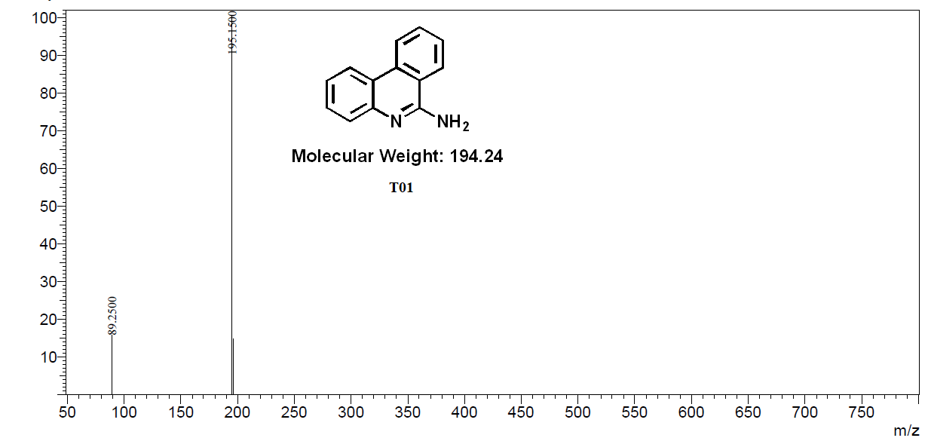
Mass spectrum of compound T01
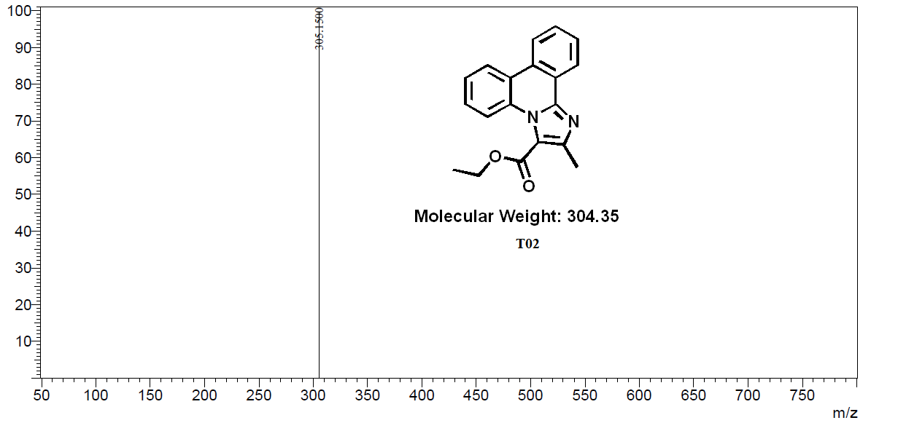
Mass spectrum of compound T02

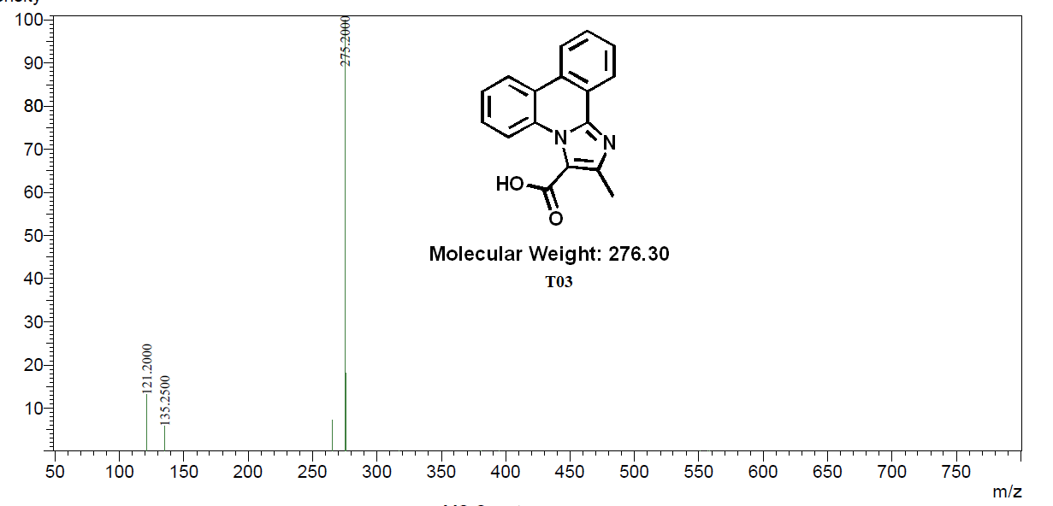
Mass spectrum of compound T03
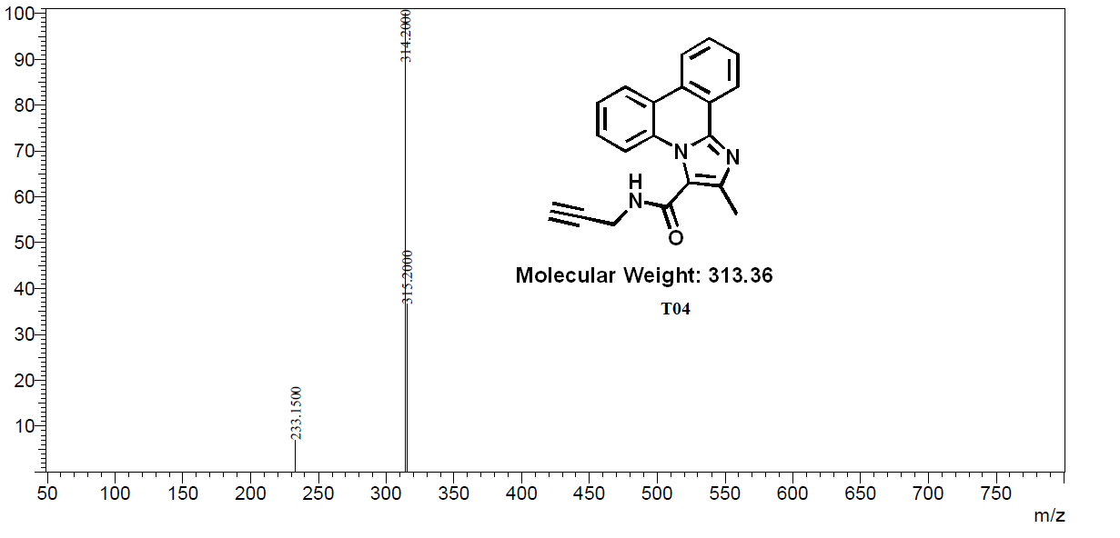
Mass spectrum of compound T04

Mass spectrum of compound T05
Mass spectrum of compound T06
Mass spectrum of compound T07

Mass spectrum of compound T08
Mass spectrum of compound T09

Mass spectrum of compound T10

Mass spectrum of compound T11
Mass spectrum of compound T12

Mass spectrum of compound T13

Mass spectrum of compound T14
8. References
1. De Muylder G, Ang KKH, Chen S, Arkin MR, Engel JC, McKerrow JH. A screen against leishmania intracellular amastigotes: Comparison to a promastigote screen and identification of a host cell-specific hit. PLoS Negl Trop Dis. 2011;5(7):e1253. doi:10.1371/journal.pntd.0001253
2. Schrödinger Release 2019-1: QikProp, Schrödinger, LLC, New York, NY, 2019.
3. QikProp Descriptors and Properties PISA, (2015) 2–4.
4. Sander T, Freyss J, Von Korff M, Rufener C. DataWarrior: An open-source program for chemistry aware data visualization and analysis. J Chem Inf Model. 2015;55(2):460-473. doi:10.1021/ci500588j
5. Schrödinger Release 2019-1: Maestro, Schrödinger, LLC, New York, NY, 2019.
6. Burley SK, Berman HM, Bhikadiya C, et al. RCSB Protein Data Bank: biological macromolecular structures enabling research and education in fundamental biology, biomedicine, biotechnology and energy. Nucleic Acids Res. 2019;47(D1):D464-D474. doi:10.1093/nar/gky1004
7. Schrödinger Release 2019-1: LigPrep, Schrödinger, LLC, New York, NY, 2019.
8. Baiocco P, Colotti G, Franceschini S, Ilari A. Molecular Basis of Antimony Treatment in Leishmaniasis. J Med Chem. 2009;52(8):2603-2612. doi:10.1021/jm900185q
9. Schrödinger Release 2019-1: Schrödinger Suite 2019-1 Protein Preparation Wizard; Epik, Schrödinger, LLC, New York, NY, 2019.
10. Friesner RA, Banks JL, Murphy RB, et al. Glide: A New Approach for Rapid, Accurate Docking and Scoring. 1. Method and Assessment of Docking Accuracy. J Med Chem. 2004;47(7):1739-1749. doi:10.1021/jm0306430.

∗Corresponding author Tel.: +91 40 66303527; E-mail: kvgc@hyderabad.bits-pilani.ac.in; kvgcs.bits@gmail.com

