Figure S1
(A) (B) (C)

(D) (E) (F)

(G) (H)
Figure S1. Binding modes of (2R,3R,11bR)-13a (A), (2S,3R,11bR)-13a (B), (2R,3S,11bR)-13a (C), (2S,3R,11bS)-13a (D), (2S,3S,11bR)-13a (E), (2R,3R,11bS)-13a (F), (2S,3S,11bS)-13a (G), (2R,3S,11bS)-13a (H) into VMAT2. Hydrogen bonds and hydrophobic interactions are shown as green dashed lines and red “eyelashes”, respectively.
The 2D plots are generated using LIGPLOT v2.2.4 [1].
[1] Laskowski, R. A.; Swindells, M. B., LigPlot+: Multiple Ligand–Protein Interaction Diagrams for Drug Discovery. Journal of Chemical Information and Modeling 2011, 51 (10), 2778-2786.
Figure S2
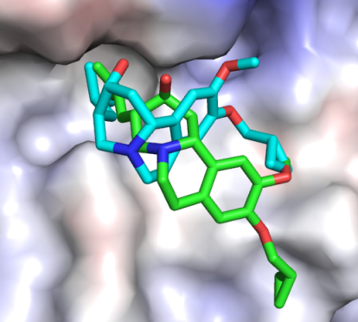
Figure S2. The bindings of compounds and VMAT2. Cyan: (2R, 3S, 11bR)-13a; green: (2S, 3S, 11bR)-13a.

Figure S3
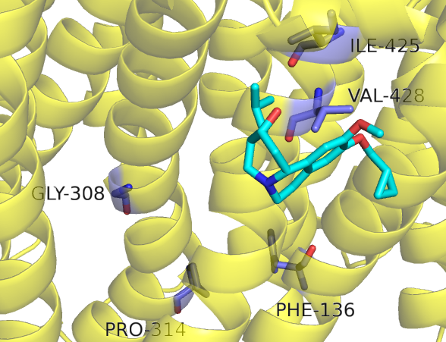
Figure S3. 3D structure of VMAT2. The protein and key residues were shown in yellow cartoon and blue sticks, and the compound (2R, 3S, 11bR)-13a was shown in cyan sticks.

