SUPPLEMENTARY APPENDIX
Supplementary Figure S1. Histogram of PD-L1 expression based on CPS in the overall cohort (N = 574). CPS, combined positive score; PD-L1, programmed death ligand 1.

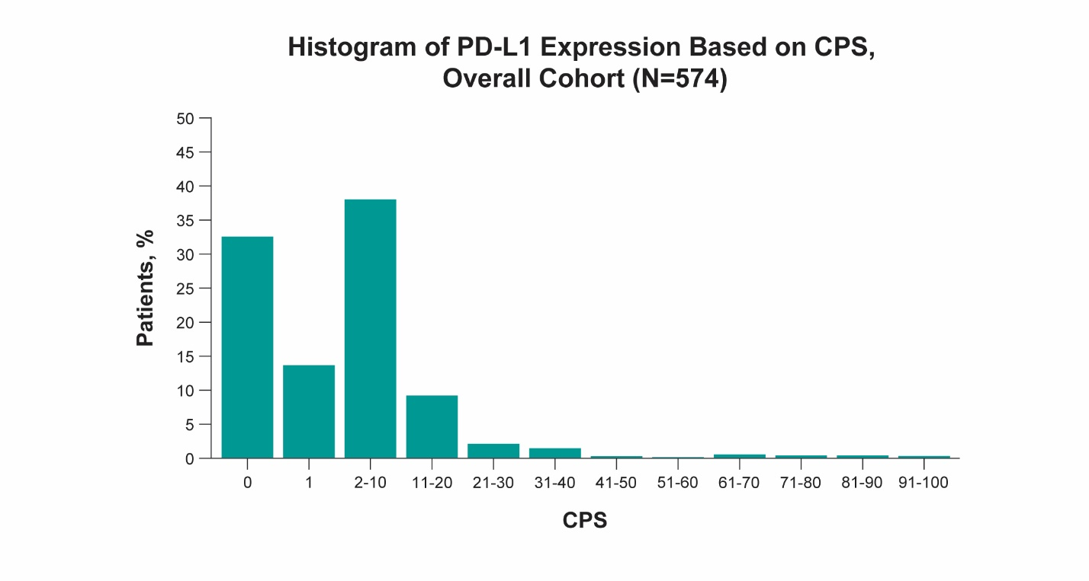

Supplementary Figure S2. OS by PD-L1 expression in (A) South Korean patients by disease stage and (B) US patients by disease stage. OS, overall survival; PD-L1, programmed death ligand 1.
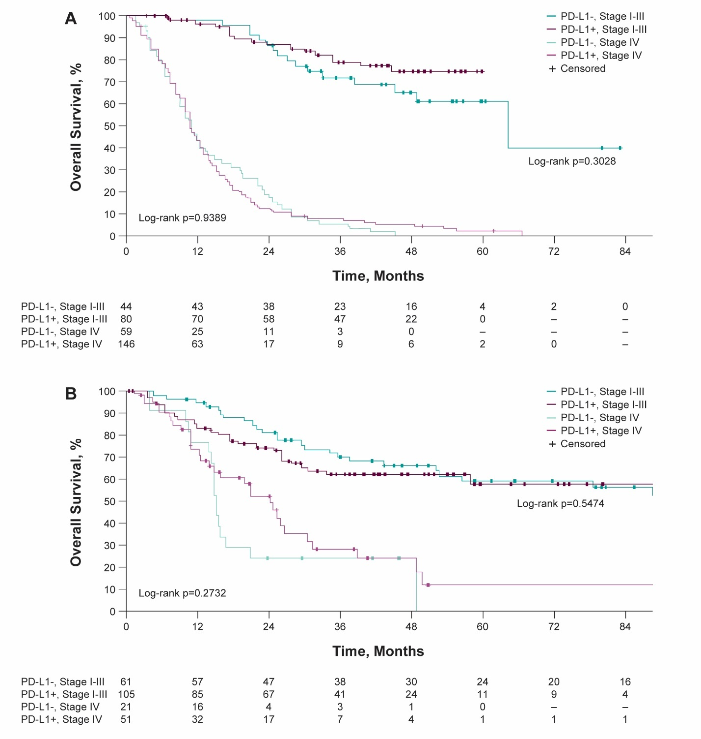
Supplementary Figure S3. OS by PD-L1 expression using a CPS cutoff of 10 for (A) all patients (n = 574), (B) stage I-III patients (n = 290) and stage IV patients (n = 277). CPS, combined positive score; PD-L1, programmed death ligand 1.

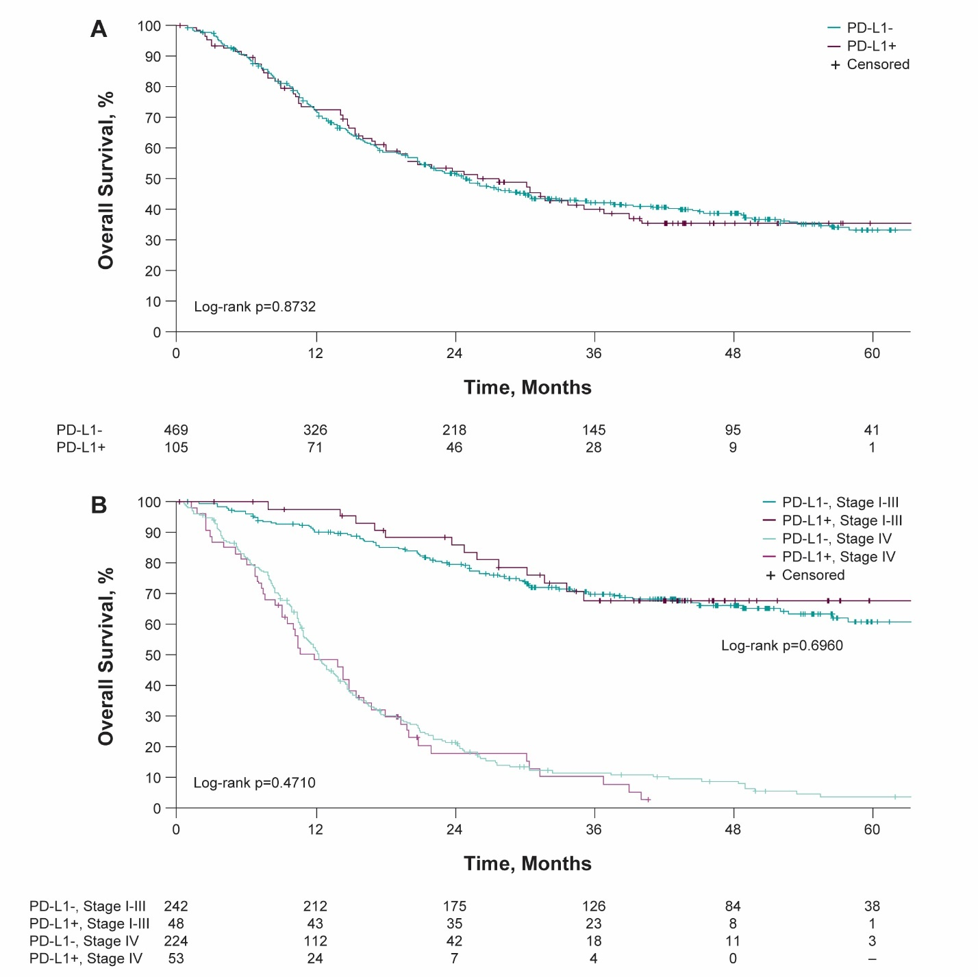

Supplementary Figure S4. GEP score for all patients and by (A) stage and (B) tissue type. GEP, gene expression profile.

