SUPPLEMENTAL FIGURES
Figure S1. Study Cohort Attrition
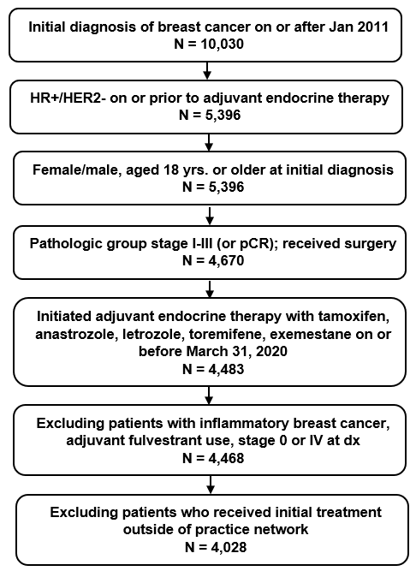
Abbreviations: dx=diagnosis; HR+=hormone receptor positive; HER2-=human epidermal growth factor receptor 2 negative; pCR=pathologic complete response

Figure S2. Kaplan-Meier Curves of IDFS (A) and DRFS (B) for the High-risk Group Compared with the Non-high-risk Group with 1-3 Positive Lymph Nodes

- Invasive disease-free survival (IDFS) in high-risk group vs. a set of patients in the non-high-risk group with 1-3 positive lymph nodes and tumor size <5cm tumor, grade <3, and Ki-67 <20% (if tested).
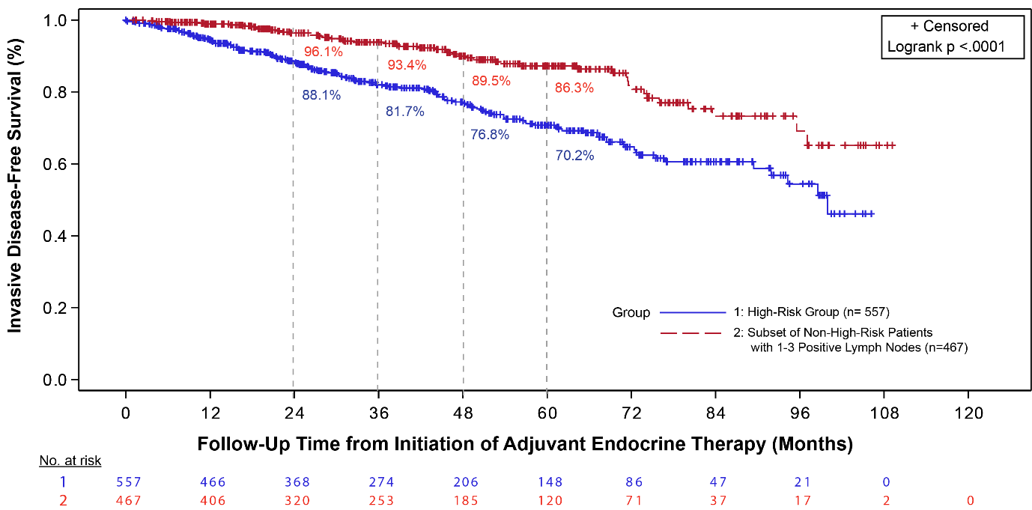

B. Distant relapse-free survival (DRFS) in high-risk group vs. non-high-risk group with1-3 positive lymph nodes and tumor size <5cm tumor, grade <3, and Ki-67 <20% (if tested).
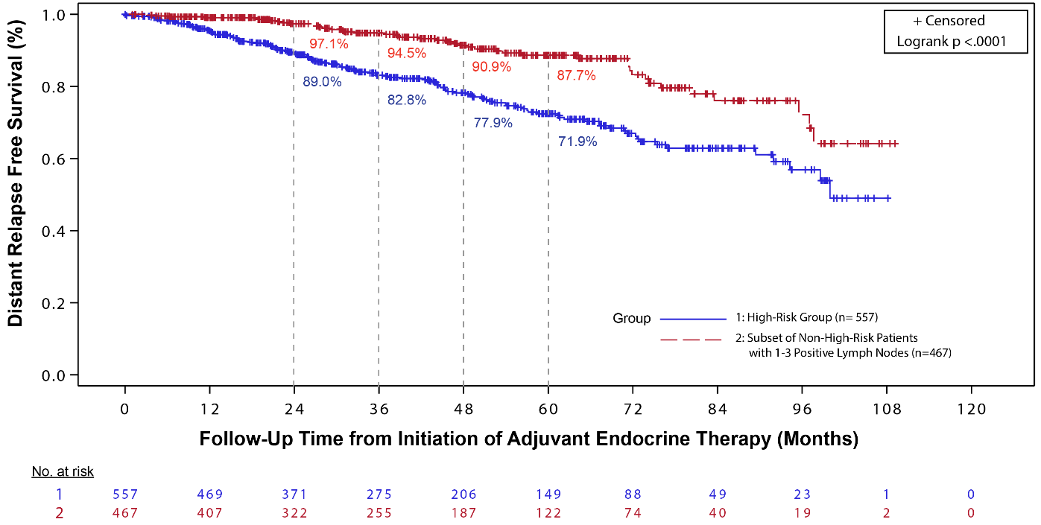

Figure S3. Kaplan-Meier Curves of Invasive Disease-free Survival (A) and Distant Relapse-free Survival (B) for the High-risk Subgroup that Matches the US Indication Compared with the Non-high-risk Group

- Invasive disease-free survival in the US (United States) Food and Drug Administration (FDA) indication subgroup with Ki-67 ≥20% vs. non-high-risk group

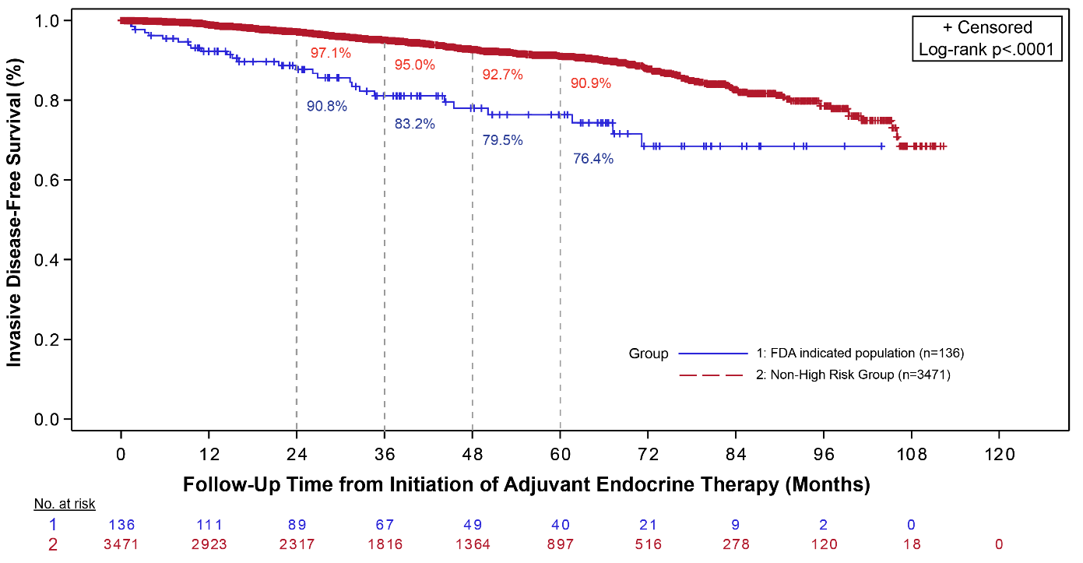
- Distant relapse-free survival in the US FDA indication subgroup with Ki-67 ≥20% vs. non-high-risk group
