Blood Cell Quantification on Dry Blood Samples - Towards Patient-Centric Complete Blood Counts (CBC)

Supplementary Information

Table of Contents

Image processing for blood cell counting

Figure S1: A diagram summarizing the image processing steps performed to obtain normalized blood cell counts.

Data processing for correlation analysis

Figure S-2: The flowchart depicting the data processing steps for performing correlation analysis on the RBC data.

Image processing for blood cell counting
Dried sample images for RBC and WBC counting, taken with a slide scanner, were processed using a Fiji image processing package. The image processing steps are shown in figure S1.
Original images (A) were first transformed to 32-bit greyscale images. From these images, the total area of the sample was measured by transforming the image to black-and-white (D) using a low threshold, and next using the “measure” function.
In a separate step, the original greyscale images were transformed to black-and-white images (B) using automatic thresholding with the “Moments” setting. Next, the “analyze particles” function was used to filter out and count the cell-like shapes to obtain blood cell counts (C).
Due to the various bright artifacts present in the dried samples, some areas of the sample could not be correctly processed to find cells. The artifact area (E) was computed as (B-C). To account for this artifact area, we normalized the cell count found in (C) by dividing through the useful area (C), which is the total area without artifacts (D-E), and multiplying with the total area (D).

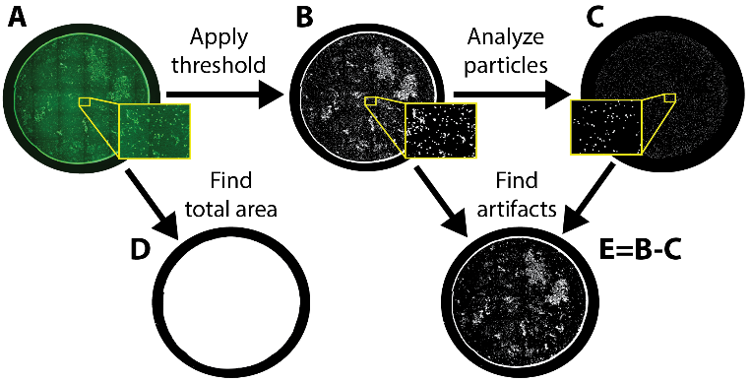
Figure S1: A diagram summarizing the image processing steps performed to obtain normalized blood cell counts.

Data processing for correlation analysis
In preparation for correlation analysis, we processed the image-based cell counting data (“RBC Dry”) and hematology analyzer data (“RBC Reference”) according to the flowchart in figure S2. The linear plot in figure 2a of the main text was obtained by plotting the two data sets against each other. Projecting the image-based data onto a calibration curve, obtained from a linear curve fit on the data in the linear plot, resulted in the calibrated data “Dry Calibrated”. Using this calibrated data and the “RBC Reference” we obtained the correlation plot in figure 2b of the main text. The “RBC Reference” was plotted on the x-axis of the correlation plot and for the y-axis we computed the percentage differences between “Dry Calibrated” and the “RBC Reference” according to the following equation:

$y= \frac{Dry Calibrated-RBC Reference}{RBC Reference}$ (1)
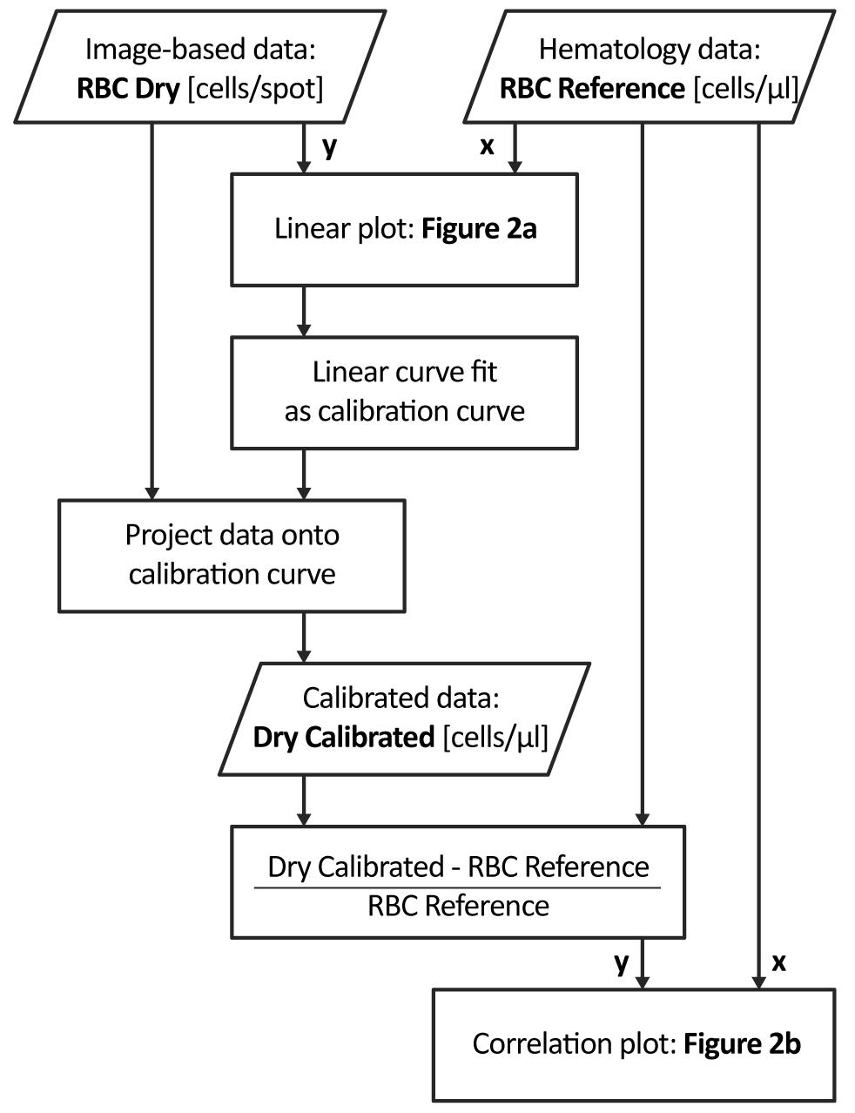
Figure S2: The flowchart depicting the data processing steps for performing correlation analysis on the RBC data.

