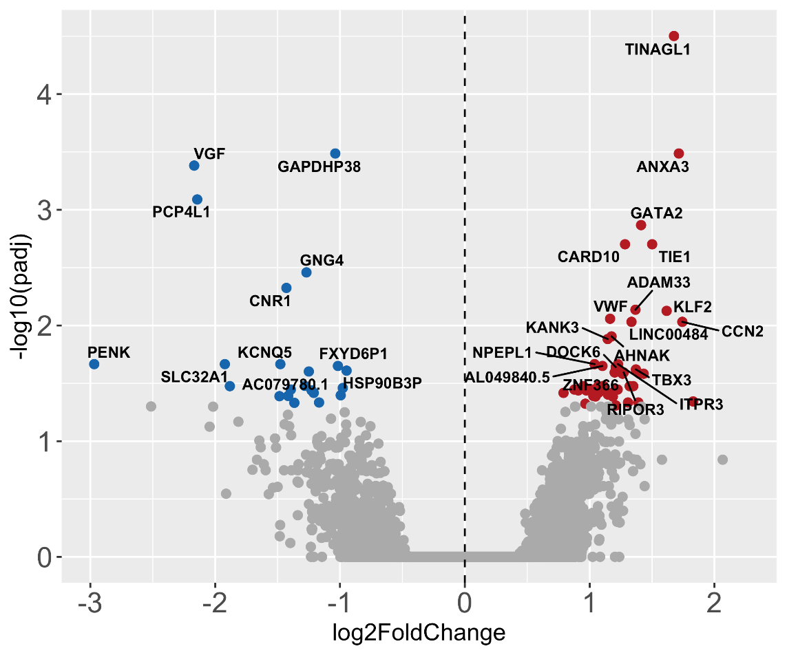
Supplementary Figure 1 – Volcano plot showing RNA-Seq up- and downregulated genes between Alzheimer’s disease patients and controls, considering all brain regions. All 69 DEGs are shown, of which 22 are downregulated and 47 are upregulated.
Supplementary Table 1 – Sample information.
ID | Group | Sex | Age (y) | Age of diagnosis (y) | Brain weight (g) | PMI^{c} (h) | Cause of death | APOE genotype
533 | CTª | Female | 76 | - | 1260 | 10.42 | Myocardial infarction | E3/E4
537 | CTª | Male | 69 | - | 1165 | 32.5 | Cardiorespiratory arrest | E3/E3
586 | CTª | Male | 77 | - | 1255 | 9.5 | N/A | E3/E3
1419 | CTª | Male | 80 | - | 1305 | 13 | N/A | E3/E3
1495 | CTª | Female | 79 | - | 1150 | 17.3 | Pancreatic cancer | E3/E3
1547 | CTª | Female | 95 | - | 1160 | 23.75 | Liver metastases, but the origin of the primary cancer is uncertain | E3/E3
1062 | AD^{b} | Female | 77 | 71 | 855 | 11.25 | Aspiration bronchopneumonia | E3/E3
1243 | AD^{b} | Female | 89 | 78 | 845 | 10.75 | Confluent bronchopneumonia | E3/E4
1330 | AD^{b} | Male | 79 | 73 | 910 | 19.25 | Cardiorespiratory arrest in the context of Alzheimer's disease, arterial hypertension and peripheral vascular disease | E4/E4
1427 | AD^{b} | Female | 82 | 76 | 970 | 14 | Alzheimer’s dementia and cervical lymphoma | E3/E4
1518 | AD^{b} | Male | 85 | 70 | 970 | 20.5 | Pneumonia in the context of Alzheimer's dementia | E3/E3
1560 | AD^{b} | Female | 83 | 74 | 950 | 13.25 | Pneumonia, Alzheimer's dementia and nephrolithiasis with pyelonephritis | E3/E4
ª Control
^{b} Alzheimer’s disease
^{c} Post-mortem interval

Supplementary Table 2 – Genes whose regulation of expression and H3K9 acetylation are found in the same direction.
Auditory cortex – upregulated
 | ChIP-Seq peak |  | RNA-Seq
Gene | Log2FCª | P-value^{b} | Log2FCª | Adj. P-value^{c}
PSTPIP1 | 6,00 | 8,31e-06 | 1,55 | 0,017
ARRDC2 | 89,68 | 1,30e-68 | 1,51 | 0,025
MYO15B | 14,64 | 2,90e-34 | 1,61 | 0,011
PLXNB1 | 147,62 | 1,44e-128 | 1,33 | 0,017
FZD7 | 32,11 | 4,42e-19 | 1,43 | 0,011
PXN | 7,57 | 3,87e-09 | 1,40 | 0,014
KLF2 | 23,62 | 1,48e-23 | 2,25 | 0,017
CDC42BPG | 50,56 | 1,17e-33 | 2,61 | 0,020
 | 20,30 | 1,63e-10
XRCC3 | 115,14 | 1,04e-94 | 1,49 | 0,011
 | 38,20 | 7,22e-46
 | 33,77 | 4,36e-38
VAC14-AS1 | 11,22 | 1,44e-38 | 1,43 | 0,016
CLDN5 | 51,30 | 1,17e-33 | 1,77 | 0,025
PKN3 | 6,37 | 1,57e-12 | 2,03 | 0,007
SLC16A3 | 12,55 | 1,32e-05 | 1,59 | 0,045
TRIOBP | 46,87 | 2,80e-30 | 1,54 | 9,68E-05
PLXNB2 | 7,75 | 2,07e-13 | 1,07 | 0,026
 | 35,06 | 1,30e-20
 | 4,37 | 1,61e-05
ARHGEF1 | 47,24 | 2,80e-30 | 1,28 | 0,011
C22orf34 | 112,56 | 1,18e-92 | 2,36 | 0,015
SLC6A12 | 50,19 | 1,17e-33 | 1,70 | 0,035
 | 43,55 | 5,66e-27
AJUBA | 26,20 | 1,19e-14 | 1,65 | 0,049
COL8A2 | 28,42 | 4,25e-16 | 1,37 | 0,041
SLC4A11 | 24,91 | 6,18e-25 | 2,44 | 0,013
EPHB4 | 83,77 | 8,25e-63 | 1,89 | 0,017
Auditory cortex – downregulated
 | ChIP-Seq peak |  | RNA-Seq
Gene | Log2FCª | P-value^{b} | Log2FCª | Adj. P-value^{c}
SCAI | 476,91 | 9,91e-101 | -1,10 | 0,044
ª Log2 fold change
^{b} P-value < 0.05, based on an FDR < 0.05
^{c} Adjusted p-value < 0.05

