SUPPLEMENTARY MATERIAL

These data are derived from [18]. The experiments reported in [18] were performed on the same batch of nanoparticles that were used for the experiments in the current manuscript.

All the characterization study was done. To attain the target product quality, 3² factorial designs were used to investigate the unique effects of major process factors on critical quality attributes. The overlay plot yielded an optimum formulation for Methotrexate solid lipid nanoparticles. Methotrexate incorporation was higher in solid lipid nanoparticles with a percent EE of more than 90% (Figure S1, S2).

From the analysis, it was observed that in 2hrs, ~100% of the drug was released (Figure S3). Prolonged-release characteristics were exhibited by the MTXSLNs that showed a primary spurt of ~29% in 2 hrs and 95.59±0.918% in a constant fashion within 5 hrs. According to the results, the values of particle size, polydispersity index (PDI), and entrapment efficiency (%EE) ranged between 64.3 to 517.8 nm (z-average), 0.212 to 0.459, and 67.8 to 96.7 %, respectively (Supplementary Table 4).

The improved MTX-SLN suspension exhibited an average particle diameter of 147.6±4.1 nm and PDI of 0.296±0.058 which is indicative of a consistent formulation. The MTX-SLNs had a zeta potential value of −19±0.98 mV (Figure S4). This demonstrated the physical stability of the formulation. The %EE was more than 90 (i.e., 94.61±2.7%). The dry and shrunk configuration of the MTX SLNs suspension was seen in the image obtained from TEM analysis where they appeared in the range of 130 nm to 150 nm (Figure S4). Methotrexate solid lipid nanoparticles showed higher drug diffusion than drug solutions containing the crystalline form of the drug due to their lipidic character. Methotrexate had lost its distinctive crystalline form, according to findings from differential scanning calorimetry and X-ray diffraction (Figure S5, S6).

To assess the stability of the drug in the formulation, FT-IR spectroscopy was performed. From the obtained FT-IR bands (Figure S7), the following was concluded: MTX alone had a distinctive absorption band around 3368.9 cm−1 as well as 3066.3 cm−1 which related to the N-H and O–H stretching. Absorption bands of nearly 1543.3 cm−1, and 1,464 cm−1 might have been due to an amide bonding that led to N-O asymmetric stretching. The Methotrexate solid lipid nanoparticles utilised in this work showed considerably higher cytotoxicity than free MTX (Figure S8). After oral administration of MTX formulations, an in vivo analysis was done to assess MTX. The relative bioavailability (Fr) was calculated using the following formula: Fr (%) = [AUC0→∞ (MTX-SLNs)/AUC0→∞ (MTX solution)] ×100. Supplementary Table 8 lists the oral pharmacokinetic variables of MTX SLNs and MTX suspension. Figure 9 shows the mean plasma concentration-time profile in rats.

Table 1a demonstrates that PEG 200 at a concentration of 3% w/w obtained the highest entrapment efficiency and the smallest size and PDI. When compared to a single surfactant (tween 80) (Batch no. 1) or a single surfactant (tween 80) with a solubilizer (PEG 200), the combination of surfactant (tween 80 and Kolliphor HS 15) and a solubilizer (PEG 200) (Batch no. 10) had the smallest size and PDI.
Size (234.21±2.3 nm to 216.43±1.3 nm) and PDI (0.253±0.045 to 0.243±0.054) showed a gradual decrease as sonication time was extended from 5 to 10 minutes, while % EE (92.14±2.57 to 94.34±2.63) increased (Batch no. 12-14, table 1b). As a result, there was no significant change in particle size, PDI, or %EE when the sonication time was raised to 12 minutes (Batch no.15, table 2b).

Table 2 shows the results of eleven different experimental runs. The particle size, PDI, and %EE values in the runs ranged from 64.3 to 517.8 nm (z-average), 0.212 to 0.459, and 67.8 to 96.7%, respectively. In all of the experimental runs, increasing the lipid concentration from 1.5% w/w to 2% w/w resulted in an increase in %EE from 67.8%±3.23 to 86 % and above. When the concentration of tween 80 and Kolliphor HS 15 (1:1) was gradually increased from 1% to 2% w/w, the size and PDI decreased while the % EE increased. The interfacial tension between the fatty acid and aqueous portions was reduced when the concentration of tween 80 and Kolliphor HS 15 (1:1) was increased from 2% to 3% w/w.

Table 3 shows the ANOVA of Size, PDI, and % EE. Significance value <0.05 shows the significant impact of CPP on CQA.

Table 2 presents the V1 and V2 formulas, whereas table 4 shows the observed vs predicted values of all responses for the validation batches, along with their degree of error.

Table 5 shows the screening procedure for the best cryoprotectant. The lyophilized powder of the formulation showed the least change in particle size when 3 % mannitol (w/v) was used as a cryoprotectant, resulting in a stable solution system.

The relative bioavailability (Fr) was calculated using the following formula: Fr (%) = [AUC0→∞ (MTX-SLNs)/AUC0→∞ (MTX solution)] ×100. Table 6 lists the oral pharmacokinetic variables of MTX SLNs and MTX suspension. After oral administration, the AUC0→24h, AUC0→∞, Cmax, and Fr of MTX-SLN formulation were roughly 3.531-fold, 3.514-fold (P<0.05), 11.270-fold (P<0.05), and 3.51-fold higher, respectively, compared to MTX suspension. The absorption of MTX following oral administration was much higher than that of MTX-SLNs, according to the findings.

SUPPLEMENTARY TABLES
Table 1a: Preliminary screening of solubilizer and a combination of surfactants (Data represents mean ± SD, n=3)
Table 1b: Optimization of the sonication time of the batch screened in table 1a (Data represents mean ± SD, n=3)
Table 2: Size, PDI and %EE of factorial runs and validation batches (Data represents mean ± SD, n=3)
Table 3: ANOVA of Size, PDI, and %EE
Table 4: Observed versus the predicted value of CQA
Table 5: The appearance, solution color and mean particle size of the lyophilized powder of MTX-SLNs (Data represents mean ± SD, n=3)
Table 6: Pharmacokinetic parameters of MTX after oral administration of MTX suspension and MTX SLNs suspension (n=6)
SUPPLEMENTARY FIGURES
Fig. S1: 3D response surface plot of CQA; (A)- Size, (B)- PDI and (C)- %EE
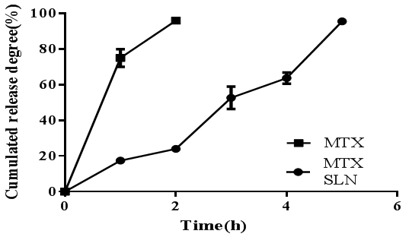
Fig. S3: In vitro release profile of MTX from MTX SLNs and free MTX suspension by a dialysis method in 0.1 N HCl for the 1st h followed by phosphate buffer (pH 7.4) for 4 h at 37 °C. Data shown are means±SEM (n = 3)
Fig. S2: Overlay plot showing a location of optimized MTX SLNs in design space

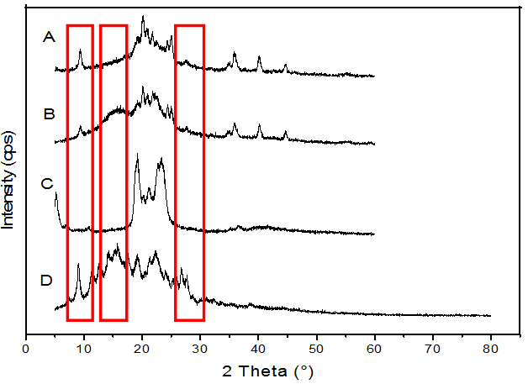
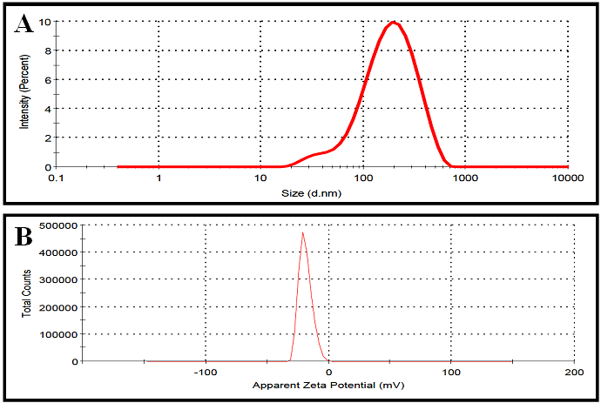
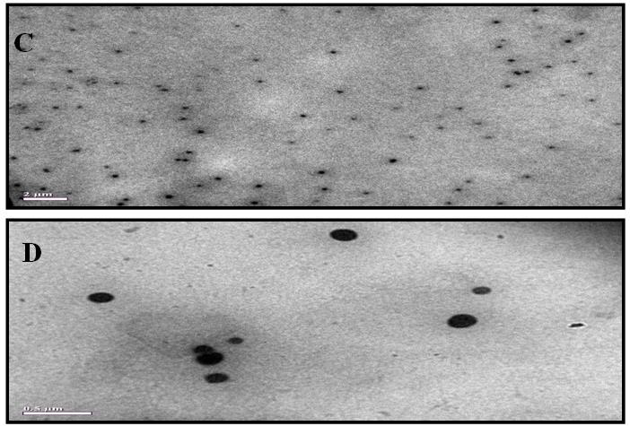
Fig. S6: X-ray diffraction patterns of MTX SLNs (A), physical mixture of MTX and blank SLN (B), GMS (C), and MTX (D)
Fig. S5: DSC analysis of MTX SLNs (A), physical mixture of MTX and blank SLN (B), GMS (C), and MTX (D)
Fig. S4: Size distribution (A) and zeta potential (B) of MTX SLN measured by dynamic light scattering; transmission electron microscopy image of MTX SLN, the bar is 2 μm (C); transmission electron microscopy image of MTX SLN showing the spherical shape of the nanoparticles, the bar is 0.5 μm
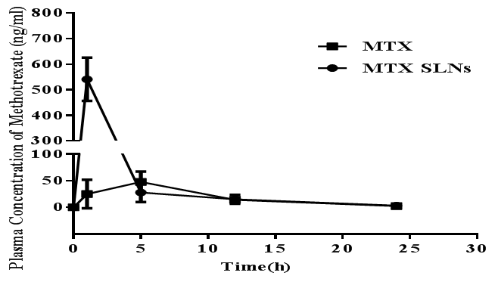
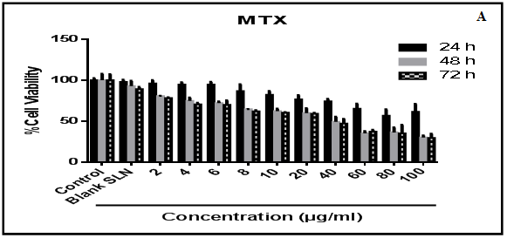
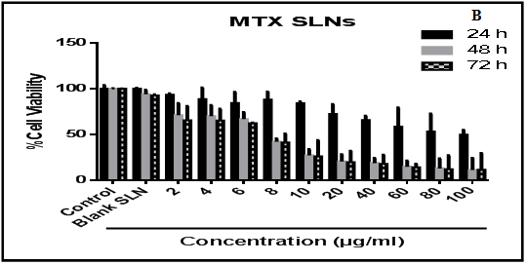
Fig. S9: In vivo bioavailability of native methotrexate (MTX) and nanoparticulate methotrexate (MTX SLNs). The rats were divided into two groups (n = 6). An equivalent concentration of native methotrexate and nanoparticulate methotrexate (0.26 mg/kg) was given to group 1 and group 2 mice, respectively. Native methotrexate and nanoparticulate methotrexate were administered orally and blood was collected at different time intervals. Serum was separated and the concentration of methotrexate was determined by LC-MS-MS analysis. Results are expressed as mean±SEM (n=3)
Fig. S8: Inhibition of proliferation following methotrexate (MTX) and methotrexate solid lipid nanoparticles (MTX SLNs) treatment. Cells (10,000 per well; HCT116), were treated with increasing concentrations (2–100 μg/ml) of MTX (A) or MTX SLNs (B) for 24–72 h. Results are expressed as % cell survival of control and shown as mean±SEM (n=3)
Fig. S7: FT-IR spectra of MTX SLNs (A), physical mixture of MTX and blank SLN (B), GMS (C), and MTX (D)

