Supplemental

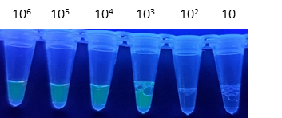
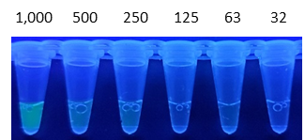
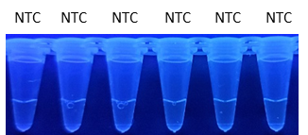
PFU/ml
PFU/ml

Supplemental Figure 1. FQ-LAMP LOD for WA1 - Reaction Tube Images
WA1 Target Log Dilution in SPS. Culture supernatants were log-serially diluted from 10⁶ /ml to 10 pfu/ml in the SPS buffer and analyzed by FQ-LAMP. B. WA1 Target Two-fold Dilution in SPS. WA1-infected Vero cell culture supernatant two-fold diluted in SPS buffer from 1,000 to 32 PFU/ml was processed with the SPS protocol and analyzed by FQ-LAMP C. No Template Control. FQ-LAMP assay using identically processed samples, but lacking WA1 with deionized water added to the SPS buffer served as the no-template control (NTC). Images were acquired using a mobile phone camera with no filters and excitation using a handheld UV lamp (302nm).

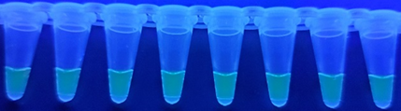
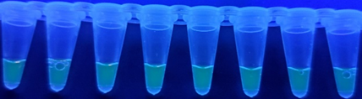
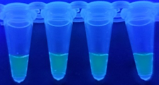
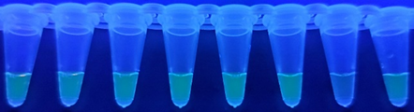
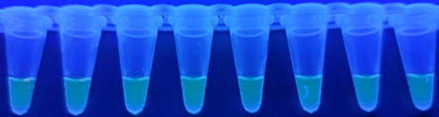
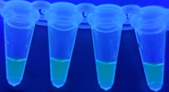
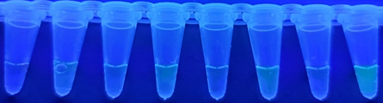
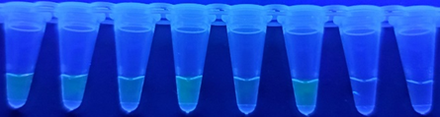
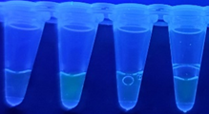
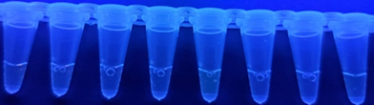
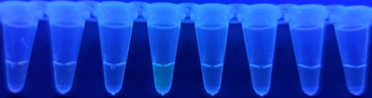
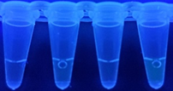
1,000 PFU/ml
(1X LOD)
500 PFU/ml
(0.5X LOD)
2,000 PFU/ml
(2X LOD)
WA1
No Spike
D.
C.
B.
A.

Supplemental Figure 2. FQ-LAMP WA1 Target Multiples to Confirm LOD – Reaction Tube Images.
FQ-LAMP assay targeting WA1 from infected Vero cells. Culture supernatants were spiked into pooled CoV2-negative nasal swab samples at: A. 2,000; B. 1,000; and C. 500 PFU/ml representing 2X, 1X, and 0.5X LOD target concentration, respectively. All samples were processed with SPS buffer as described above using n=20 replicates for each target dilution. D. Negative control assays (no spike), n=20 replicates used identically processed nasla swab sample but without WA1. Images acquired using a mobile phone camera with no optical filters under excitation with a laboratory handheld UV lamp (302nm). 1,000 PFU/ml WA1 target concentration was the highest dilution displaying at least 19/20 replicates with positive signal and was determined to be the assay LOD.

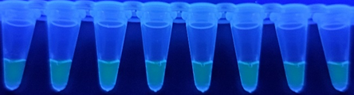
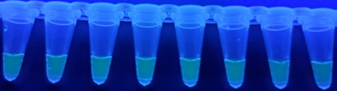
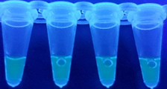
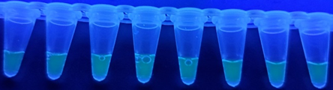
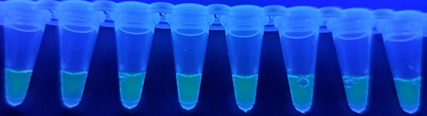
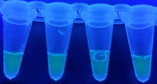
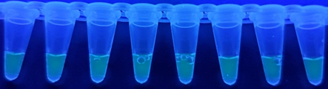
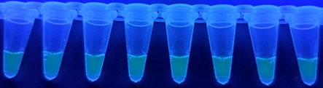
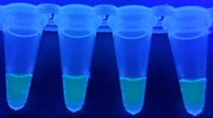
Delta (B.1.617.2)
Alpha (B.1.1.7)
Omicron (B.1.1.529)
C.
B.
A.

PFU/ml

Supplemental Figure 3. FQ-LAMP CoV2 Variants in Nasal Swab Sample (2,000 PFU/ml) Reaction Tube Images
FQ-LAMP targeting CoV2 variant viruses: A. Delta (B.1.617.2), B. Alpha (B.1.1.7), and C. Omicron (B.1.1.529) from infected Vero cell cultures. Culture supernatants were spiked into pooled CoV2-negative nasal swab sample at 2,000 PFU/ml (2X LOD for WA1) and processed with SPS buffer as described above using n=20 replicates for each target virus. Images acquired using a mobile phone camera with no filters under excitation with a standard laboratory handheld UV lamp (302nm). CoV2 variant viruses are easily detectable by FQ-LAMP in nasal swab sample background at 2X LOD, and all the heterologous virus targets, even at very high concentrations, failed to produce fluorescence signals over the background in the FQ-LAMP assay (images not shown).

Supplemental Table 1. FQ-LAMP CoV2 LOD in Nasal Swab samples
WA1 | 95% CI  (n=20 replicates)
2,000 PFU/ml | 10663 ±486 (±4.6%)  [10,176 – 11,149]
1,000 PFU/ml | 9051 ±918 (±10.1%) [8,132 – 9,969]
500 PFU/ml | 3460 ±709 (±20.5%) [2,750 – 4,169]
No Spike | 1635 ±468 (±28.6%)  [1,166 – 2,103]
CoV2 Variants  (2000 PFU/ml) | 95% CI  (n=20 replicates)
Delta (B.1.617.2) | 11585 ±548 (±4.7%) [11,036 – 12,133]
Alpha (B.1.1.7) | 11071 ±590 (±5.3%) [10,480 – 11,661]
Omicron (B.1.1.529) | 9983 ±496 (±5.0%) [9,486 – 10,479]
No Spike | 1751 ±499 (±28.5%)  [1,251 – 2,250]
Human Coronaviruses and Heterologous Viruses  (10⁵ PFU/ml) | 95% CI  (n=20 replicates)
OC43 | 1279 ±131 (±10.2%) [1,147 – 1,410]
229E | 1316 ±149 (±11.4%) [1,166 – 1,467]
NL63 | 1371 ±167 (±12.2%) [1,203 – 1,538]
RSV A2 | 1355 ±199 (±14.7%) [1,155 – 1,554]
A/Guangdong-Maonan/2019 | 1433 ±197 (±13.8%) [1,235 – 1,630]

Supplemental Table 1. FQ-LAMP targeting WA1 from infected Vero cells. Culture supernatants were spiked into pooled CoV2-negative nasal swab samples at 2,000, 1,000; and 500 PFU/ml representing 2X, 1X, and 0.5X LOD target concentration, respectively, and processed with SPS buffer as described using n=20 replicates for each target dilution (three representative samples are pictured). 1,000 PFU/ml WA1 target concentration was the highest dilution displaying at least 19/20 replicates with a positive signal in the LOD. FQ-LAMP assay targeting CoV2 variant viruses Delta (B.1.617.2), Alpha (B.1.1.7), and Omicron (B.1.1.529) from infected Vero cell culture. Culture supernatants were spiked into pooled CoV2-negative nasal swab sample at 2,000 PFU/ml (2X LOD for WA1) and processed with SPS buffer as described above using n=20 replicates for each target virus, and FQ-LAMP targeting three human coronavirus strains i.e. OC43 (GenBank: AY585228.1), 229E (GenBank: AF304460.1), and NL63 (GenBank: AY567487.2) from infected Vero cells, human respiratory syncytial virus strain A2, GenBank: KT992094.1) from infected Vero cells, and influenza A virus A/Guangdong-Maonan/SWL1536/2019 (H1N1, GISAID: EPI_ISL_419003) from infected embryonated hen eggs. Culture supernatants, or egg lysate for IAV, were spiked into pooled SARS-CoV-2 negative nasal swab sample at 10⁵ PFU/ml and processed with SPS buffer as described using n=20 replicates for each target virus, and negative control assays (no spike), n=20 replicates consisting of identically processed nasal swab sample, but without CoV2 variant virus. CoV2 variant viruses are easily detectable by FQ-LAMP in nasal swab sample background at 2X LOD, and all the heterologous virus targets, even at very high concentrations, did not produce a fluorescence signal over the background in the FQ-LAMP assay.

Supplemental Table 2. CoV2 FQ-LAMP primers and Signal Oligos
NAME | SEQUENCE (5’-3’) | Genome Position
COVID-F3 | TGGCTACTACCGAAGAGCT | 28525-28543
COVID-B3 | TGCAGCATTGTTAGCAGGAT | 28722-28741
COVID-LoopF | GCCATTTTACTTTCTAGAGTCAGGT | 28567-28591
COVID-FLB | [6FAM]ACTGAGGGAGCCTTGAATAC | 28676-28695
COVID-FIP (F1c) | GACGAATTCGTGGTGGTGA | 28548-28566
COVID-FIP (F2) | TCTGGCCCAGTTCCTAGGTAGT | 28605-28626
COVID-BIP (B1c) | CGGGTGCCAATGTGATCT | 28702-28719
COVID-BIP (B2) | AGACGGCATCATATGGGTTGCA | 28654-28675
COVID-QLB | GCTCCCTCAGT[IBHQ] | 28676-28686

Supplemental Table 2. CoV2 N gene-based FQ-LAMP primers and signal oligos were created using free Primer Explorer V software. Numbering according to CoV2 Wuhan-Hu-1 (GenBank: MN908947.3).

