Supplementary Materials
Supplementary Materials to accompany Indirect treatment comparison of anifrolumab efficacy versus belimumab in adults with systemic lupus erythematosus
Appendix A | Systematic Literature Review
Appendix B | PRISMA Flow Diagram
Appendix C | Feasibility Assessment
Appendix D | STC Analysis: Additional Details and Sensitivity Analyses

Eligibility Criteria for Systematic Literature Review
Development of Strategy: The search strategies were developed and tested through an iterative process by an experienced medical information specialist in consultation with the review team. All strategies were peer reviewed by another senior information specialist prior to execution using the PRESS Checklist.
Databases and Date of Database Search: Using the Ovid platform, Ovid MEDLINE®, including Epub Ahead of Print and In-Process & Other Non-Indexed Citations, and Embase were searched. The Cochrane Library (Wiley version) was also searched. Searches were performed on March 13, 2018, and updated on September 21, 2020 and March 11, 2021.
Additional Literature Sources and Date of Gray Literature Search: Additional gray literature searches were performed on November 11, 2020 and March 22, 2021 to supplement the database searches. This included a targeted search in ClinicalTrials.gov and a cross-reference of bibliographies of relevant systematic literature reviews (SLRs), meta-analyses (MAs), and network meta-analyses (NMAs). Additionally, the last two cycles of key conference databases not indexed on Embase were hand searched. Key conferences of interest included the American College of Rheumatology and the Association for Rheumatology Health Professionals Annual Meeting, the Annual European Congress of Rheumatology, the International Congress on Systemic Lupus Erythematosus, and the Canadian Rheumatology Association and Arthritis Health Professions Association Annual Scientific Meeting.
Table S1. Summary of inclusion and exclusion criteria for the systematic literature review.
Criteria | Include | Exclude
Population | - Adults (≥18 years) with moderately to severely active systemic lupus erythematosus (SLE) while receiving standard of care (SOC) treatment | - Non-adults (≤18 years)  - Cutaneous (discoid) lupus erythematosus, drug-induced lupus, neonatal lupus  - Lupus nephritis  - Neuropsychiatric lupus  - Animals, in vitro studies  - Any other disease areas; healthy volunteers  - Pregnant women
Comments | - “Systemic Lupus Erythematosus,” “SLE,” “Lupus Erythematosus Disseminatus,” or “lupus” needs to be explicitly stated in the title or abstract for citations to be included  Adults (≥18 years):  - Exclude mixed age population studies if the included study list is extensive  - Restrict largely to ≥18 years  Moderately to severely active SLE:  - Flag studies with vague definitions for “moderately to severely active SLE” to be reviewed by clinician  - Based on clinician input, include studies with vague descriptions of SLE severity if the inclusion criteria comprise one of the following characteristics of moderate to severe disease: SLEDAI ≥6, PGA ≥1, BILAG 1A or 2B  - Include studies that use exact terminology of “moderate” and/or “severe”  - Exclude studies with mild or unclear severity. Exclude studies with mixed populations of mild and moderate to severe SLE patients, where a subgroup of moderate to severe patients is not available  While receiving SOC treatment:  - Studies need to explicitly state that patients have SLE “while receiving SOC treatment,” referring to previous treatment undergone by participants
Intervention | Interferon-alpha inhibitor  - Anifrolumab
Comparators | Antimalarial  - Hydroxychloroquine  Protease Inhibitor  - Tofacitinib  Immunosuppressants/cytotoxic drugs  - Azathioprine  - Cyclophosphamide  - Cyclosporine/ciclosporin/cyclosporin  - Leflunomide  - Methotrexate  - Mizoribine  - Mycophenolate mofetil (MMF)  - Mycophenolate sodium  - Tacrolimus  Corticosteroids/steroids  - IV corticosteroids  - Oral corticosteroids (low and high doses)  - Prednisone  - Methylprednisolone  Immunomodulatory  - Dapirolizumab pegol  - Lupuzor  - Rontalizumab  - Ustekinumab  - Laquinimod  B Cell Modulators  - Rituximab  - Belimumab (IV or SC)  - Atacicept  T Cell Modulator  - Abatacept | - Treatments not related to SLE  - Medical devices  - Non-pharmacological interventions
Comments | - All doses and methods of administration (eg, IV, SC) of the above treatments should be included  - Any comparisons between any interventions of interest should be included; ie, the studies do not need to include anifrolumab
Outcomes | Efficacy  - Improvement in disease activity  - Steroid tapering  - Flare reduction  - Improvement in skin disease  - Fatigue  - Pain  Safety  - Infections (including serious, opportunistic, and herpes zoster)  - Malignancies  - Other outcomes of interest | - Outcomes not related to SLE (eg, outcomes related to another population or disease)
Study Design | - Phase 2, phase 3, and phase 2/3 randomized controlled trials (RCTs), including published studies, conference abstracts/posters, and gray literature  - Open label extension trials of RCTs  - Systematic reviews, meta-analyses, and network meta-analysesª | - Phase 1, phase 1/2 and phase 4 RCTs  - Non-RCTs  - Single-arm studies  - Study protocols  - Opinion pieces, commentaries, letters, editorials, case reports  - Economic/cost-effectiveness evaluations  - Narrative reviews (ie, non-systematic)
Location | - Global | - None; all countries/regions with available data should be included
Language | - English only^{b} | - Non-English
Date | - Database inception to present (ie, no date restriction) | - None
ª Systematic reviews, meta-analyses, network meta-analyses, and the bibliographies of these records were reviewed and cross-referenced with the included study lists to ensure that no primary studies were missed.
^{b} Search captured all languages, but non-English citations were excluded during screening.
BILAG: British Isles Lupus Assessment Group; IV: intravenous; MMF: mycophenolate mofetil; PGA: Physician’s Global Assessment; RCT: randomized controlled trial; SC: subcutaneous; SLE: systemic lupus erythematosus; SLEDAI: Systemic Lupus Erythematosus Disease Activity Index; SOC: standard of care.

PRISMA Flow Diagram for SLR
Figure S1. PRISMA flow diagram.

Full-text articles assessed for eligibility
(n = 374)
Additional records identified through other sources
(n = 1563)
Records identified through database searching
(n = 10860)
Records excluded
(n = 10645)
Records screened
(n = 11019)
Records after duplicates removed
(n = 11019)

Full-text articles excluded, with reasons
(n = 243)
Population (n = 16)
Intervention/comparator (n = 9)
Outcome (n = 35)
Study design (n = 34)
On-topic SLR/MA/NMA (n = 51)
Incomplete/insufficient/partial data ª (n = 40)
Duplicate (n = 37)
Unavailable (n = 14)
Non-English (n = 7)

Records included in qualitative synthesis
(n = 132)
Unique studies included in qualitative synthesis
(n = 26)

ª Studies excluded for incomplete/insufficient/partial data were SLRs without a reference list, RCT protocols without results or publications, and studies with a mixed population of eligible and ineligible patients.
MA: meta-analysis; NMA: network meta-analysis; PRISMA: Preferred Reporting Items for Systematic Reviews and Meta-Analyses; SLR: systematic literature review.

Summary of Feasibility Assessment
Note that this feasibility assessment pertained to the entire SLR, which was not limited to belimumab. However, the scope of the present ITC study was to compare to belimumab specifically.
Table S2. Overview of feasibility assessment by outcome.
Outcome | Comparator studies included that reported outcome | Study design | Eligibility criteria | Baseline characteristics | Outcome definition and time
BICLA | - Scherlinger, 2017 (rituximab) [1]  - van Vollenhoven, 2018 (UST) [2]  - Furie, 2021 (DZP) [3] | - All studies were placebo controlled and double blinded | - Furie, 2019 did not exclude SLE with renal involvement | - Baseline characteristics were poorly reported across all studies | - Furie, 2019 and van Vollenhoven, 2018 had 24 weeks follow-up instead of 52 weeks
BILAG score | - Merrill, 2010 (rituximab) [4]  - Griffiths, 2010 (cyclosporine and AZA) [5] | - Griffiths, 2010 was not placebo controlled nor double blinded | - Patients with CNS lupus or kidney diseases were not excluded in Griffiths, 2010 | - Baseline characteristics were poorly reported across all studies | - Griffiths, 2010 had a different definition for outcome that could not be leveraged from the CSR in TULIP
SLEDAI reduction | - Navarra, 2011 (belimumab) [6]  - Furie, 2011 (belimumab) [7]  - Zhang, 2018 (belimumab) [8]  - Stohl, 2017 (belimumab) [9]  - Yahya, 2013 (MYC) [10]  - van Vollenhoven, 2018 (UST) [2] | - Yahya, 2013 was not placebo controlled nor double blinded | - Inclusion criteria aligned across studies | - Baseline characteristics were poorly reported across all studies | - Yahya, 2013 and van Vollenhoven, 2018 had 16- and 24-weeks follow-up, respectively, instead of 52 weeks
SRI(4) response | - Navarra, 2011 (belimumab) [6]  - Furie, 2011 (belimumab) [7]  - Zhang, 2018 (belimumab) [8]  - Stohl, 2017 (belimumab) [9]  - D’Cruz, 2019 (belimumab) [11]  - van Vollenhoven, 2018 (UST) [2]  - Scherlinger, 2017 (rituximab) [1]  - Kalunian, 2016 (rontalizumab) [12]  - Furie, 2019 (DZP) [3]  - Zimmer, 2013 (lupuzor) [13] | - All studies were placebo controlled and double blinded | - Kalunian, 2016 did not include a SLEDAI criteria  - Furie, 2019 did not exclude SLE with renal involvement | - Baseline characteristics were poorly reported across all studies | - Kalunian, 2016; Furie, 2019; Zimmer, 2013 did had endpoint follow-up at 24 weeks  - van Vollenhoven, 2018 had endpoint evaluation at 24 weeks
OCS reduction | - Navarra, 2011 (belimumab) [6]  - Furie, 2011 (belimumab) [7]  - Zhang, 2018 (belimumab) [8]  - Stohl, 2017 (belimumab) [9]  - D’Cruz, 2019 (belimumab) [11]  - Fortin, 2008 (MTX) [14]  - Griffiths, 2010 (cyclosporine and AZA) [5]  - Furie, 2019 (DZP) [3] | - Griffiths, 2010 was not placebo controlled nor double blinded | - Furie, 2019 did not exclude SLE with renal involvement  - SLEDAI criteria was not reported in Fortin, 2008 | - Baseline characteristics were poorly reported across all studies | - Fortin, 2008; Griffiths, 2010; Furie, 2019 reported OCS use using a different measurement that was not found in the CSR
BILAG flare | - Isenberg, 2015 (atacicept) [15]  - Navarra, 2011 (belimumab) [6]  - Furie, 2011 (belimumab) [7]  - Stohl, 2017 (belimumab) [9]  - Zhang, 2018 (belimumab) [8]  - Griffiths, 2010 (cyclosporine and AZA) [5]  - Merrill, 2010 (rituximab) [4] | - Griffiths, 2010 was not placebo controlled nor double blinded | - SLEDAI criteria was not reported in Isenberg, 2015 | - Baseline characteristics were poorly reported across all studies | - Merrill, 2010; Zhang, 2018 and Stohl, 2017 had a different definition for BILAG flare than used in the TULIP trials
Swollen and tender joints | - van Vollenhoven, 2018 (UST) [2] | - Study was placebo controlled and had shorter follow-up | - Inclusion criteria aligned across studies | - Baseline characteristics were poorly reported | - Differences in outcome definition noted  - CSR from TULIP was leveraged to match outcome definitions
AZA: azathioprine; BICLA: BILAG–based Composite Lupus Assessment; BILAG: British Isles Lupus Assessment Group; CNS: central nervous system; CSR: clinical study report; DZP: dapirolizumab pegol; MTX: methotrexate; MYC: mycophenolate; OCS: oral corticosteroid; SLE: systemic lupus erythematosus; SLEDAI: Systematic Lupus Erythematosus Disease Activity Index; SRI: SLE Responder Index.

STC Analysis: Additional Details and Sensitivity Analyses

Additional Details
Table S3. Factors adjusted in each base case STC analysis.
Potential treatment effect modifier | Adjusted in base case STC analysis?
 | SLEDAI reduction | SRI(4) response | BILAG flares | OCS reduction*
Female patients (proportion) | Yes | Yes | No | No
White patients (proportion) | Yes | Yes | Yes | No
Age (mean) | Yes | Yes | Yes | Yes
Body mass index (kg/m²) (mean) | No | No | No | Yes
SLEDAI score at baseline (mean) | Yes | Yes | Yes | Yes
Organ domain score of ≥1 BILAG A item or ≥2 BILAG B items (proportion) | Yes | Yes | Yes | Yes
Antinuclear antibody titer ≥1:80 (proportion) | No | No | No | Yes
Abnormal low C3 (proportion) | Yes | Yes | Yes | Yes
Abnormal low C4 (proportion) | Yes | Yes | Yes | No
Anti-dsDNA ≥ 30 IU/mL (proportion) | Yes | Yes | Yes | Yes
Antimalarial use (proportion) | No | No | Yes | No
Azathioprine use (proportion) | Yes | Yes | Yes | No
Methotrexate use (proportion) | Yes | Yes | Yes | No
Mycophenolate use (proportion) | Yes | Yes | Yes | No
OCS dose ≥7.5 mg at baseline (proportion) | Yes | Yes | Yes | Yes

*Fewer baseline characteristics were available for the OCS reduction outcome because a different source publication was leveraged for the BLISS data.
anti–dsDNA: anti–double-stranded DNA; BICLA: BILAG–based Composite Lupus Assessment; BILAG: British Isles Lupus Assessment Group; OCS: oral corticosteroid; SLE: systemic lupus erythematosus; SLEDAI: Systemic Lupus Erythematosus Disease Activity Index; SRI(4): SLE Responder Index-4; STC: simulated treatment comparison.

Sensitivity Analysis: Inclusion of MUSE
Figure S2: SLEDAI reduction STC sensitivity analysis: Inclusion of MUSE
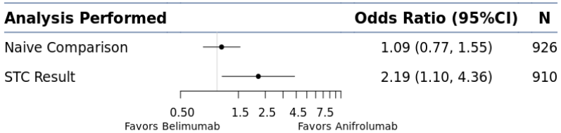

CI: confidence interval; N: sample size; SLEDAI: Systemic Lupus Erythematosus Disease Activity Index;
STC: simulated treatment comparison.

Figure S3: SRI(4) response STC sensitivity analysis: Inclusion of MUSE
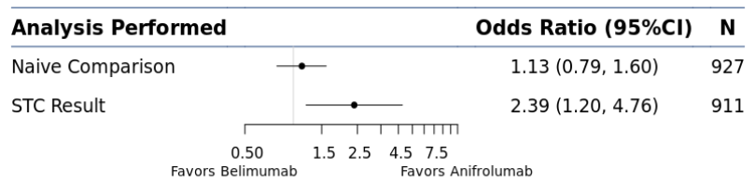

CI: confidence interval; N: sample size; SRI(4): SLE Responder Index-4; STC: simulated treatment comparison.

Figure S4: BILAG flares STC sensitivity analysis: Inclusion of MUSE
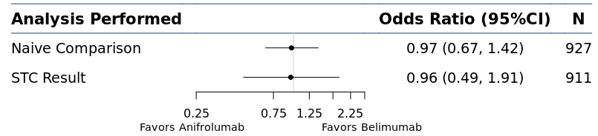

BILAG: British Isles Lupus Assessment Group; CI: confidence interval; N: sample size; STC: simulated treatment comparison.
Figure S5: OCS reduction STC sensitivity analysis: Inclusion of MUSE
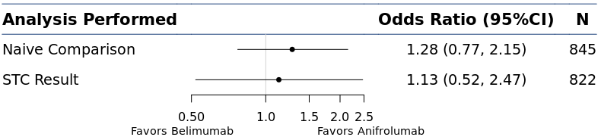

CI: confidence interval; N: sample size; OCS: oral corticosteroid; STC: simulated treatment comparison.

Sensitivity Analysis: Comparison With Belimumab 200 mg SC
Figure S6: SLEDAI reduction STC sensitivity analysis: Comparison with belimumab SC
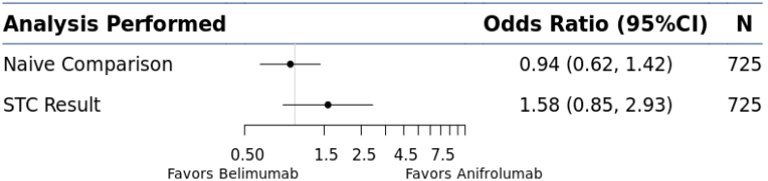

CI: confidence interval; N: sample size; SC: subcutaneous; SLEDAI: Systemic Lupus Erythematosus Disease Activity Index; STC: simulated treatment comparison.

Figure S7: SRI(4) response STC sensitivity analysis: Comparison with belimumab 200 mg SC
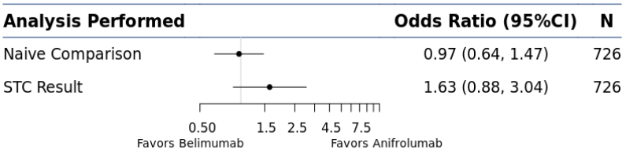

CI: confidence interval; N: sample size; SC: subcutaneous; SRI(4): SLE Responder Index-4; STC: simulated treatment comparison.

Figure S8: BILAG flares STC sensitivity analysis: Comparison with belimumab 200 mg SC
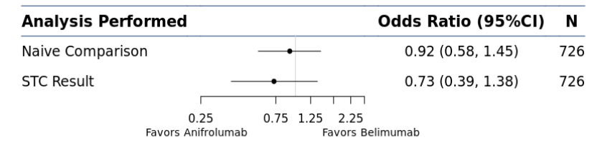

BILAG: British Isles Lupus Assessment Group; CI: confidence interval; N: sample size; SC: subcutaneous;
STC: simulated treatment comparison.

References
1. Scherlinger M, Carcaud C, Barnetche T et al. Explorer Study: Rituximab Use in Systemic LupusErythematosus, a New Look on Old Data [abstract]. Arthritis Rheumatol. 69(Suppl 10), (2017).
2. Van Vollenhoven RF, Hahn BH, Tsokos GC et al. Efficacy and safety of ustekinumab, an IL-12 and IL-23 inhibitor, in patients with active systemic lupus erythematosus: results of a multicentre, double-blind, phase 2, randomised, controlled study. Lancet 392(10155), 1330-1339 (2018).
3. Furie R, Bruce IN, Dörner T et al. Efficacy and safety of dapirolizumab pegol (DZP) in patients with moderately to severely active systemic lupus erythematosus (SLE): A randomised, placebo (PBO)-controlled study [abstract]. Arthritis Rheum. Dis. 78(Suppl 2), (2019).
4. Merrill JT, Neuwelt CM, Wallace DJ et al. Efficacy and safety of rituximab in moderately-to-severely active systemic lupus erythematosus: the randomized, double-blind, phase II/III systemic lupus erythematosus evaluation of rituximab trial. Arthritis Rheum. 62(1), 222-233 (2010).
5. Griffiths B, Emery P, Ryan V et al. The BILAG multi-centre open randomized controlled trial comparing ciclosporin vs azathioprine in patients with severe SLE. Rheumatology (Oxford) 49(4), 723-732 (2010).
6. Navarra SV, Guzmán RM, Gallacher AE et al. Efficacy and safety of belimumab in patients with active systemic lupus erythematosus: a randomised, placebo-controlled, phase 3 trial. Lancet 377(9767), 721-731 (2011).
7. Furie R, Petri M, Zamani O et al. A phase III, randomized, placebo-controlled study of belimumab, a monoclonal antibody that inhibits B lymphocyte stimulator, in patients with systemic lupus erythematosus. Arthritis Rheum. 63(12), 3918-3930 (2011).
8. Zhang F, Bae SC, Bass D et al. A pivotal phase III, randomised, placebo-controlled study of belimumab in patients with systemic lupus erythematosus located in China, Japan and South Korea. Ann. Rheum. Dis. 77(3), 355-363 (2018).
9. Stohl W, Schwarting A, Okada M et al. Efficacy and Safety of Subcutaneous Belimumab in Systemic Lupus Erythematosus: A Fifty-Two-Week Randomized, Double-Blind, Placebo-Controlled Study. Arthritis Rheumatol. 69(5), 1016-1027 (2017).
10. Yahya F, Jasmin R, Ng CT, Cheah TE, Sockalingam S. Open label randomized controlled trial assessing the efficacy of mycophenolate sodium against other conventional immunosuppressive agents in active systemic lupus erythematosus patients without renal involvement. Int. J. Rheum. Dis. 16(6), 724-730 (2013).
11. D'cruz D, Maksimowicz-Mckinnon K, Oates J et al. Efficacy and safety of belimumab in patients of black race with systemic lupus erythematosus: Results from the EMBRACE Study. Lupus Sci. Med. 6(Suppl 1), A1-A227 (2019).
12. Kalunian KC, Merrill JT, Maciuca R et al. A Phase II study of the efficacy and safety of rontalizumab (rhuMAb interferon-alpha) in patients with systemic lupus erythematosus (ROSE). Ann. Rheum. Dis. 75(1), 196-202 (2016).
13. Zimmer R, Scherbarth HR, Rillo OL, Gomez-Reino JJ, Muller S. Lupuzor/P140 peptide in patients with systemic lupus erythematosus: a randomised, double-blind, placebo-controlled phase IIb clinical trial. Ann. Rheum. Dis. 72(11), 1830-1835 (2013).
14. Fortin PR, Abrahamowicz M, Ferland D et al. Steroid-sparing effects of methotrexate in systemic lupus erythematosus: a double-blind, randomized, placebo-controlled trial. Arthritis Rheum. 59(12), 1796-1804 (2008).
15. Isenberg D, Gordon C, Licu D, Copt S, Rossi CP, Wofsy D. Efficacy and safety of atacicept for prevention of flares in patients with moderate-to-severe systemic lupus erythematosus (SLE): 52-week data (APRIL-SLE randomised trial). Ann. Rheum. Dis. 74(11), 2006-2015 (2015).

