Supplemental Tables
Supplemental Table S1. Genetic information of the genotyped SNPs.
CHR | POS | SNP | A1 | A2 | FUNC | LOCI | MAF | HWE
7 | 150329343 | rs147530050 | T | C | near-gene-5 | RARRES2 | 0.05 | 0.34
7 | 150333889 | rs76735405 | G | A | near-gene-5 | RARRES2 | 0.13 | 1.00
7 | 150334397 | rs143367396 | A | G | near-gene-5 | RARRES2 | 0.05 | 0.69
7 | 150337862 | rs3735168 | A | G | near-gene-5 | RARRES2 | 0.10 | 0.66
7 | 150338094 | rs11538922 | T | C | near-gene-5 | RARRES2 | 0.25 | 0.92
7 | 150338370 | rs1047586 | G | T | intron | RARRES2 | 0.25 | 1.00
7 | 150338437 | rs4721 | G | T | intron | RARRES2 | 0.42 | 0.65
19 | 7669160 | rs3219176 | T | C | intron | RETN | 0.07 | 1.00
19 | 7669625 | rs3745367 | A | G | intron | RETN | 0.35 | 1.00
19 | 7670065 | rs3219178 | G | C | intron | RETN | 0.25 | 0.71
19 | 7670203 | rs10402265 | G | C | intron | RETN | 0.35 | 0.79
19 | 7670411 | rs3745368 | A | G | untranslated-3 | RETN | 0.18 | 0.94
CHR: chromosome; POS:position; A1: minor allele; A2: major allele; FUNC: function; MAF: minor allele frequency; HWE: Hardy-Weinberg Equilibrium.

Supplemental Table S2. Parameters setting for power analysis
Parameters | Values | Note
No. of cases | 1,180 | No. of cases in this study
No. of controls | 2,560 | No. of controls in this study
Significance level | 0.004 | 0.05/12
Prevalence | 0.16 | Global pooled prevalence of OA
Disease allele frequency | 0.2 | Average minor allele frequency

Supplemental Table S3. Full results of single marker based association analyses.
CHR | SNP | A1 | A2 | TEST | AFF | UNAFF | χ² | DF | P Values
7 | rs1047586 | G | T | GENO | 68/439/673 | 159/957/1444 | 0.33 | 2 | 0.8477
7 | rs1047586 | G | T | ALLELIC | 575/1785 | 1275/3845 | 0.25 | 1 | 0.6163
7 | rs1047586 | G | T | DOM | 507/673 | 1116/1444 | 0.13 | 1 | 0.7189
7 | rs1047586 | G | T | REC | 68/1112 | 159/2401 | 0.28 | 1 | 0.5937
7 | rs11538922 | T | C | GENO | 78/448/654 | 161/968/1431 | 0.17 | 2 | 0.9194
7 | rs11538922 | T | C | ALLELIC | 604/1756 | 1290/3830 | 0.14 | 1 | 0.7130
7 | rs11538922 | T | C | DOM | 526/654 | 1129/1431 | 0.07 | 1 | 0.7859
7 | rs11538922 | T | C | REC | 78/1102 | 161/2399 | 0.14 | 1 | 0.7091
7 | rs143367396 | A | G | GENO | 5/120/1055 | 8/251/2301 | 0.42 | 2 | 0.8121
7 | rs143367396 | A | G | ALLELIC | 130/2230 | 267/4853 | 0.28 | 1 | 0.5986
7 | rs143367396 | A | G | DOM | 125/1055 | 259/2301 | 0.20 | 1 | 0.6558
7 | rs143367396 | A | G | REC | 5/1175 | 8/2552 | 0.29 | 1 | 0.5912
7 | rs147530050 | T | C | GENO | 4/118/1058 | 10/261/2289 | NA | NA | NA
7 | rs147530050 | T | C | ALLELIC | 126/2234 | 281/4839 | 0.07 | 1 | 0.7914
7 | rs147530050 | T | C | DOM | 122/1058 | 271/2289 | NA | NA | NA
7 | rs147530050 | T | C | REC | 4/1176 | 10/2550 | NA | NA | NA
7 | rs3735168 | A | G | GENO | 16/219/945 | 28/461/2071 | 0.67 | 2 | 0.7141
7 | rs3735168 | A | G | ALLELIC | 251/2109 | 517/4603 | 0.51 | 1 | 0.4763
7 | rs3735168 | A | G | DOM | 235/945 | 489/2071 | 0.34 | 1 | 0.5584
7 | rs3735168 | A | G | REC | 16/1164 | 28/2532 | 0.48 | 1 | 0.4895
7 | rs4721 | G | T | GENO | 254/573/353 | 412/1244/904 | 20.38 | 2 | 3.75E-05
7 | rs4721 | G | T | ALLELIC | 1081/1279 | 2068/3052 | 19.43 | 1 | 1.05E-05
7 | rs4721 | G | T | DOM | 827/353 | 1656/904 | 10.54 | 1 | 0.0012
7 | rs4721 | G | T | REC | 254/926 | 412/2148 | 16.28 | 1 | 5.46E-05
7 | rs76735405 | G | A | GENO | 16/260/904 | 41/568/1951 | 0.35 | 2 | 0.8415
7 | rs76735405 | G | A | ALLELIC | 292/2068 | 650/4470 | 0.15 | 1 | 0.6961
7 | rs76735405 | G | A | DOM | 276/904 | 609/1951 | 0.07 | 1 | 0.7895
7 | rs76735405 | G | A | REC | 16/1164 | 41/2519 | 0.32 | 1 | 0.5688
19 | rs10402265 | G | C | GENO | 144/540/496 | 305/1167/1088 | 0.10 | 2 | 0.9497
19 | rs10402265 | G | C | ALLELIC | 828/1532 | 1777/3343 | 0.10 | 1 | 0.7500
19 | rs10402265 | G | C | DOM | 684/496 | 1472/1088 | 0.07 | 1 | 0.7886
19 | rs10402265 | G | C | REC | 144/1036 | 305/2255 | 0.06 | 1 | 0.8003
19 | rs3219176 | T | C | GENO | 8/156/1016 | 12/328/2220 | 0.80 | 2 | 0.6702
19 | rs3219176 | T | C | ALLELIC | 172/2188 | 352/4768 | 0.42 | 1 | 0.5153
19 | rs3219176 | T | C | DOM | 164/1016 | 340/2220 | 0.26 | 1 | 0.6076
19 | rs3219176 | T | C | REC | 8/1172 | 12/2548 | 0.66 | 1 | 0.4149
19 | rs3219178 | G | C | GENO | 67/446/667 | 156/968/1436 | 0.26 | 2 | 0.8777
19 | rs3219178 | G | C | ALLELIC | 580/1780 | 1280/3840 | 0.16 | 1 | 0.6936
19 | rs3219178 | G | C | DOM | 513/667 | 1124/1436 | 0.06 | 1 | 0.8047
19 | rs3219178 | G | C | REC | 67/1113 | 156/2404 | 0.25 | 1 | 0.6178
19 | rs3745367 | A | G | GENO | 144/543/493 | 323/1172/1065 | 0.13 | 2 | 0.9386
19 | rs3745367 | A | G | ALLELIC | 831/1529 | 1818/3302 | 0.06 | 1 | 0.8036
19 | rs3745367 | A | G | DOM | 687/493 | 1495/1065 | 0.01 | 1 | 0.9182
19 | rs3745367 | A | G | REC | 144/1036 | 323/2237 | 0.13 | 1 | 0.7220
19 | rs3745368 | A | G | GENO | 58/387/735 | 72/722/1766 | 21.44 | 2 | 2.21E-05
19 | rs3745368 | A | G | ALLELIC | 503/1857 | 866/4254 | 20.91 | 1 | 4.81E-06
19 | rs3745368 | A | G | DOM | 445/735 | 794/1766 | 16.35 | 1 | 5.27E-05
19 | rs3745368 | A | G | REC | 58/1122 | 72/2488 | 10.64 | 1 | 0.0011
CHR: chromosome; GENO: genotyic analyses; A1:minor allele; A2: major allele; AFF: cases; UNAFF: controls; ALLELIC: allelic analyses; DOM: dominant mode; REC: recessive mode; DF: degree of freedom.

Supplemental Table S4. eQTL signals of SNP rs4721 on gene RARRES2 in multiple types of human tissues.
Gene Symbol | SNP | P Value | NES | T-statistic | Tissue
RARRES2 | rs4721 | 1.10E-13 | 0.23 | 7.60 | Adipose - Subcutaneous
RARRES2 | rs4721 | 1.10E-04 | 0.11 | 3.90 | Adipose - Visceral (Omentum)
RARRES2 | rs4721 | 0.04 | 0.10 | 2.10 | Adrenal Gland
RARRES2 | rs4721 | 1.30E-08 | 0.24 | 5.80 | Artery - Aorta
RARRES2 | rs4721 | 0.04 | 0.13 | 2.10 | Artery - Coronary
RARRES2 | rs4721 | 4.40E-10 | 0.15 | 6.40 | Artery - Tibial
RARRES2 | rs4721 | 0.14 | -0.07 | -1.50 | Brain - Amygdala
RARRES2 | rs4721 | 0.22 | -0.06 | -1.20 | Brain - Anterior cingulate cortex (BA24)
RARRES2 | rs4721 | 0.70 | 0.01 | 0.38 | Brain - Caudate (basal ganglia)
RARRES2 | rs4721 | 0.42 | 0.04 | 0.80 | Brain - Cerebellar Hemisphere
RARRES2 | rs4721 | 0.78 | 0.01 | 0.28 | Brain - Cerebellum
RARRES2 | rs4721 | 0.67 | -0.02 | -0.42 | Brain - Cortex
RARRES2 | rs4721 | 0.37 | -0.04 | -0.90 | Brain - Frontal Cortex (BA9)
RARRES2 | rs4721 | 0.42 | -0.04 | -0.80 | Brain - Hippocampus
RARRES2 | rs4721 | 0.98 | 0.00 | -0.02 | Brain - Hypothalamus
RARRES2 | rs4721 | 0.85 | 0.01 | 0.18 | Brain - Nucleus accumbens (basal ganglia)
RARRES2 | rs4721 | 0.92 | 0.00 | 0.10 | Brain - Putamen (basal ganglia)
RARRES2 | rs4721 | 0.02 | -0.17 | -2.50 | Brain - Spinal cord (cervical c-1)
RARRES2 | rs4721 | 0.91 | 0.01 | 0.12 | Brain - Substantia nigra
RARRES2 | rs4721 | 8.40E-07 | 0.15 | 5.00 | Breast - Mammary Tissue
RARRES2 | rs4721 | 2.00E-22 | 0.32 | 10.00 | Cells - Cultured fibroblasts
RARRES2 | rs4721 | 0.05 | -0.19 | -2.00 | Cells - EBV-transformed lymphocytes
RARRES2 | rs4721 | 0.02 | 0.09 | 2.30 | Colon - Sigmoid
RARRES2 | rs4721 | 7.70E-03 | -0.07 | -2.70 | Colon - Transverse
RARRES2 | rs4721 | 0.21 | 0.03 | 1.20 | Esophagus - Mucosa
RARRES2 | rs4721 | 1.00E-05 | 0.11 | 4.50 | Esophagus - Muscularis
RARRES2 | rs4721 | 0.93 | 0.00 | 0.08 | Heart - Atrial Appendage
RARRES2 | rs4721 | 5.60E-04 | 0.13 | 3.50 | Heart - Left Ventricle
RARRES2 | rs4721 | - | - | - | Kidney - Medulla
RARRES2 | rs4721 | 0.76 | 0.02 | 0.30 | Liver
RARRES2 | rs4721 | 0.15 | -0.03 | -1.40 | Lung
RARRES2 | rs4721 | 0.18 | 0.09 | 1.30 | Minor Salivary Gland
RARRES2 | rs4721 | 1.10E-17 | 0.21 | 8.80 | Muscle - Skeletal
RARRES2 | rs4721 | 1.10E-17 | 0.16 | 8.90 | Nerve - Tibial
RARRES2 | rs4721 | 0.13 | -0.08 | -1.50 | Ovary
RARRES2 | rs4721 | 5.60E-09 | -0.22 | -6.00 | Pancreas
RARRES2 | rs4721 | 0.01 | -0.10 | -2.50 | Pituitary
RARRES2 | rs4721 | 0.03 | -0.06 | -2.10 | Prostate
RARRES2 | rs4721 | 1.40E-03 | 0.09 | 3.20 | Skin - Not Sun Exposed (Suprapubic)
RARRES2 | rs4721 | 1.80E-05 | 0.10 | 4.30 | Skin - Sun Exposed (Lower leg)
RARRES2 | rs4721 | 0.68 | -0.01 | -0.41 | Small Intestine - Terminal Ileum
RARRES2 | rs4721 | 0.90 | 0.00 | -0.13 | Spleen
RARRES2 | rs4721 | 0.01 | -0.07 | -2.50 | Stomach
RARRES2 | rs4721 | 0.10 | 0.04 | 1.60 | Testis
RARRES2 | rs4721 | 0.29 | 0.03 | 1.10 | Thyroid
RARRES2 | rs4721 | 0.67 | -0.03 | -0.43 | Uterus
RARRES2 | rs4721 | 0.18 | -0.05 | -1.40 | Vagina
RARRES2 | rs4721 | 0.92 | 2.90E-03 | 0.10 | Whole Blood
NES: normalized effect size. Threshold of P values was 0.05/48≈0.001.

Supplemental Table S5. eQTL signals of SNP rs3745368 on gene RETN in multiple types of human tissues.
Gene | SNP | P Value | NES | T-statistic | Tissue
RETN | rs3745368 | 0.26 | -0.11 | -1.10 | Adipose - Subcutaneous
RETN | rs3745368 | 0.16 | -0.14 | -1.40 | Adipose - Visceral (Omentum)
RETN | rs3745368 | 0.42 | 0.15 | 0.81 | Adrenal Gland
RETN | rs3745368 | 0.03 | -0.30 | -2.20 | Artery - Aorta
RETN | rs3745368 | 0.58 | 0.09 | 0.56 | Artery - Coronary
RETN | rs3745368 | 0.08 | -0.20 | -1.80 | Artery - Tibial
RETN | rs3745368 | 0.09 | 0.46 | 1.70 | Brain - Amygdala
RETN | rs3745368 | 0.35 | -0.23 | -0.95 | Brain - Anterior cingulate cortex (BA24)
RETN | rs3745368 | 0.60 | -0.12 | -0.52 | Brain - Caudate (basal ganglia)
RETN | rs3745368 | 0.52 | -0.12 | -0.64 | Brain - Cortex
RETN | rs3745368 | 0.52 | 0.12 | 0.65 | Brain - Frontal Cortex (BA9)
RETN | rs3745368 | 0.92 | -0.02 | -0.10 | Brain - Hypothalamus
RETN | rs3745368 | 0.05 | -0.40 | -2.00 | Brain - Nucleus accumbens (basal ganglia)
RETN | rs3745368 | 0.85 | -0.04 | -0.18 | Brain - Putamen (basal ganglia)
RETN | rs3745368 | 0.37 | 0.26 | 0.89 | Brain - Spinal cord (cervical c-1)
RETN | rs3745368 | 0.88 | 0.05 | 0.15 | Brain - Substantia nigra
RETN | rs3745368 | 0.97 | 0.01 | 0.04 | Breast - Mammary Tissue
RETN | rs3745368 | 0.50 | -0.10 | -0.68 | Colon - Sigmoid
RETN | rs3745368 | 0.06 | -0.25 | -1.90 | Colon - Transverse
RETN | rs3745368 | 0.16 | -0.14 | -1.40 | Esophagus - Mucosa
RETN | rs3745368 | 0.01 | -0.29 | -2.50 | Esophagus - Muscularis
RETN | rs3745368 | 0.23 | -0.15 | -1.20 | Heart - Atrial Appendage
RETN | rs3745368 | 0.51 | -0.08 | -0.66 | Heart - Left Ventricle
RETN | rs3745368 | - | - | - | Kidney - Medulla
RETN | rs3745368 | 0.46 | 0.12 | 0.73 | Liver
RETN | rs3745368 | 0.02 | -0.20 | -2.30 | Lung
RETN | rs3745368 | 0.63 | 0.08 | 0.49 | Minor Salivary Gland
RETN | rs3745368 | 0.53 | -0.06 | -0.62 | Muscle - Skeletal
RETN | rs3745368 | 0.04 | -0.22 | -2.00 | Nerve - Tibial
RETN | rs3745368 | 0.84 | 0.05 | 0.21 | Ovary
RETN | rs3745368 | 0.59 | 0.08 | 0.54 | Pancreas
RETN | rs3745368 | 0.88 | -0.03 | -0.15 | Pituitary
RETN | rs3745368 | 0.16 | -0.23 | -1.40 | Prostate
RETN | rs3745368 | 0.89 | 0.02 | 0.14 | Skin - Not Sun Exposed (Suprapubic)
RETN | rs3745368 | 0.10 | -0.17 | -1.60 | Skin - Sun Exposed (Lower leg)
RETN | rs3745368 | 0.03 | -0.53 | -2.10 | Small Intestine - Terminal Ileum
RETN | rs3745368 | 0.10 | -0.25 | -1.70 | Spleen
RETN | rs3745368 | 0.74 | -0.05 | -0.33 | Stomach
RETN | rs3745368 | 0.38 | 0.15 | 0.88 | Testis
RETN | rs3745368 | 0.53 | -0.06 | -0.62 | Thyroid
RETN | rs3745368 | 0.19 | -0.44 | -1.30 | Uterus
RETN | rs3745368 | 0.62 | -0.14 | -0.50 | Vagina
RETN | rs3745368 | 1.30E-06 | -0.27 | -4.90 | Whole Blood
NES: normalized effect size. Threshold of P values was 0.05/48≈0.001.

Supplemental Figures.

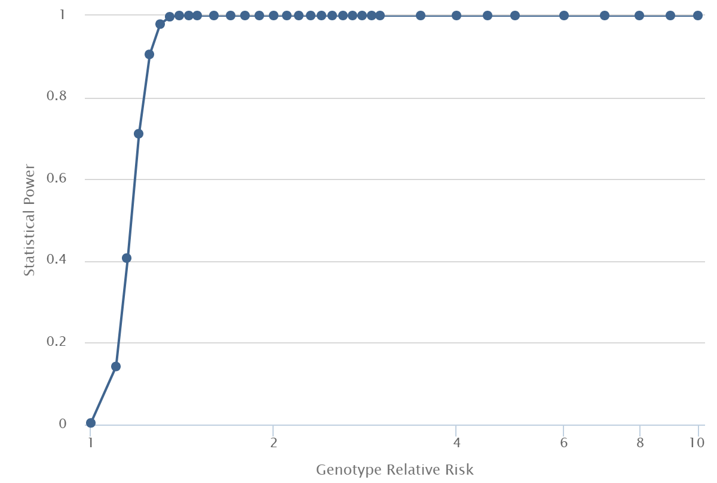
Power=90.5%, RR=1.25
Supplemental Figure S1. Results of power analysis.

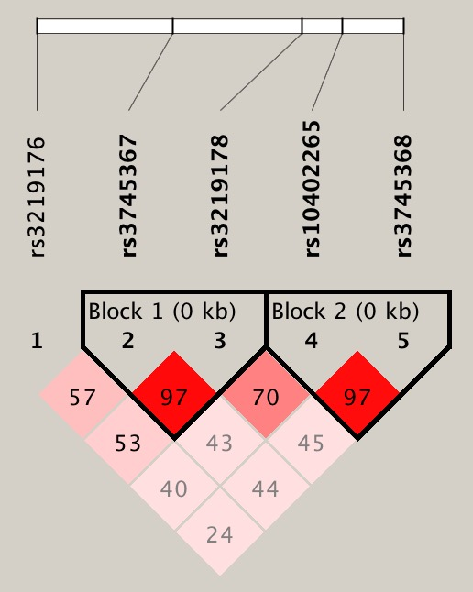
Supplemental Figure S2. Linkage disequilibrium structure for genotyped SNPs in gene RTEN. Values of D’ were indicated in each cell.

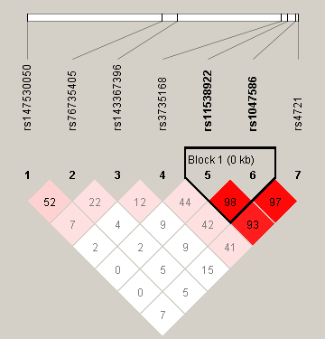
Supplemental Figure S3. Linkage disequilibrium structure for genotyped SNPs in gene RARRES2. Values of D’ were indicated in each cell.

