Supporting information

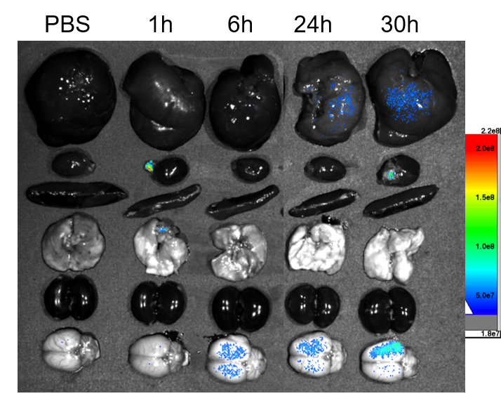
Fig. S1. The biodistribution of LIPs. HBC labeled LIPs were vein injected into MCAO rats and the major organs were harvested and imaged after different hours.

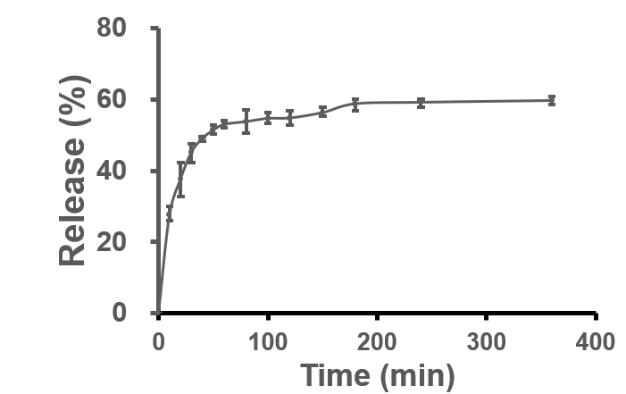
Fig. S2. Release profiles of edaravone from edaravone-loaded liposomes in PBS at pH 7.4.

