Characterization of the impact of MYBBP1A gene and rs3809849 on asparaginase sensitivity and cellular functions

Running Title: MYBBP1A and ASNase: a functional follow-up

Supplemental Material

Supplemental Figures

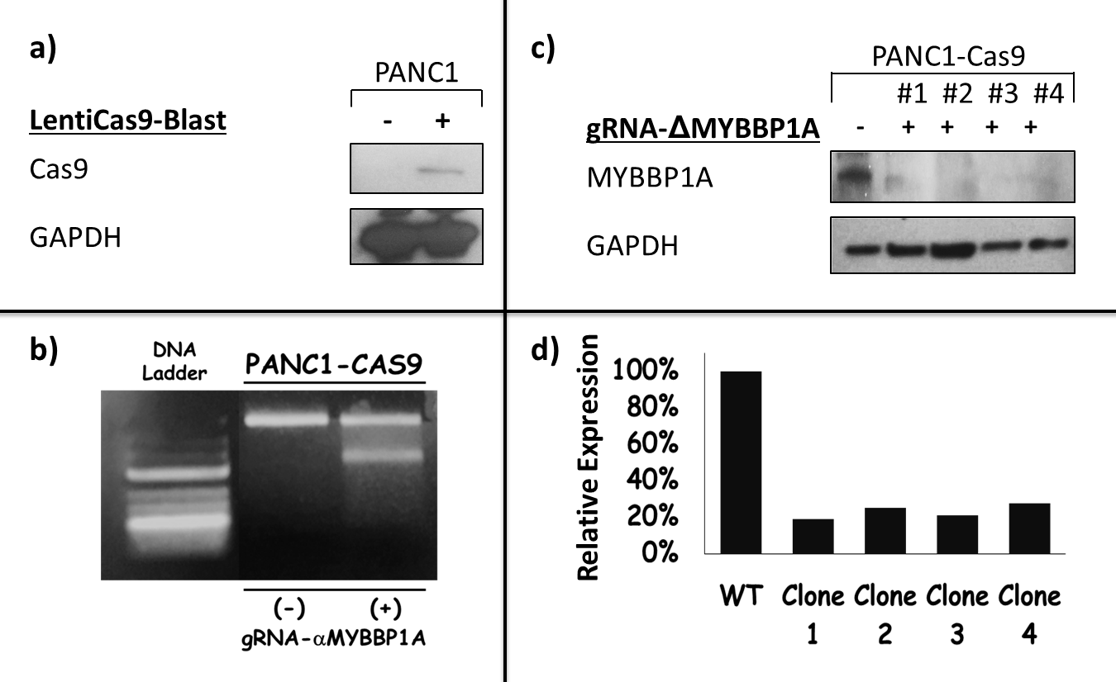
Supplemental Figure S1. Production of Cas9 expressing, & MYBBP1A gene knock-out PANC1 cell lines.
a) PANC1 cells were transduced with LentiCas9-Blast virus to constitutively express Cas9 protein. The success of viral transduction was assessed by a Western Blot against Cas9. b) The result of the mismatch cleavage assay performed on the cell population used for clonal selection indicates an approximate cleavage efficiency of 30% within the cell population used for clonal selection. This roughly corresponds to the percentage of cells where a gene-editing event occurred. c) Cas9-expressing PANC1 cells were used to produce MYBBP1A knock-out PANC1 cells by CRISPR-Cas9 genome editing technique. The efficiency of gene deletion was confirmed in several clones by the absence of a signal on Western Blot using anti-MYBBP1A antibodies. d) FACS quantification of the expression levels of MYBBP1A in ΔMYBBP1A knock-out clones.
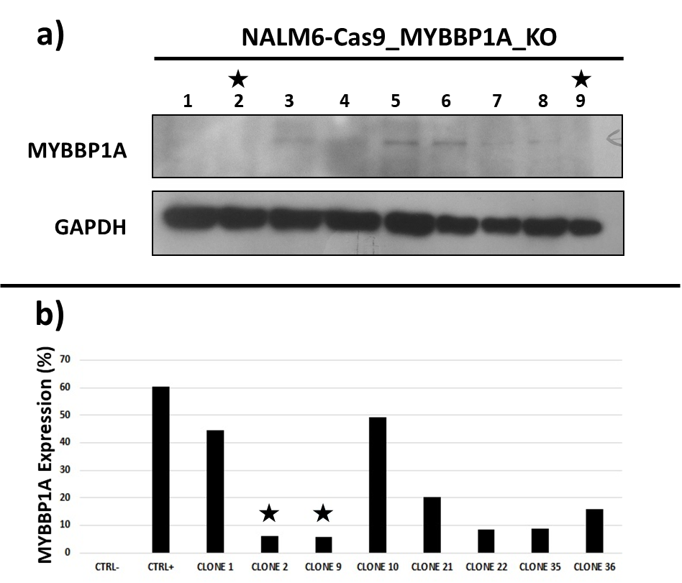
Supplemental Figure S2. Production of MYBBP1A gene knock-out in Cas9 expressing NALM6 cell line.
a) Cas9-expressing NALM6 cells were used to produce MYBBP1A knock-out PANC1 cells by CRISPR-Cas9 genome editing technique. The efficiency of gene deletion was confirmed in several clones by the absence of a signal on Western Blot using anti-MYBBP1A antibodies. b) Further validation and selection of the two most successful MYBBP1A knock-out clones (2 and 9, identified by a (*) was done using FACS to quantify the expression of MYBBP1A on the clones chosen above which demonstrates a significant reduction in MYBBP1A expression.
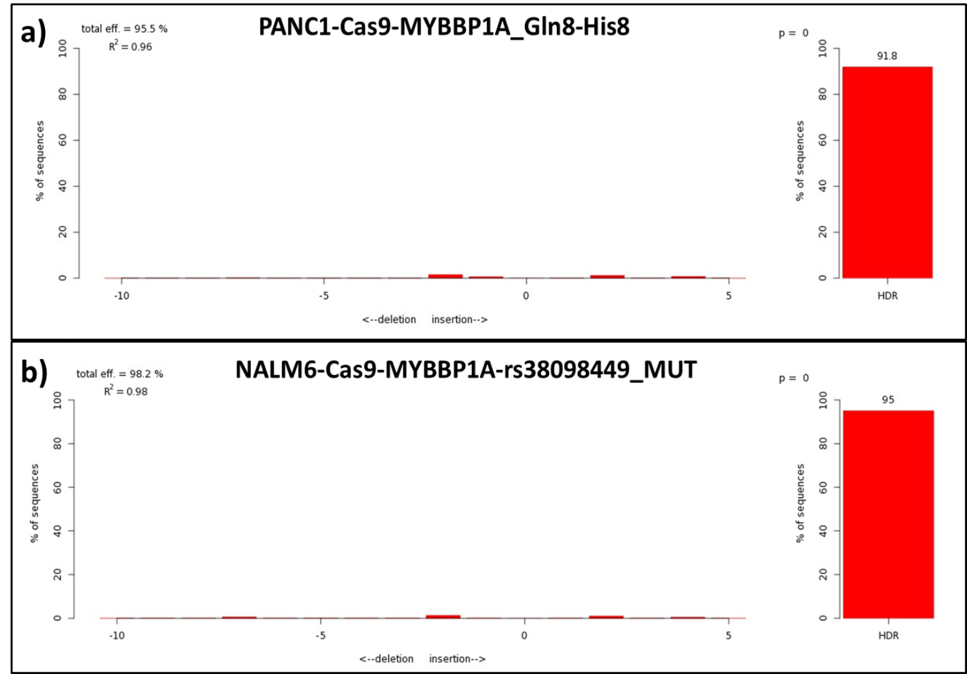

Supplemental Figure S3. INDEL spectrum and TIDE analysis of the efficacy of the knock-in experiments performed to produce the a) PANC1-Cas9-MYBBP1A-Gln8-His8 and b) NALM6-Cas9-mybbp1a-rs38098449-MUT cell lines.
Following multiple unsuccessful attempts to produce the desired mybbp1a-rs3809849-MUT knock-in PANC1 cell-line, the intriguing question was whether such failure occurred due to a technical difficulty, or a potential SNP specific effect. Accordingly, we modified the donor sequence used for the KI (CCCACCCGATGTCGCCTGGA) to allow the introduction of a Glutamine (Gln) to Histidine (His) mutation at the same position of the protein (8th amino acid), instead of the initially intended Glutamine (Gln) to Glutamic Acid (Glu) (CCGAGCCGATGTCGCCTGGA) mutation, and as compared to the WT sequence (CCCAGCCGATGTCGCCTGGA ).
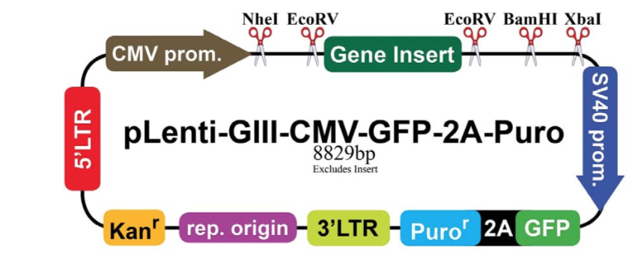

Supplemental Figure S4. Illustration of the general construct of the pLenti plasmid vectors used for the transfection of the PANC1 cells.
The template of the vector was pre-designed at abm®goods and modifications to the « gene insert » part were introduced to serve the purpose of the experiment. Accordingly, the gene insert part was kept untouched to produce the Blank reference vector, while the MYBBP1A gene was inserted into the vector with rs3809849 in the wild-type and mutant forms to produce the WT vector and MUT vector, respectively.

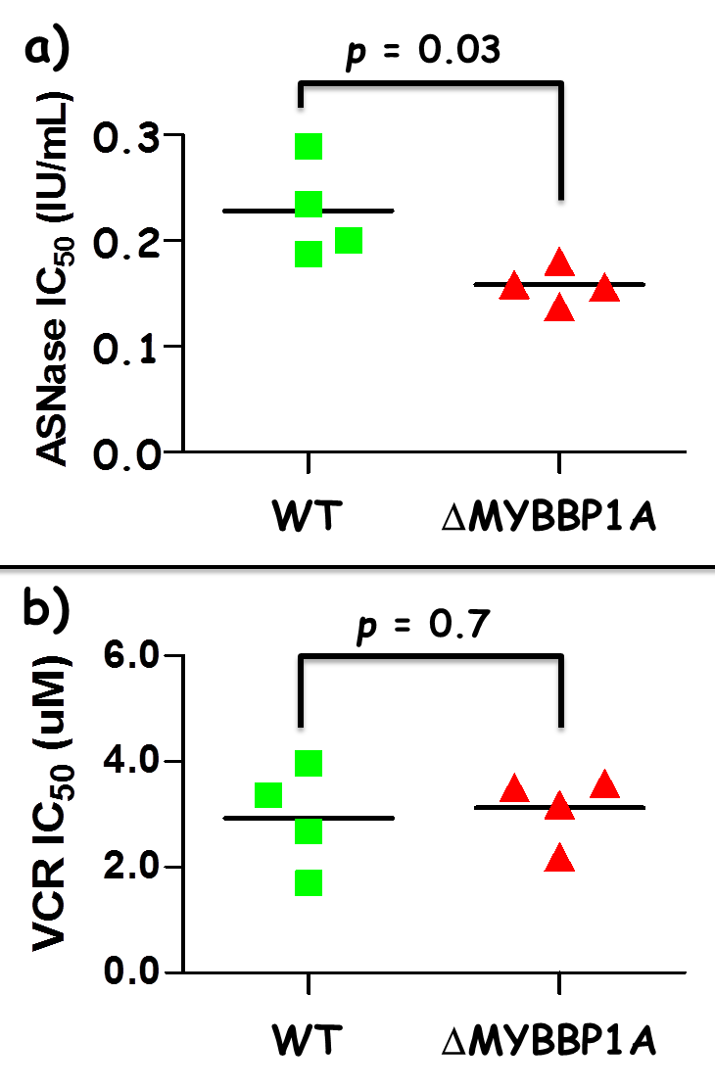
Supplemental Figure S5. In-vitro sensitivity to asparaginase and vincristine in relation to MYBBP1A gene knock-out 96 hours post incubation with a) asparaginase (ASNase) or b) vincristine (VCR).
IC₅₀ values were calculated using WST-1 viability assay 96 hours post incubation with several concentrations of the drugs. The experiment was repeated 4 times and IC₅₀ values were calculated for each experiment separately. The horizontal lines represent the mean IC₅₀ value of each group. The shapes represent independent values calculated for WT PANC1 cells (gray squares) or MYBBP1A knock-out PANC1 cells (black triangles). The p value obtained by the Student’s t-test represents the difference in drug sensitivity between the two cell lines and is provided on the top of the graph.
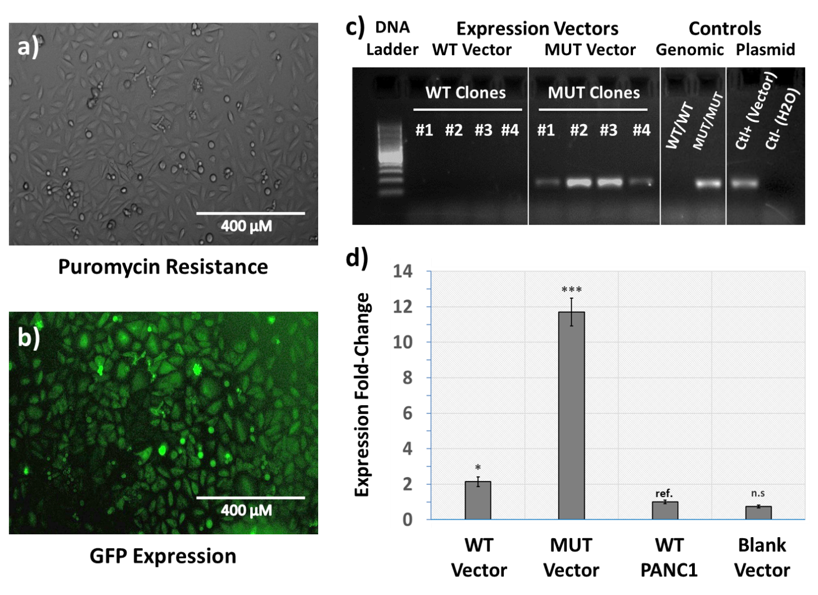
Supplemental Figure S6. Steps used in the validation and clonal selection of MYBBP1A overexpressing vectors in PANC1 cell lines.
a) Bright-field microscopy image of puromycin-resistant PANC1 cells culture, a property they acquired post-transfection with the expression vector. b) Light microscopy Image of the same culture with the filter to visualize GFP expression, confirming that these cells possess both the puromycin-resistance and the GFP-expression genes. These cells were maintained in culture under the selection pressure for 3 weeks and then selected clones were sorted out using flow-cytometry based on their capacity of expressing GFP. c) Image of the allele-specific PCR gel electrophoresis results targeted at the selective validation of the expression of the mutant MYBBP1A vector. d) RTqPCR analysis performed on the selected clones using MYBBP1A specific primers, and ß-2 microglobulin as a housekeeping reference gene. The Ct was compared to the reference cDNA of untransfected WT PANC1 as a control and whose relative expression of MYBBP1A is reported as 1. WT and MUT correspond to vectors expressing the MYBBP1A gene with rs3809849 in the wild-type and mutant forms, respectively, while Blank corresponds to cells transfected with the pLenti vector without gene insertion. Each experiment was carried in triplicates. ref= reference; * = p< 0.05; *** = p< 0.005; n.s = not significant.

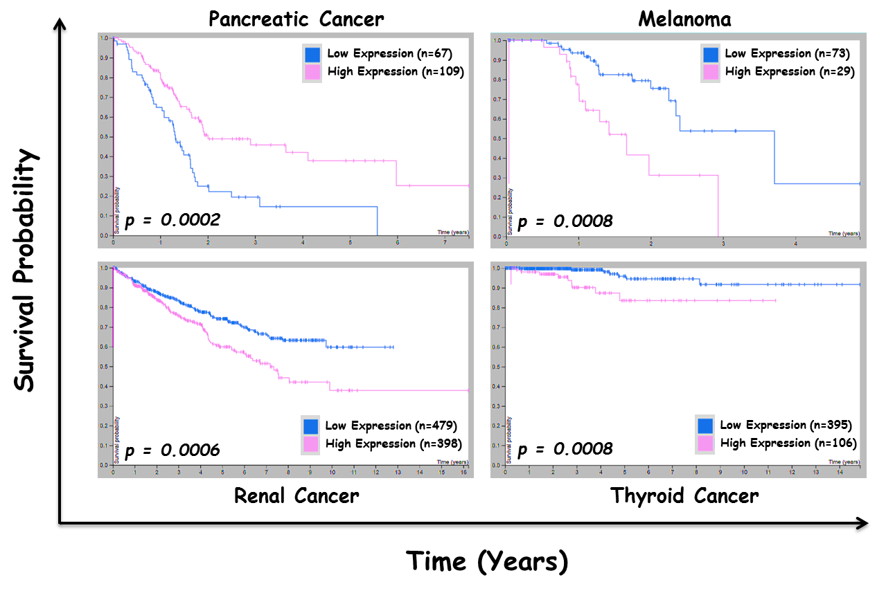
Supplemental Figure S7. Association of MYBBP1A gene expression levels with survival probability in different types of cancer.
The expression of MYBBP1A is prognostic for outcome in several types of cancers but the direction of the effect is dependent on the type of cancer. A high level of expression is significantly associated with favourable outcome in pancreatic cancer, while it portends a worsening prognosis in renal cancer, melanoma and thyroid cancer. High and low expression levels are represented by light and dark gray colours, respectively. The p-values obtained by the log rank test for the difference across expression levels are provided on each plot.

This figure was created based on publicly available data from the Human Protein Atlas website: https://www.proteinatlas.org/ENSG00000132382-MYBBP1A/pathology

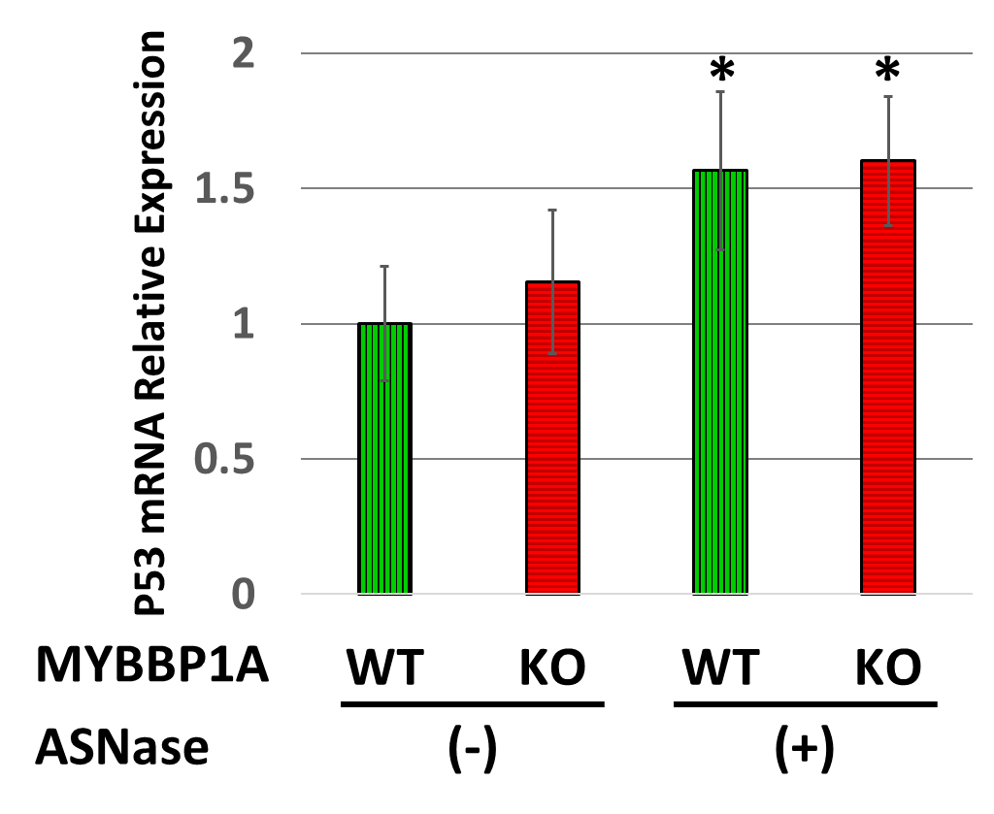
Supplemental Figure S8. Relative expression of p53 in response to MYBBP1A gene deletion and asparaginase exposure.
Coloured bars represent the relative mRNA expression levels of p53 in PANC1-Cas9-WT wild-type cells (WT) and PANC1-Cas9-Δmybbp1a cells (KO) following 48 hours of incubation with and without treatment with asparaginase (ASNase). A significant difference in the marker’s level as compared to the untreated WT cells is indicated by the presence of asterisks on the top of the bars (* = p<0.05).
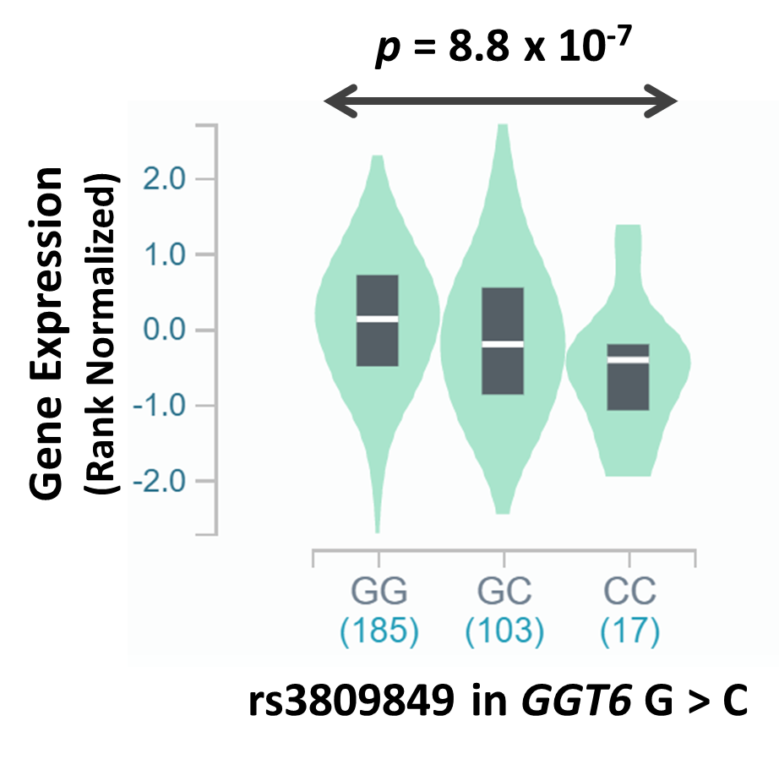
Supplemental Figure S9. Association between rs3809849 and the expression of GGT6 gene based on the genotype.
The plot represents the association between the polymorphism and the Rank-Normalized gene expression of the gene. p-value of the association across the genotype groups is provided inside of the graph. Obtained from the Genotype-Tissue Expression (GTEx) project site: https://gtexportal.org/home/snp/rs3809849

Supplemental Tables
Supplemental Table S1. List of primers used for qPCR
Target | Forward primer (5’→3’) | Reverse primer(5’→3’)
N-Cadherin | ACAGTGGCCACCTACAAAGG | CCGAGATGGGGTTGATAATG
Vimentin | GAGAACTTTGCCGTTGAAGC | GCTTCCTGTAGGTGGCAATC
ZEB1 | TCATTTTTCCTGAGGCACCTGAA | ATTGTGAAAATGCATCTGGTGTTCC
HMBS | AACGGCAATGCGGCTGCAA | GGGTACCCACGCGAATCAC
TBP | GCTGGCCCATAGTGATCTTTGC | CTTCACACGCCAAGAAACAGTGA
p53 | GCAGCCAGACTGCCTTCCGG | GGGACGGCAAGGGGGACAGA

HMBS, Hydroxymethylbilane Synthase; TBP, TATA-Box Binding Protein; p53, Tumor protein P53; ZEB1, Zinc finger E-box-binding homeobox 1.

Supplemental Methods
Virus production
HEK293 cells were plated in a 6-well plate (9x10⁵) coated with amine (Fisher Scientific) and were covered with 2ml per well of DMEM + 10% FBS without antibiotic. The next day, the DMEM medium was replaced with RPMI +10% FBS without antibiotic. For transfection, two mixes were prepared: MIX A was composed of 100µL of OPTI-MEM, 300ng pREV, 390ng pVSVG, 750ng pMDL and 450ng of the vector construct of interest. MIX B: contained 100µL of OPTI-MEM and 4µL of lipofectamine 2000. After 5 to 20 minutes of separate incubation at room temperature, the two mixes were combined and left at room temperature for one hour. This new mix (200uL) was then added to the prepared cells for a total volume of 1.2mL and incubated overnight at 37°C. The following day, the medium was removed and replaced with 1.2mL DMEM + 10% FBS + antibiotic (Penicillin + Streptomycin) and the transfected cells were incubated for 30 hours at 37°C. After the incubation period, the culture medium was collected, spinning was done at 3000 rpm for 5 minutes, and the virus-containing supernatant was collected for later use.
MYBBP1A single-guide RNA expression vector construction
CRISPR-Cas9 (Clustered regularly interspaced palindromic repeats (CRISPR)-Cas9) is a gene-editing technology which involves two essential components: a guide RNA (gRNA) to match a desired target gene, and Cas9 (CRISPR-associated protein 9)—an endonuclease which causes a double-stranded DNA break, allowing modifications to the genome. Briefly, 5 μg of plasmid was digested with 3 μl FastDigest BsmBI (Fermentas) for 30 min at 37°C in the presence of 3 μl FastAP (Fermentas) and 6 μl 10X FastDigest Buffer in a total reaction volume of 60 μl. Digested plasmid was gel purified using QIAquick Gel Extraction Kit. One hundred micromolar of each pair of oligos was phosphorylated and annealed using T4 polynucleotide kinase (New England Biolabs (NEB) M0201S) and 1 μl 10× T4 Ligation Buffer (NEB) in a total volume of 10 μl in a thermal cycler (Applied Biosystems). The cycling conditions were 37°C for 30 min, then 95°C for 5 min, followed by a ramp to 25°C at 5°C/min. The annealed oligo duplex was ligated into the BbsI-digested pLentiGuide vector using 5 μl of 5X T4 DNA Ligase Buffer (NEB 15224-041) and 1 μl T4 DNA Ligase (NEB 15224-041) in a total reaction of 11 μl. The ligation mixture was then transformed into STBL3 bacteria and incubated overnight on Luria agar + ampicillin 100μg/mL at 37°C. Mini-prep was then performed for several clones and sent to the McGill platform for sequencing.

Western Blotting
Protein lysates were prepared according to a standardized protocol published elsewhere.[1] Protein concentration was measured by the BCA Protein Assay (BioRad, CA, USA) and the lysates were stored at −80°C. 20 μg of protein were separated by electrophoresis on an SDS-PAGE 10% and transferred to a PVDF membrane as described.[2] After blocking, the membrane was incubated with primary antibodies and secondary antibodies. Protein-antibody complexes were detected by the Clarity Western ECL (BioRad).

Antibodies
For western blotting, primary antibodies were diluted in BlottoA (1x TBS, 5% skim milk, and 0.05% Tween-20) at 1/1000 and secondary antibodies at 1/5000. For immunofluorescence, antibodies were diluted in 3% BSA/PBS at 1 μg/mL and for primary and secondary antibodies, respectively. Cas9 mAb (clone 7A9-3A3) (#61978) were provided from Active Motif (CA, USA). Anti-GAPDH (sc-31915), donkey anti-rabbit IgG-HRP (sc-2077) and m-IgG_{k} BP-HRP (sc-516102) were from Santa Cruz Biotechnology (CA, USA), and Recombinant Anti-MYBBP1A antibody [EPR7205] (ab202896) was from Abcam (UK).

Generation of MYBBP1A KO and KI Cell Lines
- MYBBP1A knock-out cell lines
Briefly, after the lentiviral production of LentiCas9-Blast, 50 µL of the LentiCas9-Blast virus-containing supernatant was added to 5x10⁵ cells in a 6-well plate (ThermoFisher scientific, MA, USA), at a volume of 1 mL of culture medium containing Polybrene (8mg/mL) (Sigma-Aldrich). The cells were incubated overnight at 37°C and the following day the culture medium was changed based on the cell type. The transfected cells were allowed to grow for 24 hours before the Blasticidin treatment (5ng/mL) was added to select the positive clones, which were then further confirmed by immunoblotting with the Cas9 antibody.
A guide RNA (gRNA) targeting DNA sequence within the first exon of the MYBBP1A gene was designed (ACTCGCGACTGTGCTTCAAT) (IDT, IA, USA) and cloned into the pLentiGuide vector (see Supplemental Methods). To induce the production of MYBBP1A knock-out cells, 5x10⁵ Cas9-expressing cells were plated in 1 mL of appropriate culture medium in a 6-well plate. Next, 50 μL of the supernatant containing the gRNA-expressing vector (produced as mentioned above) was added along with 1 μl of Polybrene (8mg/mL). The cells were incubated overnight at 37°C and the medium was changed to regular culture medium the following day. After 24 hours, the regular culture medium was replaced with the selection medium containing the antibiotic mix (Blasticidin (5ng/mL) + Puromycin (1μg/mL)) in order to select positive clones that both express Cas9 and the gRNA. A mismatch assay was performed using GeneArt cleavage detection kit according to the manufacturer’s protocol (ThermoFisher scientific). MYBBP1A knock-out cells (PANC1-Cas9-Δmybbp1a or NALM6-Cas9-Δmybbp1a) were then sorted using a clonal selection process whereby cells were separated into single cells using BD FACSAria II flow-cytometer and BDFACS Diva software (BD Biosciences, CA, USA) and each cell was individually transferred into a separate well of a 96-well plate and left to establish a single-cell based colony. A Western Blot with anti-MYBBP1A antibodies was performed to characterize knock-out positive clones, then the loss of expression of MYBBP1A was confirmed by FACS analysis (FACSCanto II) (BD Biosciences).
- MYBBP1A-rs3809849-MUT cell lines
The KI protocol for generating the MYBBP1A-rs3809849-MUT cell line consisted of nucleofecting with the Amaxa's Nucleofector 2b (Lonza, ON, Canada), 1x10⁶ NALM6-Cas9 cells with 500 ng of sgRNA-MYBBP1A (TCCAGGCGACATCGGCTGGG) (IDT) and 100 pMol of ssODN-MYBBP1A-MUT (CGGTGAGTGAAGCTTAGATGGAGAGCCGGGATCACGCCGAGCCGATGTCGCCTGGAGAAGCGACGCAGAGTGGCGCCCGGCCTGCCGACCGCTATGGCCTATTGAAGCACAGTCGCGAGTTCTTGGACTTCTTCTGGGACATTGCGAAGCCTGAGCAGGA) (IDT) according to the manufacturer’s protocol (Lonza, Kit T; pr. X-005). Forty-Eight hours later, 2x10⁵cells were re-suspended in 50 μL of QuickExtract DNA Extraction Solution (Lucigen, WI, USA) and lysed by heat (68°C, 15min; 95°C, 10min; 4°C, ∞). Then a PCR was carried out with the primers MYBBP1A-FWD (AGCAGAAGGCTGGGAAAGAT) and MYB_MUT-REV (TCCTGCTCAGGCTTCGCAA) by using the following cycle: 95°C, 10min; 40x[95°C, 30s; 53.2°C, 30s; 72°C, 30s]; 72°C, 7min; 4°C, ∞. The PCR product was purified with the QIAquick PCR Purification kit (Qiagen, ON, Canada) then sequenced by Genome Québec (QC, Canada). Following the acquisition of a positive signal confirming the presence of the mutation, clonal selection was then carried as described above. After 1 month of culture, a second round of sequencing/selection was performed on the single-clone based cultures and the one that exhibited homologous recombination with a biallelic insertion of the donor sequence was retained.

Generation of MYBBP1A Overexpression Cell Lines
- Overexpression Vectors
cDNA expression vectors for each of MYBBP1A-rs3809849-WT, MYBBP1A-rs3809849-MUT and Blank reference vector were designed and purchased through a commercial supplier (ABMgood). Expression vectors are lentiviral plasmids allowing for target gene expression driven by a CMV promoter. To allow for transfection success validation and clonal selection, these vectors were designed so that the expression of the vector is coupled with a copGFP reporter (Green Fluorescent Protein) as well as conferring resistance to Kanamycin and Puromycin. The general plasmid construct of these vectors is presented in SUPPLEMENTAL FIGURE 1.

- Transfection
The viral vectors were conditioned in FBS-free DMEM medium (Wisent Inc.) containing DNAfectin™ 2100 (ABMgood) and 1% Primocin. The respective vectors were added to 6x10⁴ PANC-1 cells plated in a 24-well plate and covered with DMEM culture medium supplemented with 10% FBS (Sigma-Aldrich) and 1% Primocin and the mixture was incubated for 24 hours in 5% CO2 at 37°C conditions. The medium was then changed using a fresh culture medium and the cells were incubated for additional 48 hours. The culture medium was then replaced with a selection medium that had the same composition of the culture medium with the addition of the selection agent, Puromycin at a concentration of 5µg/mL which was determined by performing a killing curve. Conventionally, it is considered that the lineage of transfected cells has a high potential to permanently integrate the vector into its genome after 3 weeks of incubation in the selection medium. Accordingly, the transfected PANC-1 cells were transferred to T75 Flasks (Thermo Fisher Scientific) and maintained in the selection medium under the selection pressure for 4 weeks during which the cells were passaged before reaching 80% confluence. The cells were then subjected to clonal selection and were separated into single cells in a 96-well plate using flow-cytometry techniques based on their capacity of expressing GFP. Cells were left to establish a single-cell based colonies and the clones obtained were then characterized in respect to their expression of MYBBP1A.
- Screening of the lines obtained
  - Allele Specific PCR
To check the integration of the vectors allowing for the overexpression of MYBBP1A a specific allele PCR has been designed to identify the presence of the mutant allele. Briefly, a specific allele primer was designed so that the 3' end nucleotide hybridizes to the SNP position. In addition, the specificity was increased by modifying the nucleotide at the fifth position starting from the 3’ end of the primer. Specific allele primers for the WT form of MYBBP1A could not be used to identify the integration of the MYBBP1A-WT overexpressing vector in PANC-1 cells (as it will always give a positive result). Therefore, the integration of the vector allowing expression of the WT form was verified using quantitative reverse transcription PCR (RTqPCR), as successful integration of the vector would result in an overexpression of MYBBP1A-WT in these cells.

  - RTqPCR
The allele specific PCR was carried out in parallel with the RTqPCR. The quantitative analysis was performed on total RNAs which were extracted from the respective PANC1 clones produced above, and the mRNAs were reverse transcribed using the cDNA Cycle Kit (Invitrogen). PCR was carried out in a final volume of 25 μL, using 5 ng of cDNA, 0.1 μM of each of the primers, and SYBR Green PCR Master Mix (Applied Biosystems, Foster City, CA). The real-time PCR was performed using ABI 7000 Sequence Detection System (Applied Biosystems) and consisted of denaturation at 95°C for 10 minutes and 40 cycles of amplification (15 seconds at 95°C and 1 minute at 60°C). The ΔΔCT method was used to relative target-gene quantification. All samples were assayed in triplicate for MYBBP1A and B2-microglobulin, against which relative MYBBP1A gene expression was normalized. Sequences of qPCR primers can be made available upon request.

1. Schreiber E, Matthias P, Muller MM, Schaffner W. Rapid detection of octamer binding proteins with 'mini-extracts', prepared from a small number of cells. Nucleic Acids Res 17(15), 6419 (1989).
2. Gioia M, Vindigni G, Testa B et al. Membrane Cholesterol Modulates LOX-1 Shedding in Endothelial Cells. PLoS One 10(10), e0141270 (2015).

