Supplementary Information

Discovery of novel and potent InhA inhibitors by an in silico screening and pharmacokinetic prediction

Chayanin Hanwarinroj¹, Nareudon Phusi¹, Bundit Kamsri ¹, Pharit Kamsri², Auradee Punkvang², Sombat Ketrat³, Patchreenart Saparpakorn⁴, Supa Hannongbua⁴, Khomson Suttisintong⁵, Prasat Kittakoop^{6,7,8}, James Spencer⁹, Adrian J. Mulholland¹⁰ and Pornpan Pungpo¹*

¹Department of Chemistry, Faculty of Science, Ubon Ratchathani University, Ubon Ratchathani, 34190, Thailand
²Division of Chemistry, Faculty of Science, Nakhon Phanom University, Nakhon Phanom, 48000, Thailand
³School of Information Science and Technology, Vidyasirimedhi Institute of Science and Technology, Rayong, 21210, Thailand
⁴Department of Chemistry, Faculty of Science, Kasetsart University, Bangkok, 10900 Thailand
⁵National Nanotechnology Center, NSTDA, 111 Thailand Science Park, Klong Luang, Pathum Thani, 12120, Thailand
⁶Chulabhorn Research Institute, 10210 Bangkok, Thailand
⁷Chulabhorn Graduate Institute, Chemical Biology Program, Chulabhorn Royal Academy, 10210 Bangkok, Thailand
⁸Center of Excellence on Environmental Health and Toxicology (EHT), CHE, Ministry of Education, 10300 Bangkok, Thailand
⁹School of Cellular and Molecular Medicine, Biomedical Sciences Building, University of Bristol, Bristol, BS8 1TD, United Kingdom
¹⁰Centre for Computational Chemistry, School of Chemistry, University of Bristol, Bristol, BS8 1TS, United Kingdom

Contents | Page
Figure S1. RMSD plots of template molecule (a), AG-690/13705356 (b), AG-690/14006355 (c), AP-845/40876827 (d), AE-848/34504008 (e), AP-845/40876825 (f), AP-845/40876828 (g), AP-845/40876832 (h) and AS-871/41615872 (i) complexed with InhA | 3
Table S1. The antimycobacterial prediction of hit compounds by antiBac-Pred | 4
Table S2. The antimycobacterial prediction of hit compounds by mycoCSM | 4
Table S3. Hydrogen bonding analysis of candidate compounds | 5

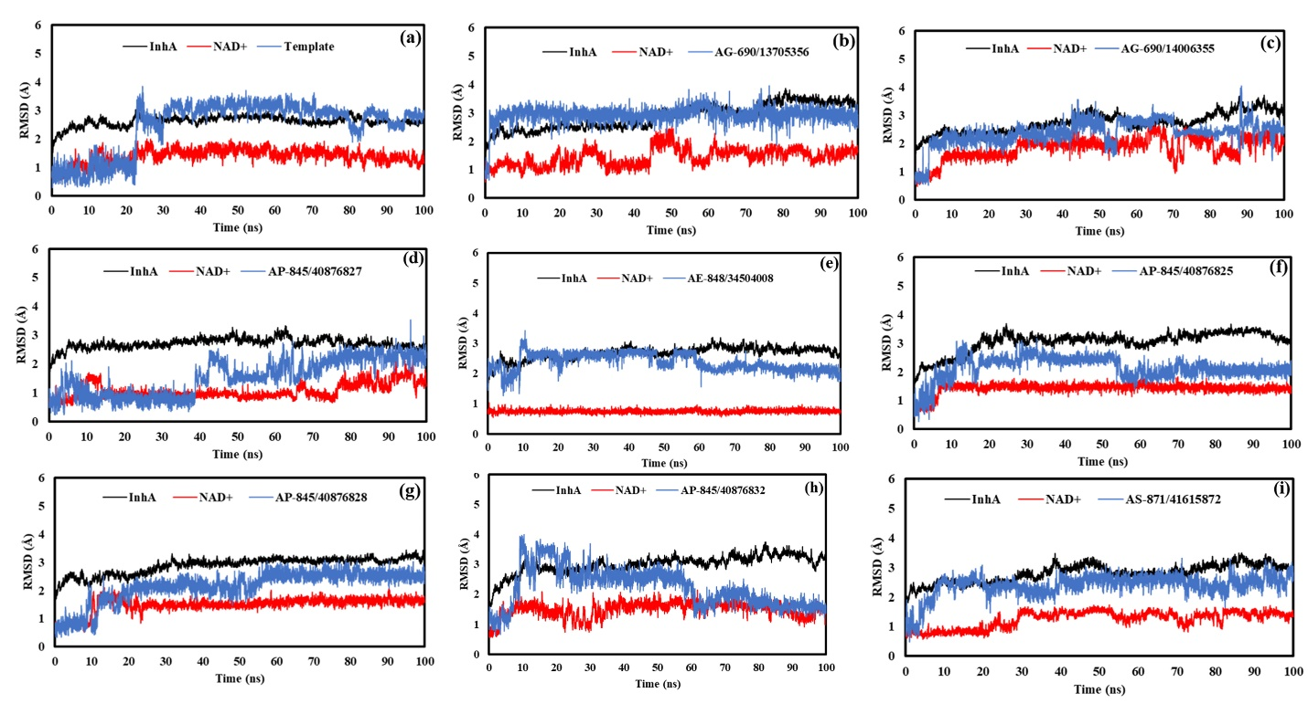
Figure S1. RMSD plots of template molecule (a), AG-690/13705356 (b), AG-690/14006355 (c), AP-845/40876827 (d), AE-848/34504008 (e), AP-845/40876825 (f), AP-845/40876828 (g), AP-845/40876832 (h) and AS-871/41615872 (i) complexed with InhA

Table S1. The antimycobacterial prediction of hit compounds by antiBac-Pred

Compound | M. tuberculosis | M. tuberculosis H37Rv | M. avium | M. bovis BCG | M. kansasii | Resistant M. avium | Resistant M. tuberculosis H37Rv | M. bovis
AP-124/43238118 (template) | none | 0.1 | none | none | none | none | none | none
AE-848/34504008 | 0.1 | 0.2 | none | none | none | none | none | none
AG-690/13705356 | none | 0.1 | 0.1 | 0.1 | 0.1 | 0.1 | 0.1 | none
AG-690/14006355 | none | none | none | none | none | none | none | none
AP-845/40876825 | none | 0.1 | none | none | none | none | none | none
AP-845/40876827 | none | none | none | none | none | none | none | none
AP-845/40876828 | none | none | none | none | none | none | none | none
AP-845/40876832 | none | none | 0.1 | none | none | none | none | none
AS-871/41615872 | none | none | none | none | none | none | none | 0.1

Table S2. The antimycobacterial prediction of hit compounds by mycoCSM

Compound | M. avium | M. bovis | M. fortuitum | M. intracellulare | M. kansasii | M. phlei | M. smegmatis | M. tuberculosis
AP-124/43238118 (template) | -4.8 | -6.2 | -4.2 | -4.2 | -4.4 | -4.4 | -4.2 | -4.9
AE-848/34504008 | -3.8 | -6.0 | -4.1 | -4.2 | -4.3 | -4.4 | -4.1 | -5.1
AS-871/41615872 | -4.3 | -5.2 | -4.0 | -4.3 | -4.0 | -4.3 | -4.2 | -4.9
AP-845/40876827 | -4.6 | -6.2 | -4.2 | -4.3 | -4.8 | -4.1 | -4.8 | -4.9
AP-845/40876828 | -4.6 | -6.2 | -4.1 | -4.3 | -4.2 | -4.2 | -4.8 | -4.7
AP-845/40876832 | -5.0 | -5.1 | -4.1 | -4.1 | -4.5 | -4.2 | -4.3 | -4.8
AG-690/13705356 | -4.1 | -6.3 | -4.1 | -4.3 | -3.7 | -3.8 | -4.7 | -5.4
AG-690/14006355 | -4.2 | -3.5 | -4.1 | -4.1 | -4.1 | -4.3 | -4.3 | -4.4
AP-845/40876825 | -4.7 | -5.2 | -4.3 | -4.2 | -4.6 | -4.5 | -4.0 | -4.9

Table S3. Hydrogen bonding analysis of candidate compounds
Compound | Acceptor | DonorH | Donor | %Occupation  (%) | Average distance (Å) | Average angle (º)
AP-124/43238118 (template) | NAD@O1N | LIG@H20 | LIG@O1 | 79.5 | 2.60 | 167.7
 | NAD@O2A | LIG@H20 | LIG@O1 | 13.8 | 2.68 | 165.2
AG-690/13705356 | LIG@O13 | Gln214@HE22 | Gln214@NE2 | 24.2 | 2.89 | 160.9
AG-690/14006355 | Gln214@OE1 | LIG@H38 | LIG@O13 | 24.0 | 2.70 | 165.6
AP-845/40876828 | NAD@O1A | LIG@H13 | LIG@O1 | 44.4 | 2.63 | 165.7
AP-845/40876832 | LIG@N7 | Gln214@HE22 | Gln214@NE2 | 5.4 | 2.92 | 162.6

