Supporting Information

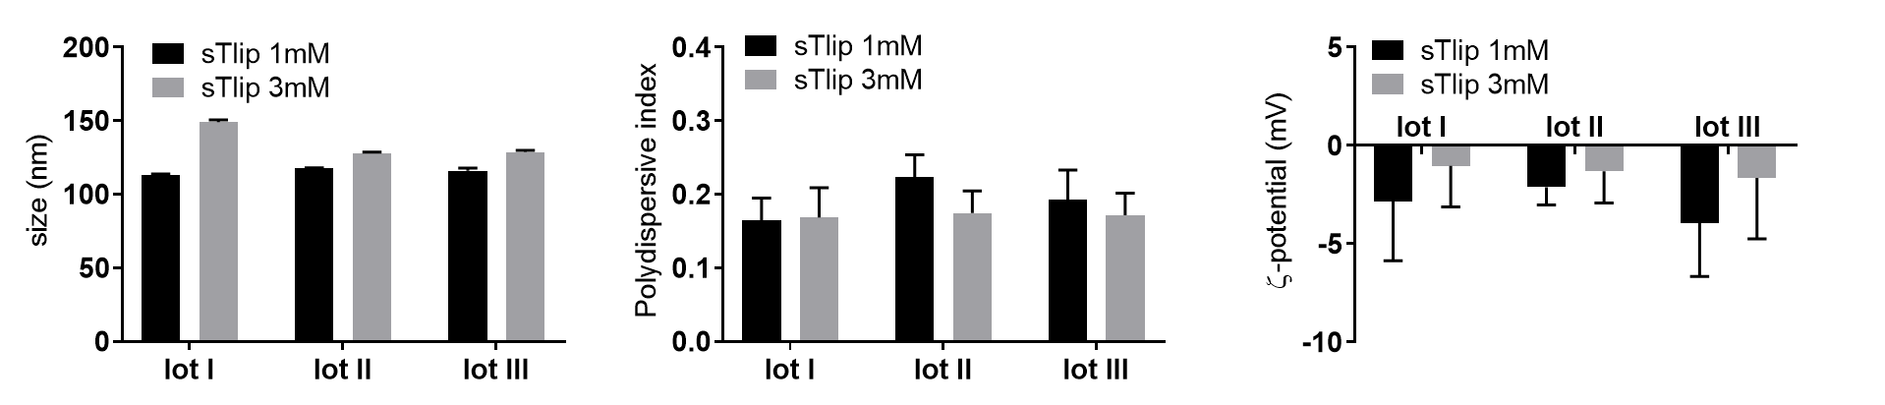
Figure S1: Stealth nanoliposomes reproducibility. DLS (size and PDI) and ELS (ζ-potential) characterization at total lipid concentrations of 1 mM and 3 mM. Error bars represent standard deviation of 5 measurements of the same sample.

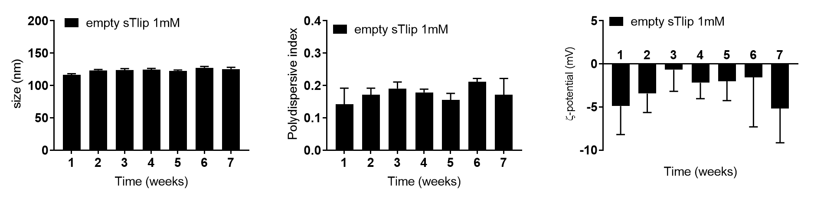
Figure S2: Shelf-stability of stealth nanoliposomes. DLS (size and PDI) and ELS (ζ-potential) characterization at total lipid concentration of 1 mM. Error bars represent standard deviation of 5 measurements of the same sample.

Cell line | Equation | R² | EC50 (nM)
PC-3 | y = 1.5E-4x2 -0.1x + 96.2 | 0.90 | 105.3
MCF-7 | y = 62.3 + (377.7)/(1 + 10^((-1.1-x)*-0.8)) | 0.89 | 1.2

Figure S3 – YTX dose-response (0 to 500 nM) for the three cell lines tested: normal epithelial cells (HK-2), prostate (PC-3) and breast (MCF-7) adenocarcinoma models

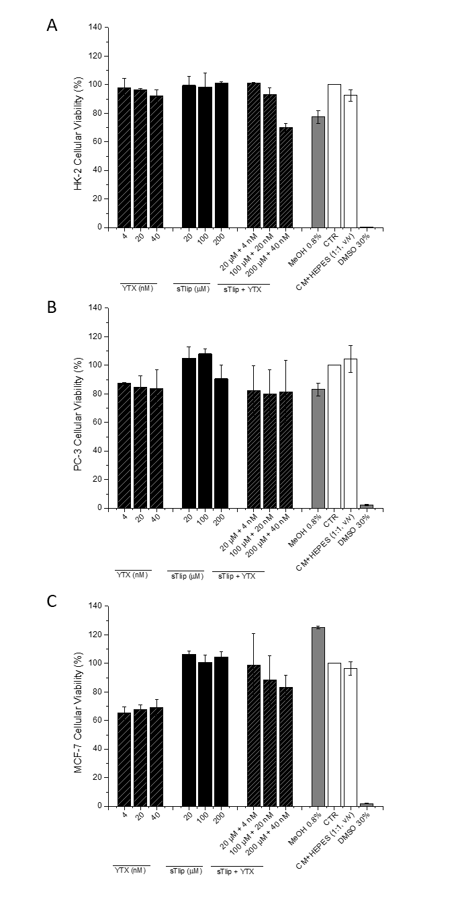
Figure S4 – Dose response of sTlip (at 20, 100 and 200 µM) loaded with YTX (at 4, 20 and 40 nM) and respective controls (free YTX and unloaded sTlip nanoliposomes) for the three cell lines tested: (A) HK-2, (B) PC-3 and (C) MCF-7.

