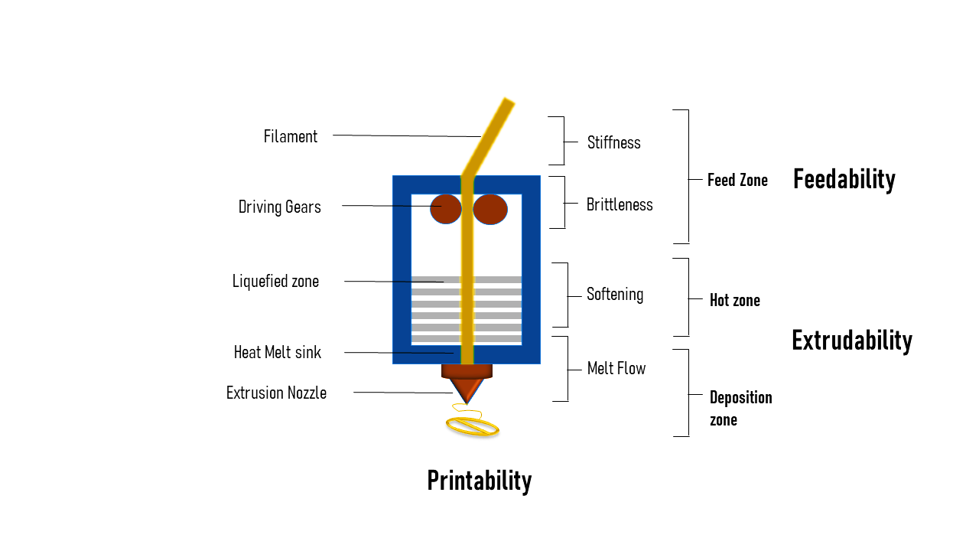

**Figure S1:** Mechanical properties of the melt-extruded filament for feedability, extrudability & printability attributes.

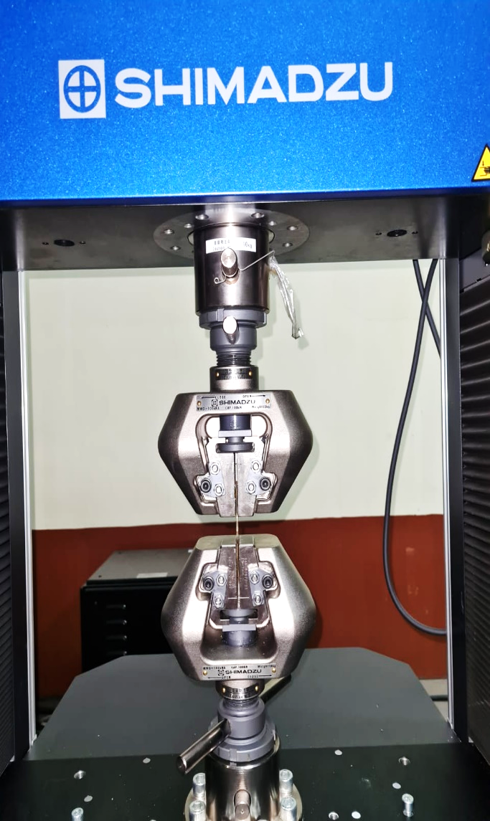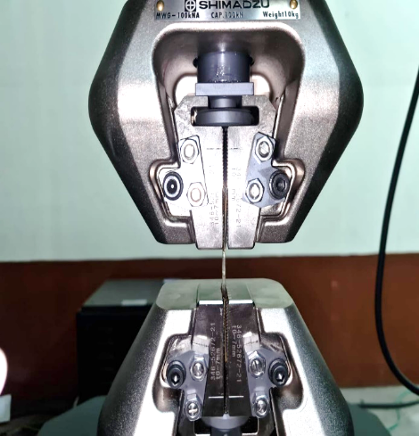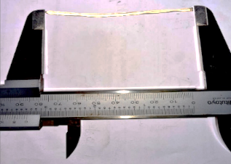

**Figure S3:** FTIR-ATR spectra of non-plasticized (EH-PZQ: 0.0% w/w) and plasticized (EH-PZQ: 3.5% w/w & EH-PZQ 6.5%w/w) melt-extruded filament.

**Figure S2:** Photographic representation of tensile strength analysis of melt-extruded filament.

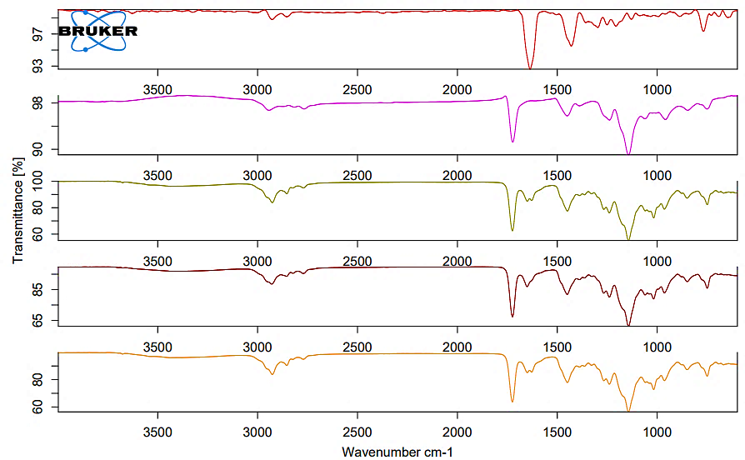

**EH-PZQ: 0.0%w/w**

**EH-PZQ: 3.5%w/w**

**EH-PZQ 6.5%w/w**

**Transmittance [%]**

**Wavenumber (cm-1)**

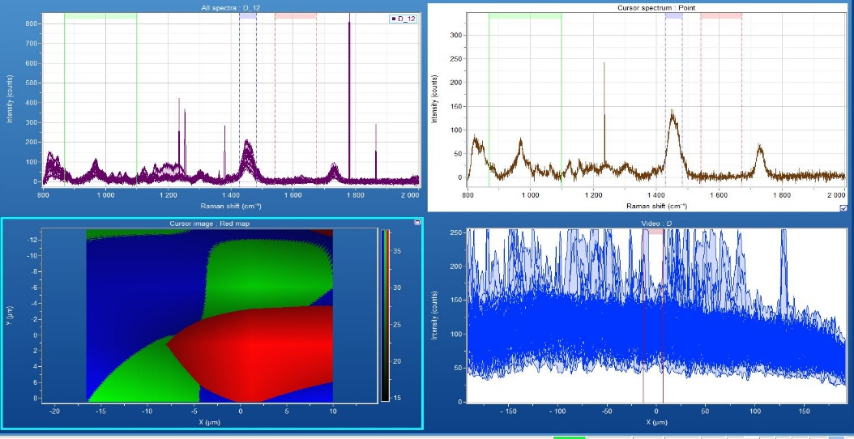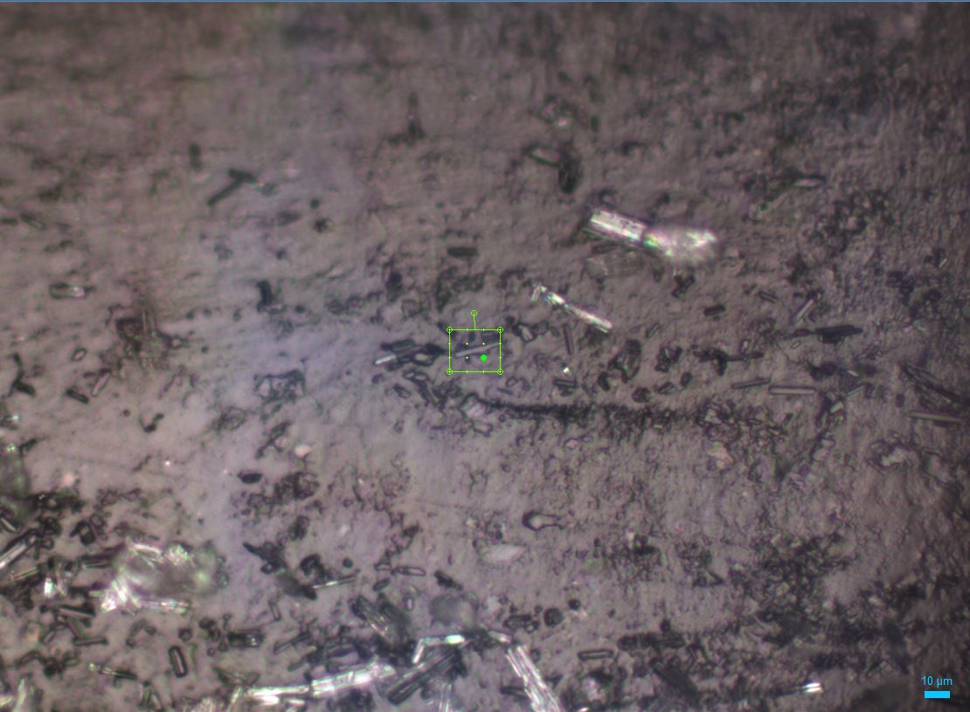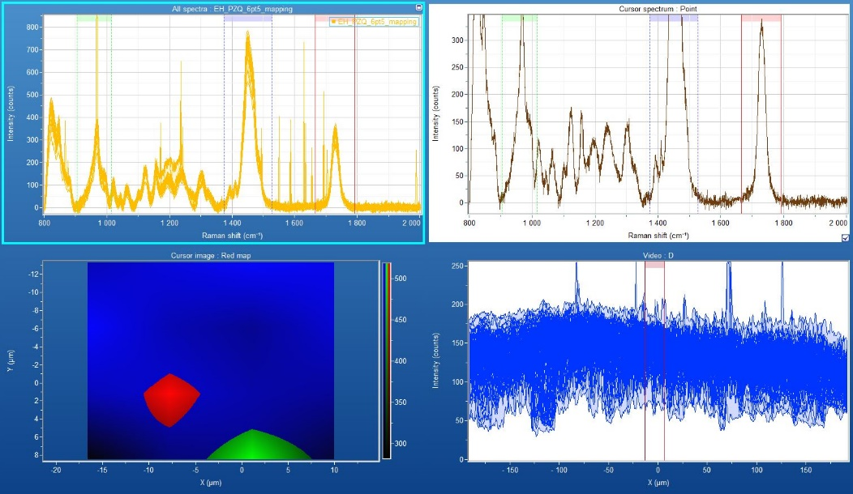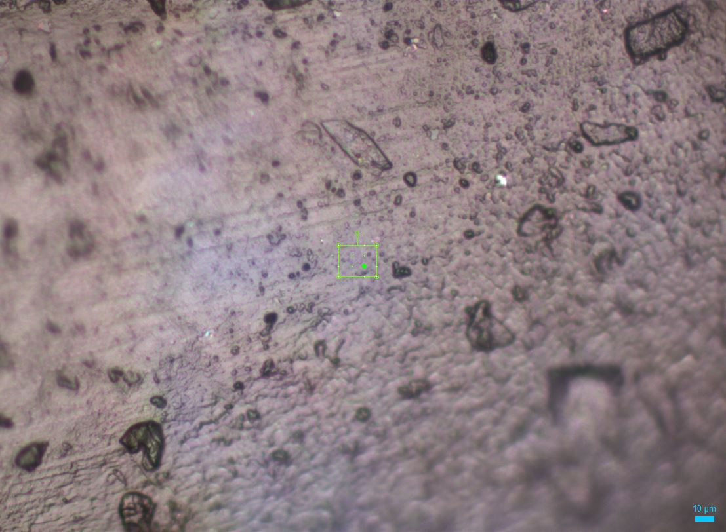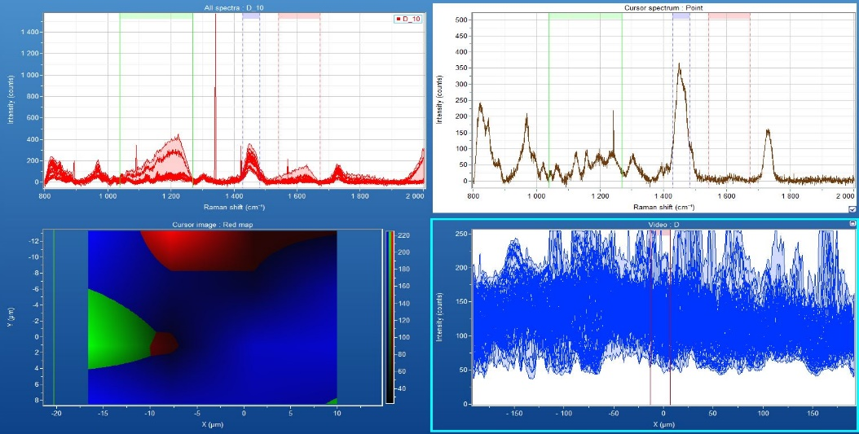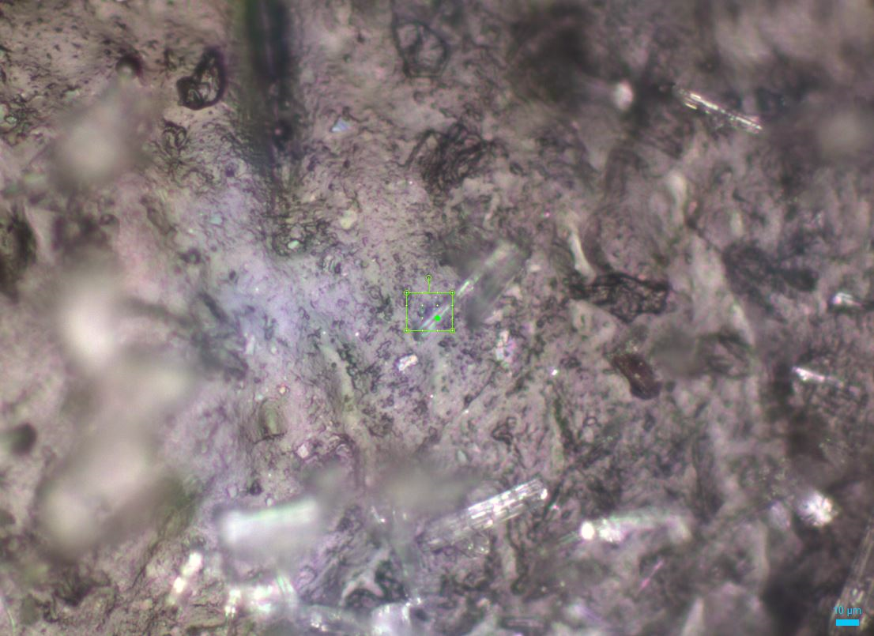

**EH-PZQ: 0.0%w/w**

**EH-PZQ: 3.5%w/w**

**EH-PZQ: 6.5%w/w**

**Figure S4:** Raman maps of non-plasticized (EH-PZQ: 0.0% w/w) and plasticized (EH-PZQ: 3.5% w/w & EH-PZQ 6.5%w/w) melt-extruded filament.