Fabrication of pH/H₂O₂-responsive POSS self-assembled fluorescent vesicles for enhanced in vivo anti-tumor efficacy

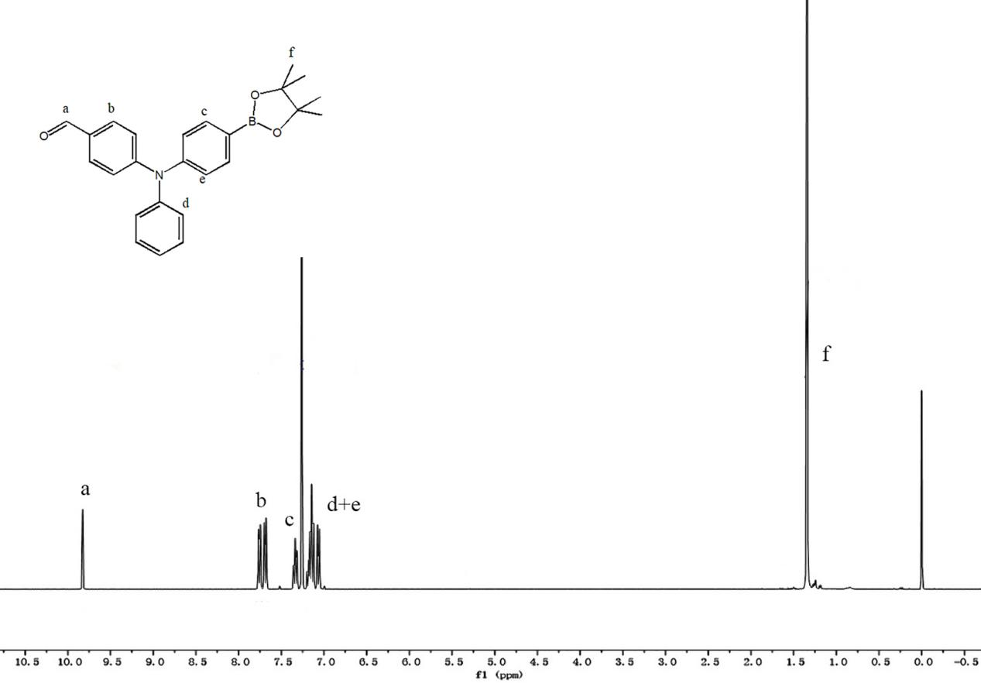
Fig.S1 ¹H NMR spectrum of OTB in CDCl₃

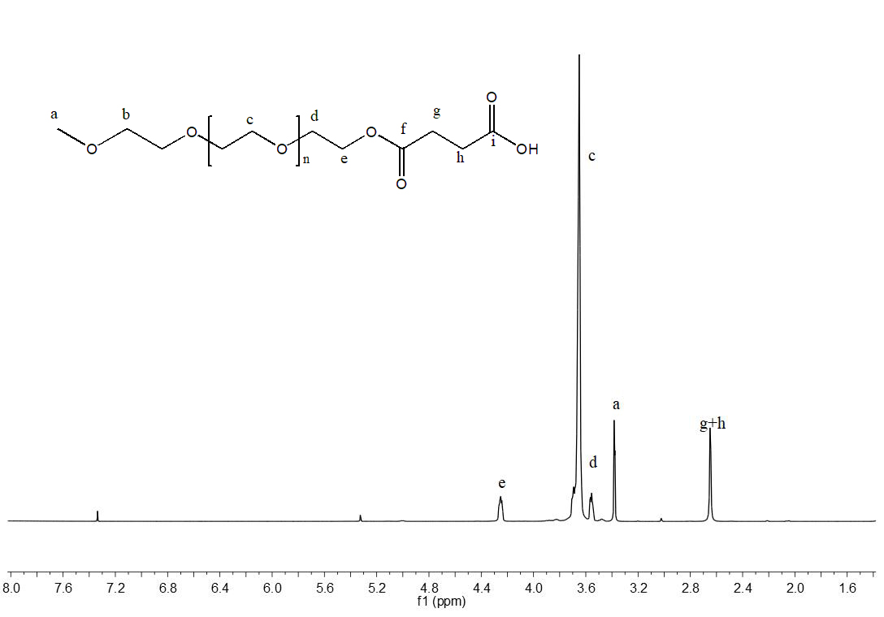
Fig. S2 ¹H NMR spectrum of PEG-COOH in CDCl₃

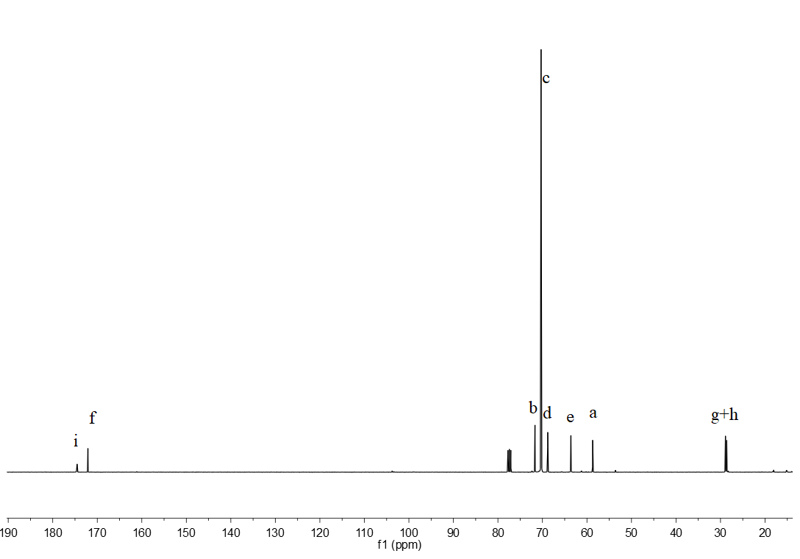
Fig. S3 ¹³C NMR spectrum of PEG-COOH in CDCl₃

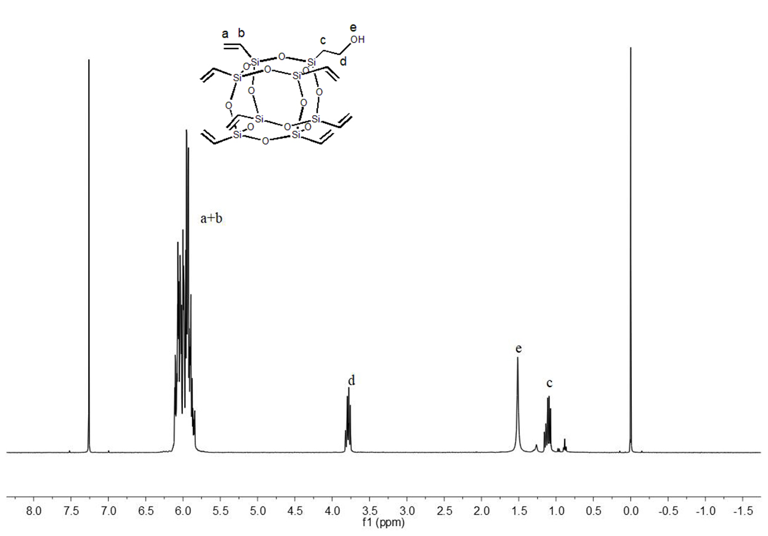
Fig. S4 ¹H NMR spectrum of POSS-OH in CDCl₃

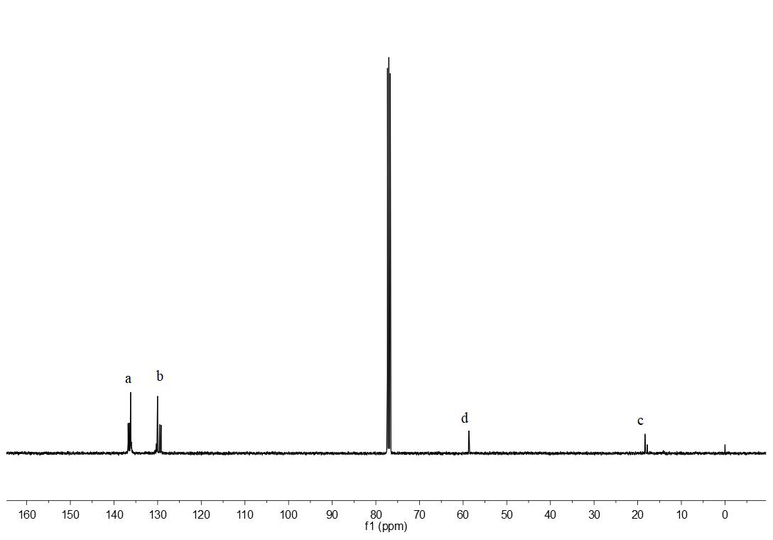
Fig. S5 ¹³C NMR spectrum of POSS-OH in CDCl₃

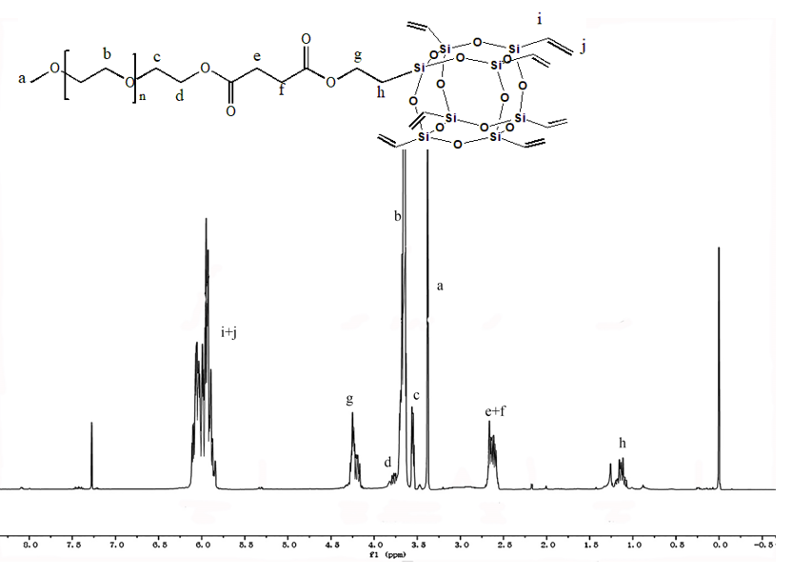

Fig. S6 ¹H NMR spectrum of PEG-POSS in CDCl₃
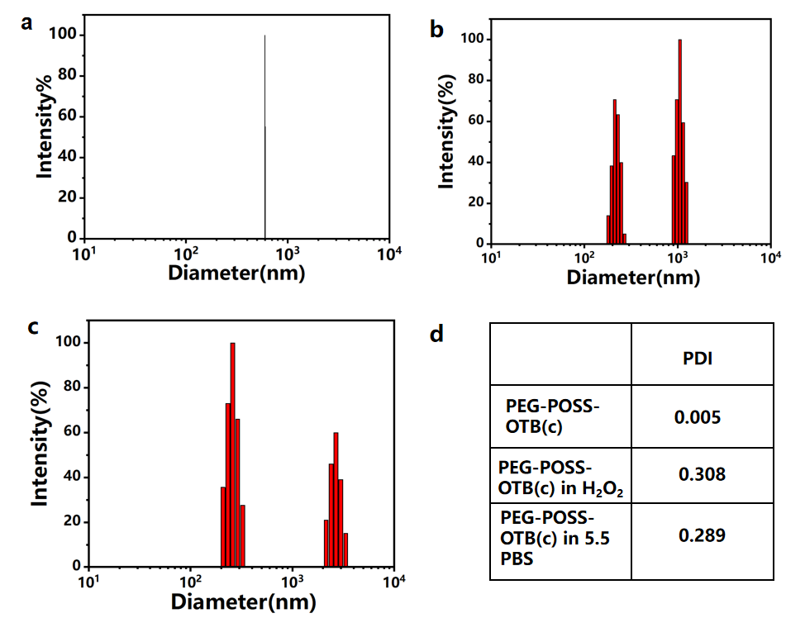
Fig. S7 The size of PEG-POSS-OTB(c) vesicles in different solvents. H₂O(a), 10⁻⁴mol/L H₂O₂ solution(b), PBS solution(c). The PDI of PEG-POSS-OTB(c) in different solvents.
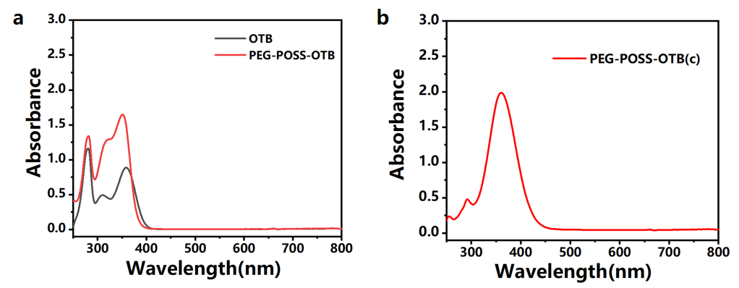
Fig. S8 The Ultraviolet spectra of OTB and PEG-POSS-OTB in THF(a). The Ultraviolet spectrum of PEG-POSS-OTB(c) in water(b).

