Supplemental Information
Vaping additives negatively impact the stability and lateral film organization of lung surfactant model systems
Nicolas van Bavel, Patrick Lai, Raimar Loebenberg, Elmar J Prenner

Vaping additives like vitamin E and cannabinoids negatively impact the stability and lateral film organization of lung surfactant model systems, a biophysical investigation

Langmuir Surface Pressure-Area per Molecule Isotherm
Langmuir isotherms start at large areas and are compressed using movable Teflon barriers to reduce the available surface area. During the compression isotherm lipid monolayers transition through several phases [1]. At large surface areas the individual lipid molecules are not interacting with neighbouring molecules. Lipid tails have a high degree of freedom and are very mobile in this so-called gas phase. As the area is further restricted, lipids start interacting resulting in the first increase in surface pressure after transition into the liquid expanded phase (LE). From this phase the. Further compression of monolayer results in the formation of the LC phase usually indicated by a change to a steeper slope. Individually lipids more pack into condensed lipid clusters called lipid domains which can be visualized. Lipid molecules are now interacting with their neighbours and the acyl chains are becoming ordered. This denoted by a rapid increase in surface pressure as the area is further reduced until the monolayer collapses. At the so-called collapse pressure, lipid molecules are forced above into the air or below into the subphase. This pressure is an indicator for film stability or change in the presence of additives. The area and surface pressures changes reflect the packing of the lipids and any changes in the presence of additives.

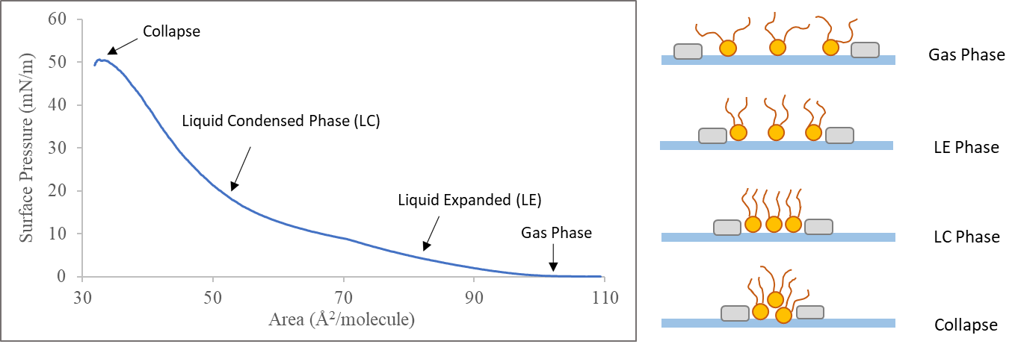

Figure S1: Lipid monolayer phases demonstrated by a surface pressure-area isotherm of DPPC:POPG (4:1 mol ratio).
Brewster Angle Microscopy (BAM)
In principle, imaging with BAM is achieved by directing p-polarized light at the air-water interface. The refractive index between air and water result in a Brewster angle of ~53.1º. At this angle, there is a minimum intensity of light reflected [4,5]. Addition of a lipid film at the air-water interface changes the refractive index. This causes light to be reflected off the surface and into a camera for visualization of the film. The intensity of the reflected light is also captured providing information in the z-axis that is used to generate 3D images.
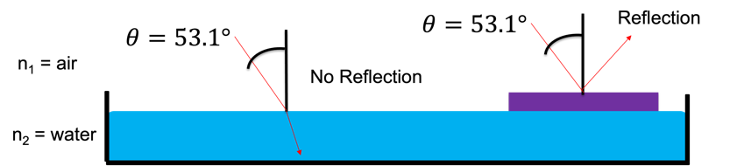
Figure S2: Principle of Brewster angle microscopy, comparing refractive index between two phases

Brewster Angle Microscopy Images
BAM images of the subphase are dark and do not show any visible features as no light is reflected into the camera (left image). Lipid domains in BAM images as lighter grey or bright spots (yellow arrow) if they signficantly protrude from the monofilm with a darker background for the more fluid LE phase (red arrow, right image).
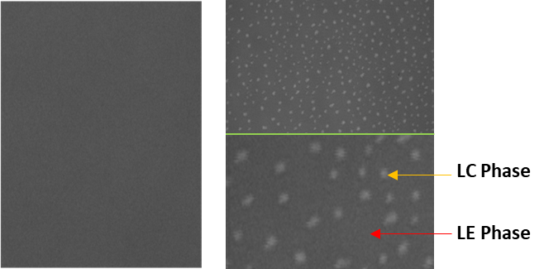
Figure S3: Brewster Angle microscopy images of subphase (left) and lipid film (right) showing the LC phase domains (yellow arrow) and LE phase (red arrow). A 4x magnification of the lipid film is shown below the green line.
Hydrogen Bonding of Vitamin E acetate with Cannabinoids
Tetrahydrocannabinol was shown to hydrogen bond with vitamin e acetate by using infrared spectroscopy to measure bond stretching [6]. The structure of cannabidiol does not have a closed ring which allows for the rotation of the molecule across the bond highlighted by the doubled ended green arrow. This allows for hydrogen bonding between either of the two hydroxyl groups (red arrow).
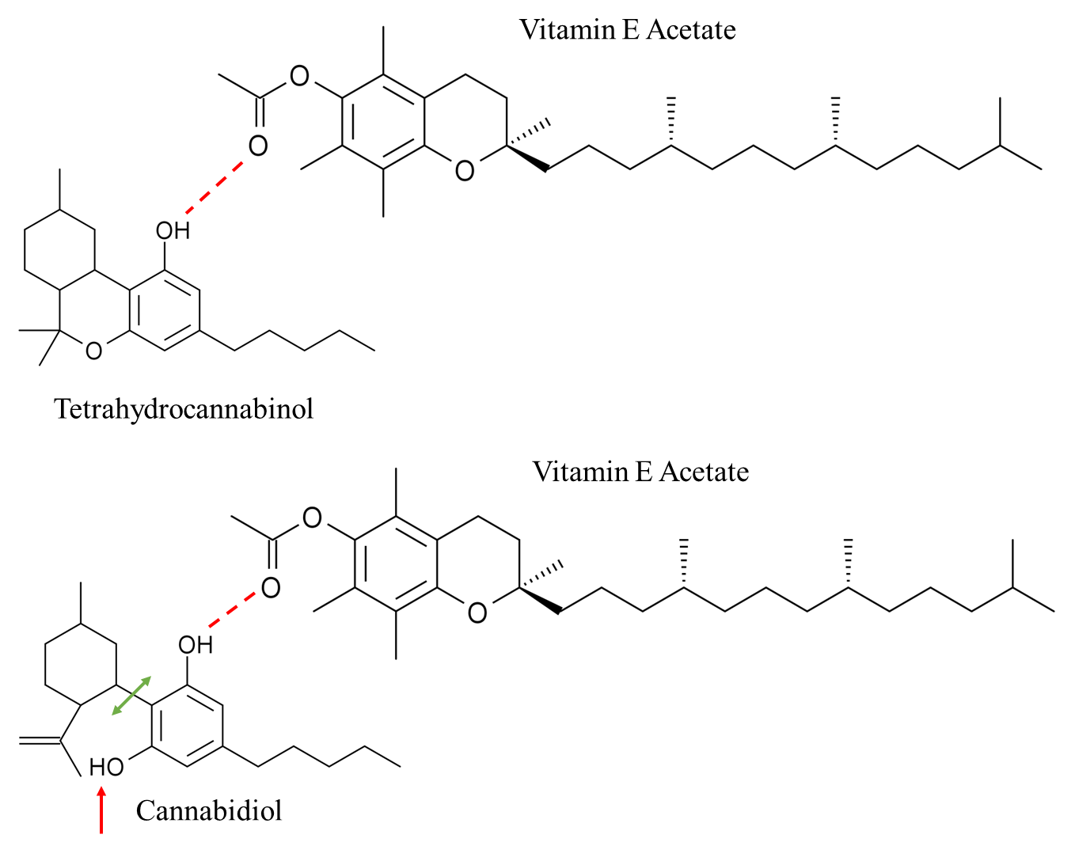
Figure S4: Hydrogen bonding between vitamin e acetate and tetrahydrocannabinol or cannabidiol.

References
[1] Kaganer V.M., Möhwald H., and Dutta P. (2021) Structure and phase transitions in Langmuir monolayers. Rev. Mod. Phys. 71, 779. https://doi.org/10.1007/978-1-4613-8389-5_12
[2] Brown R.E. and Brockman H.L. (2007) Using Monomolecular Films to Characterize Lipid Lateral Interactions. In: McIntosh T.J. (eds) Lipid Rafts. Methods in Molecular Biology, vol 398. Humana Press. https://doi.org/10.1007/978-1-59745-513-8_5
[3] Davis J.T. and Rideal E.K. Properties of Monolayers, Interfacial Phenomena, 2nd Edition, New York, Academic Press Inc. 1961 p. 217-265. https://doi.org/10.1016/B978-0-12-206056-4.X5001-2
[4] Kaercher, T., Hönig D., Möbius D. Brewster Angle Microscopy - A New Method of Visualizing the Spreading of Meibomian Lipids. Int. Ophthalmol. 1993, 17 (6), 341–348. https://doi.org/10.1007/BF00915741
[5] Henon S. and Meunier J. (1991) Microscope at the Brewster angle: Direct observations of first-order phase transitions in monolayers. Rev. Sci. Instrum. 62, 936. https://doi.org/10.1063/1.1142032
[6] Pusterla J.M., Malfatti-Gasperini A.A., Puentes-Martinez X.E., Cavalcanti L.P. and Oliveira R.G. (2017) Refractive index and thickness determination in Langmuir monolayers of myelin lipids. Biochim. Biophys. Acta 1859. 924-930. https://doi.org/10.1016/j.bbamem.2017.02.005

