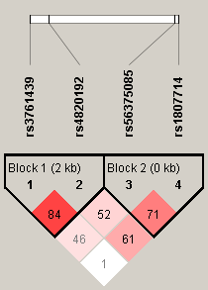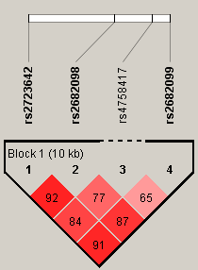
HMOX1 HPX
Figure S1. Linkage disequilibrium block constructed from tagSNPs in HMOX1 and HPX gene. This LD plot was generated with Haploview 4.2 software. Markers with LD (D’<1 and LOD >2) are shown in red through pink (color intensity decreases with decreasing D’ value).
HMOX1, heme oxygenase 1; HPX, haemopexin; LD, linkage equilibrium; LOD, logarithm of odds score; D', coefficient of linkage disequilibrium.

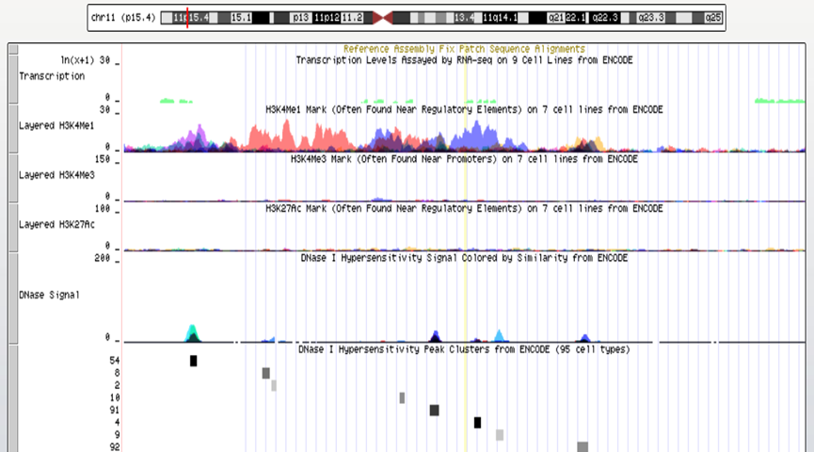
Figure S2. Functional annotation for rs2682099 using Encyclopedia of DNA Elements (ENCODE) data from University of California, Santa Cru (UCSC) genome browser.

Figure S3. Expression Quantitative Trait Loci (eQTL) violin plot of HMOX1 and HPX gene expression in liver tissue

