Figure S2
(A) Neutrophil-lymphocyte ratio (PFS)
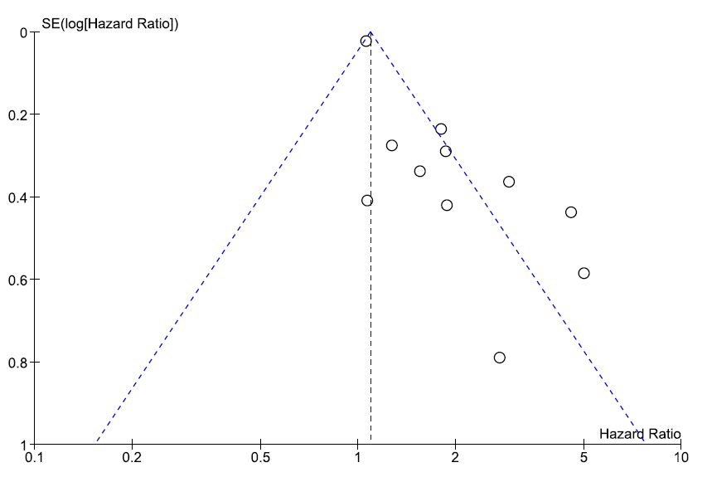
(B) Neutrophil-lymphocyte ratio (OS)
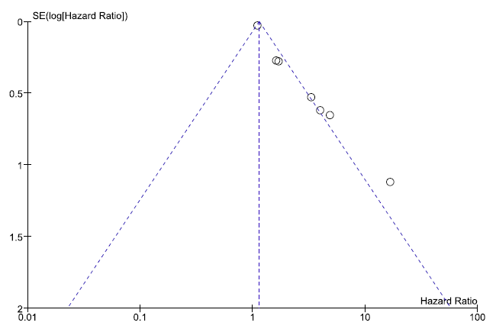
(C) Platelet-lymphocyte ratio (PFS)
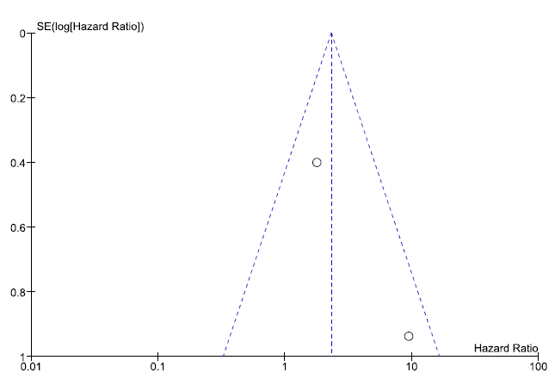
(D) Platelet-lymphocyte ratio (OS)
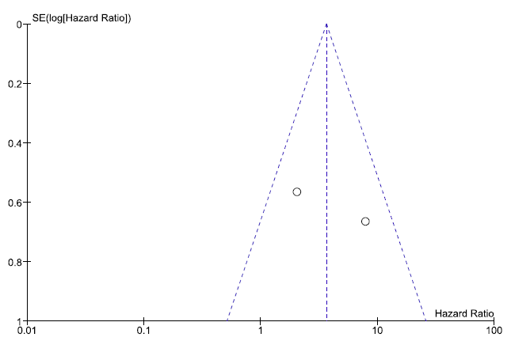
(E) C-reactive protein (PFS)
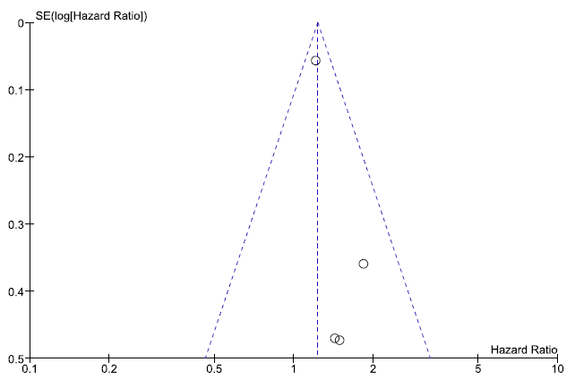
(F) C-reactive protein (OS)
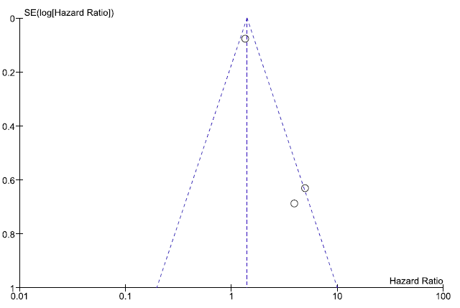

(G) Lactate dehydrogenase (PFS)
