SUPPLEMENTARY MATERIALS

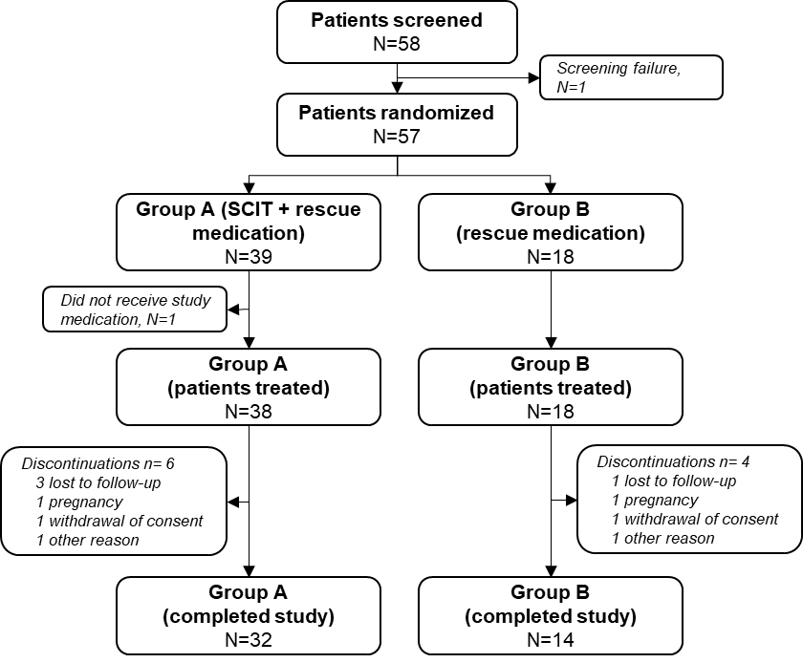

Supplementary Figure 1. CONSORT diagram.

