Supplementary File
Drug Delivery through Nanoparticles in Solid Tumors: A Mechanistic Understanding
Farshad Moradi Kashkooli, Mohsen Rezaeian, M. Soltani
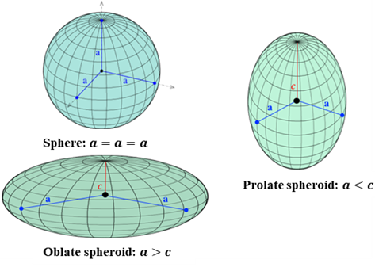 | 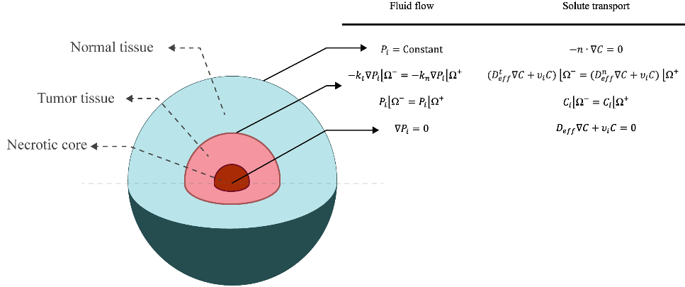
(a) Tumor shapes | (b) BCs
Fig. S1. Different shapes of tumor considered in the present study along with BCs

(a) IFV and IFP distribution
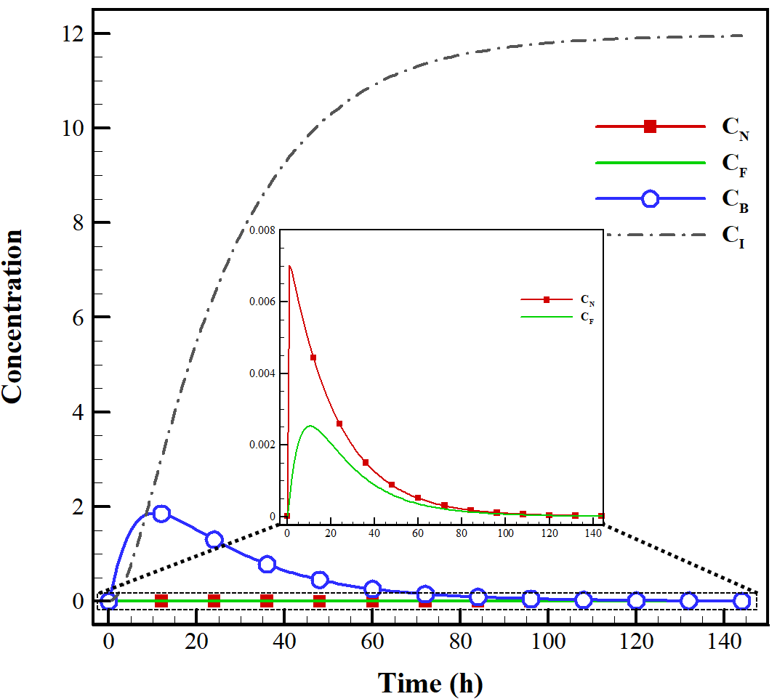
(b) Concentration-time distribution
Fig. S2. Distribution of (a) IFV and IFP (b) Concentration-time

Fig. S3. FKCs over time for different sizes of tumor for NSDDS

Fig. S4. FKCs over time for different shapes of tumor for NSDDS

Fig. S5. Effect of NP size on FKCs

Fig. S6. Effect of binding affinity on FKCs

Fig. S7. Effect of release rate of drug on FKCs

(a) ψ = 0.1 | (b) ψ = 0.2 | (c) ψ =0.5 | (d) ψ =1
(e) ψ = 2 | (f) ψ = 5 | (g) ψ = 10
Fig. S8. 2D maps of IFP for the different tumor shapes

(a) ψ = 0.1 | (b) ψ = 0.2 | (c) ψ =0.5 | (d) ψ =1
(e) ψ = 2 | (f) ψ = 5 | (g) ψ = 10
Fig. S9. 2D maps of IFV for the different tumor shapes

(a) ψ = 0.1 | (b) ψ = 0.2 | (c) ψ =0.5 | (d) ψ =1
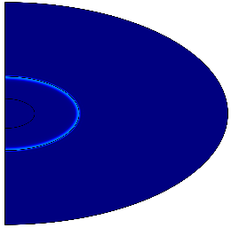
(e) ψ = 2 | (f) ψ = 5 | (g) ψ = 10
Fig. S10. 2D maps of drug concentration for the different tumor shapes

References
[1] El-Kareh AW, Secomb TW. A Mathematical Model for comparison of bolus injection, continuous infusion, and liposomal delivery of doxorubicin to tumor cells. Neoplasia 2, 325 (2000).
[2] Zhang A, Mi X, Yang G, Xu LX. Numerical study of thermally targeted liposomal drug delivery in tumor. J. heat transfer 131(4), 043209 (2009).
[3] Hendriks BS, Reynolds JG, Klinz SG, Geretti E, Lee H, Leonard SC, et al. Multiscale kinetic modeling of liposomal doxorubicin delivery quantifies the role of tumor and drug-specific parameters in local delivery to tumors. CPT Pharmacometrics Syst. Pharmacol. 1(11), e15 (2012).
[4] Chauhan VP, Stylianopoulos T, Martin JD, Popović Z, Chen O, Kamoun WS, et al. Normalization of tumour blood vessels improves the delivery of nanomedicines in a size-dependent manner. Nat. Nanotechnol. 7, 383–388 (2012).
[5] Gasselhuber A, Dreher MR, Rattay F, Wood BJ, Haemmerich D. Comparison of conventional chemotherapy, stealth liposomes and temperature-sensitive liposomes in a mathematical model. PlOS One 7(10), e47453 (2012).
[6] Zhan W, Xu XY. A Mathematical model for thermosensitive liposomal delivery of doxorubicin to solid tumour. J. Drug Deliv. 172529 (2013).
[7] Stylianopoulos T, Soteriou K, Fukumura D, Jain RK. Cationic nanoparticles have superior transvascular flux into solid tumors: Insights from a mathematical model. Ann. Biomed. Eng. 41, 68–77 (2013).
[8] Stylianopoulos T, Economides E-A, Baish JW, Fukumura D, Jain RK. Towards optimal design of cancer nanomedicines: Multi-stage nanoparticles for the treatment of solid tumors. Ann. Biomed. Eng. 43, 2291–300 (2015).
[9] Chou C-Y, Chang W-I, Horng T-L, Lin W-L. Numerical modeling of nanodrug distribution in tumors with heterogeneous vasculature. PlOS One 12, e0189802 (2017).
[10] Zhan W, Wang C-H. Convection enhanced delivery of liposome encapsulated doxorubicin for brain tumour therapy. J. Controlled Release (2018) 285:212–29.
[11] Huang Y, Gu B, Liu C, Stebbing J, Gedroyc W, Thanou M, et al. Thermosensitive liposome-mediated drug delivery in chemotherapy: Mathematical modelling for spatio-temporal drug distribution and model-based optimisation. Pharmaceutics 11(12), 637 (2019).
[12] Rezaeian M, Sedaghatkish A, Soltani M. Numerical modeling of high-intensity focused ultrasound-mediated intraperitoneal delivery of thermosensitive liposomal doxorubicin for cancer chemotherapy. Drug Delivery 26, 898–917 (2019).
[13] Wirthl B, Kremheller J, Schrefler BA, Wall WA. Extension of a multiphase tumour growth model to Study Nanoparticle Delivery to Solid Tumours. PlOS One 15(2), e0228443 (2020).
[14] Dogra P, Butner JD, Ramírez JR, Chuang Y-L, Noureddine A, Brinker CJ, et al. A mathematical model for nanomedicine pharmacokinetics and tumor delivery. Comput. Struct. Biotechnol. J. 18, 518–531 (2020).
[15] Moradi Kashkooli F, Soltani M., Momeni M.M., Rahmim A. Enhanced drug delivery to solid tumors via drug-loaded nanocarriers: An image-based computational framework. Front. Oncol. 11, 655781 (2021).
[16] Soltani M, Souri M, Moradi Kashkooli F. Effects of hypoxia and nanocarrier size on pH-responsive nano-delivery system to solid tumors. Sci. Rep. 11, 19350 (2021).
[17] Soltani M, Chen P. Numerical modeling of fluid flow in solid tumors. PLoS ONE 6, 1-15 (2011).
[18] Mpekris F, Baish JW, Stylianopoulos T et al. Role of vascular normalization in benefit from metronomic chemotherapy. PNAS 114, 1994–1999 (2017).
[19] Chou CY, Chang WI, Horng TL et al. Numerical modeling of nanodrug distribution in tumors with heterogeneous vasculature. PLoS ONE 12, e0189802 (2017).
[20] Eikenberry S. A tumor cord model for Doxorubicin delivery and dose optimization in solid tumors. Theor. Biol. Med. Model. 6, 16 (2009).
[21] Moradi Kashkooli F, Soltani M, Hamedi MH. Drug delivery to solid tumors with heterogeneous microvascular networks: Novel insights from image-based numerical modeling. Eur. J. Pharm. Sci. 151, 105399 (2020).
[22] Mpekris F, Angeli S, Pirentis AP et al. Stress-mediated progression of solid tumors: effect of mechanical stress on tissue oxygenation, cancer cell proliferation, and drug delivery. Biomech Model Mechanobiol. 14, 1391–1402 (2015).
[23] Chauhan VP, Stylianopoulos T, Martin JD et al. Normalization of tumour blood vessels improves the delivery of nanomedicines in a size-dependent manner. Nat. Nanotechnol. 7, 383–388 (2012).
[24] Stylianopoulos T, Economides EA, Baish JW et al. Towards optimal design of cancer nanomedicines: multi-stage nanoparticles for the treatment of solid tumors. Ann. Biomed. Eng. 43, 2291–2300 (2015).
[25] Stylianopoulos T, Jain RK. Combining two strategies to improve perfusion and drug delivery in solid tumors. PNAS 110, 18632–18637 (2013).
[26] Stylianopoulos T, Soteriou K, Fukumura D et al. Cationic nanoparticles have superior transvascular flux into solid tumors: insights from a mathematical model. Ann. Biomed. Eng. 41, 68–77 (2013).
[27] Deen WM. Hindered transport of large molecules in liquid-filled pores. AIChE J. 33, 1409–1425 (1987).

