Supplemental Figures

Supplemental Figure 1. Kaplan-Meier Estimates of Overall Survival (OS) in Patients With Advanced BRAF-Mt Melanoma Receiving 1L Treatment With CPI (ipilimumab/nivolumab) or TT.

Kaplan-Meier estimates of OS in patients who received CPI (ipilimumab/nivolumab) and TT as 1L treatments. HR (95% CI) corresponds to unweighted Cox proportional hazards with only a term for treatment.
Abbreviations: 1L, first-line; CI, confidence interval; CPI, checkpoint inhibitors; HR, hazard ratio; OS, overall survival; TT, targeted therapies.

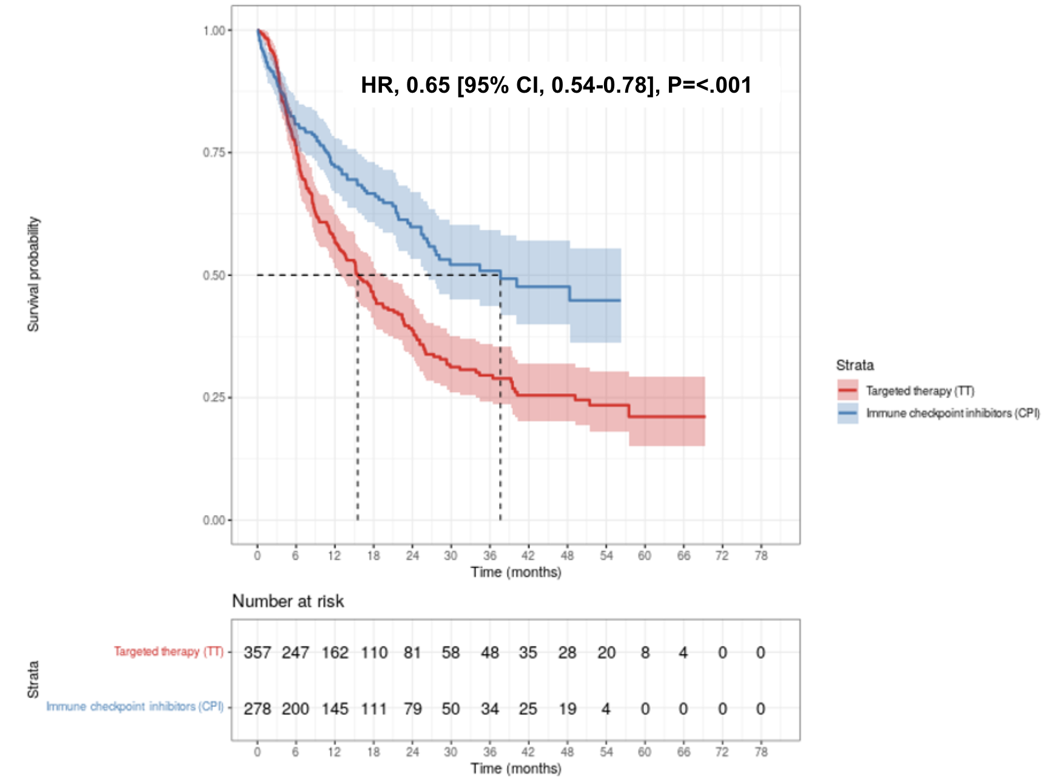

Supplemental Figure 2. Kaplan-Meier estimates of Overall Survival (OS) in Patients With Advanced BRAF-Mt Melanoma Receiving 1L Treatment With CPI (ipilimumab/nivolumab) or TT weighted by IPTW.
Kaplan-Meier estimates of OS in patients who received CPI (ipilimumab/nivolumab) and TT as 1L treatments. Curves shown for 1 imputation of 20. HR (95% CI) corresponds to adjusted and IPTW model; the referent for each is the TT group.
Abbreviations: 1L, first-line; CI, confidence interval; CPI, checkpoint inhibitors; HR, hazard ratio; IPTW, inverse probability of treatment weighting; OS, overall survival; TT, targeted therapies.
Note: patient counts are IPTW weighted, so do not match the unweighted counts in our sensitivity analysis.

