Title: Real-world evidence of mesenchymal stem cell therapy in knee osteoarthritis: a large prospective 2-year case series.

Supplementary Material

Contents Page

Table | Description | Page
Table 1.  Table 2.  Table 3. | Adverse Events associated with abdominal lipoharvest procedure  Adverse Events associated with ADMSC therapy  Non injection related Adverse Events documented during the 24month period of follow-up | 2  3  3

Figure | Description | Page
Figure 1.  Figure 2.  Figure 3.  Figure 4.  Figure 5.  Figure 6.  Figure 7. | Whole cohort vs. non total joint replacement cohort outcome analysis – NPRS  Whole cohort vs. non total joint replacement cohort outcome analysis – WOMAC  OA compartment outcome analysis - WOMAC  Carrier media outcome analysis - NPRS  Carrier media outcome analysis - WOMAC  Linear regression analysis of BMI vs change in baseline WOMAC  Linear regression analysis of age vs change in baseline WOMAC | 4  5  6  7  8  9  10

Table 1. Adverse Events associated with abdominal lipoharvest procedure (n=329)

Adverse Event (AE) | Incidence | Expected/Unexpected
Discomfort  - Mild  - Moderate  - Severe  Swelling  - Mild  - Moderate  - Severe | 152  1  0  18  0  0 | Expected  Expected  Expected
Bruising  - Mild  - Moderate  - Severe | 171  1  0 | Expected  Expected
Wound discharge  - Mild  - Moderate  - Severe  Other* | 151  0  0  4 | Expected  Expected
Serious AE | 0 | NA

*4 participants noted a local skin reaction associated with the wound dressings

Table 2. Adverse Events associated with ADMSC therapy (n=329)

 | Initial ADMSC Injection (n=329) |  | 6 month ADMSC Injection (n=329)
Adverse Event (AE) | Incidence | Expected / Unexpected | Incidence | Expected / Unexpected
Pain  - Mild  - Moderate  - Severe  Stiffness  - Mild  - Moderate  - Severe | 145  56  2  143  28  0 | Expected  Expected  Expected  Expected  Expected | 141  91  4  169  55  0 | Expected  Expected  Expected  Expected  Expected
Swelling  - Mild  - Moderate  - Severe | 163  50  5 | Expected  Expected  Expected | 155  84  8 | Expected  Expected  Expected
Other | Nil | NA | 1* | Expected
Serious AE | Nil | NA | Nil | NA
*A single participant experienced a self-limiting vasovagal episode in the immediate period post IA ADMSC therapy.

Table 3. Non injection related Adverse Events documented during the 24month period of follow-up

Adverse Event (AE) | Incidence
Neoplasm  - Prostate Ca  Musculoskeletal  - Polymyalgia Rheumatica  Hospital Admission  - Knee arthroscopy (acute meniscus tear)  - Gastric Sleeve Surgery | 1  4  1  1
Figure 1. Numeric Pain Rating Scale (NPRS) scores at baseline, 6, 12 and 24 months for all patients (n=329 at baseline) compared to those patients who did not undergo total knee replacement after 12 months (n=297). Group mean data and 95% confidence intervals are depicted. An * equals significant differences (p<0.05) when compared to baseline for that compartment. No significant differences were apparent between groups for any time point. Power of performed tests with alpha 0.05 = 1.
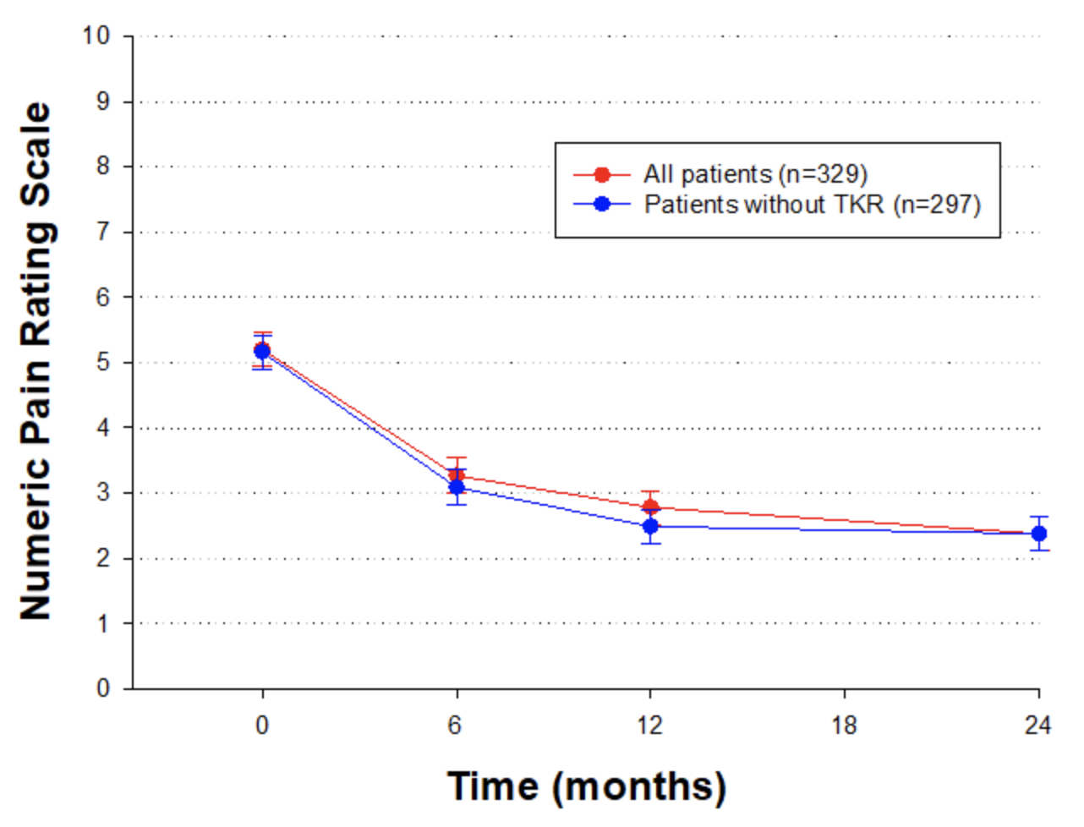
Figure 2. Western Ontario and McMaster Universities Osteoarthritis Index (WOMAC) at baseline, 6, 12 and 24 months for all patients (n=329 at baseline) compared to those patients who did not undergo total knee replacement after 12 months (n=297). Group mean data and 95% confidence intervals are depicted. No significant differences were apparent between groups for any time point. Power of performed tests with alpha 0.05 = 1.
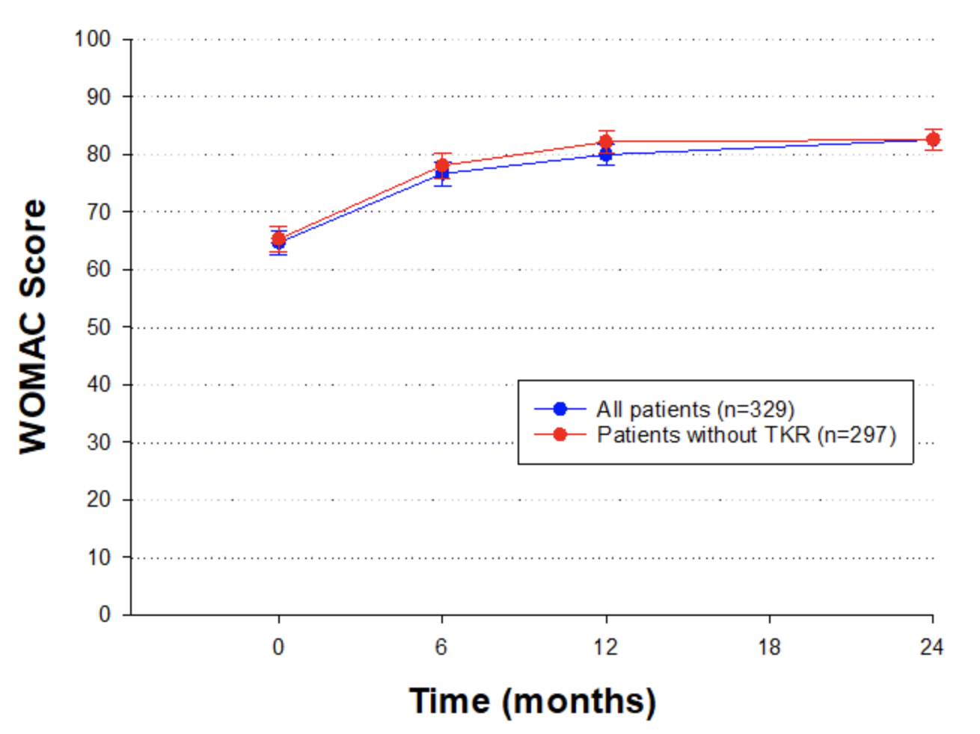

Figure 3. Western Ontario and McMaster Universities Osteoarthritis Index (WOMAC) for each osteoarthritis (OA) compartment at baseline, 6, 12 and 24 months after ADMSC therapy. Group mean data and 95% confidence intervals are depicted. Significant differences (p<0.05*) were found within the Multiple Compartment OA group at 12 and 24 months compared to baseline. No significant differences were apparent between compartments for any time point. Power of performed tests with alpha 0.05 = 1.
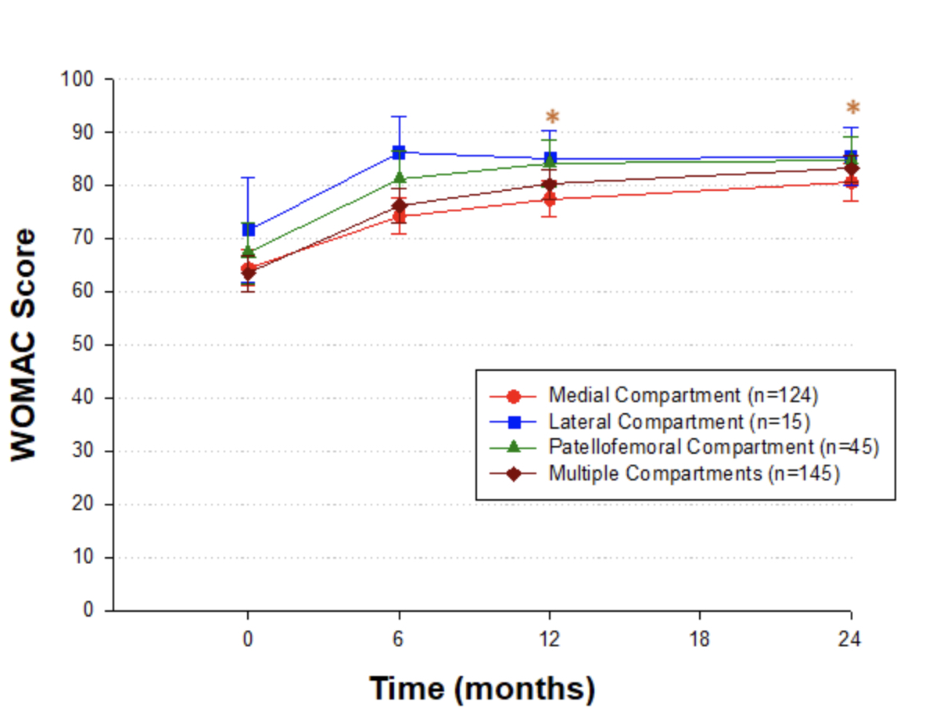
Figure 4. Numeric Pain Rating Scale (NPRS) scores for each carrier media used with ADMSC injections at baseline, 6, 12 and 24 months. An * equals significant differences (p<0.05) when compared to baseline for that carrier media. No significant differences were apparent between carrier medias at any time point. Power or performed tests with alpha 0.05 = 1.
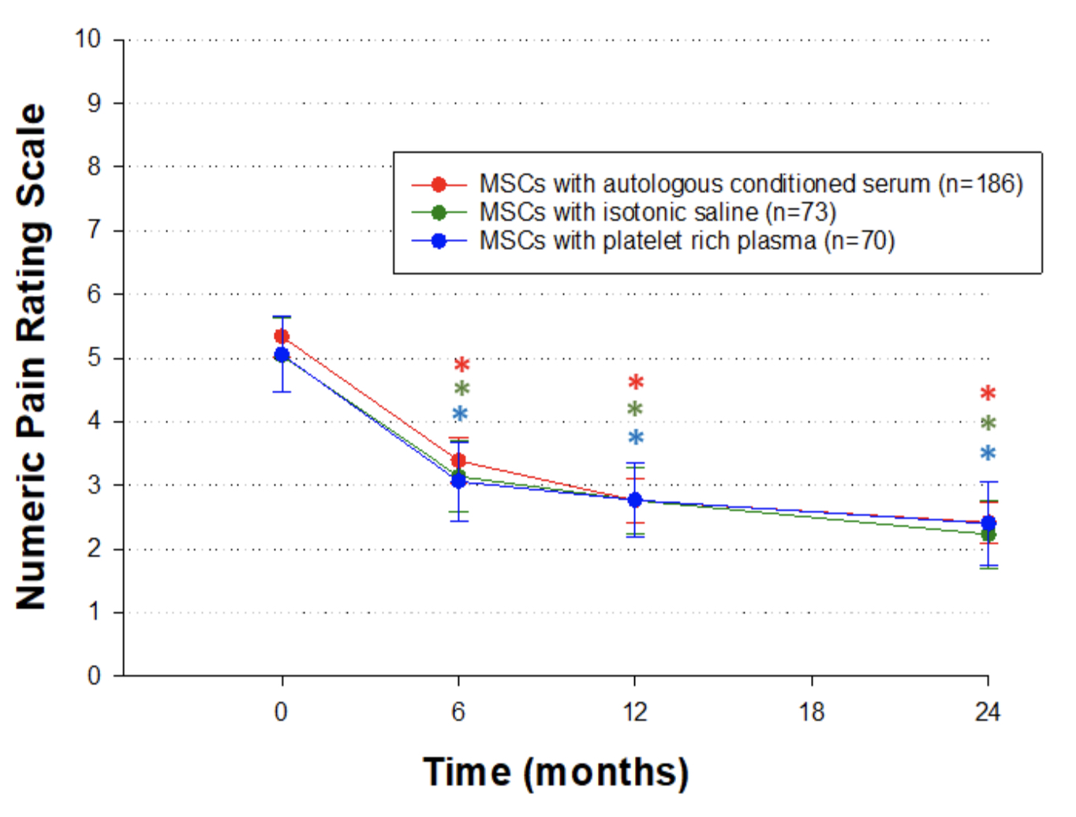
Figure 5. Western Ontario and McMaster Universities Osteoarthritis Index (WOMAC) for each carrier media used with ADMSC injections at baseline, 6, 12 and 24 months. An * equals significant differences (p<0.05) when compared to baseline for that carrier media. No significant differences were apparent between carrier medias at any time point. Power or performed tests with alpha 0.05 = 1.
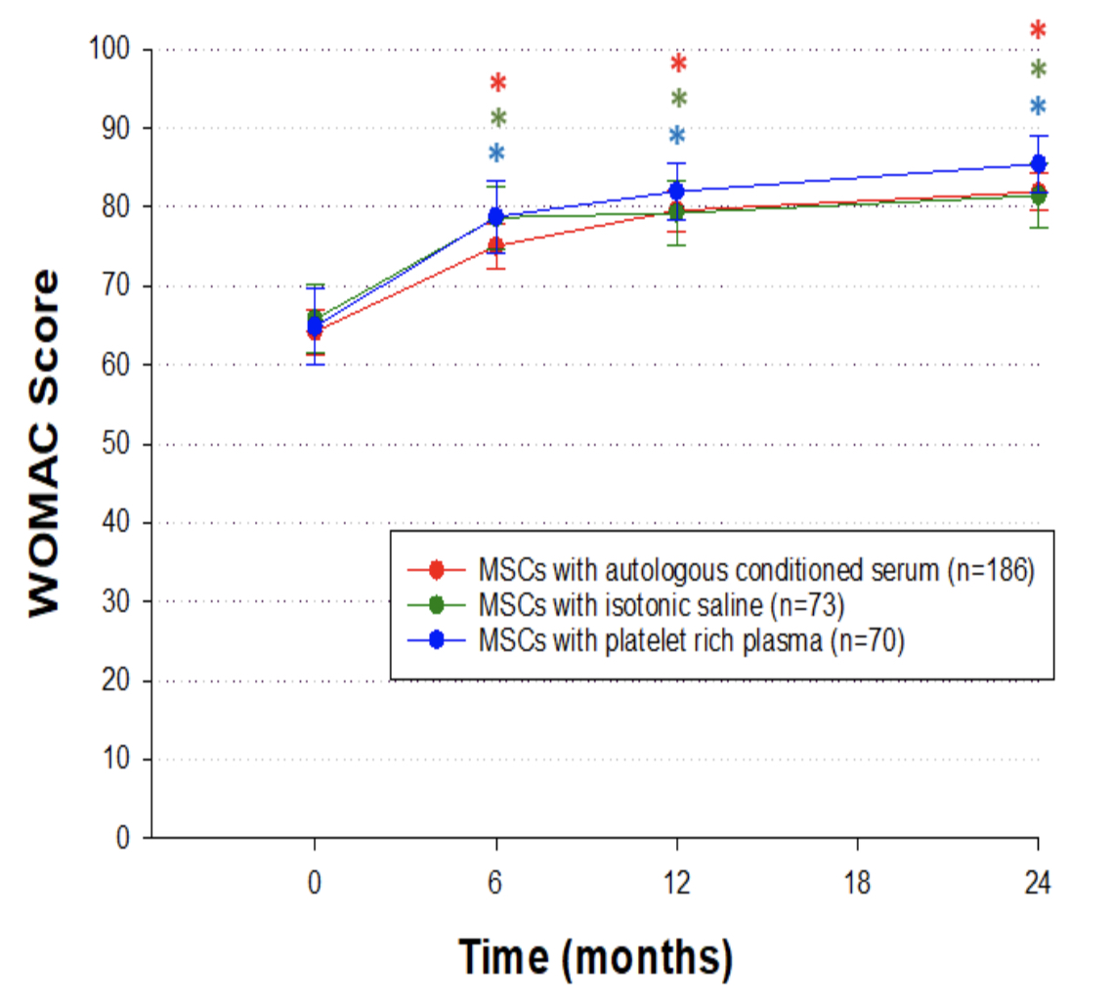

Figure 6. Linear regression analysis of Body Mass Index (BMI) vs. change in Western Ontario and McMaster Universities Osteoarthritis Index (WOMAC) score at 24 months from baseline following ADMSC therapy. The regression line shows that BMI is able to only predict 1% of the variability in change in WOMAC score. Group mean data from 297 knees. Significance of the associated variables in p=0.87 and the power of the performed test with alpha 0.05 = 0.402.

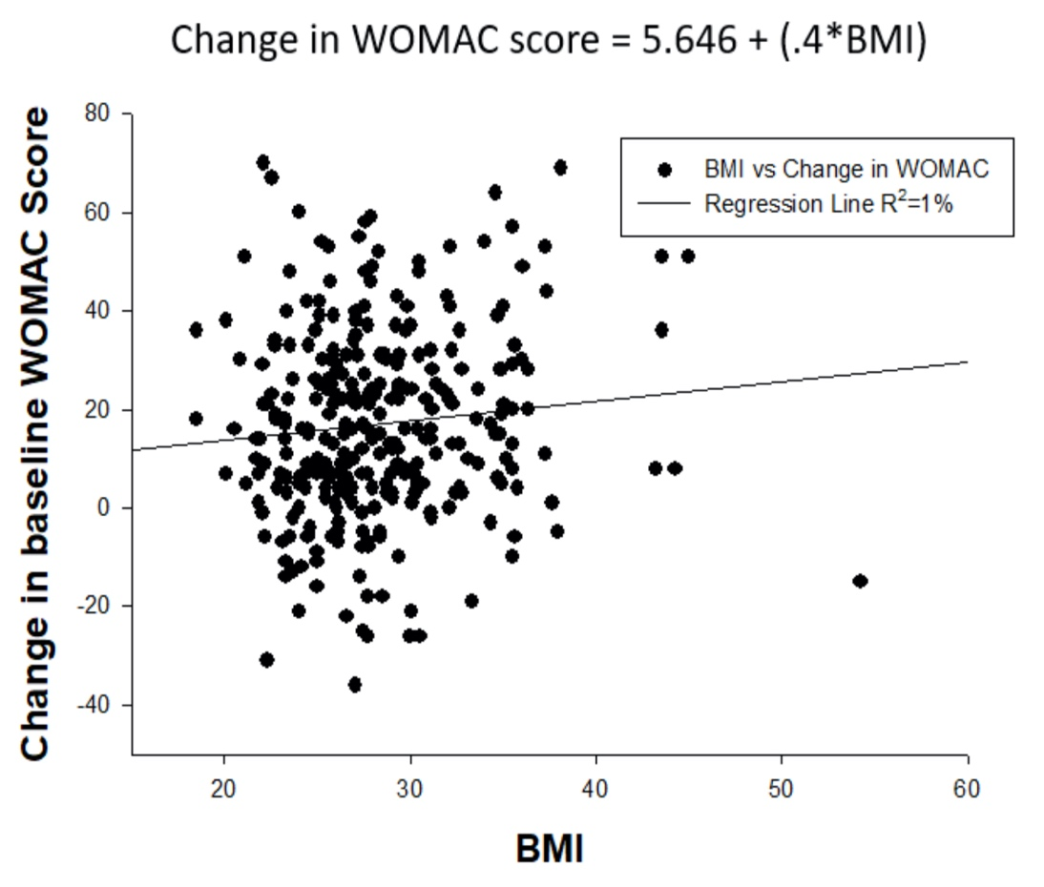
Figure 7. Linear regression analysis of age (years) vs. change in Western Ontario and McMaster Universities Osteoarthritis Index (WOMAC) score at 24 months from baseline following ADMSC therapy. The regression line shows that BMI is able to only predict 1% of the variability in change in WOMAC score. Group mean data from 297 knees. Significance of the associated variables in p=0.339 and the power of the performed test with alpha 0.05 = 0.158.

