Supplementary Table 1: The lead molecules of anti-MARV from ChemDiv antiviral library
S. No. | ChemDiv ID and IUPAC Name | Chemical Structures
1 | 8019-0673  2‐(1,3‐dimethyl‐1H‐pyrazol‐4‐yl)‐2‐(3‐phenyl‐4,5‐dihydro‐1H‐pyrazol‐1‐yl)acetonitrile | 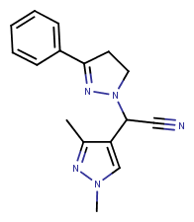
2 | 8019-6148  5‐bromo‐2‐(piperidin‐1‐yl)pyrimidine‐4‐carboxylic acid | 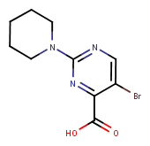
3 | 8019-7190  3‐amino‐N‐(2,3‐dimethylphenyl)benzamide | 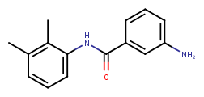
4 | E155-0978  N'‐[(2R)‐2‐(2,3‐dihydro‐1H‐indol‐1‐yl)‐2‐(pyridin‐3‐yl)ethyl]‐N‐(2,5‐dimethylphenyl)ethanediamide | 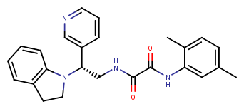
5 | e155-0983  N‐(2H‐1,3‐benzodioxol‐5‐yl)‐N'‐[(2R)‐2‐(2,3‐dihydro‐1H‐indol‐1‐yl)‐2‐(pyridin‐3‐yl)ethyl]ethanediamide | 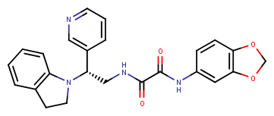
6 | e155-0988  N'‐[(2R)‐2‐(2,3‐dihydro‐1H‐indol‐1‐yl)‐2‐(pyridin‐3‐yl)ethyl]‐N‐(3‐fluoro‐4‐methylphenyl)ethanediamide | 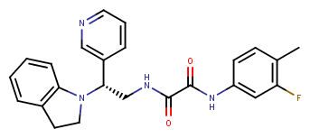
7 | e155-0994  N‐(3‐chloro‐2‐methylphenyl)‐N'‐[(2R)‐2‐(2,3‐dihydro‐1H‐indol‐1‐yl)‐2‐(pyridin‐3‐yl)ethyl]ethanediamide | 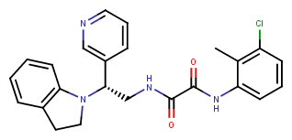
8 | e155-0995  N'‐[(2R)‐2‐(2,3‐dihydro‐1H‐indol‐1‐yl)‐2‐(pyridin‐3‐yl)ethyl]‐N‐(2,4,6‐trimethylphenyl)ethanediamide | 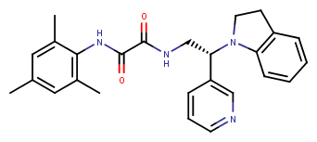
9 | f058-0162  1‐methyl‐N‐(5‐methyl‐1,2‐oxazol‐3‐yl)‐1H‐1,2,3‐benzotriazole‐5‐carboxamide | 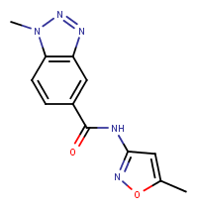
10 | g645-0041  N‐(2‐oxo‐2,3‐dihydro‐1,3‐benzothiazol‐6‐yl)thiophene‐2‐carboxamide | 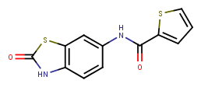
11 | p166-0326  3‐[(3R)‐1‐[6‐(cyclopropylamino)pyrimidin‐4‐  yl]piperidin‐3‐yl]‐N‐[2‐  (dimethylamino)ethyl]propanamide | 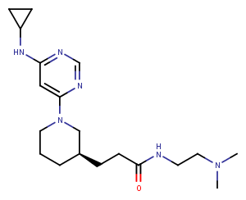
12 | p166-1267  N‐{2‐[3‐(3‐fluorophenyl)‐1,2,4‐oxadiazol‐5‐yl]thiophen‐3‐yl}‐1‐methyl‐1H‐indazole‐3‐  carboxamide | 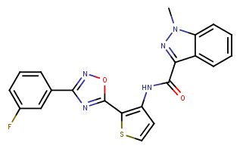
13 | p166-1799  N‐{2‐[3‐(3,4‐difluorophenyl)‐1,2,4‐oxadiazol‐5‐yl]thiophen‐3‐yl}‐1‐ethyl‐1H‐pyrazole‐3‐carboxamide | 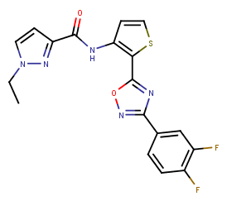
14 | p166-2041  N‐benzyl‐5‐(5‐{[cyclohexyl(methyl)amino]methyl}‐  1,2,4‐oxadiazol‐3‐yl)‐N‐methylpyridin‐2‐amine | 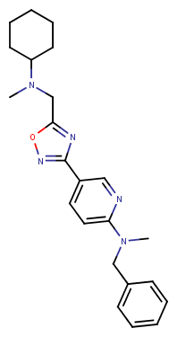
15 | p549-0042  5‐(5‐cyclobutyl‐1,2,4‐oxadiazol‐3‐yl)‐2‐(1H‐pyrazol‐1‐yl)pyridine | 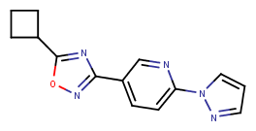
16 | p633-0038  N‐(2‐methylphenyl)‐1H‐pyrrolo[2,3‐b]pyridine‐3‐Sulfonamide | 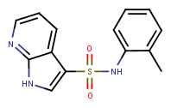
17 | p633-0061  N‐(2‐fluorophenyl)‐1H‐pyrrolo[2,3‐b]pyridine‐3‐Sulfonamide | 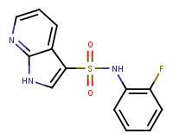
18 | s695-1987  4‐[3‐(2‐methyl‐1H‐imidazol‐1‐yl)azetidine‐1‐carbonyl]benzonitrile | 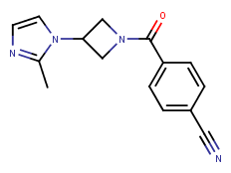
19 | s695-1995  3‐[3‐(2‐methyl‐1H‐imidazol‐1‐yl)azetidine‐1‐carbonyl]benzonitrile | 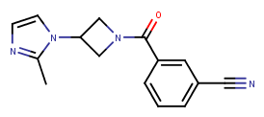
20 | t001-0365  N‐[2‐(pyridin‐3‐yl)‐1,3‐benzoxazol‐5‐yl]but‐2‐ynamide | 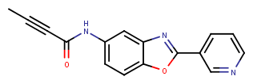
21 | y030-1629  4‐chloro‐N‐(3‐chlorophenyl)‐1‐methyl‐1H‐pyrazole‐5‐Carboxamide | 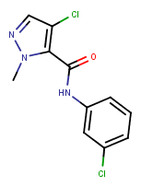
22 | y040-3666  N‐(4‐methyl‐1,3‐thiazol‐2‐yl)‐1,3‐benzothiazole‐6‐Carboxamide | 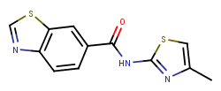
23 | y040-3667  N‐(5‐methyl‐1,3‐thiazol‐2‐yl)‐1,3‐benzothiazole‐6-carboxamide | 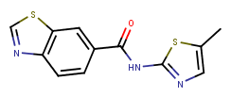
24 | y040-4650  N‐(4‐methyl‐1,3‐thiazol‐2‐yl)‐1H‐1,3‐benzodiazole‐6‐carboxamide | 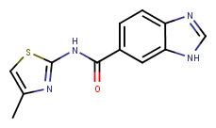
25 | y200-0316  methyl 2‐(pyridin‐4‐yl)quinoline‐4‐carboxylate | 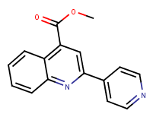

Supplementary Table 2: The lead molecules of anti-MARV from ChEMBL antiviral library.
S. No. | Chemical ID and Name | Chemical Structures
1 | CHEMBL2106705  Famotine Hydrochloride | 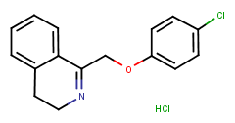
2 | CHEMBL2110933  Famotine | 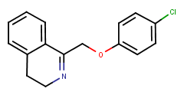
3 | CHEMBL535396  Rimantadine Hydrochloride | 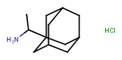
4 | CHEMBL959  Rimantadine | 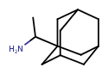

Supplementary Table 3: The lead molecules of anti-MARV from phytochemical database.
S. No. | Chemical ID and Name | Chemical Structure
1 | NPACT00508  (3S,3aS,11aR)‐3‐hydroxy‐6,10‐dimethyl‐  2H,3H,3aH,4H,5H,8H,9H,11aH‐cyclodeca[b]furan‐2‐one | 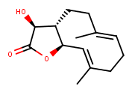
2 | NPACT00753  4‐methyl‐1H,2H,5H,10H‐benzo[g]quinoline‐2,5,10‐  Trione | 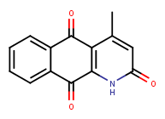
3 | NPACT00844  (1S,2S,4R,7E,11S)‐4,8‐dimethyl‐12‐methylidene‐3,14‐  dioxatricyclo[9.3.0.0^{2,4}]tetradec‐7‐en‐13‐on | 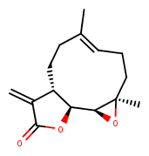

Supplementary Table 4: The lead molecules of anti-MARV from natural product NCI diversity setIV.
S. No. | Chemical ID and Name | Chemical Structure
1 | NSC: 21728  Sempervirine, Nitrate | 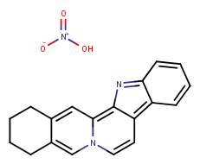
2 | NSC: 332294  (6Ar,9R,10aR)-7,9-dimethyl-4-propyl-6,6a,8,9,10,10a-hexahydroindolo[4,3-fg]quinoline;(2R,3R)-2,3-dihydroxybutanedioic acid | 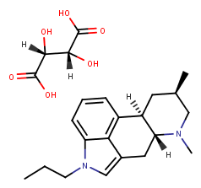
3 | NSC: 85235  Ambrosin | 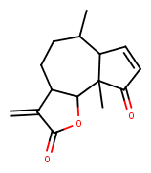
4 | NSC: 157035  Parthenolide | 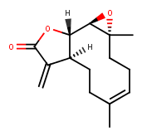
5 | NSC: 26326  Lapachone, Beta | 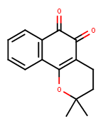
6 | NSC: 26327  Lapachone, Alpha | 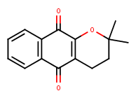
7 | NSC: 785152  Apocodeine hydrochloride | 