Supplementary Figure S5. ORR, Relative Effects, Observational Studies and Clinical Trials (Forest Plot) 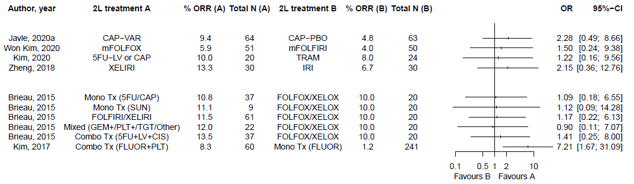
Observational | Clinical Trials
*Median rather than mean age reported; “-“ or “+” indicates that combination treatment was received (eg, CAP-PBO, capecitabine plus placebo, CAP+CIS, capecitabine plus cisplatin). “±” indicates that a treatment was received either in combination with the next listed treatment or as a monotherapy (eg, FLUOR±PLT, fluoropyrimidine with or without a platinum). “/” indicates that either treatment listed was received (eg, GEM+CIS/S1, gemcitabine plus cisplatin or S1).

