**Fig. S1**



**(1)**

**(2)**

**(3)**

**(4)**

**(5)**

**(6)**

**(7)**

**(8)**

**Fig. S1** Synthesis route for probe FHS-1. Fluorophore 4'-dimethylamino-3-hydroxyflavone (compound 4) (step 1-3) and recognition group 4-chloro-7-nitrobenzo-2-oxa-1, 3-diazole (NBD-Cl) (step 5-7) were synthesized. FHS-1 was obtained by connecting them via ether bond (step 8).

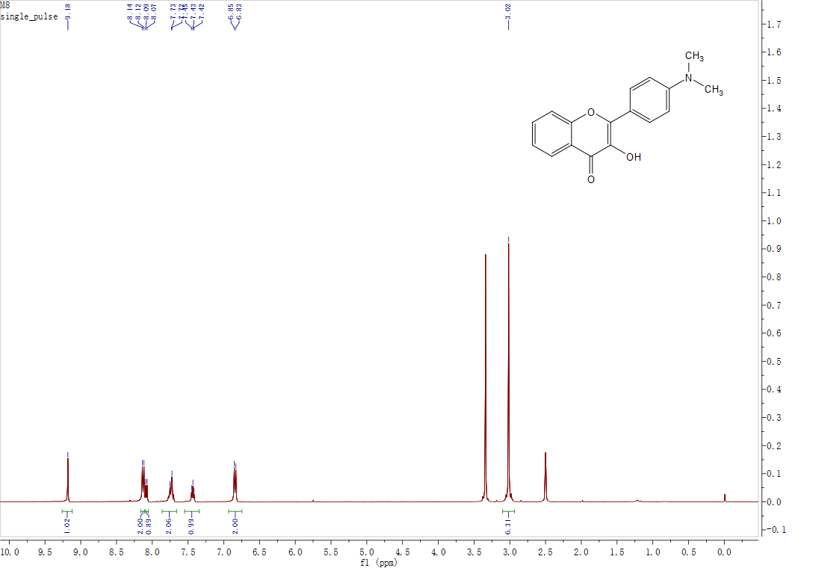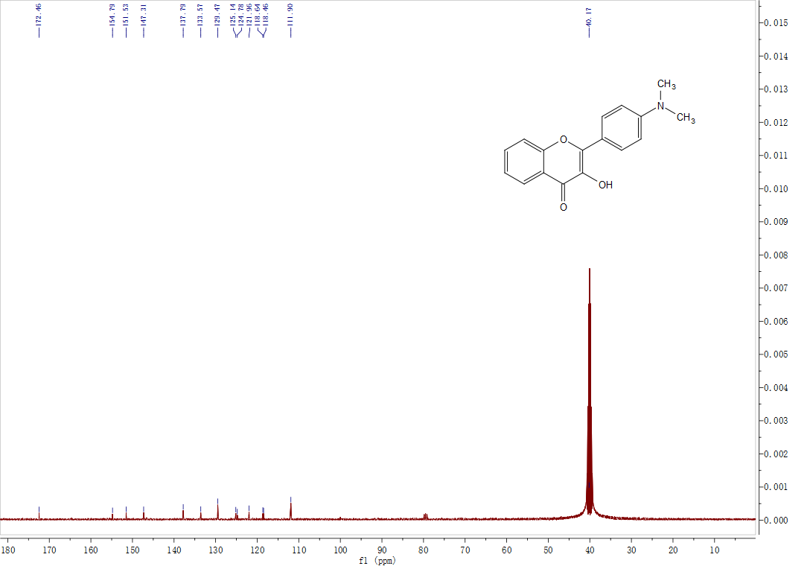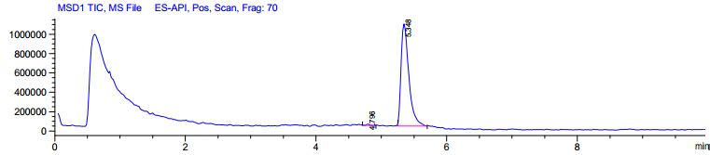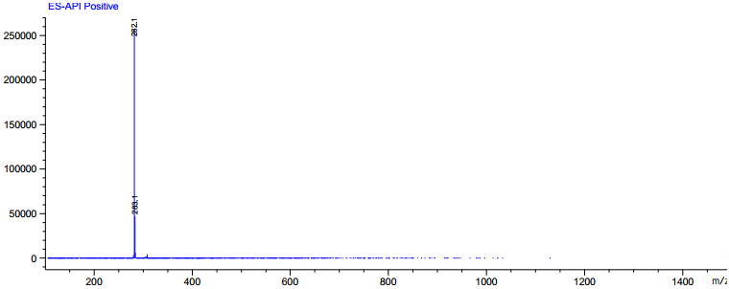

**a**

**b**

**c**

**Fig. S2**

**0.015**

**0.014**

**0.013**

**0.012**

**0.011**

**0.010**

**0.009**

**0.008**

**0.007**

**0.006**

**0.005**

**0.004**

**0.003**

**0.002**

**0.001**

**0.000**

**-0.1**

**0.0**

**1.7**

**0.2**

**1.6**

**1.5**

**1.4**

**1.3**

**1.2**

**1.1**

**1.0**

**0.9**

**0.8**

**0.7**

**0.6**

**0.5**

**0.4**

**0.3**

**0.1**

**0.0**

**1.0**

**10.0**

**9.0**

**8.0**

**7.0**

**6.0**

**5.0**

**4.0**

**3.0**

**2.0**

**fl （ppm）**

**30**

**40**

**50**

**170**

**150**

**160**

**130**

**110**

**90**

**70**

**140**

**120**

**100**

**80**

**60**

**180**

**20**

**10**

**fl （ppm）**

**Fig. S2** (a) 1H NMR spectrum of compound 4; (b) 13C NMR spectrum of compound 4;

(c) LC-MS spectrum of compound 4.

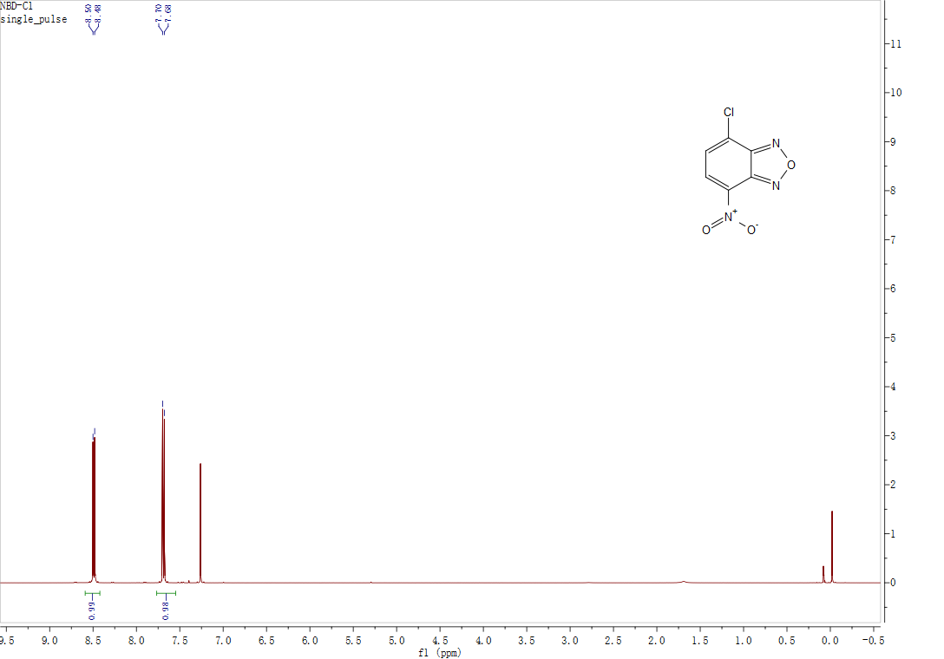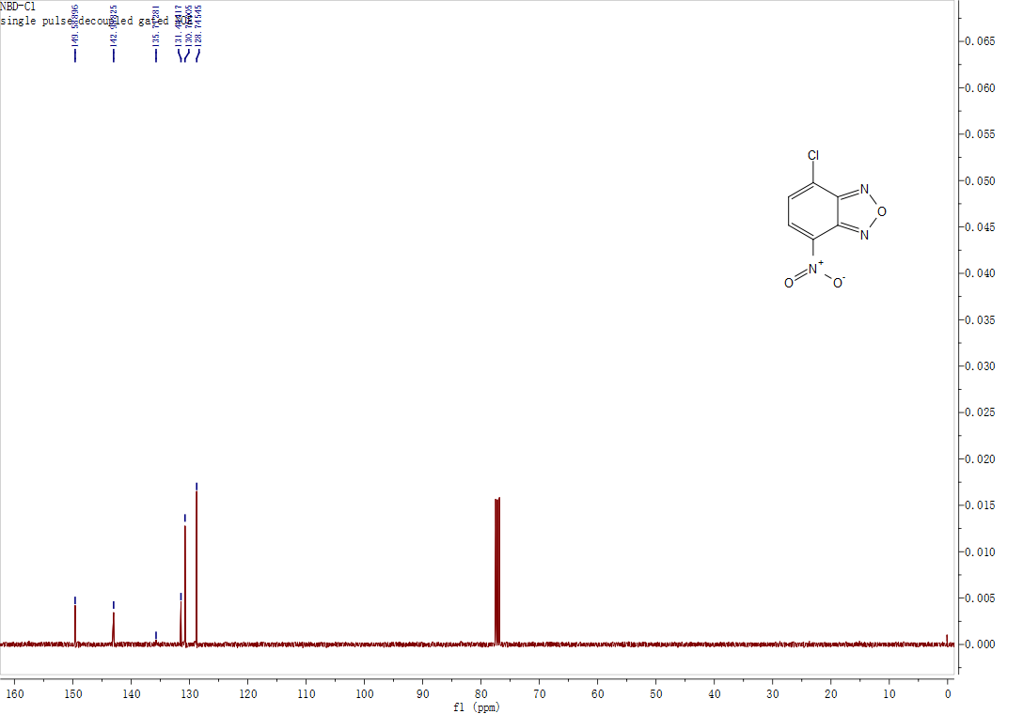

**a**

**b**

**Fig. S3**

**Fig. S3** (a) 1H NMR spectrum of NBD-Cl; (b) 13C NMR spectrum of NBD-Cl.

**0.065**

**0.060**

**0.055**

**0.050**

**0.045**

**0.040**

**0.035**

**0.030**

**0.025**

**0.020**

**0.015**

**0.010**

**0.005**

**0.000**

**11**

**10**

**9**

**8**

**7**

**6**

**5**

**4**

**3**

**2**

**1**

**0**

**0.0**

**0.5**

**1.0**

**9.0**

**9.5**

**8.0**

**8.5**

**7.0**

**7.5**

**6.0**

**6.5**

**5.0**

**4.0**

**3.0**

**2.0**

**5.5**

**4.5**

**3.5**

**2.5**

**1.5**

**-0.5**

**fl （ppm）**

**30**

**40**

**50**

**150**

**160**

**130**

**110**

**90**

**70**

**140**

**120**

**100**

**80**

**60**

**20**

**10**

**0**

**fl （ppm）**

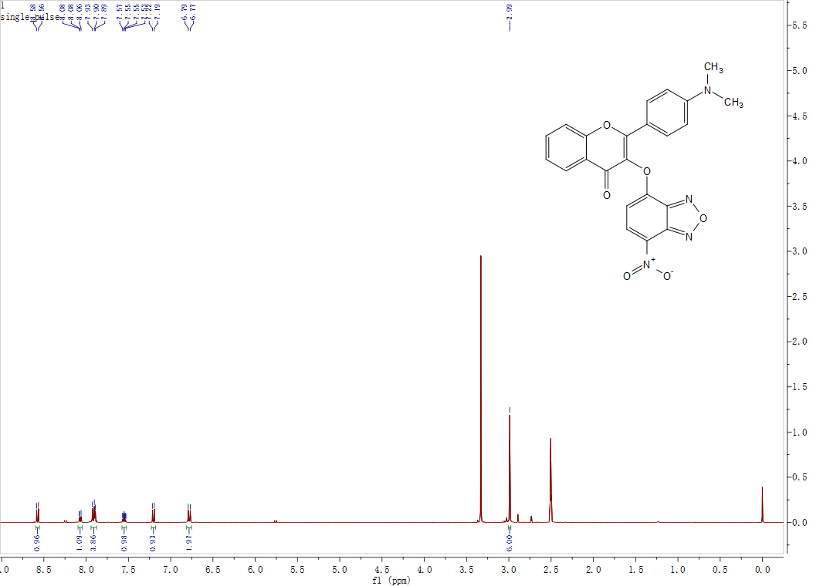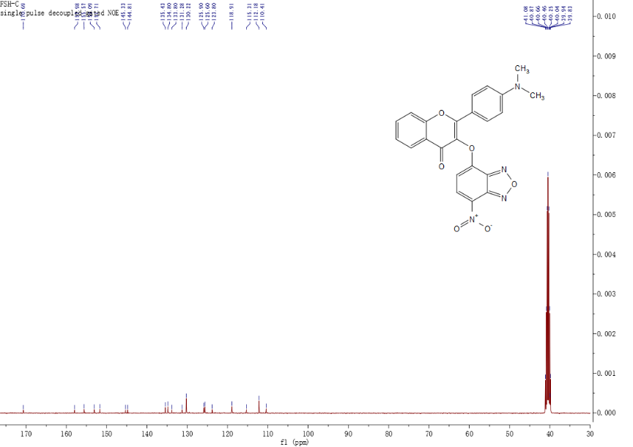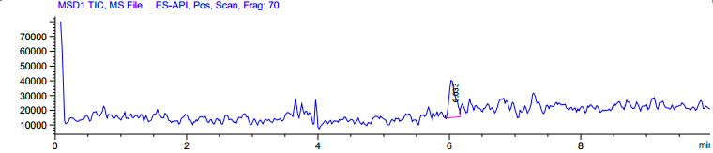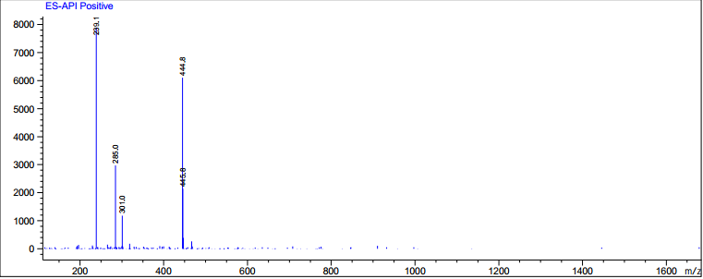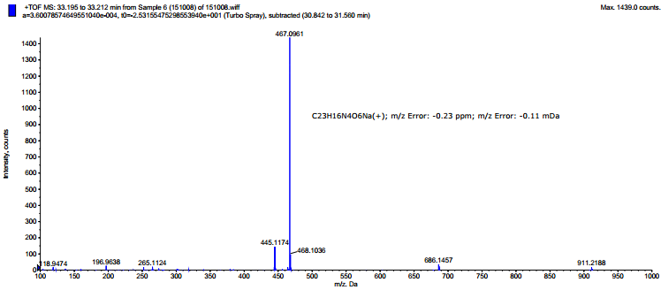

**a**

**b**

**c**

**d**

**Fig.S4 S4**

**Fig. S4** (a)1H NMR spectrum of FHS-1; (b)13C NMR spectrum of FHS-1; (c)LC-MS spectrum of FHS-1; (d)HR-MS spectrum of FHS-1.

**0.010**

**0.009**

**0.008**

**0.007**

**0.006**

**0.005**

**0.004**

**0.003**

**0.002**

**0.001**

**0.000**

**5.5**

**5.0**

**4.5**

**4.0**

**3.5**

**3.0**

**2.5**

**2.0**

**1.5**

**1.0**

**0.5**

**0.0**

**0.0**

**0.5**

**1.0**

**9.0**

**8.0**

**8.5**

**7.0**

**7.5**

**6.0**

**6.5**

**5.0**

**4.0**

**3.0**

**2.0**

**5.5**

**4.5**

**3.5**

**2.5**

**1.5**

**fl （ppm）**

**30**

**40**

**50**

**170**

**150**

**160**

**130**

**110**

**90**

**70**

**140**

**120**

**100**

**80**

**60**

**fl （ppm）**

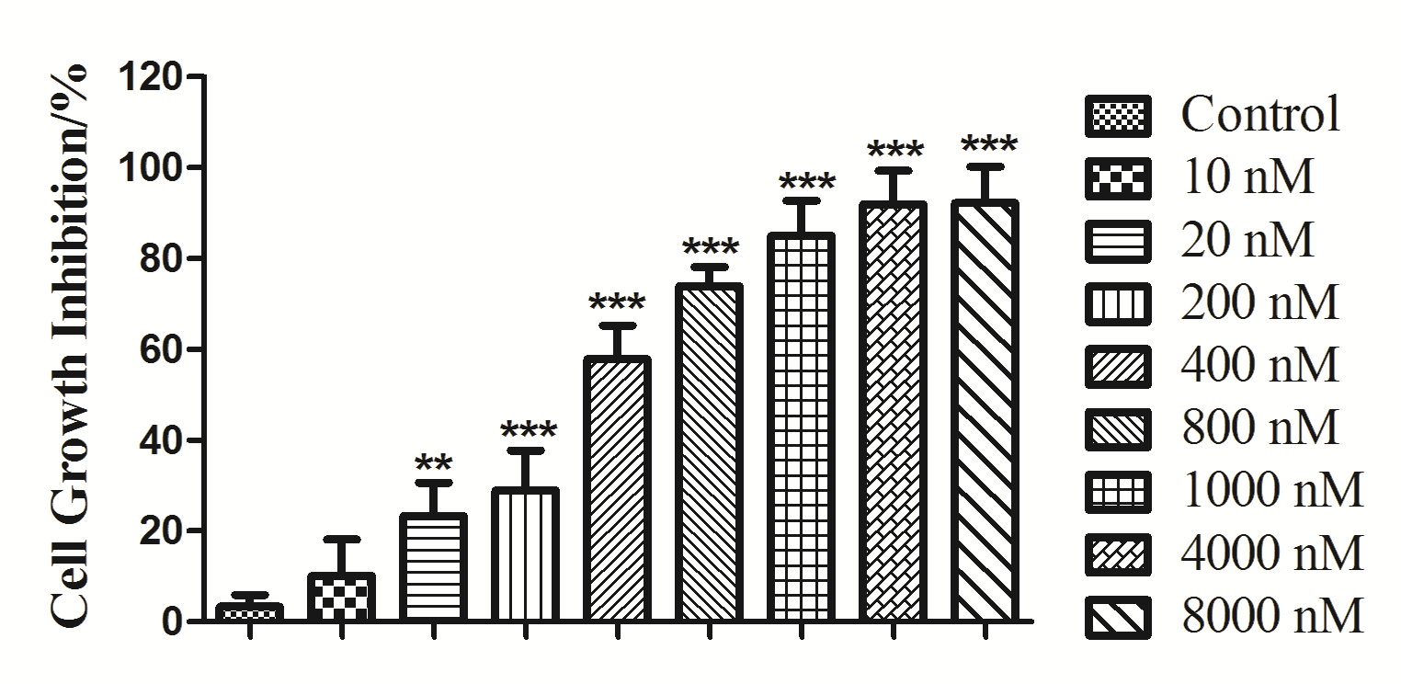

**a**

**b**

**Fig. S5**

**Fig. S5** (a) Effects of Rap treatment on the cell viability of MCF-7 cells. Cells were treated with indicated concentrations of them for 36 h. Cell viability was estimated by MTT method after treatment. (b) Effects of S3I-201 treatment on the cell viability of MCF-7 cells. Cells were treated with indicated concentrations of them for 36 h. Cell viability was estimated by MTT method after treatment. Data were expressed as mean ± SD (n = 3). \**P* < 0.05, \*\**P* < 0.01 and \*\*\**P* < 0.001 vs control group.