Supplementary materials
Precondition | Freq | %
Abdominal migraines | 2 | 0.4%
ADHD/ADS | 28 | 5.5%
Allergies | 81 | 15.9%
Anxiety | 38 | 7.5%
Asthma | 74 | 14.5%
Autism | 29 | 5.7%
Cerebral Palsy | 2 | 0.4%
Coeliac | 8 | 1.6%
Downs Syndrome | 3 | 0.6%
Dyspraxia | 6 | 1.2%
Eczema | 63 | 12.4%
EDS | 6 | 1.2%
Epilepsy | 9 | 1.8%
Epstein Bar | 6 | 1.2%
Gluten sensitivity | 2 | 0.4%
Hayfever | 2 | 0.4%
Headaches | 36 | 7.1%
Heart disease | 2 | 0.4%
Heart murmur | 2 | 0.4%
HPV Virus | 2 | 0.4%
HSV virus | 2 | 0.4%
Hyper-mobility | 51 | 10%
Hypertonia | 5 | 1%
IBS | 4 | 0.8%
Lyme Disease | 3 | 0.6%
OCD/Depression/Anxiety | 36 | 7.1%
Pandas | 2 | 0.4%
POT’s | 6 | 1.2%
Sensory Processing Disorder | 4 | 0.8%
Stomach pain | 2 | 0.4%
TICS/Tourettes | 3 | 0.6%
Urticaria | 2 | 0.4%
Other | 48 | 9.4%
None | 223 | 43.7%

Table S1. Pre-existing conditions before COVID-19 infection (multiple choices and free text allowed). Conditions found only in 1 Long-COVID child were grouped into Other
Symptom | All | Clinical Diagnosis | Positive Test | Unconfirmed but Suspected
Cardio-respiratory
Heart palpitations | 205 (40.2%) | 71 (45.5%) | 61 (42.1%) | 73 (34.9%)
Coughing | 151 (29.6%) | 52 (33.3%) | 43 (29.7%) | 56 (26.8%)
Throat clearing | 107 (21%) | 30 (19.2%) | 30 (20.7%) | 47 (22.5%)
Dermatologic
A rash | 267 (52.4%) | 83 (53.2%) | 73 (50.3%) | 111 (53.1%)
Red and cracked lips | 201 (39.4%) | 69 (44.2%) | 53 (36.6%) | 79 (37.8%)
Peeling skin on your hands and feet | 143 (28%) | 52 (33.3%) | 37 (25.5%) | 54 (25.8%)
Swollen hands and feet | 107 (21%) | 43 (27.6%) | 24 (16.6%) | 40 (19.1%)
Ulcers | 79 (15.5%) | 24 (15.4%) | 17 (11.7%) | 38 (18.2%)
Gastrointestinal
Tummy pain or cramps | 387 (75.9%) | 124 (79.5%) | 111 (76.6%) | 152 (72.7%)
Nausea | 233 (45.7%) | 80 (51.3%) | 67 (46.2%) | 86 (41.1%)
Diarrhea and vomiting | 216 (42.4%) | 78 (50%) | 67 (46.2%) | 71 (34%)
HEENT (Head, ears, eyes, nose, throat)
Red eyes | 206 (40.4%) | 74 (47.4%) | 55 (37.9%) | 77 (36.8%)
Sore throat | 230 (45.1%) | 80 (51.3%) | 60 (41.4%) | 90 (43.1%)
Swollen neck glands | 128 (25.1%) | 49 (31.4%) | 36 (24.8%) | 43 (20.6%)
Musculoskeletal
Muscle aches and pains | 349 (68.4%) | 117 (75%) | 102 (70.3%) | 130 (62.2%)
Muscle and joint pain | 309 (60.6%) | 103 (66%) | 92 (63.4%) | 114 (54.5%)
Neurological
Headache | 401 (78.6%) | 131 (84%) | 116 (80%) | 154 (73.7%)
Unexplained irritability | 262 (51.4%) | 90 (57.7%) | 70 (48.3%) | 102 (48.8%)
Dizzyness | 245 (48%) | 82 (52.6%) | 77 (53.1%) | 86 (41.1%)
Twitches | 55 (10.8%) | 17 (10.9%) | 16 (11%) | 22 (10.5%)
Word repetition | 52 (10.2%) | 20 (12.8%) | 16 (11%) | 16 (7.7%)
Tics | 47 (9.2%) | 18 (11.5%) | 8 (5.5%) | 21 (10%)
Stuttering | 40 (7.8%) | 11 (7.1%) | 10 (6.9%) | 19 (9.1%)
Swearing | 26 (5.1%) | 11 (7.1%) | 4 (2.8%) | 11 (5.3%)
Growling | 24 (4.7%) | 9 (5.8%) | 6 (4.1%) | 9 (4.3%)
General
Tiredness and weakness | 444 (87.1%) | 139 (89.1%) | 131 (90.3%) | 174 (83.3%)
Fatigue | 410 (80.4%) | 139 (89.1%) | 116 (80%) | 155 (74.2%)
Post-exertional malaise | 274 (53.7%) | 110 (70.5%) | 71 (49%) | 93 (44.5%)
Fever | 151 (29.6%) | 63 (40.4%) | 45 (31%) | 43 (20.6%)
Flu-like symptoms | 121 (23.7%) | 49 (31.4%) | 37 (25.5%) | 35 (16.7%)
Other
Sepsis | 7 (1.4%) | 2 (1.3%) | 1 (0.7%) | 4 (1.9%)
Appendicitis | 7 (1.4%) | 2 (1.3%) | 1 (0.7%) | 4 (1.9%)
Peritonitis | 1 (0.2%) | 1 (0.6%) | 0 (0%) | 0 (0%)

Table S2. Symptoms present since COVID-19 infection (multiple choices allowed), by confirmation status of COVID-19 infection.

Changed since COVID | All | Clinical Diagnosis | Positive Test | Unconfirmed but Suspected | Had Pre-conditions | No Pre-conditions
Appetite | 253 (49.6%) | 93 (59.6%) | 72 (49.7%) | 88 (42.1%) | 146 (50.9%) | 107 (48%)
Behaviour | 166 (32.5%) | 46 (29.5%) | 40 (27.6%) | 80 (38.3%) | 91 (31.7%) | 75 (33.6%)
Cognitive function | 197 (38.6%) | 75 (48.1%) | 56 (38.6%) | 66 (31.6%) | 126 (43.9%) | 71 (31.8%)
Energy levels | 425 (83.3%) | 137 (87.8%) | 127 (87.6%) | 161 (77%) | 241 (84%) | 184 (82.5%)
Eye sight | 110 (21.6%) | 39 (25%) | 25 (17.2%) | 46 (22%) | 63 (22%) | 47 (21.1%)
Hearing | 36 (7.1%) | 15 (9.6%) | 4 (2.8%) | 17 (8.1%) | 18 (6.3%) | 18 (8.1%)
Mental health | 188 (36.9%) | 56 (35.9%) | 60 (41.4%) | 72 (34.4%) | 115 (40.1%) | 73 (32.7%)
Mobility | 187 (36.7%) | 70 (44.9%) | 50 (34.5%) | 67 (32.1%) | 113 (39.4%) | 74 (33.2%)
Mood | 300 (58.8%) | 89 (57.1%) | 87 (60%) | 124 (59.3%) | 173 (60.3%) | 127 (57%)
Skin | 189 (37.1%) | 64 (41%) | 47 (32.4%) | 78 (37.3%) | 109 (38%) | 80 (35.9%)
Sleep | 287 (56.3%) | 95 (60.9%) | 91 (62.8%) | 101 (48.3%) | 164 (57.1%) | 123 (55.2%)
Toilet habits | 124 (24.3%) | 45 (28.8%) | 32 (22.1%) | 47 (22.5%) | 67 (23.3%) | 57 (25.6%)

Table S3. Changes reported since COVID infection, by confirmation status of COVID-19 infection, and by the pre-existence of comorbidity conditions

Number of changes since COVID-19 | All | Clinical Diagnosis | Positive Test | Unconfirmed but suspected | Had Pre-Conditions | No Pre-Conditions
1 | 63 (12.4%) | 16 (10.3%) | 15 (10.3%) | 32 (15.3%) | 31 (10.8%) | 32 (14.3%)
2 | 59 (11.6%) | 15 (9.6%) | 17 (11.7%) | 27 (12.9%) | 31 (10.8%) | 28 (12.6%)
3 | 63 (12.4%) | 20 (12.8%) | 17 (11.7%) | 26 (12.4%) | 38 (13.2%) | 25 (11.2%)
4 or more | 325 (63.7%) | 105 (67.3%) | 96 (66.2%) | 124 (59.3%) | 187 (65.2%) | 138 (61.9%)

Table S4. Number of changes since COVID-19 infection, by confirmation status of infection, and by the pre-existence of comorbidity conditions

Activity before infection | Activity first 6 weeks
 | No | Unsure | Yes | Total
Daily Sports/Dance | 44 | 4 | 96 | 144
Weekly Sports/Dance | 77 | 10 | 92 | 179
Weekly Moderate Activity | 76 | 13 | 71 | 160
Very Occasional Activity | 13 | 4 | 1 | 18
Rare Activity | 7 | 0 | 2 | 9

Table S5. Activity level before infection by Participation in Any level of activity in the first 6 weeks of COVID-19 infection

Current Activity | Activity before infection
 | Daily Sports/Dance | Weekly Sports/Dance | Weekly Moderate | Very Occasional | Rare Activity | Total
Returned to previous | 17 | 15 | 18 | 1 | 0 | 51
Level varies by day | 38 | 59 | 58 | 6 | 4 | 165
Occasional, same symptoms | 10 | 9 | 9 | 4 | 0 | 32
Occasional, worst symptoms | 44 | 59 | 46 | 2 | 3 | 154
Unable to enjoy | 35 | 37 | 29 | 5 | 2 | 108

Table S6. Child’s current activity level by Activity level before infection

Mental Health / Cognitive Issues | All | Clinical Diagnosis | Positive Test | Unconfirmed but Suspected | Had Pre-conditions | No Pre-conditions
Difficulty in doing everyday tasks | 204 (40%) | 79 (50.6%) | 61 (42.1%) | 64 (30.6%) | 122 (42.5%) | 82 (36.8%)
Difficulty processing information | 167 (32.7%) | 62 (39.7%) | 49 (33.8%) | 56 (26.8%) | 110 (38.3%) | 57 (25.6%)
Difficulty remembering information | 234 (45.9%) | 88 (56.4%) | 66 (45.5%) | 80 (38.3%) | 140 (48.8%) | 94 (42.2%)
Difficulty understanding instruction | 147 (28.8%) | 57 (36.5%) | 35 (24.1%) | 55 (26.3%) | 86 (30%) | 61 (27.4%)
Finds it difficult to make a decision | 139 (27.3%) | 46 (29.5%) | 38 (26.2%) | 55 (26.3%) | 81 (28.2%) | 58 (26%)
Finds it hard to work out what order to do things in | 89 (17.5%) | 30 (19.2%) | 28 (19.3%) | 31 (14.8%) | 55 (19.2%) | 34 (15.2%)
Forgets what they are saying | 146 (28.6%) | 54 (34.6%) | 46 (31.7%) | 46 (22%) | 91 (31.7%) | 55 (24.7%)
Hesitating before speaking or moving | 102 (20%) | 34 (21.8%) | 32 (22.1%) | 36 (17.2%) | 58 (20.2%) | 44 (19.7%)
Lack of concentration | 309 (60.6%) | 108 (69.2%) | 89 (61.4%) | 112 (53.6%) | 180 (62.7%) | 129 (57.8%)
Often has a vacant look | 107 (21%) | 31 (19.9%) | 44 (30.3%) | 32 (15.3%) | 67 (23.3%) | 40 (17.9%)
Short term memory issues | 167 (32.7%) | 66 (42.3%) | 47 (32.4%) | 54 (25.8%) | 108 (37.6%) | 59 (26.5%)
Struggles to choose appropriate clothes | 54 (10.6%) | 16 (10.3%) | 16 (11%) | 22 (10.5%) | 31 (10.8%) | 23 (10.3%)
Struggles to find the right words | 162 (31.8%) | 65 (41.7%) | 41 (28.3%) | 56 (26.8%) | 95 (33.1%) | 67 (30%)
Stuttering | 40 (7.8%) | 9 (5.8%) | 14 (9.7%) | 17 (8.1%) | 19 (6.6%) | 21 (9.4%)
Uses the wrong words for people or objects | 73 (14.3%) | 26 (16.7%) | 21 (14.5%) | 26 (12.4%) | 45 (15.7%) | 28 (12.6%)
None of the above | 111 (21.8%) | 24 (15.4%) | 29 (20%) | 58 (27.8%) | 57 (19.9%) | 54 (24.2%)
Other | 53 (10.4%) | 18 (11.5%) | 11 (7.6%) | 24 (11.5%) | 33 (11.5%) | 20 (9%)

Table S7. Mental health / cognitive issues since COVID-19 infection (multiple issues per child are usual), by confirmation status of infection, and by the pre-existence of comorbidity conditions

Number of issues since COVID-19 | All | Clinical Diagnosis | Positive Test | Unconfirmed but suspected | Had Pre-Conditions | No Pre-Conditions
0 | 132 (25.9%) | 28 (17.9%) | 32 (22.1%) | 72 (34.4%) | 68 (23.7%) | 64 (28.7%)
1 | 54 (10.6%) | 17 (10.9%) | 18 (12.4%) | 19 (9.1%) | 29 (10.1%) | 25 (11.2%)
2 | 45 (8.8%) | 9 (5.8%) | 12 (8.3%) | 24 (11.5%) | 18 (6.3%) | 27 (12.1%)
3 or more | 279 (54.7%) | 102 (65.4%) | 83 (57.2%) | 94 (45%) | 172 (59.9%) | 107 (48%)

Table S8. Number of mental health / cognitive issues since COVID-19 infection (from those in Table 5, excluding “None of the above” and “Other”), by confirmation status of infection, and by the pre-existence of comorbidity conditions

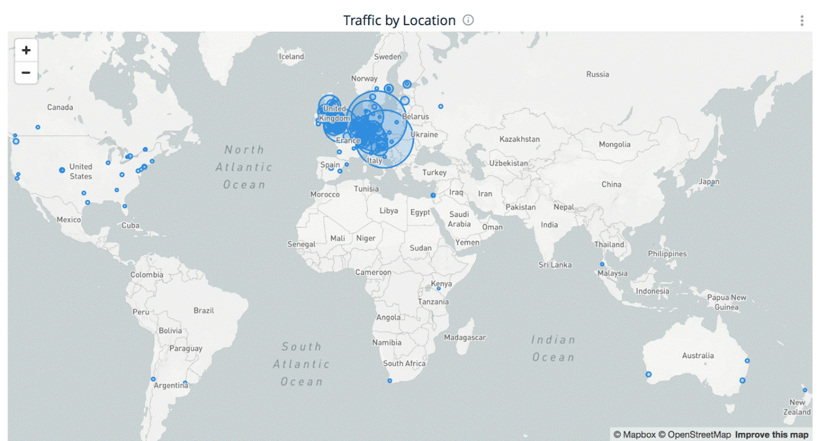
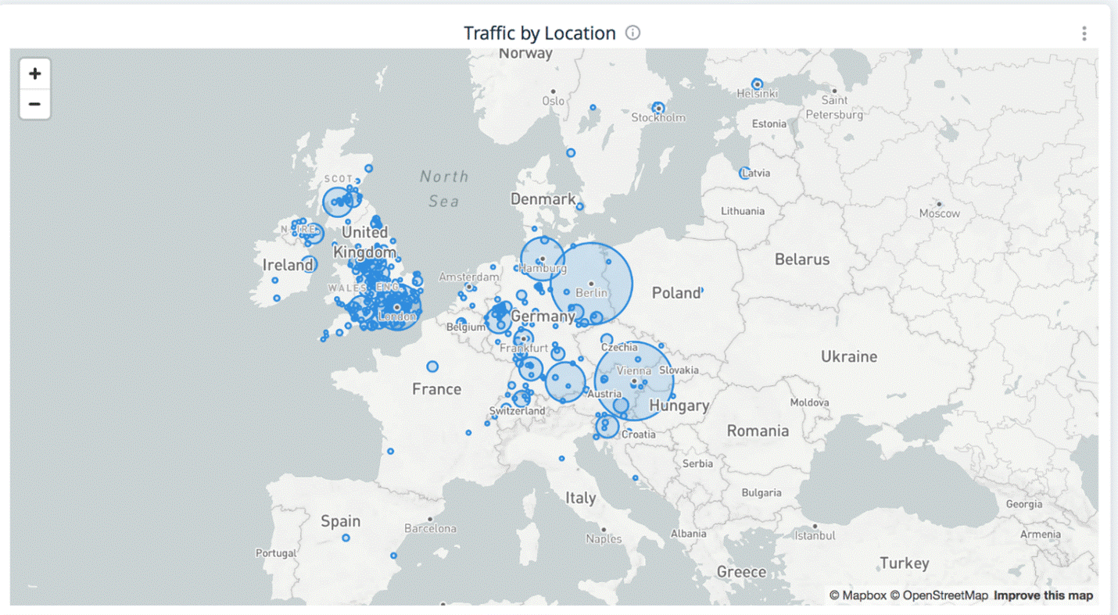
Supplemental Figure S1. Social media traffic of the Long Covid Kids UK platform.

