SUPPLEMENTAL MATERIALS
Supplemental Figure 1. Algorithm for assessing FN risk and the need for primary prophylactic G-CSF
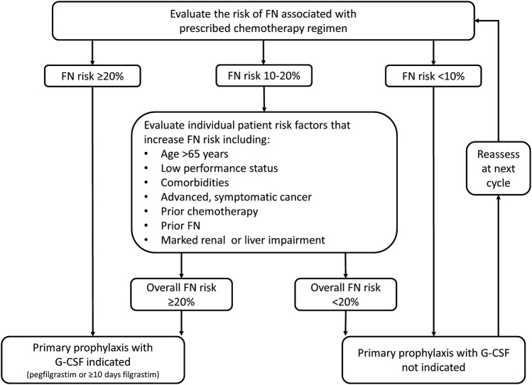
Source: Cornes et al. [5]. Adapted from guidelines by the European Organization for Research and Treatment of Cancer [57], the European Society of Medical Oncology [44], and the National Comprehensive Cancer Network [45]
Abbreviations: FN, febrile neutropenia; G-CSF granulocyte colony stimulating factor.

Supplemental Figure 2. PSA Cost-Effectiveness Acceptability Curves, by Outcome and Risk Group
A1. Cost per QALY gained, high-risk group | A2. Cost per QALY gained, intermediate-risk group
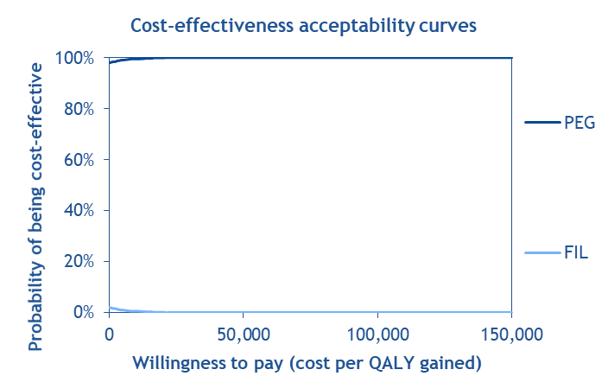 | 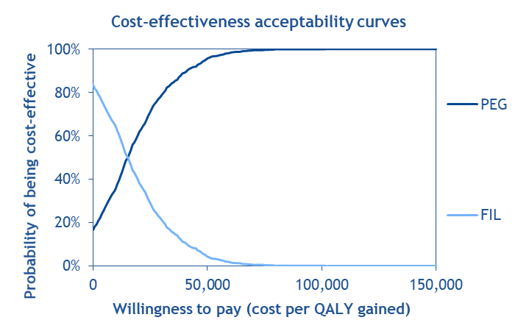
B1. Cost per LY gained, high-risk group | B2. Cost per LY gained, intermediate-risk group
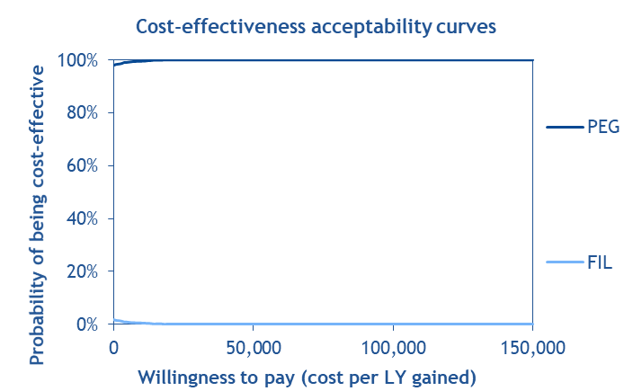 | 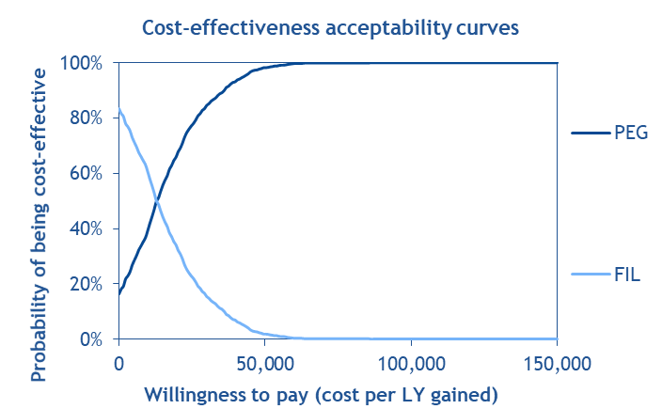
C1. Cost per FN avoided, high-risk group | C2. Cost per FN avoided, intermediate-risk group
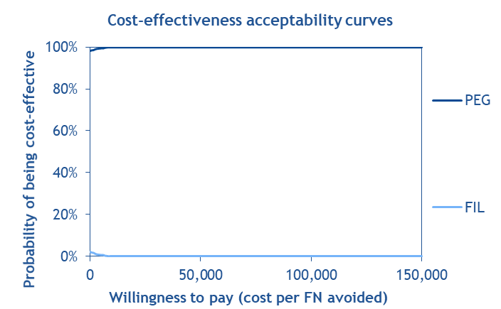 | 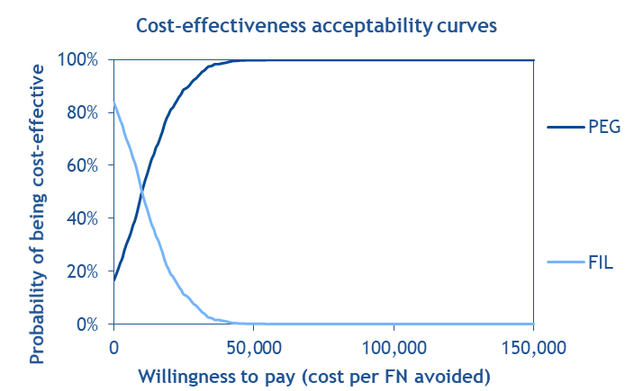
Notes: Given that reference products are always dominated by their less costly biosimilar products, assuming equivalent efficacy, only the biosimilar products are included in the sensitivity analyses for the comparison of PEG vs FIL.
Abbreviations: FIL, filgrastim; FN, febrile neutropenia; LY, life year; PEG, pegfilgrastim; PSA, probability sensitivity analysis; QALY, quality-adjusted life year.

Supplemental Figure 3. OWSA Tornado Diagrams for Incremental Cost-effectiveness Ratios, By Outcome
A. Cost per QALY gained, intermediate risk
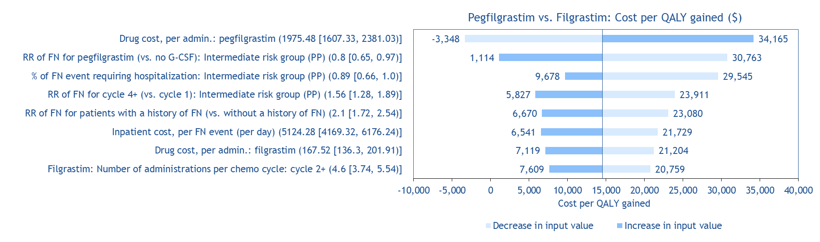
B. Cost per LY gained, intermediate risk
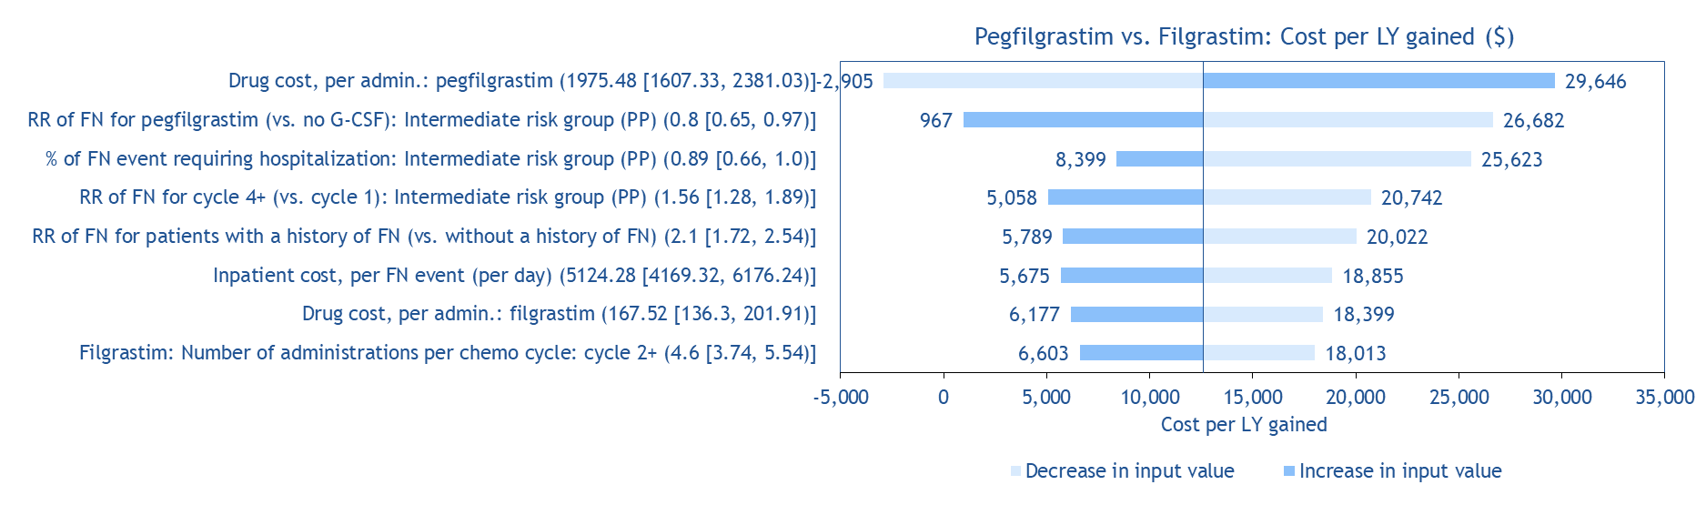
C. Cost per FN avoided, intermediate risk
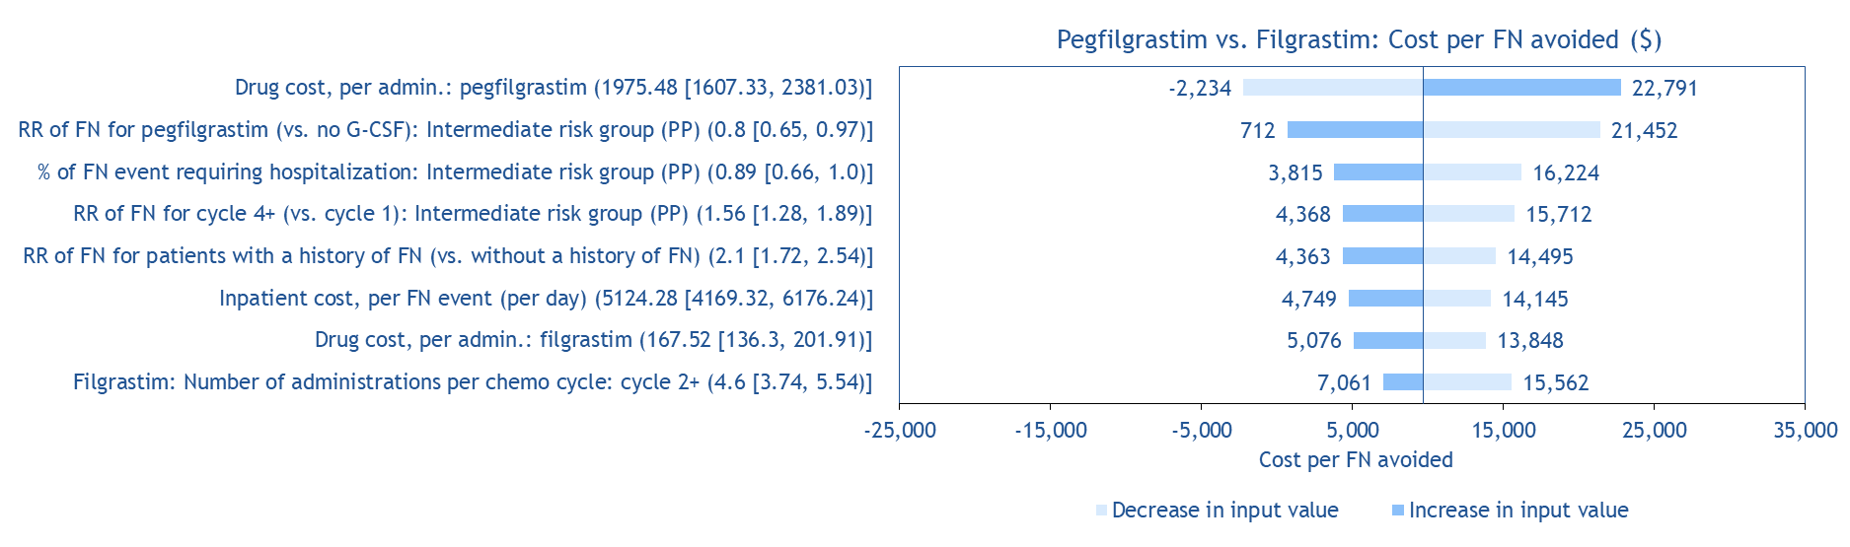
Notes: First, given that reference products are always dominated by their less costly biosimilar products, assuming equivalent efficacy, only the biosimilar products were included in the sensitivity analyses for the comparison of pegfilgrastim vs filgrastim. Second, given that pegfilgrastim biosimilar was estimated to be dominant over filgrastim biosimilar in all the OWSA for the high risk group, in which the incremental cost-effectiveness ratios are not applicable, the tornado diagrams are only presented for the intermediate risk group.
Abbreviations: Admin., administration; chemo, chemotherapy; FN, febrile neutropenia; G-CSF, granulocyte colony-stimulating factor; PP, primary prophylaxis; RR, relative risk.

