Systematic literature review and network meta-analysis of pembrolizumab versus other interventions for previously untreated, unresectable or metastatic, microsatellite instability-high or mismatch repair deficient colorectal cancer
Supplementary Figure

Figure S1: Process for selection of analytical approach

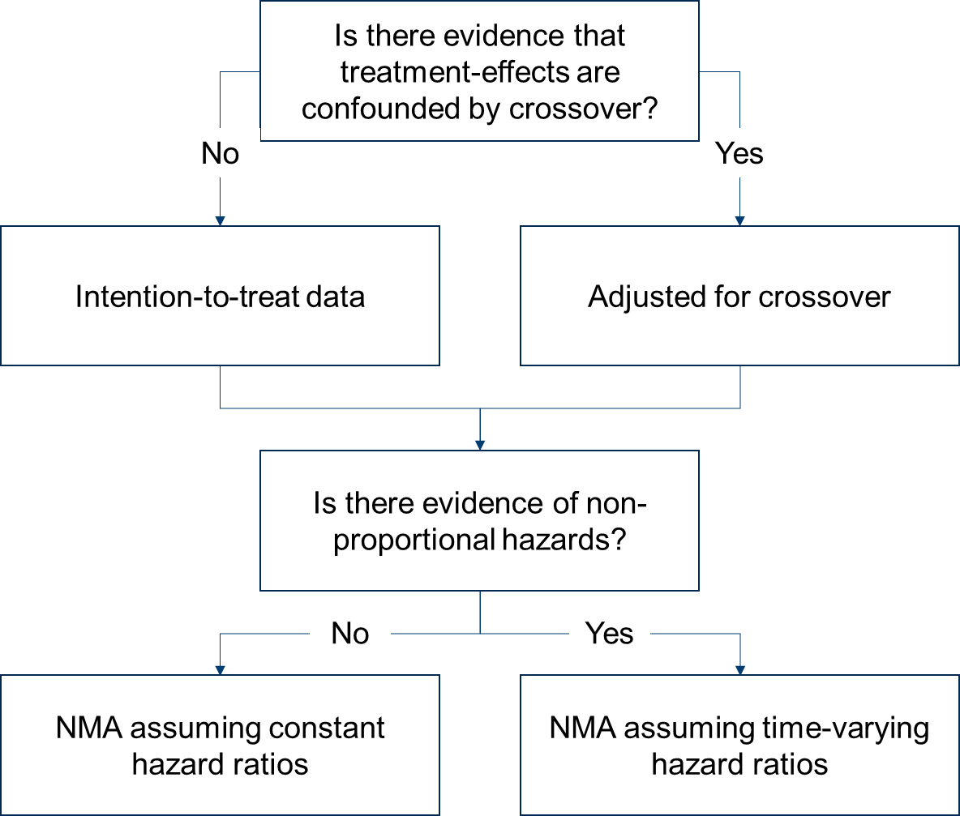

Abbreviations: NMA, network meta-analysis.

