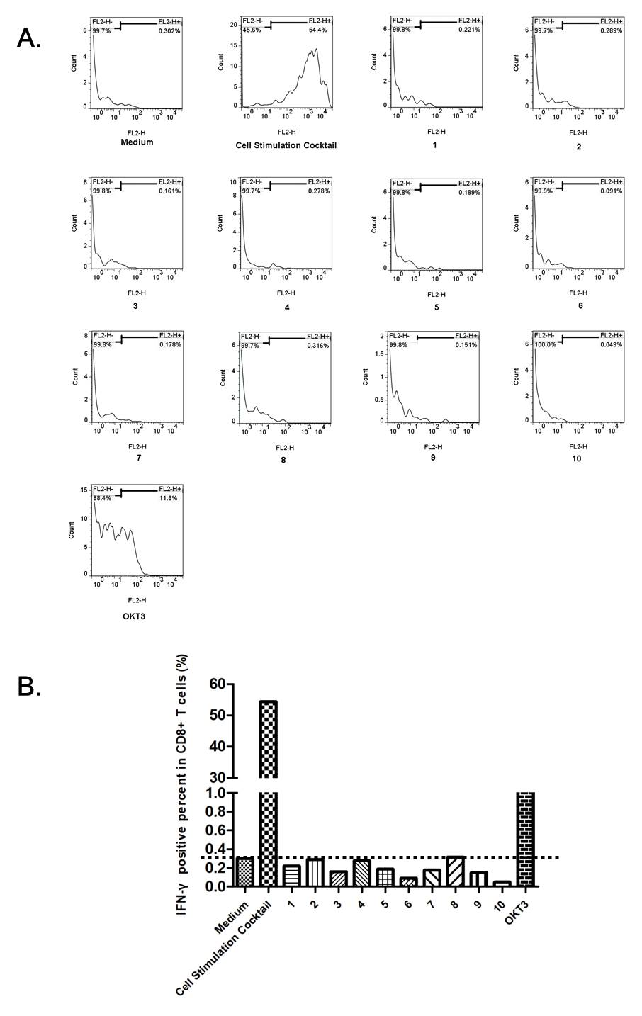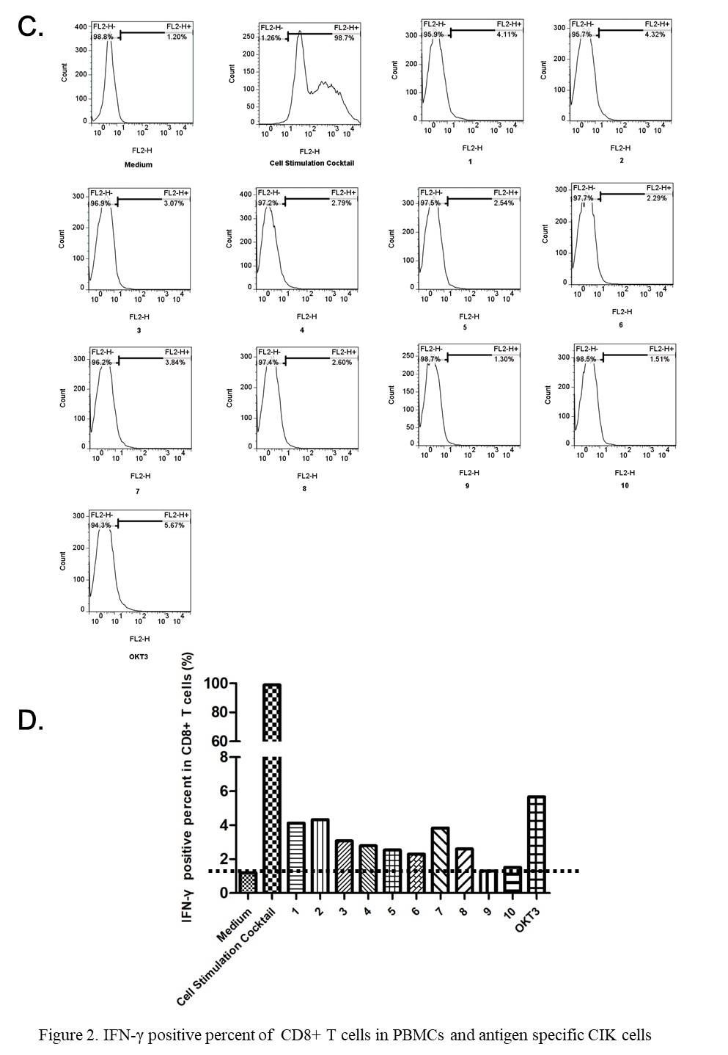
Figure S1. IFN-γ positive percent of CD8+ T cells in PBMCs and antigen specific CIK cells. (A) (B) IFN-γ positive percent in CD3+CD8+ T cells in the uncultured PBMC; (C) (D) IFN-γ positive percent in CD3+CD8+ T cells antigen-specific CIK cells in patients after culture. 1# MTAP/SPINK1 Merged Gene peptide: VLLPRHMKV; 2# FER^{S70F}: NYVSNVSKF; 3# SPINK1: FLLSALALL; 4# CLCN6^{F507S}: ALIGAAASL; 5# MTAP: AESFMFRTW; 6# TAP1^{V252A}: RLSLFLALV; 7# MAN2C1^{Q255R}: FLQGRNFFL; 8# CLCN6-wt: ALIGAAAFL; 9# TAP1-wt: RLSLFLVLV; 10# MAN2C1-wt: FLQGQNFFL;

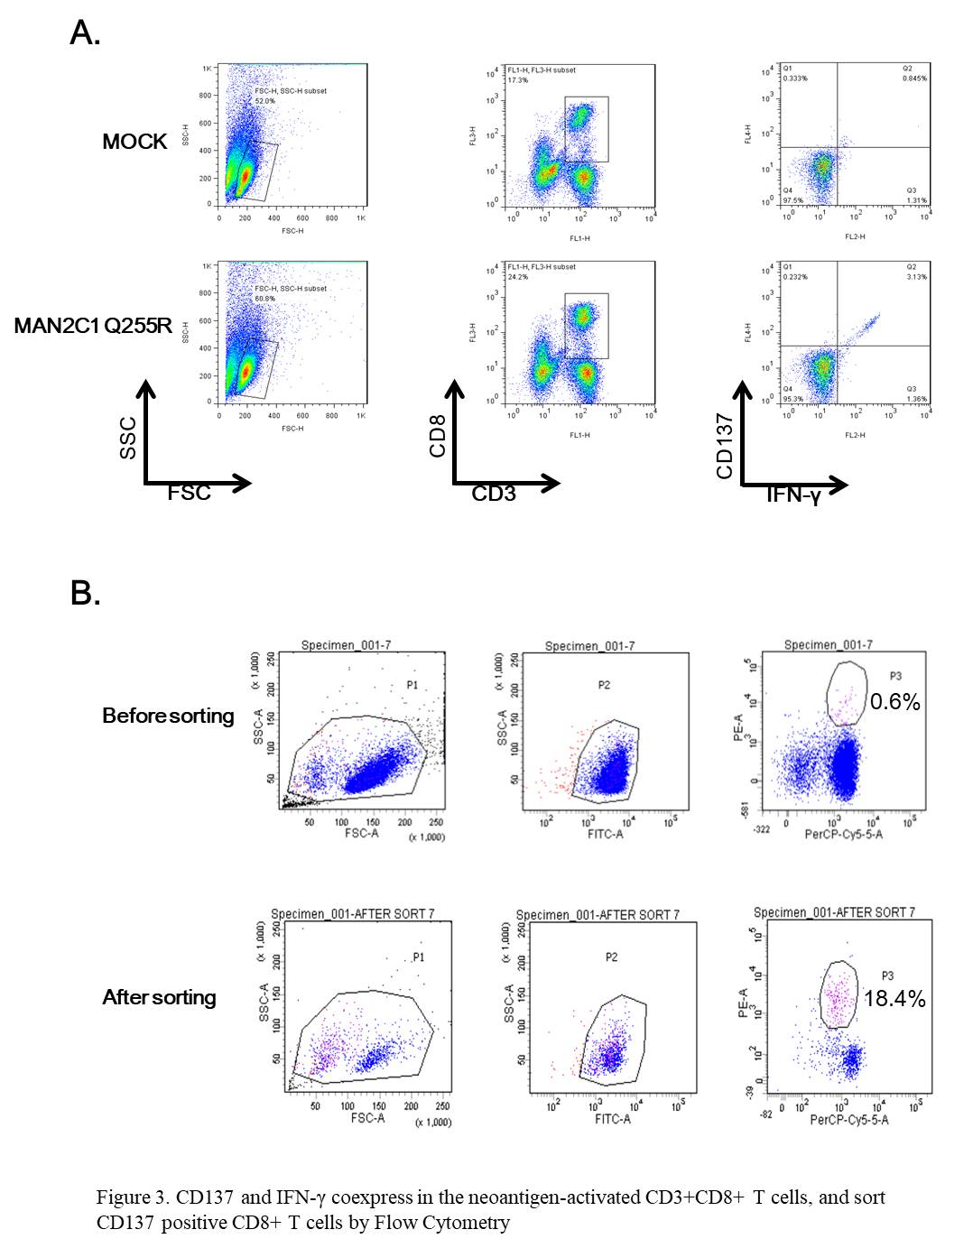
Figure S2. CD137 and IFN-γ coexpress in the neoantigen-activated CD3+CD8+ T cells, and sort CD137 positive CD8+ T cells by Flow Cytometry (A) Percentage of CD137 and IFN-γ co-expressing cells in antigen-specific CIK cells stimulated by tumor antigen 7# MAN2C1 ^{Q255R} : FLQGRNFFL. The antigen-specific CIK cells were cultured for about 10 days, and then 50 ug/mL tumor antigen 7# MAN2C1 ^{Q255R} : FLQGRNFFL was added to stimulate the antigen-specific CIK cells for 12 h, after which flow cytometry was used to measure the percentage of CD137 and IFN-γ co-expressing cells in CD3+CD8+ T cells. MOCK referred to antigen-specific CIK cells not stimulated by 7# MAN2C1 ^{Q255R}. 7# MAN2C1 ^{Q255R} referred to the antigen-specific CIK cells stimulated by 7# MAN2C1 ^{Q255R}. (B) CD3+CD8+CD137+ T cells activated by the stimulation of 7# MAN2C1 ^{Q255R} in tumor antigen specific CIK cells sorted by flow cytometry. The percentage of CD3+CD8+CD137+ T cells was about 0.6% before the sorting, which was concentrated by about 30 folds to 18.3% after the sorting.

