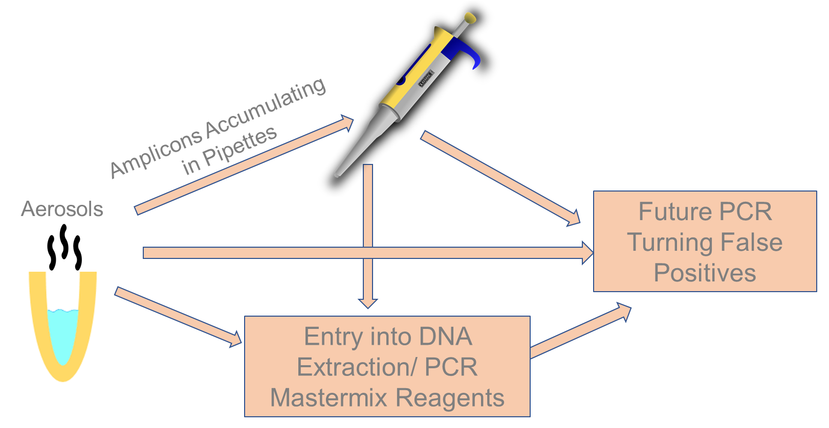

Figure 1: Routes of PCR carryover contamination include pipettes and aerosolization.

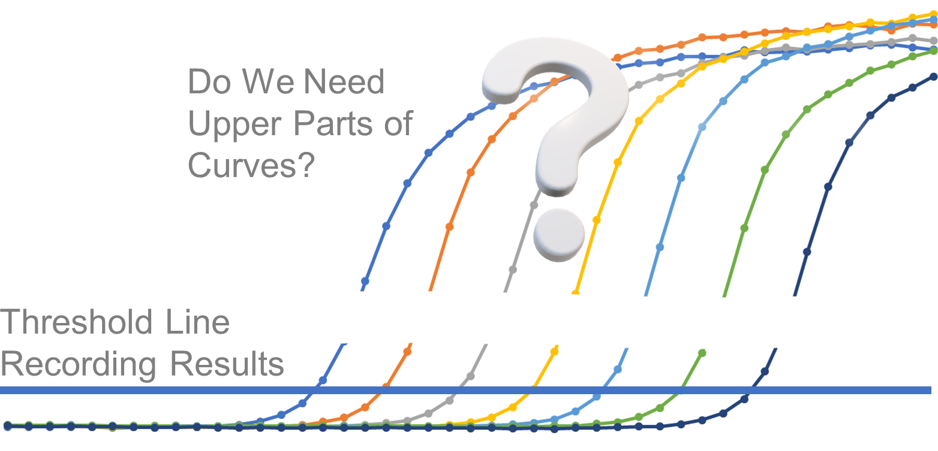
Figure 2: Real-time PCR quantification only requires the initial part of the amplification curves.

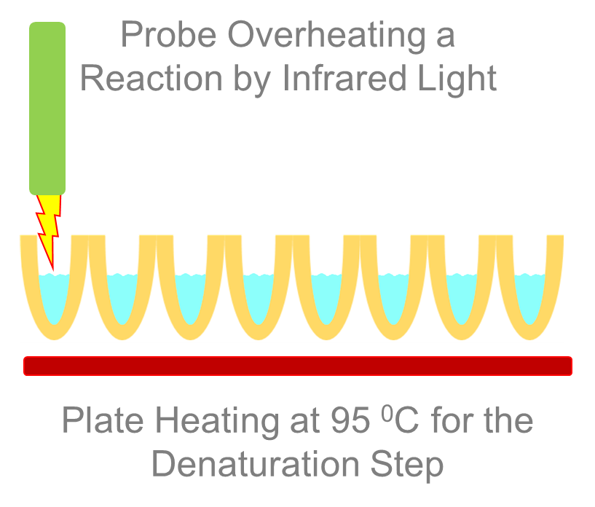
Figure 3: A possible model for OptiStop PCR

