SUPPLEMENTARY FIGURES AND VIDEOS

Supplementary Figures
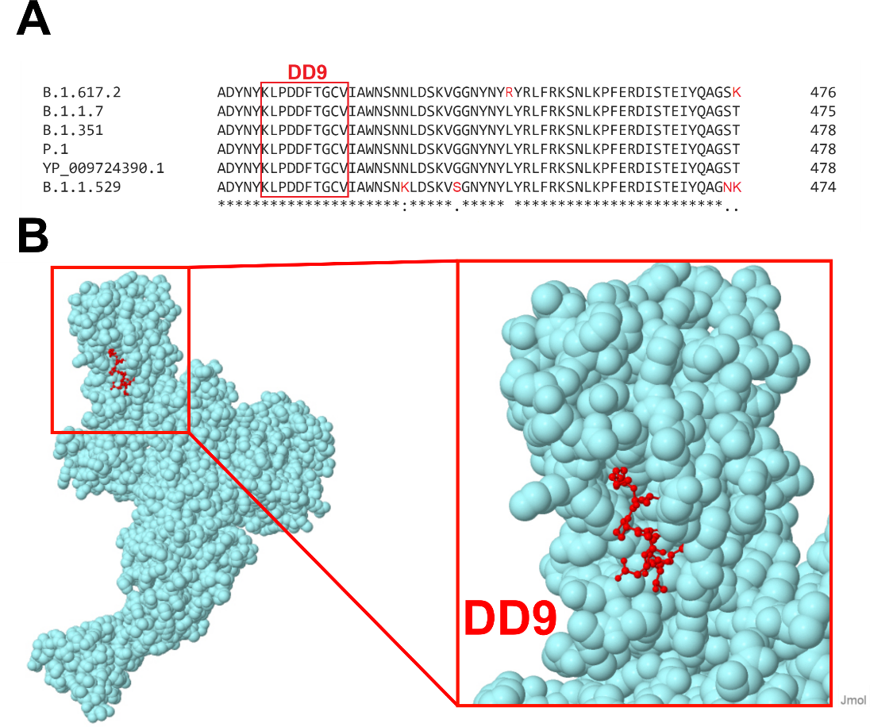
Supplementary Figure 1: (A) Multiple sequence alignment of the conserved epitope (DD9) on the spike protein of SARS-CoV-2 variants; YP_009724390 (Wuhan), B.1.617.2 (Delta), B.1.1.7 (Alpha), B.1.351 (Beta), P.1 (Gamma), and B.1.1.529 (Omicron). All sequences were downloaded from NCBI and aligned by Clustal Omega. (B) 3D structure of SARS-CoV-2 spike protein (PDB ID 6VYB) highlighted with DD9 peptide in red (Constructed in Jmol: an open-source Java viewer for chemical structures in 3D. http://www.jmol.org/).

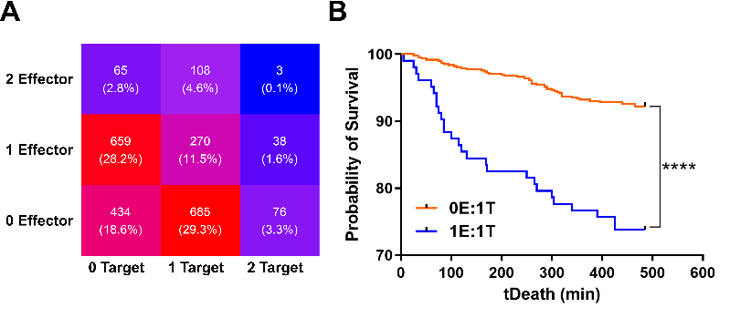
Supplementary Figure 2: (A) The distribution of T cells (effector) and target cells (target) in the nanowell array. (B) The Kaplan Meier survival curve of target cells in absence (0E:1T) and presence of one T cell (1E:1T).

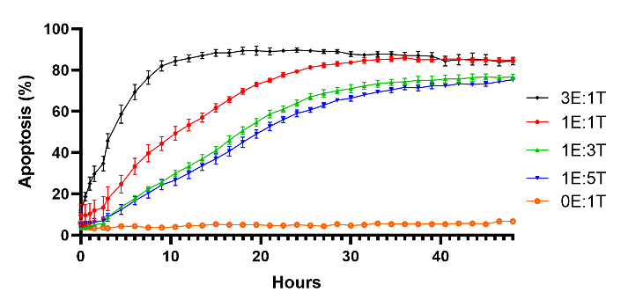
Supplementary Figure 3: The percentage of target cell apoptosis in different E:T ratios in a bulk assay for 48 hours (Cytation). All target cells were pre-incubated with peptide for 60 minutes before co-culturing.

Supplementary Videos
Supplementary Video S1: Representative TIMING Videos (each containing one T cell and one or more target cells) displaying killer, non-killer, and serial killer T cells.
Supplementary Video S2: Representative TIMING Videos displaying a killer T cell detaching from a target cell before induction of apoptosis.
Supplementary Video S3: Representative TIMING Videos displaying differences in motility and polarization of T cells.
Supplementary Video S4: Representative TIMING Videos displaying single nanowells containing killer or non-killer T cells with differences in IFNγ secretion.
Supplementary Video S5: Representative TIMING Videos displaying a killer T cell (1E:1T) succumbing to Activation-Induced Cell Death (AICD) and a serial killer T cell (1E:2T) resistant to AICD.

