Supplementary section

Estimation of molecular weight of BSA-peptide conjugate
To transform BSA as carrier protein azido-PEG₄ (15-Azido-4,7,10,13-tetraoxa-pentadecanoic acid succinimidyl ester) was deployed as spacer and functional group provider for immobilization of antigenic peptides. For the estimation of the molecular weight of the conjugate after spacer crosslinking and peptide click coupling all available primary NH₂ side chains were considered as available for spontaneous crosslinking (mature BSA protein sequence; lysine, arginine, glutamine and asparagine considered: 1-146 groups for crosslinking available). Hence the peptide-conjugate should be observable between 70.1 and 553.8 kDa in Western Blotting analysis.
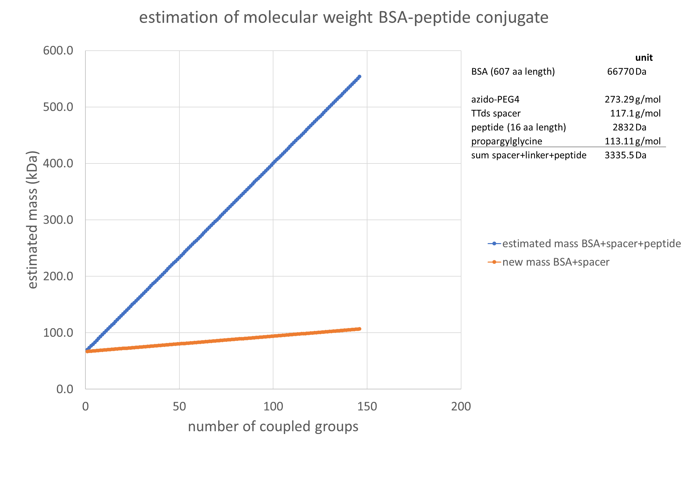
Supplementary Figure 1: estimated mass (kDa) of the BSA-peptide conjugate on the y-axis plotted against the number of coupled spacer+linker+peptide group on the x-axis. Blue line shows the estimated masses for coupling of azido-PEG4 and spacer-peptide-propargylglycine to 1 to 146 available -NH₂ groups based on the published sequence of BSA (lysine, arginine, glutamine and asparagine were considered as primary -NH₂ group providers). Orange line shows the estimated masses of coupled azido-PEG4 coupled to BSA.

Confirmation of conjugation of peptides to BSA
Conjugation of short antigenic peptides onto BSA is conducted via click chemistry and schematically presented in figure 1.

To confirm the conjugation reaction Western Blotting analysis using a monoclonal anti-FLAG antibody was performed. An eight amino-acid N-terminal FLAG tag (DYKDDDDK) was incorporated upon peptide synthesis and these control peptides coupled simultaneously to target peptides. For blotting analysis, 10 azido-BSA peptide-conjugates were selected based on seroreactivities on multiplexed ELISA experiments (unpublished data). Between 0.5 and 5 µg of peptide-BSA conjugate (depending on the available volume) were amended with 1 µL corresponding peptide stock, 2.5 µL 4X LDS buffer (ThermoFisher #NP0007) added and volume adjusted to 10 µL with 1X PBS. The sample mixtures were heated for 10 min at 70°C and loaded onto precasted 4-12% NovexTM BisTris gel (ThermoFisher #NP0329) in 1X MOPS (ThermoFisher #NP0001). Unlabelled BSA and azido-BSA were incorporated as controls. After SDS-Page electrophoresis (1h at 180V), the gel chamber was opened and the gel residuals (chamber and foot) removed to create a flat surface for blotting. A nitrocellulose membrane (ThermoFisher #88025) was placed on top of the gel, filter paper and blotting pads stacked and the assembly placed in the blotting module (XCell IITM Blotting module, according manufacturer’s instructions). Blotting was conducted for 1h at 25V in 1X Transfer Buffer (ThermoFisher #LC3675). Complete protein staining of the membrane was conducted with the reversible total protein staining kit (ThermoFisher #24585) and imaged with the ChemiDocTM Imaging system (BioRad) according manufacturer’s instructions. The residuals in the gel were stained with the SimplyBlueTM SafeStain according manufacturer’s instructions (Invitrogen LC6060). Meanwhile, the membrane was destained and washed three times with ultrapure water to remove residuals from staining. The membrane was blocked in 1XTBS 5% skimmed milkpowder overnight at 4°C, followed by five washes with 1X TBS 0.1 Tween-20 (TBST). Biotinylated anti-FLAG antibody was diluted to a concentration of 1 µg/µL in 1X TBS 1% skimmed milkpowder and the membrane incubated for 2h at RT. Detection was conducted by five washes with TBST and incubation with 1:200 diluted streptavidin-HRP conjugate in TBS 1% MP for 30min at RT. Blot was washed three times with TBST and bands developed with the Clarity Western ECL substrate kit (BioRad # 1705061) according manufacturer’s instructions. The blot and stained gel residuals were imaged with the ChemiDocTM imaging system.

Supplementary Figure 2: 10 peptide BSA conjugates were selected for Western Blot investigation of coupling confirmation. (A) shows the total protein staining of the membrane after transfer, (B) the anti-FLAG detection using anti-FLAG HRP antibody.

Incorporation of a blocking step
The effect of a blocking step was investigated via immobilization of modified BSA (without peptide) and isolated IgG. The ELISA protocol was therefore tested with and without prior blocking (PBST 1%BSA for 30min RT). Blocked wells showed 1 to 6.55 fold increased signals (150 pmol/well) compared to unblocked wells, with increasing tendency upon increasing concentration (0.98 – 10.22 fold increased at 300 pmol/well and 1.01 – 7.07 fold increased at 600 pmol/well, Figure 2b).To elaborate, we compared PBST with 1% BSA and PBST with 1% skimmed milk-powder (MP) to PBST without protein in (1) blocking, (2) sample solution and (3) detection solution. Results of this evaluation are shown as ratios of blocked versus unblocked signals (2 peptides were tested, Table 2).

Supplementary Figure 3: (a) dilution series of peptides plotted for blank-uncorrected absorption values at 450nm. Two peptides (EBV1, EBV2) on the three evaluated surfaces are shown. (b) absorbance values for blocked (1% BSA in PBST) and unblocked wells obtained for dilution series of unmodified, azide modified carrier molecule (BSA, azido BSA) and IgG incubated with 0.15 mg/mL IgG. Uncoated wells are shown as “buffer”, “blank” wells represent BSA (unmodified) coated wells incubated with 0.15 mg/mL IgG.
EBV1_IgG in PBST, detAb in PBST |  |  |  |  | EBV1_IgG in PBST, detAb in PBST+BSA |  |  |  |  | EBV1_IgG in PBST, detAb in PBST+MP
pmol/well | 300 | 150 | 60 | 30 | pmol/well | 300 | 150 | 60 | 30 | pmol/well | 300 | 150 | 60 | 30
BSA/unblocked | 0.87 | 1.57 | 1.73 | 0.73 | BSA/unblocked | 1.21 | 1.93 | 0.85 | 0.84 | BSA/unblocked | 0.81 | 0.80 | 0.82 | 0.72
MP/unblocked | 0.61 | 0.92 | 0.85 | 0.40 | MP/unblocked | 0.66 | 1.17 | 0.48 | 0.44 | MP/unblocked | 0.56 | 0.53 | 0.53 | 0.58
EBV2_IgG in PBST, detAb in PBST |  |  |  |  | EBV2_IgG in PBST, detAb in PBST+BSA |  |  |  |  | EBV2_IgG in PBST, detAb in PBST+MP
pmol/well | 300 | 150 | 60 | 30 | pmol/well | 300 | 150 | 60 | 30 | pmol/well | 300 | 150 | 60 | 30
BSA/unblocked | 0.66 | 0.63 | 0.69 | 0.44 | BSA/unblocked | 0.75 | 0.68 | 0.64 | 0.57 | BSA/unblocked | 0.59 | 0.65 | 0.63 | 0.61
MP/unblocked | 0.41 | 0.32 | 0.23 | 0.20 | MP/unblocked | 0.45 | 0.37 | 0.34 | 0.32 | MP/unblocked | 0.39 | 0.39 | 0.38 | 0.42

Supplementary Table 1: ratio of absorbance values for blocked versus unblocked wells for 2 peptides (EBV1, EBV2) in four dilutions steps (30, 60, 150 and 300 pmol per well) and different blocking agents (none, BSA and MP) for detection antibody (detAb) solution.

pmol peptide/well | HighBind N- vs C-terminal immobilization | Maleimide N- vs C-terminal immobilization
600 | 0.6791 | 0.5836
300 | 0.7502 | 0.4014
150 | 0.9806 | 0.1358
60 | 0.0162 | 0.4136
30 | 0.0468 | 0.3119
15 | 0.0659 | 0.4725
Supplementary Table 2: t-statistics of the comparison of absorbance values for N- & C-terminal orientation of the peptides immobilized as BSA-conjugates in HighBind plates and Maleimide coated plates

