Supplementary materials

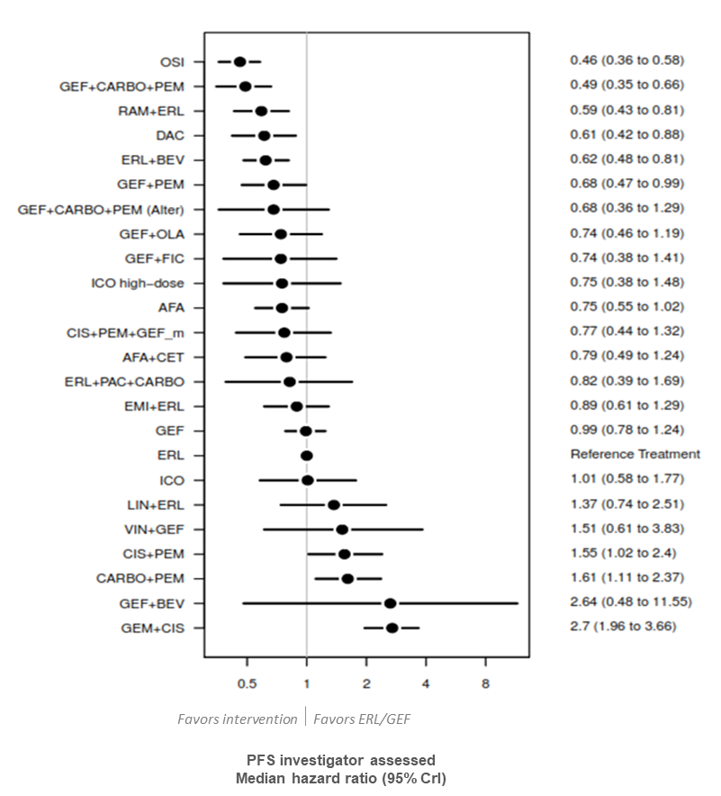

Figure A1. Sensitivity analysis of PFS splitting the erlotinib and gefitinib node (random effects).
AFA: afatinib; BEV: bevacizumab; CARBO: carboplatin; CET: cetuximab; CIS: cisplatin; CrI: credible interval; DAC: dacomitinib; EMI: emibutazumab; ERL: erlotinib; FIC: ficlatuzumab; GEF: gefitinib; GEF_m: gefitinib maintenance; GEM: gemcitabine; ICO: icotinib; LIN: linsitinib; OLA: olaparib; OSI: osimertinib; PAC: paclitaxel; PEM: pemetrexed; PFS: progression-free survival; RAM: ramucirumab; VIN: Vinorelbine

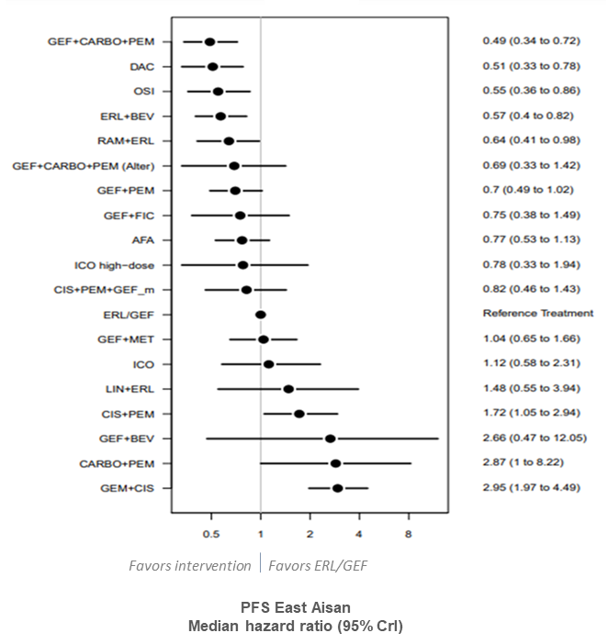

Figure A2. Subgroup analysis of PFS of treatments versus erlotinib/gefitinib in East Asian patients (random effects).
AFA: afatinib; BEV: bevacizumab; CARBO: carboplatin; CIS: cisplatin; CrI: credible interval; DAC: dacomitinib; ERL: erlotinib; FIC: ficlatuzumab; GEF: gefitinib; GEF_m: gefitinib maintenance; GEM: gemcitabine; ICO: icotinib; LIN: linsitinib; MET: Metformin; OSI: osimertinib; PEM: pemetrexed; PFS: progression-free survival; RAM: ramucirumab.

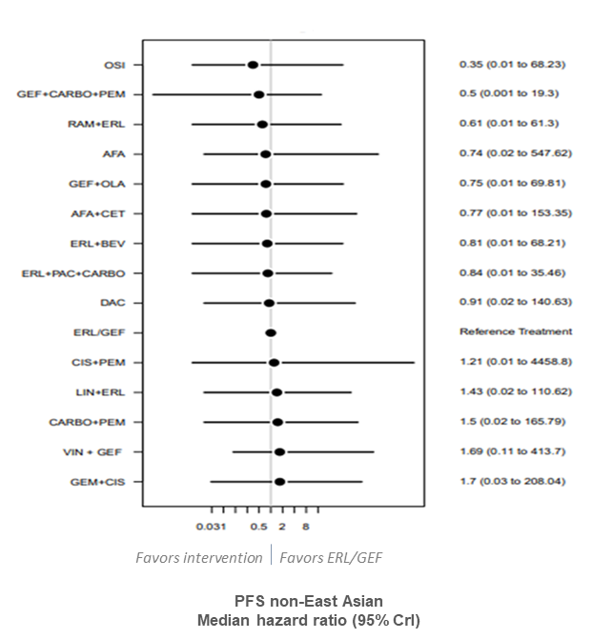

Figure A3. Subgroup analysis of PFS of treatments versus erlotinib/gefitinib in non-East Asian patients (random effects).
AFA: afatinib; BEV: bevacizumab; CARBO: carboplatin; CET: cetuximab; CIS: cisplatin; CrI: credible interval; DAC: dacomitinib; ERL: erlotinib; GEF: gefitinib; GEM: gemcitabine; LIN: linsitinib; OLA: olaparib; OSI: osimertinib; PAC: paclitaxel; PEM: pemetrexed; PFS: progression-free survival; RAM: ramucirumab; VIN: Vinorelbine.

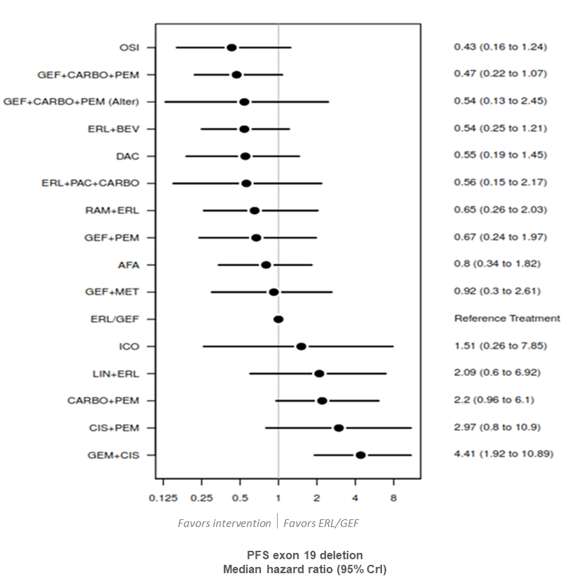

Figure A4. Subgroup analysis of PFS of treatments versus erlotinib/gefitinib in exon 19 deletion patients (random effects).
AFA: afatinib; BEV: bevacizumab; CARBO: carboplatin; CI: confidence interval; CIS: cisplatin; CrI: credible interval; DAC: dacomitinib; ERL: erlotinib; GEF: gefitinib; GEM: gemcitabine; ICO: icotinib; LIN: linsitinib; MET: Metformin; OSI: osimertinib; PAC: paclitaxel; PEM: pemetrexed; PFS: progression-free survival; RAM: ramucirumab.

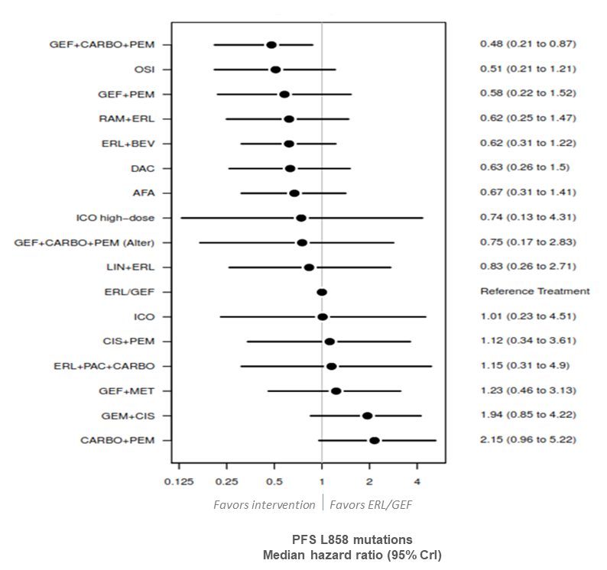

Figure A5. Subgroup analysis of PFS of treatments versus against erlotinib/gefitinib in patients with L858 mutations (random effects).
AFA: afatinib; BEV: bevacizumab; CARBO: carboplatin; CIS: cisplatin; CrI: credible interval; DAC: dacomitinib; ERL: erlotinib; GEF: gefitinib; GEM: gemcitabine; ICO: icotinib; LIN: linsitinib; MET: Metformin; OSI: osimertinib; PAC: paclitaxel; PEM: pemetrexed; PFS: progression-free survival; RAM: ramucirumab.

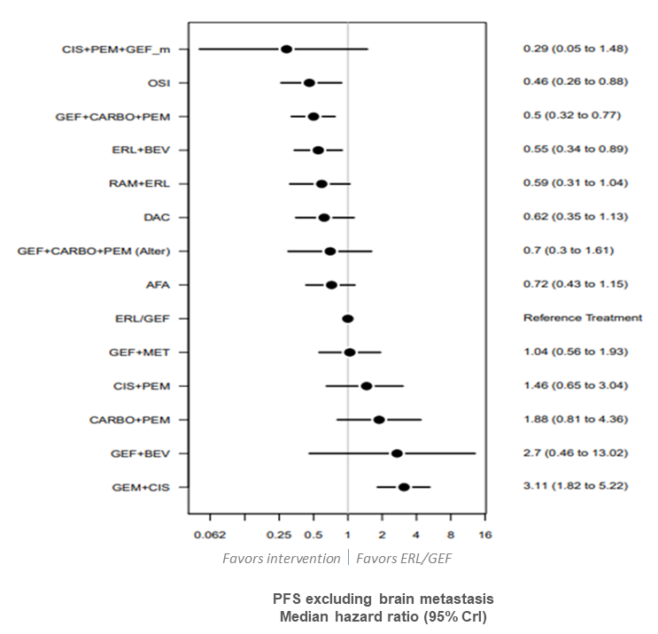

Figure A6. Subgroup analysis of PFS of treatments versus erlotinib/gefitinib excluding brain metastasis (random effects).
AFA: afatinib; BEV: bevacizumab; CARBO: carboplatin; CIS: cisplatin; CrI: credible interval; DAC: dacomitinib; ERL: erlotinib; GEF: gefitinib; GEF_m: gefitinib maintenance; GEM: gemcitabine; MET: Metformin; OSI: osimertinib; PEM: pemetrexed; PFS: progression-free survival; RAM: ramucirumab.

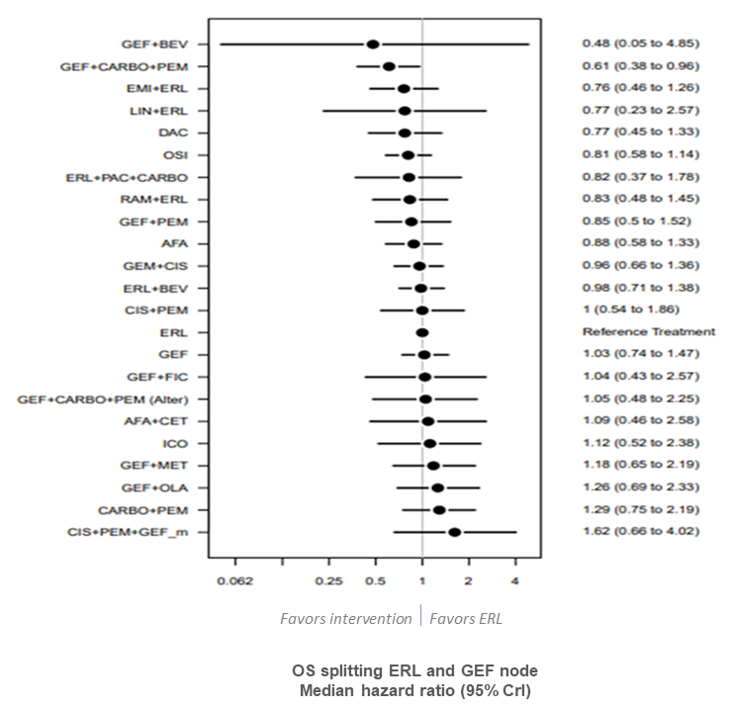

Figure A7. Sensitivity analysis of OS splitting the erlotinib and gefitinib node (random effects).
AFA: afatinib; BEV: bevacizumab; CARBO: carboplatin; CET: cetuximab; CIS: cisplatin; CrI: credible interval; DAC: dacomitinib; EMI: Emibutazumab; ERL: erlotinib; FIC: ficlatuzumab; GEF: gefitinib; GEF_m: gefitinib maintenance; GEM: gemcitabine; ICO: icotinib; LIN: linsitinib; MET: Metformin; OLA: olaparib; OS: overall survival; OSI: osimertinib; PAC: paclitaxel; PEM: pemetrexed; RAM: ramucirumab.

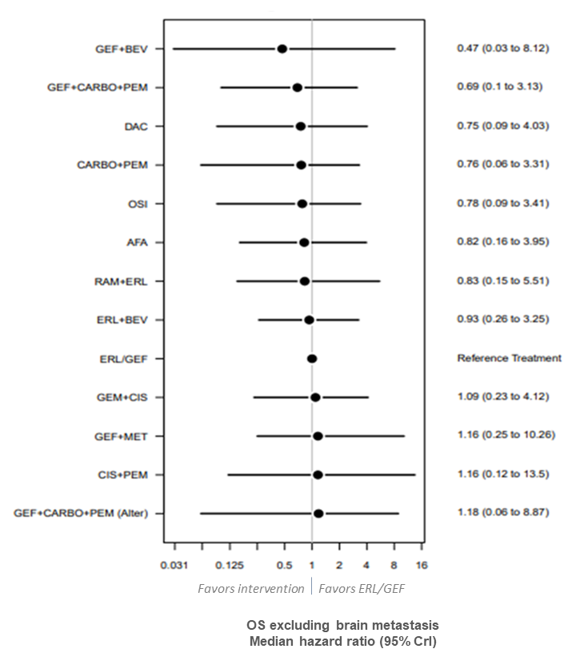

Figure A8. Subgroup analysis of OS of treatments versus erlotinib/gefitinib excluding brain metastasis (random effects).
AFA: afatinib; BEV: bevacizumab; CARBO: carboplatin; CIS: cisplatin; CrI: credible interval; DAC: dacomitinib; ERL: erlotinib; GEF: gefitinib; GEF_m: gefitinib maintenance; GEM: gemcitabine; MET: Metformin; OS: overall survival; OSI: osimertinib; PEM: pemetrexed; RAM: ramucirumab.

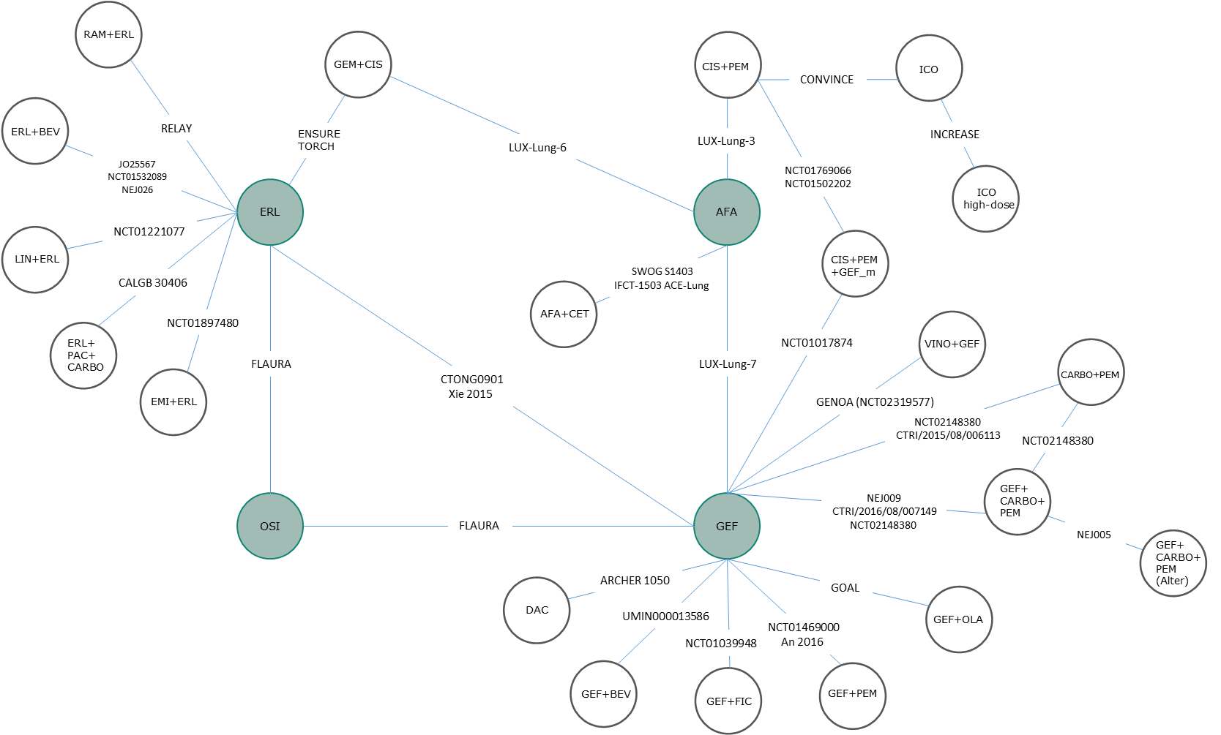

Figure A9. Evidence network for sensitivity analysis splitting ERL and GEF nodes for PFS
AFA: afatinib; BEV: bevacizumab; CARBO: carboplatin; CET: cetuximab; CIS: cisplatin; DAC: dacomitinib; EMI: Emibetuzumab; ERL: erlotinib; FIC: ficlatuzumab; GEF: gefitinib; GEF_m: gefitinib maintenance; GEM: gemcitabine; ICO; icotinib; LIN: linsitinib; OLA: olaparib; OSI: osimertinib; PAC: paclitaxel; PEM: pemetrexed; PFS: progression-free survival; RAM: ramucirumab; VIN: vinorelbine.

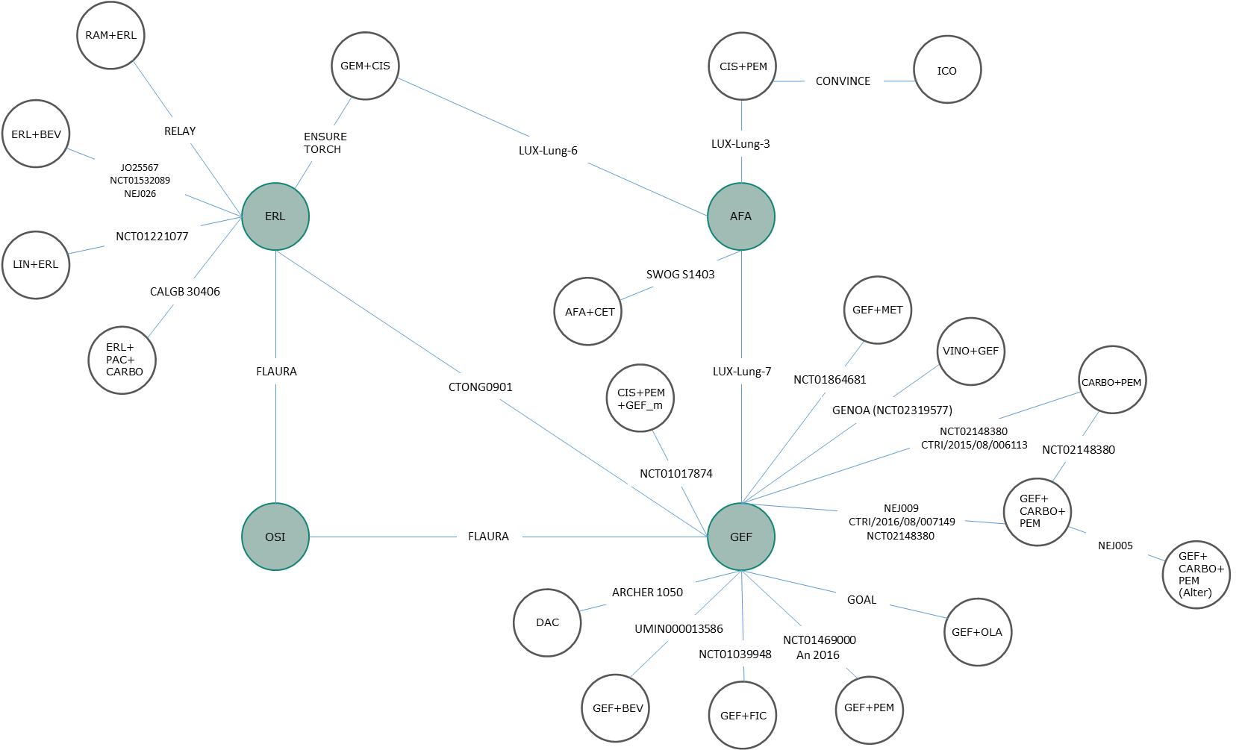

Figure A10. Evidence network for sensitivity analysis splitting ERL and GEF nodes for OS
AFA: afatinib; BEV: bevacizumab; CARBO: carboplatin; CET: cetuximab; CIS: cisplatin; DAC: dacomitinib; ERL: erlotinib; FIC: ficlatuzumab; GEF: gefitinib; GEF_m: gefitinib maintenance; GEM: gemcitabine; ICO; icotinib; LIN: linsitinib; MET: metformin; OLA: olaparib; OS: overall survival; OSI: osimertinib; PAC: paclitaxel; PEM: pemetrexed; RAM: ramucirumab; VIN: vinorelbine.

References
1. Relay. RELAY: A multinational, doubleblind, randomized Phase 3 study of erlotinib (ERL) in combination with ramucirumab (RAM) or placebo (PL) in previously untreated patients with epidermal growth factor receptor mutation-positive (EGFRm) metastatic non-small cell lung cancer (NSCLC). (2019).
2. Yan BD, Meng SS, Ren Jet al. Asthma control and severe exacerbations in patients with moderate or severe asthma in Jilin Province, China: A multicenter cross-sectional survey. BMC Pulmonary Medicine, 16 (1) (no pagination)(130), (2016).
3. Mok T, Cheng Y, Zhou Xet al. Dacomitinib (daco) versus gefitinib (gef) for first-line treatment of advanced NSCLC (ARCHER 1050): Final overall survival (OS) analysis. Journal of Clinical Oncology. Conference, 36 (2018).
4. Nakagawa K. Dacomitinib versus gefitinib for first-line treatment of advanced EGFR+ NSCLC in Japanese Patients (ARCHER 1050). Journal of Thoracic Oncology, 12 (11 Supplement 2) S2229-S2230 (2017).
5. Wu Y-L. First-line dacomitinib versus gefitinib in advanced non-small-cell lung cancer with EGFR mutation subgroups. Journal of Thoracic Oncology, 12 (11 Supplement 2) S1754 (2017).
6. Mok TSK, Cheng Y, Zhou Xet al. Safety and efficacy of dacomitinib for EGFR+ NSCLC in the subgroup of Asian patients from ARCHER 1050. Annals of Oncology, 30 (Supplement 9) ix160-ix161 (2019).
7. Nishio M, Kato T, Niho Set al. Safety and efficacy of first-line dacomitinib in Japanese patients with advanced non-small cell lung cancer. Cancer Science., doi:http://dx.doi.org/10.1111/cas.14384 (2020).
8. Mok TSK, Cheng Y, Zhou Xet al. Updated overall survival (OS) from extended follow up in ARCHER 1050: A randomized phase III study comparing dacomitinib with gefitinib as first-line therapy for patients (pts) with EGFR mutations. Annals of Oncology, 30 (Supplement 9) ix200-ix201 (2019).
9. Zhou C, Wu Y-L, Chen Get al. BEYOND: A Randomized, Double-Blind, Placebo-Controlled, Multicenter, Phase III Study of First-Line Carboplatin/Paclitaxel Plus Bevacizumab or Placebo in Chinese Patients With Advanced or Recurrent Nonsquamous Non-Small-Cell Lung Cancer. J Clin Oncol, 33 2197-2204 (2015).
10. Jänne PA, Wang X, Socinski MAet al. Randomized phase II trial of erlotinib alone or with carboplatin and paclitaxel in patients who were never or light former smokers with advanced lung adenocarcinoma: CALGB 30406 trial. J Clin Oncol, 30 2063-2069 (2012).
11. Shi YK, Wang L, Han BHet al. First-line icotinib versus cisplatin/pemetrexed plus pemetrexed maintenance therapy for patients with advanced EGFR mutation-positive lung adenocarcinoma (CONVINCE): a phase 3, open-label, randomized study. Annals of Oncology, 28 2443-2450 (2017).
12. Crawford J, Swanson P, Schwarzenberger Pet al. A phase 2 randomized trial of paclitaxel and carboplatin with or without panitumumab for first-line treatment of advanced non-small-cell lung cancer. J Thorac Oncol, 8 1510-1518 (2013).
13. Yang JJ, Zhou Q, Yan HHet al. A phase III randomised controlled trial of erlotinib vs gefitinib in advanced non-small cell lung cancer with EGFR mutations. Br J Cancer, 116 568-574 (2017).
14. Zhou QW, Y. L.Cheng, Y.Liu, Y.Chen, G.Cui, J.Yang, N.Song, Y.Li, X. L.Lu, S.Zhou, J.Ma, Z.Yu, S. Y.Huang, C.Shu, Y. CTONG 1509: Phase III study of bevacizumab with or without erlotinib in untreated Chinese patients with advanced EGFR-mutated NSCLC. Annals of Oncology, 30 (Supplement 5) v603 (2019).
15. Patil VM, Noronha V, Joshi Aet al. Phase III study of gefitinib or pemetrexed with carboplatin in EGFR-mutated advanced lung adenocarcinoma. ESMO open, 2(1), e000168 (2017).
16. Noronha V, Joshi A, Patil VMet al. Phase III randomized trial comparing gefitinib to gefitinib with pemetrexed-carboplatin chemotherapy in patients with advanced untreated EGFR mutant non-small cell lung cancer (gef vs gef+C). J Clin Oncol, 37(15_suppl), 9001-9001 (2019).
17. Noronha V, Patil VM, Joshi Aet al. Gefitinib versus gefitinib plus pemetrexed and carboplatin chemotherapy in EGFR-mutated lung cancer. J Clin Oncol, 38(2), 124-136 (2019).
18. Wu YL, Zhou C, Liam CKet al. First-line erlotinib versus gemcitabine/cisplatin in patients with advanced EGFR mutation-positive non-small-cell lung cancer: analyses from the phase III, randomized, open-label, ENSURE study. Annals of Oncology, 26 1883-1889 (2015).
19. Wu Y-L, Zhou C, Lu Set al. Erlotinib versus gemcitabine/cisplatin in Chinese patients with EGFR mutation-positive advanced non-small-cell lung cancer: Crossover extension and post-hoc analysis of the ENSURE study. Lung Cancer, 130 18-24 (2019).
20. Wu Y-L, Zhou C, Wu Get al. Quality of life (QOL) analysis from ensure, a phase 3, open-label study of first-line erlotinib versus gemcitabine/cisplatin (GP) in asian patients with epidermal growth factor receptor (EGFR) mutation-positive (MUT+) non-small-cell lung cancer (NSCLC). Journal of Thoracic Oncology, 1) S37 (2014).
21. Rosell R, Carcereny E, Gervais Ret al. Erlotinib versus standard chemotherapy as first-line treatment for European patients with advanced EGFR mutation-positive non-small-cell lung cancer (EURTAC): a multicentre, open-label, randomised phase 3 trial. Lancet Oncology, 13 239-246 (2012).
22. Marinis FD, Vergnenegre A, Passaro Aet al. Erlotinib-associated rash in patients with EGFR mutation-positive non-small-cell lung cancer treated in the EURTAC trial. Future Oncology, 11 421-429 (2015).
23. Wu Y-L, Lee JS, Thongprasert Set al. Intercalated combination of chemotherapy and erlotinib for patients with advanced stage non-small-cell lung cancer (FASTACT-2): a randomised, double-blind trial. Lancet Oncology, 14 777-786 (2013).
24. Mok T, Ladrera G, Srimuninnimit Vet al. Tumor marker analyses from the phase III, placebo-controlled, FASTACT-2 study of intercalated erlotinib with gemcitabine/platinum in the first-line treatment of advanced non-small-cell lung cancer. Lung Cancer, 98 43678 (2016).
25. Soria JC, Ohe Y, Vansteenkiste Jet al. Osimertinib in Untreated EGFR-Mutated Advanced Non-Small-Cell Lung Cancer. N Engl J Med, 378 113-125 (2018).
26. Cho BC, Chewaskulyong B, Lee KHet al. Osimertinib versus Standard of Care EGFR TKI as First-Line Treatment in Patients with EGFRm Advanced NSCLC: FLAURA Asian Subset. Journal of Thoracic Oncology, 14 99-106 (2019).
27. Gray J, Okamoto I, Sriuranpong V. Osimertinib vs SoC EGFR-TKI as first-line treatment in patients with EGFRm advanced NSCLC (FLAURA): Plasma ctDNA analysis. Journal of Thoracic Oncology, 12 (11 Supplement 2) S1754-S1755 (2017).
28. Leighl N, Karaseva N, Nakagawa Ket al. Patient-reported outcomes from FLAURA: Osimertinib versus standard of care (SoC) epidermal growth factor receptor tyrosine kinase inhibitor (EGFR-TKI) in patients with EGFR-mutated advanced non-small cell lung cancer (NSCLC). Journal of Thoracic Oncology, 13 (4 Supplement 1) S81-S82 (2018).
29. Planchard D, Boyer MJ, Lee J-Set al. Osimertinib vs standard of care (SoC) EGFRTKI as first-line therapy in patients (pts) with untreated EGFRm advanced NSCLC: FLAURA post-progression outcomes. Journal of Thoracic Oncology, 13 (4 Supplement 1) S72-S73 (2018).
30. Reungwetwattana T, Nakagawa K, Cho BCet al. CNS response to osimertinib versus standard epidermal growth factor receptor tyrosine kinase inhibitors in patients with untreated EGFR-mutated advanced non-small-cell lung cancer. J Clin Oncol, 36 3290-3297 (2018).
31. Zhou C, Cheng Y, He Yet al. Osimertinib vs Standard of Care (SoC) EGFR-TKI as First-Line Treatment in Chinese Patients With EGFRm Advanced NSCLC. Journal of Thoracic Oncology, 13 (10 Supplement) S507-S508 (2018).
32. Reinmuth N, Bischoff H, Bohnet Set al. Osimertinib vs comparator EGFR-TKI as first-line treatment for EGFRM advanced NSCLC (Flaura): Final overall survival analysis. Oncology Research and Treatment, 43 (Supplement 1) 116 (2020).
33. Ramalingam SS, Vansteenkiste J, Planchard Det al. Overall Survival with Osimertinib in Untreated, EGFR-Mutated Advanced NSCLC. N Engl J Med, 382(1), 41-50 (2020).
34. Ohe Y, Imamura F, Nogami Net al. Osimertinib versus standard-of-care EGFR-TKI as first-line treatment for EGFRm advanced NSCLC: FLAURA Japanese subset. Jpn J Clin Oncol, 49(1), 29-36 (2019).
35. Leighl NB, Karaseva N, Nakagawa Ket al. Patient-reported outcomes from FLAURA: Osimertinib versus erlotinib or gefitinib in patients with EGFR-mutated advanced non-small-cell lung cancer. Eur J Cancer, 125 49-57 (2020).
36. Planchard D, Boyer MJ, Lee JSet al. Postprogression Outcomes for Osimertinib versus Standard-of-Care EGFR-TKI in Patients with Previously Untreated EGFR-mutated Advanced Non-Small Cell Lung Cancer. Clin Cancer Res, 25(7), 2058-2063 (2019).
37. Genova C, Rossi G, Pezzuto Aet al. P2.14-02 Interim Survival Analysis of Gefitinib Plus Vinorelbine in Advanced EGFR-Mutant Non-Small Cell Lung Cancer (Genoa Trial). Journal of Thoracic Oncology, 14 (10 Supplement) S829-S830 (2019).
38. Campelo. Combination of gefitinib and olaparib versus gefitinib alone in EGFR mutant non-small-cell lung cancer (NSCLC): A randomized phase 2 study (GOAL, Spanish Lung Cancer Group). Journal of Clinical Oncology. Conference, 36 (2018).
39. Cortot AB, Madroszyk A, Leprieur EGet al. Phase II randomized trial of afatinib with or without cetuximab as first-line treatment for EGFR mutated non-small cell lung cancer (NSCLC) patients (IFCT-1503 ACE-Lung). J Clin Oncol, 37(15_suppl), 9079-9079 (2019).
40. Li X, Zhang L, Da Jet al. High-Dose Icotinib in Advanced Non-Small Cell Lung Cancer with EGFR 21 L858R Mutation: The Randomized, Open-Label INCREASE Study. Journal of Thoracic Oncology, 13 (10 Supplement) S810 (2018).
41. Thomas M, Fischer J, Andreas Set al. Erlotinib and bevacizumab versus cisplatin, gemcitabine and bevacizumab in unselected nonsquamous nonsmall cell lung cancer. Eur Respir J, 46 219-229 (2015).
42. Mok TS, Wu Y-L, Thongprasert Set al. Gefitinib or carboplatin-paclitaxel in pulmonary adenocarcinoma. N Engl J Med, 361 947-957 (2009).
43. Fukuoka M, Wu Y-L, Thongprasert Set al. Biomarker analyses and final overall survival results from a phase III, randomized, open-label, first-line study of gefitinib versus carboplatin/paclitaxel in clinically selected patients with advanced non-small-cell lung cancer in Asia (IPASS). J Clin Oncol, 29 2866-2874 (2011).
44. Goto K, Ichinose Y, Ohe Yet al. Epidermal growth factor receptor mutation status in circulating free DNA in serum: from IPASS, a phase III study of gefitinib or carboplatin/paclitaxel in non-small cell lung cancer. J Thorac Oncol, 7 115-121 (2012).
45. Thongprasert S, Duffield E, Saijo Net al. Health-related quality-of-life in a randomized phase III first-line study of gefitinib versus carboplatin/paclitaxel in clinically selected patients from Asia with advanced NSCLC (IPASS). J Thorac Oncol, 6 1872-1880 (2011).
46. Wu YL, Saijo N, Thongprasert Set al. Efficacy according to blind independent central review: Post-hoc analyses from the phase III, randomized, multicenter, IPASS study of first-line gefitinib versus carboplatin/paclitaxel in Asian patients with EGFR mutation-positive advanced NSCLC. Lung Cancer, 104 119-125 (2017).
47. Wu Y-L, Fukuoka M, Mok TSKet al. Tumor response and health-related quality of life in clinically selected patients from Asia with advanced non-small-cell lung cancer treated with first-line gefitinib: post hoc analyses from the IPASS study. Lung Cancer, 81 280-287 (2013).
48. Abe T, Takeda K, Ohe Yet al. Randomized phase III trial comparing weekly docetaxel plus cisplatin versus docetaxel monotherapy every 3 weeks in elderly patients with advanced non-small-cell lung cancer: The intergroup trial JCOG0803/WJOG4307L. J Clin Oncol, 33 575-581 (2015).
49. Takeda K. Final overall survival results of a randomized phase III trial comparing weekly docetaxel plus cisplatin (DP) with 3-weekly docetaxel (D) monotherapy in elderly patients (pts) with advanced non-small-cell lung cancer (NSCLC): Intergroup trial JCOG0803/WJOG4307L. J Clin Oncol, 33 CONFERENCE START: 2015 May 2029 CONFERENCE END: 2015 Jun 2012 (2015).
50. Seto T, Kato T, Nishio Met al. Erlotinib alone or with bevacizumab as first-line therapy in patients with advanced non-squamous non-small-cell lung cancer harbouring EGFR mutations (JO25567): an open-label, randomised, multicentre, phase 2 study. Lancet Oncology, 15 1236-1244 (2014).
51. Kato T, Seto T, Nishio Met al. Erlotinib Plus Bevacizumab Phase ll Study in Patients with Advanced Non-small-Cell Lung Cancer (JO25567): Updated Safety Results. Drug Safety, 41 229-237 (2018).
52. Kato T, Seto T, Nishio Met al. Erlotinib plus bevacizumab (EB) versus erlotinib alone (E) as first-line treatment for advanced EGFR mutation-positive nonsquamous non-small cell lung cancer (NSCLC): An open-label randomized trial. Journal of Clinical Oncology. Conference, 32 (2014).
53. Seto T. Erlotinib plus bevacizumab (EB) versus erlotinib alone (E) as first-line treatment for advanced EGFR mutation-positive nonsquamous non-small-cell lung cancer (NSCLC): Survival follow-up results of JO25567. Journal of Clinical Oncology. Conference, 36 (2018).
54. Kubota K, Yoshioka H, Oshita Fet al. Phase III, Randomized, Placebo-Controlled, Double-Blind Trial of Motesanib (AMG-706) in Combination With Paclitaxel and Carboplatin in East Asian Patients With Advanced Nonsquamous Non-Small-Cell Lung Cancer. J Clin Oncol, 35 3662-3670 (2017).
55. Yang JCG, S. M.Sequist, L. V.Wu, C. L.Papadimitrakopoulou, V. A.Su, W. C.Fiore, J.Saraf, S.Raftopoulos, H.Patnaik, A. Pembrolizumab in Combination With Erlotinib or Gefitinib as First-Line Therapy for Advanced NSCLC With Sensitizing EGFR Mutation. J Thorac Oncol, 14(3), 553-559 (2019).
56. Sequist LV, Yang JC-H, Yamamoto Net al. Phase III study of afatinib or cisplatin plus pemetrexed in patients with metastatic lung adenocarcinoma with EGFR mutations. J Clin Oncol, 31 3327-3334 (2013).
57. Kato T, Yoshioka H, Okamoto Iet al. Afatinib versus cisplatin plus pemetrexed in Japanese patients with advanced non-small cell lung cancer harboring activating EGFR mutations: Subgroup analysis of LUX-Lung 3. Cancer Sci, 106 1202-1211 (2015).
58. Yang JC-H, Hirsh V, Schuler Met al. Symptom control and quality of life in LUX-Lung 3: a phase III study of afatinib or cisplatin/pemetrexed in patients with advanced lung adenocarcinoma with EGFR mutations. J Clin Oncol, 31 3342-3350 (2013).
59. Yang JC-H, Srimuninnimit V, Ahn M-Jet al. First-Line Afatinib versus Chemotherapy in Patients with Non-Small Cell Lung Cancer and Common Epidermal Growth Factor Receptor Gene Mutations and Brain Metastases. J Thorac Oncol, 11 380-390 (2016).
60. Schuler M, Wang J, Sequist LVet al. Overall survival (OS) with afatinib (A) vs chemotherapy (CT) in patients (PTS) with NSCLC harbouring EGFR mutations (MUT): Subgroup analyses by race in lux-lung 3 (LL3) and lux-lung 6 (LL6). Annals of oncology, 26 (2015).
61. Yang JC-H, Wu Y-L, Schuler Met al. Afatinib versus cisplatin-based chemotherapy for EGFR mutation-positive lung adenocarcinoma (LUX-Lung 3 and LUX-Lung 6): analysis of overall survival data from two randomised, phase 3 trials. Lancet Oncology, 16 141-151 (2015).
62. Schuler M, Paz-Ares L, Sequist LVet al. First-line afatinib for advanced EGFR mutation-positive (EGFRm+) NSCLC: Analysis of long-term responders in the Phase III LUX-Lung 3, 6 and 7 trials. Eur J Cancer, 72 (Supplement 1) S176-S177 (2017).
63. Schuler M. First-line afatinib in patients with EGFR mutation-positive (EGFRm+) non-small-cell lung cancer (NSCLC): Analysis of long-term responders (LTRs) in the LUX-Lung 3, 6 and 7 trials. Oncology Research and Treatment, 40 (Supplement 3) 172 (2017).
64. Wu Y-L, Sequist LV, Tan E-Het al. Afatinib as First-line Treatment of Older Patients With EGFR Mutation-Positive Non-Small-Cell Lung Cancer: Subgroup Analyses of the LUX-Lung 3, LUX-Lung 6, and LUX-Lung 7 Trials. Clinical lung cancer, 19 e465-e479 (2018).
65. Wu Y-L, Hirsh V, Sequist LVet al. Does EGFR Mutation Type Influence Patient-Reported Outcomes in Patients with Advanced EGFR Mutation-Positive Non-Small-Cell Lung Cancer? Analysis of Two Large, Phase III Studies Comparing Afatinib with Chemotherapy (LUX-Lung 3 and LUX-Lung 6). Patient, 11 131-141 (2018).
66. Schuler M, Paz-Ares L, Sequist LVet al. First-line afatinib for advanced EGFRm+ NSCLC: Analysis of long-term responders in the LUX-Lung 3, 6, and 7 trials. Lung Cancer, 133 10-19 (2019).
67. Wu Y-L, Zhou C, Hu C-Pet al. Afatinib versus cisplatin plus gemcitabine for first-line treatment of Asian patients with advanced non-small-cell lung cancer harbouring EGFR mutations (LUX-Lung 6): an open-label, randomised phase 3 trial. Lancet Oncology, 15 213-222 (2014).
68. Geater SL, Xu C-R, Zhou Cet al. Symptom and Quality of Life Improvement in LUX-Lung 6: An Open-Label Phase III Study of Afatinib Versus Cisplatin/Gemcitabine in Asian Patients With EGFR Mutation-Positive Advanced Non-small-cell Lung Cancer. J Thorac Oncol, 10 883-889 (2015).
69. Wu Y, Xu C, Hu Cet al. Afatinib versus gemcitabine/cisplatin for first-line treatment of Chinese patients with advanced non-small-cell lung cancer harboring EGFR mutations: subgroup analysis of the LUX-Lung 6 trial. Onco Targets Ther, 11 8575-8587 (2018).
70. Park K, Tan E-H, O'byrne Ket al. Afatinib versus gefitinib as first-line treatment of patients with EGFR mutation-positive non-small-cell lung cancer (LUX-Lung 7): a phase 2B, open-label, randomised controlled trial. Lancet Oncology, 17 577-589 (2016).
71. Corral J, Park K, Yang J. Afatinib (A) vs gefitinib (G) in patients with EGFR mutation-positive (EGFRm1) NSCLC: Updated OS data from the phase IIb trial LUX-Lung 7 (LL7). Annals of Oncology, 28 (Supplement 2) iii34 (2017).
72. O'byrne K, Yang J, Paz-Ares L. Afatinib vs Gefitinib in patients with EGFRM+ NSCLC: Analysis of time to treatment failure and impact of afatinib dose adjustment. Asia-Pacific Journal of Clinical Oncology, 14 (Supplement 3) 68-69 (2018).
73. Paz-Ares L, Tan EH, O’byrne Ket al. Afatinib versus gefitinib in patients with EGFR mutation-positive advanced non-small-cell lung cancer: overall survival data from the phase IIb LUX-Lung 7 trial. Annals of Oncology, 28 270-277 (2017).
74. Schuler M, Tan E-H, O’byrne Ket al. First-line afatinib vs gefitinib for patients with EGFR mutation-positive NSCLC (LUX-Lung 7): impact of afatinib dose adjustment and analysis of mode of initial progression for patients who continued treatment beyond progression. Journal of Cancer Research and Clinical Oncology., doi:http://dx.doi.org/10.1007/s00432-019-02862-x (2019).
75. Hirsch FR, Kabbinavar F, Eisen Tet al. A randomized, phase II, biomarker-selected study comparing erlotinib to erlotinib intercalated with chemotherapy in first-line therapy for advanced non-small-cell lung cancer. J Clin Oncol, 29 3567-3573 (2011).
76. Yang JC-H, Kang JH, Mok Tet al. First-line pemetrexed plus cisplatin followed by gefitinib maintenance therapy versus gefitinib monotherapy in East Asian patients with locally advanced or metastatic non-squamous non-small cell lung cancer: a randomised, phase 3 trial. Eur J Cancer, 50 2219-2230 (2014).
77. Yang JC-H, Srimuninnimit V, Ahn M-Jet al. First-Line Pemetrexed plus Cisplatin followed by Gefitinib Maintenance Therapy versus Gefitinib Monotherapy in East Asian Never-Smoker Patients with Locally Advanced or Metastatic Nonsquamous Non-Small Cell Lung Cancer: Final Overall Survival Results from a Randomized Phase 3 Study. J Thorac Oncol, 11 370-379 (2016).
78. Mok TSK, Geater SL, Su W-Cet al. A Randomized Phase 2 Study Comparing the Combination of Ficlatuzumab and Gefitinib with Gefitinib Alone in Asian Patients with Advanced Stage Pulmonary Adenocarcinoma. J Thorac Oncol, 11 1736-1744 (2016).
79. Zhao W, Liu X, Tian Qet al. Randomized phase II study of erlotinib as first-line or second-line therapy for EGFR mutation-positive advanced lung adenocarcinoma patients. Biomedical Research (India), 28 1917-1921 (2017).
80. Chen Y-M, Tsai C-M, Fan W-Cet al. Phase II randomized trial of erlotinib or vinorelbine in chemonaive, advanced, non-small cell lung cancer patients aged 70 years or older. J Thorac Oncol, 7 412-418 (2012).
81. Leighl NB, Rizvi NA, De Lima LGet al. Phase 2 Study of Erlotinib in Combination With Linsitinib (OSI-906) or Placebo in Chemotherapy-Naive Patients With Non-Small-Cell Lung Cancer and Activating Epidermal Growth Factor Receptor Mutations. Clinical lung cancer, 18 34-42.e32 (2017).
82. Cheng Y, Murakami H, Yang P-Cet al. Randomized Phase II Trial of Gefitinib With and Without Pemetrexed as First-Line Therapy in Patients With Advanced Nonsquamous Non-Small-Cell Lung Cancer With Activating Epidermal Growth Factor Receptor Mutations. J Clin Oncol, 34 3258-3266 (2016).
83. Yang J, Cheng Y, Murakami Het al. Randomized phase 2 trial of gefitinib with and without pemetrexed as first-line therapy in East Asian patients with advanced, epidermal growth factor receptor (EGFR) mutation-positive (mt+), nonsquamous (NS) non-small cell lung cancer (NSCLC): Translational research and interim overall survival (OS). Annals of Oncology. Conference: 41st European Society for Medical Oncology Congress, ESMO, 27 (2016).
84. Yang JC-H, Cheng Y, Murakami Het al. A Randomized Phase 2 Study of Gefitinib With or Without Pemetrexed as First-line Treatment in Nonsquamous NSCLC With EGFR Mutation: Final Overall Survival and Biomarker Analysis. Journal of Thoracic Oncology, 15(1), 91-100 (2020).
85. Lee LS, Lee YJ, Kim HYet al. Randomized phase II trial of intercalated gefitinib (G) and pemetrexed/cisplatin (Pem/Cis) for never-smokers with chemo-naive stage IIIB/IV lung adenocarcinoma (LADC). Journal of Clinical Oncology. Conference, 34 (2016).
86. Stinchcombe T, Janne P, Wang Xet al. 1444P A randomized phase II trial of erlotinib or erlotinib and bevacizumab in patients with advanced EGFR mutant non-small cell lung cancer (NSCLC). Annals of Oncology, 29(suppl_8), mdy292. 066 (2018).
87. Stinchcombe TE, Jänne PA, Wang Xet al. Effect of Erlotinib Plus Bevacizumab vs Erlotinib Alone on Progression-Free Survival in Patients With Advanced EGFR-Mutant Non-Small Cell Lung Cancer: A Phase 2 Randomized Clinical Trial. JAMA Oncol, 08 08 (2019).
88. Sun S, Jiao SC, Fang Jet al. Icotinib as first-line or maintenance therapy in patients with advanced lung adenocarcinoma with positive EGFR mutation and the influence of cytokines shift on survival. Journal of Clinical Oncology. Conference, 35 (2017).
89. Yu H, Zhang J, Wu Xet al. A phase II randomized trial evaluating gefitinib intercalated with pemetrexed/platinum chemotherapy or pemetrexed/platinum chemotherapy alone in unselected patients with advanced non-squamous non-small cell lung cancer. Cancer Biol Ther, 15 832-839 (2014).
90. Qin SY, H.Wu, X.Luo, Z.Wang, H.Sun, S.Huang, M.Jin, J.Tao, Z.Qiao, J.Feng, Y.Wang, J.Chang, J. Weekly albumin-bound paclitaxel/cisplatin versus gemcitabine/cisplatin as first-line therapy for patients with advanced non-small-cell lung cancer: A phase II open-label clinical study. Chin, 31(2), 339-348 (2019).
91. Li L, Jiang L, Wang Yet al. Combination of Metformin and Gefitinib as First-Line Therapy for Nondiabetic Advanced NSCLC Patients with EGFR Mutations: A Randomized, Double-Blind Phase II Trial. Clin Cancer Res, 25(23), 6967-6975 (2019).
92. He Y, Li L, Jiang Let al. Combination of metformin and gefitinib as first-line therapy for nondiabetic advanced non-small cell lung cancer (NSCLC) patients with epidermal growth factor receptor (EGFR) mutations: A multicenter, randomized, double-blind, placebo-controlled phase II trial. Journal of Clinical Oncology. Conference, 37(Supplement 15), (2019).
93. Scagliotti G, Moro-Sibilot D, Kollmeier Jet al. A randomized, controlled, open label phase II study of erlotinib (E) with or without the MET antibody emibetuzumab (Emi) as first-line treatment for EGFRmt non-small cell lung cancer (NSCLC) patients who have disease control after an 8-week lead-in treatment with erlotinib. Journal of Clinical Oncology. Conference, 35 (2017).
94. Scagliotti G, Moro-Sibilot D, Kollmeier Jet al. A Randomized-Controlled Phase 2 Study of the MET Antibody Emibetuzumab in Combination with Erlotinib as First-Line Treatment for EGFR Mutation-Positive NSCLC Patients. Journal of Thoracic Oncology, 15(1), 80-90 (2020).
95. Han B, Jin B, Chu Tet al. Combination of chemotherapy and gefitinib as first-line treatment for patients with advanced lung adenocarcinoma and sensitive EGFR mutations: A randomized controlled trial. Int J Cancer, 141 1249-1256 (2017).
96. Zhang W, Xu J, Lou Y, Zhang Y, Han B. OA11.07 Chemotherapy Plus EGFR-TKI as First-Line Treatment Provides Better Survival for EGFR Mutation NSCLC Patients: Update Data for NCT02148380. Journal of Thoracic Oncology, 14 (10 Supplement) S236 (2019).
97. Kelly RJ, Shepherd FA, Krivoshik A, Jie F, Horn L. A phase III, randomized, open-label study of ASP8273 versus erlotinib or gefitinib in patients with advanced stage IIIB/IV non-small-cell lung cancer. Annals of Oncology, 30(7), 1127-1133 (2019).
98. Inoue A, Kobayashi K, Maemondo Met al. Updated overall survival results from a randomized phase III trial comparing gefitinib with carboplatin-paclitaxel for chemo-naive non-small cell lung cancer with sensitive EGFR gene mutations (NEJ002). Annals of Oncology, 24 54-59 (2013).
99. Mitsudomi T, Morita S, Yatabe Yet al. Gefitinib or chemotherapy for non-small-cell lung cancer with mutated EGFR. N Engl J Med, 362 2380-2388 (2010).
100. Sugawara S, Oizumi S, Minato Ket al. Randomized phase II study of concurrent versus sequential alternating gefitinib and chemotherapy in previously untreated non-small cell lung cancer with sensitive EGFR mutations: NEJ005/TCOG0902. Annals of Oncology, 26 888-894 (2015).
101. Oizumi S, Sugawara S, Minato Ket al. Updated survival outcomes of NEJ005/TCOG0902, a randomized phase II study of concurrent (C) versus sequential alternating (S) gefitinib and chemotherapy in previously untreated non-small cell lung cancer (NSCLC) with sensitive epidermal growth factor receptor (EGFR) mutations. Journal of Clinical Oncology. Conference, 35 (2017).
102. Nakamura A, Inoue A, Morita Set al. Phase III study comparing gefitinib monotherapy (G) to combination therapy with gefitinib, carboplatin, and pemetrexed (GCP) for untreated patients (pts) with advanced non-small cell lung cancer (NSCLC) with EGFR mutations (NEJ009). Journal of Clinical Oncology. Conference, 36 (2018).
103. Hosomi Y, Morita S, Sugawara Set al. Gefitinib alone versus gefitinib plus chemotherapy for non-small-cell lung cancer with mutated epidermal growth factor receptor: NEJ009 study. J Clin Oncol, 38(2), 115-123 (2020).
104. Kawashima1 Y, Fukuhara T, Furuya Net al. 1441P Phase III study comparing bevacizumab plus erlotinib (BE) to erlotinib (E) in patients (pts) with untreated NSCLC harboring EGFR mutations: NEJ026. Annals of Oncology, 29(suppl_8), mdy292. 063 (2018).
105. Saito H, Fukuhara T, Furuya Net al. Erlotinib plus bevacizumab versus erlotinib alone in patients with EGFR-positive advanced non-squamous non-small-cell lung cancer (NEJ026): interim analysis of an open-label, randomised, multicentre, phase 3 trial. Lancet Oncology, 20(5), 625-635 (2019).
106. Maemondo M, Fukuhara T, Saito Het al. NEJ026: Final overall survival analysis of bevacizumab plus erlotinib treatment for NSCLC patients harboring activating EGFR-mutations. J Clin Oncol, 38(15_suppl), 9506-9506 (2020).
107. Zhou C, Wu Y-L, Chen Get al. Erlotinib versus chemotherapy as first-line treatment for patients with advanced EGFR mutation-positive non-small-cell lung cancer (OPTIMAL, CTONG-0802): a multicentre, open-label, randomised, phase 3 study. Lancet Oncology, 12 735-742 (2011).
108. Chen G, Feng J, Zhou Cet al. Quality of life (QoL) analyses from OPTIMAL (CTONG-0802), a phase III, randomised, open-label study of first-line erlotinib versus chemotherapy in patients with advanced EGFR mutation-positive non-small-cell lung cancer (NSCLC). Annals of Oncology, 24 1615-1622 (2013).
109. Zhou C, Wu YL, Chen Get al. Final overall survival results from a randomised, phase III study of erlotinib versus chemotherapy as first-line treatment of EGFR mutation-positive advanced non-small-cell lung cancer (OPTIMAL, CTONG-0802). Annals of Oncology, 26 1877-1883 (2015).
110. Prabhash K. Pemetrexed versus gefitinib in EGFR mutation positive lung cancer: Results of a phase 3 study from India. Journal of Thoracic Oncology, 12 (1 Supplement 1) S1246 (2017).
111. Prabhash K, Noronha V, Patil V, Joshi A, Chougule A. P1.01-88 PS 2 Patients with Advanced EGFR Mutant NSCLC: Subset Analysis of a Phase III Randomized Trial Comparing Gefitinib to Gefitinib with Chemotherapy. Journal of Thoracic Oncology, 14 (10 Supplement) S395 (2019).
112. Prabhash K, Noronha V, Patil Vet al. P2.01-102 Outcome of Patients with EGFR Exon 19 Mutation in a Phase III Randomized Trial Comparing Gefitinib to Gefitinib with Chemotherapy. Journal of Thoracic Oncology, 14 (10 Supplement) S681 (2019).
113. Singh C. Gefitinib in treatment of metastatic non-small cell lung cancer (NSCLC) with mutated epidermal growth factor receptor (EGFR). Journal for ImmunoTherapy of Cancer, 2 CONFERENCE START: 2014 Nov 2016 CONFERENCE END: 2014 Nov 2019 (2014).
114. Goldberg S, Redman M, Lilenbaum Ret al. Afatinib With or Without Cetuximab for EGFR-Mutant Non-Small Cell Lung Cancer: Safety and Efficacy Results from SWOG S1403. Journal of Thoracic Oncology, 13 (10 Supplement) S343-S344 (2018).
115. Lee SM, Khan I, Upadhyay Set al. First-line erlotinib in patients with advanced non-small-cell lung cancer unsuitable for chemotherapy (TOPICAL): a double-blind, placebo-controlled, phase 3 trial. Lancet Oncology, 13 1161-1170 (2012).
116. Gridelli C, Ciardiello F, Gallo Cet al. First-line erlotinib followed by second-line cisplatin-gemcitabine chemotherapy in advanced non-small-cell lung cancer: the TORCH randomized trial. J Clin Oncol, 30 3002-3011 (2012).
117. Di Maio M, Leighl NB, Gallo Cet al. Quality of life analysis of TORCH, a randomized trial testing first-line erlotinib followed by second-line cisplatin/gemcitabine chemotherapy in advanced non-small-cell lung cancer. J Thorac Oncol, 7 1830-1844 (2012).
118. Kitagawa C, Mori M, Ichiki Met al. Gefitinib plus bevacizumab vs. Gefitinib Alone for EGFR Mutant Non-squamous Non-small Cell Lung Cancer. In Vivo, 33 477-482 (2019).
119. Mitsudomi T, Morita S, Yatabe Yet al. Gefitinib versus cisplatin plus docetaxel in patients with non-small-cell lung cancer harbouring mutations of the epidermal growth factor receptor (WJTOG3405): an open label, randomised phase 3 trial. Lancet Oncology, 11 121-128 (2010).
120. Yoshioka H, Mitsudomi T, Morita Set al. Final overall survival results of WJTOG 3405, a randomized phase 3 trial comparing gefitinib (G) with cisplatin plus docetaxel (CD) as the first-line treatment for patients with non-small cell lung cancer (NSCLC) harboring mutations of the epidermal growth factor receptor (EGFR). Journal of Clinical Oncology. Conference, 32 (2014).
121. Yoshioka H, Shimokawa M, Seto Tet al. Final overall survival results of WJTOG3405, a randomized phase III trial comparing gefitinib versus cisplatin with docetaxel as the first-line treatment for patients with stage IIIB/IV or postoperative recurrent EGFR mutation-positive non-small-cell lung cancer. Annals of oncology : official journal of the European Society for Medical Oncology, 30(12), 1978-1984 (2019).
122. Xie Y. [Gefitinib versus Erlotinib as first-line treatment for patients with advanced EGFR mutation-positive non-small-cell lung cancer]. Nan Fang Yi Ke Da Xue Xue Bao, 35 446-449 (2015).
123. Nakagawa K, Garon EB, Seto Tet al. Ramucirumab plus erlotinib in patients with untreated, EGFR-mutated, advanced non-small-cell lung cancer (RELAY): a randomised, double-blind, placebo-controlled, phase 3 trial. The Lancet Oncology, 20(12), 1655-1669 (2019).
124. Wu Y-L, Cheng Y, Zhou Xet al. Dacomitinib versus gefitinib as first-line treatment for patients with EGFR-mutation-positive non-small-cell lung cancer (ARCHER 1050): a randomised, open-label, phase 3 trial. Lancet Oncology, 18 1454-1466 (2017).
125. Cortot A, Madroszyk A, Giroux Leprieur Eet al. Phase II randomized trial of afatinib with or without cetuximab as first-line treatment for EGFR mutated non-small cell lung cancer (NSCLC) patients (IFCT-1503 ACE-Lung). Journal of Clinical Oncology. Conference, 37(Supplement 15), (2019).
126. Scagliotti G, Morosibilot D, Kollmeier Jet al. A Randomized-Controlled Phase 2 Study of the MET Antibody Emibetuzumab in Combination with Erlotinib as First-line Treatment for EGFR-mutation Positive NSCLC Patients. Journal of thoracic oncology, (2019).

