Supplementary file for review

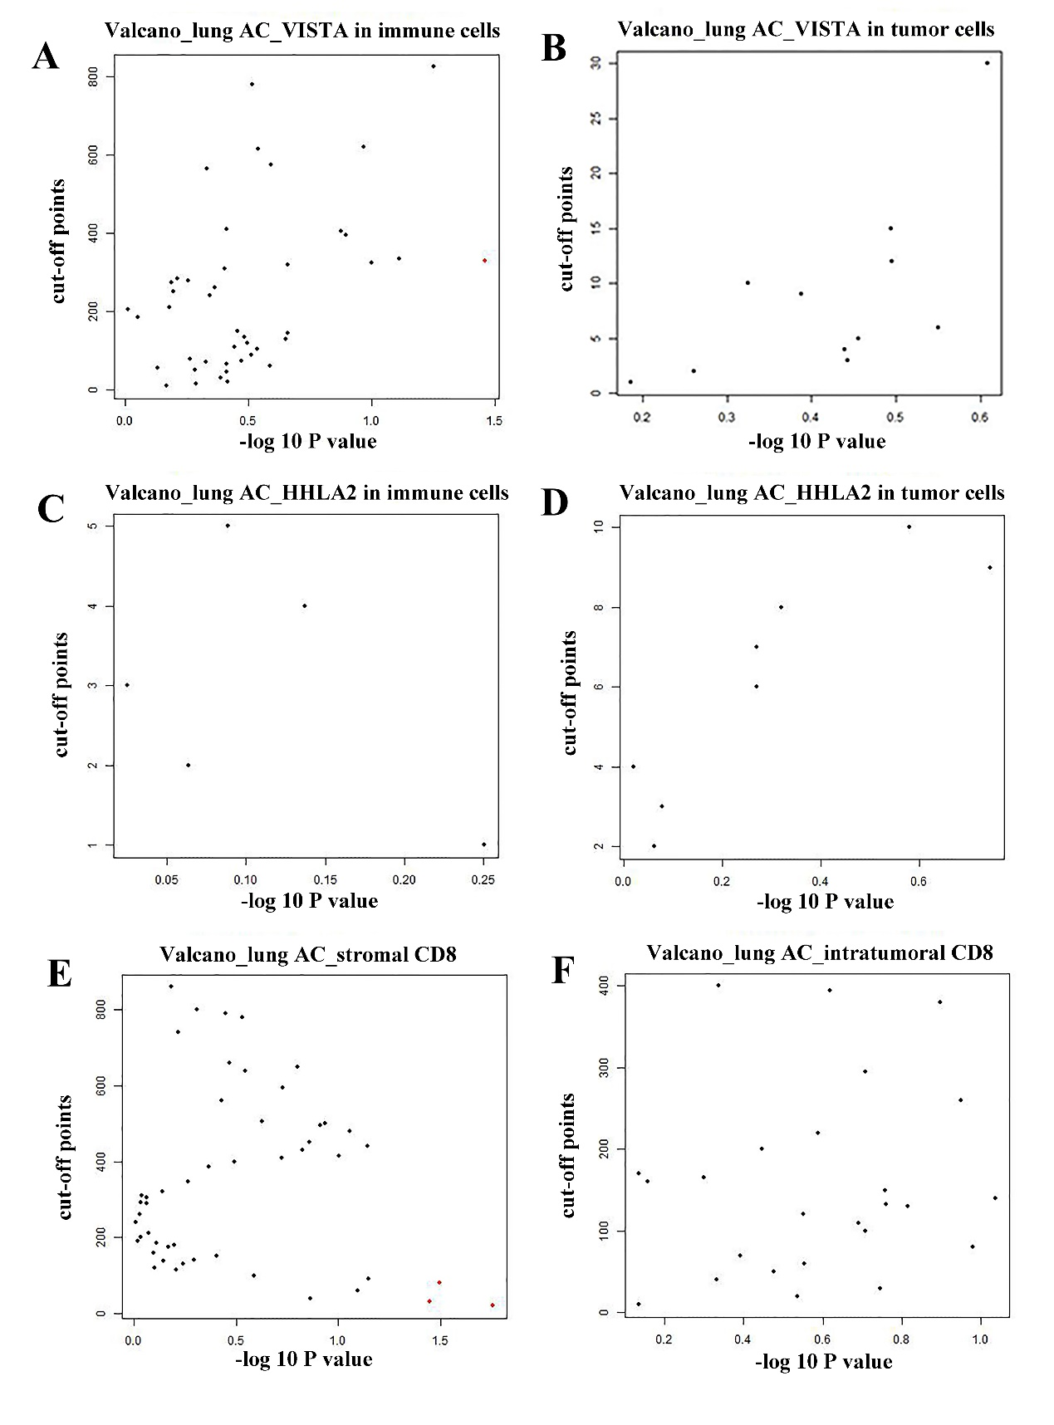
Figure. S1 Volcano plots to determine cut-off points for biomarkers.

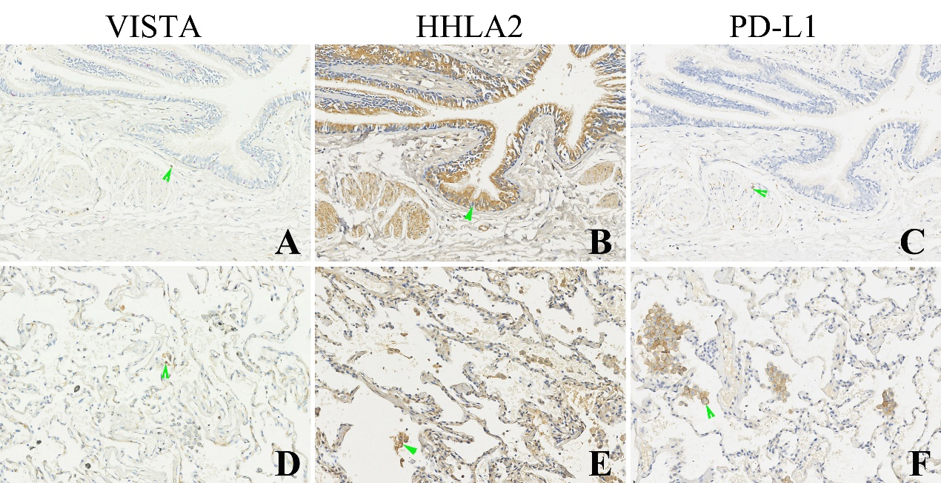
Figure. S2 Expression of VISTA, HHLA2 and PD-L1 proteins in the adjacent noncancerous lung tissues. VISTA and PD-L1 expression was negative in the bronchial epithelium, but HHLA2 expression was positive in the bronchial epithelium (green arrow head showed) and smooth muscle cells. The three proteins could express in the immune cells such as lymphocytes and macrophages (green arrow head showed)(original magnification A-F ×200 ).
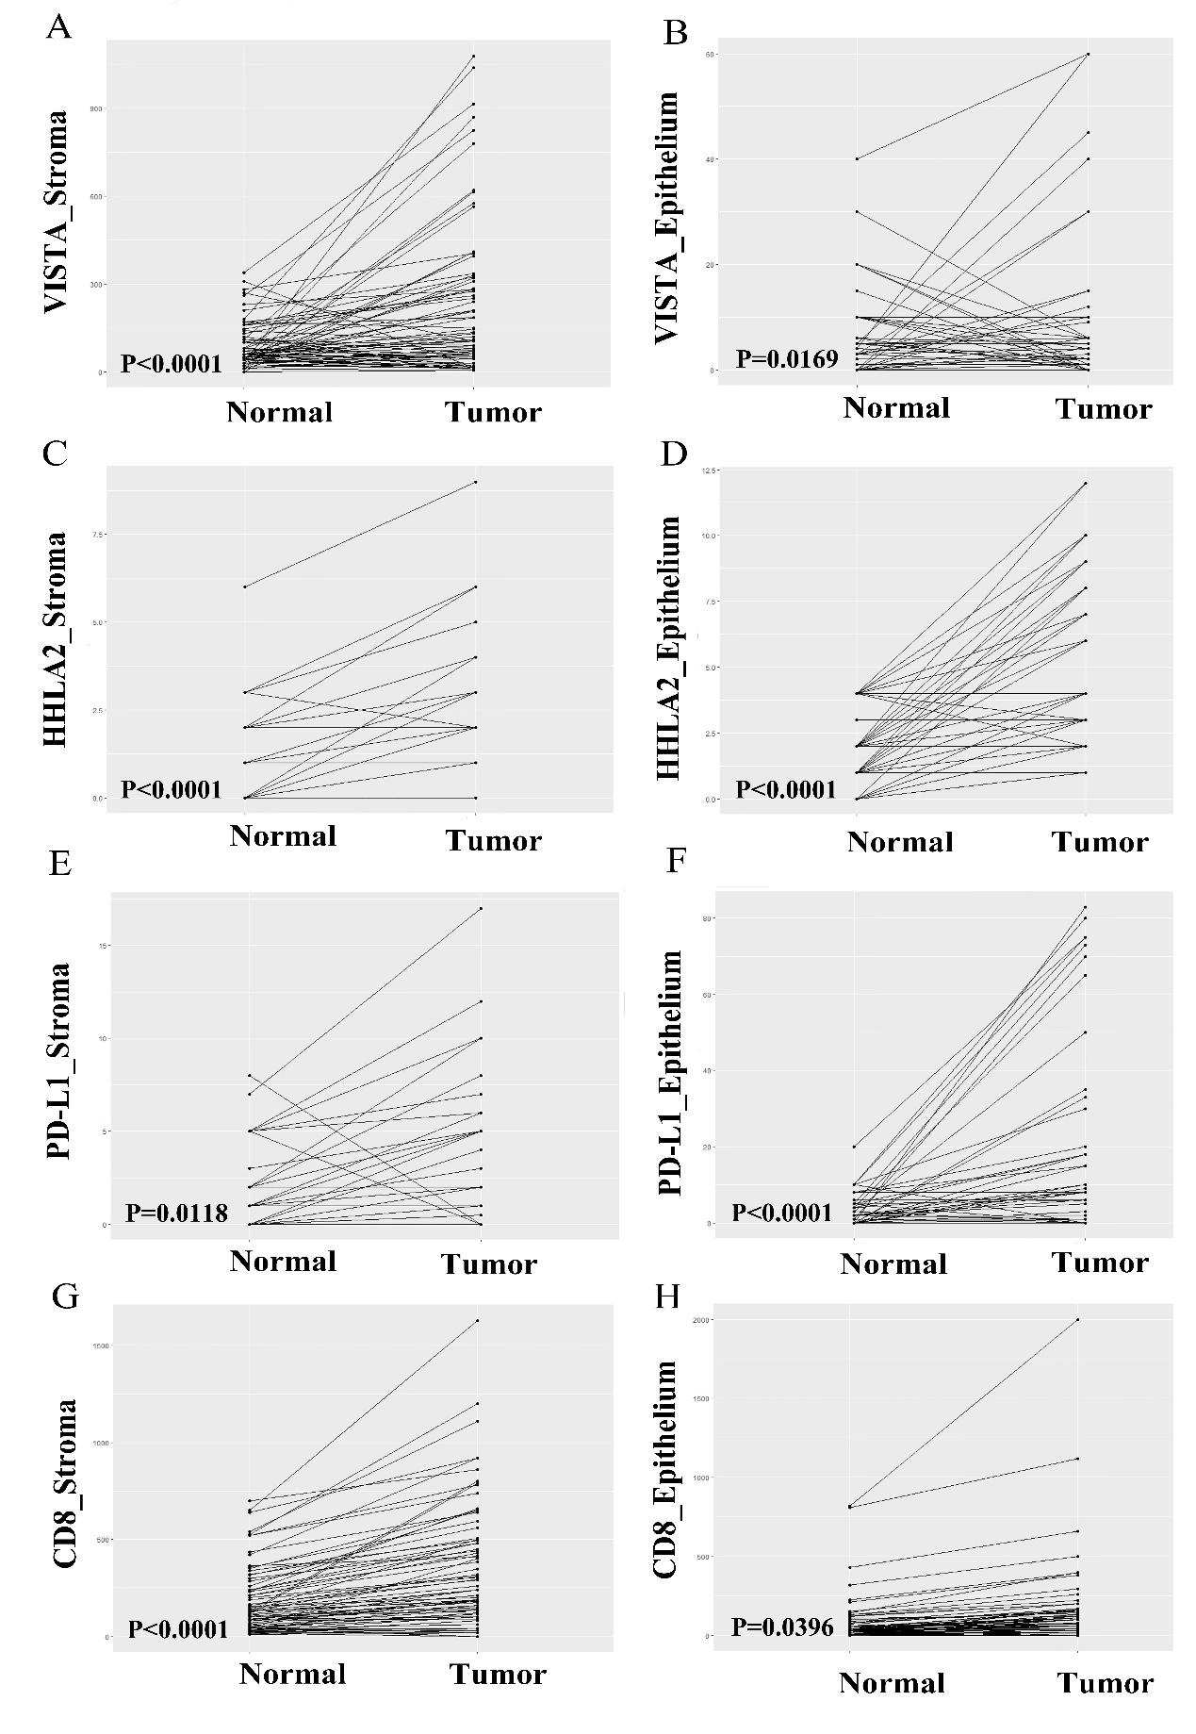
Figure.S3 Comparison of immune biomarkers expression trends between tumor and corresponding normal tissues.

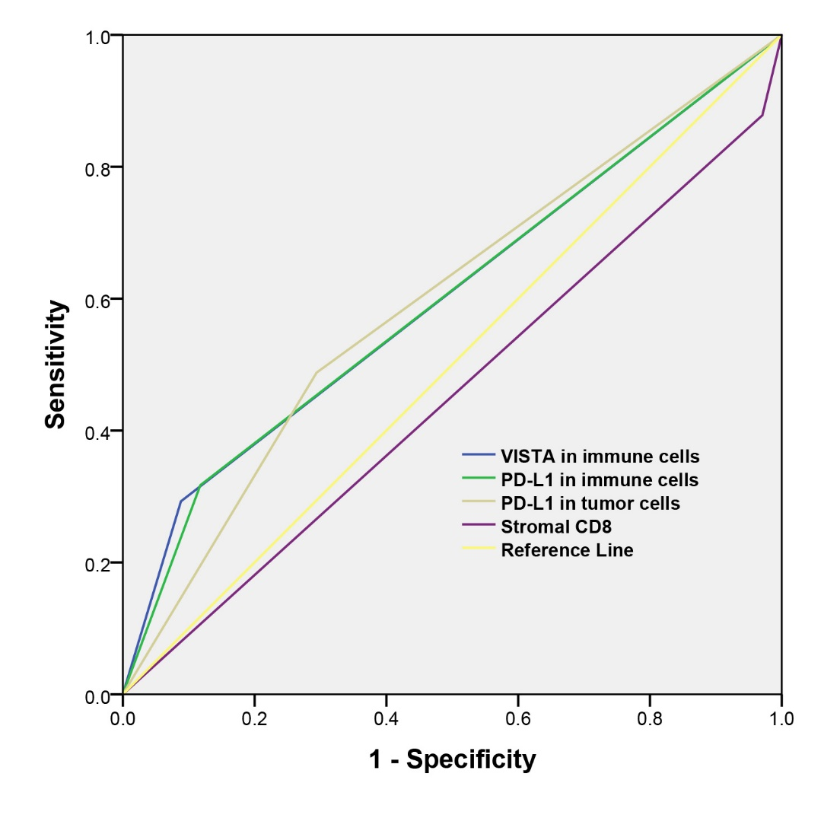
Figure. S4 ROC analysis of immune biomarkers by overall survival.

Supplementary table 1.Volcano Plots to determine cut-off points for biomarkers.
Biomarkers | LUAD cohort
 | Cut-off point | Minimum P value
VISTA in immune cells | 330 | 0.034798
VISTA in tumor cells | 30 | 0.246693
HHLA2 in immune cells | 1 | 0.561902
HHLA2 in tumor cells | 9 | 0.180455
Stromal CD8 | 20 | 0.017497
Intratumoral CD8 | 140 | 0.092036

Supplementary table 2. Spearman rank correlation between VISTA, HHLA2, PD-L1 and CD8⁺ T cell infiltration in the LUAD patients.
Tumor types | VISTA in IC | VISTA in TC | HHLA2 in IC | HHLA2 in TC | PD-L1 in IC | PD-L1 in TC | Stromal CD8 | Intratumoral CD8
VISTA in IC | 1(NA) | 0.509(P<0.001) | 0.371(P=0.001) | 0.095(P=0.418) | 0.580(P<0.001) | 0.320(P=0.005) | 0.380(P<0.001) | 0.469(P<0.001)
VISTA in TC | 0.509(P<0.001) | 1(NA) | 0.133(P=0.254) | 0.139(P=0.234) | 0.274(P=0.017) | 0.282(P=0.014) | 0.042(P=0.718) | 0.178(P=0.127）
HHLA2 in IC | 0.371(P=0.001) | 0.133(P=0.254) | 1(NA) | 0.334(P=0.003) | 0.296(P=0.010) | 0.027(P=0.817) | 0.184(P=0.114) | 0.209(P=0.072)
HHLA2 in TC | 0.095(P=0.418) | 0.139(P=0.234) | 0.334(P=0.003) | 1(NA) | 0.073(P=0.536) | 0.003(P=0.980) | -0.044(P=0.705) | 0.207(P=0.074)
PD-L1 in IC | 0.580(P<0.001) | 0.274(P=0.017) | 0.296(P=0.010) | 0.073(P=0.536) | 1(NA) | 0.379(P=0.001) | 0.189(P=0.105) | 0.393(P<0.001)
PD-L1 in TC | 0.320(P=0.005) | 0.282(P=0.014) | 0.027(P=0.817) | 0.003(P=0.980) | 0.379(P=0.001) | 1(NA) | 0.165(P=0.157) | 0.379(P=0.001)
Stromal CD8 | 0.380(P<0.001) | 0.042(P=0.718) | 0.184(P=0.114) | -0.044(P=0.705) | 0.189(P=0.105) | 0.165(P=0.157) | 1(NA) | 0.500(P<0.001)
Intratumoral CD8 | 0.469(P<0.001) | 0.178(P=0.127） | 0.209(P=0.072) | 0.207(P=0.074) | 0.393(P<0.001) | 0.379(P=0.001) | 0.500(P<0.001) | 1(NA)

