Supporting Information

Photodynamic Therapy-Mediated Extirpation of Cutaneous Resistant Dermatophytosis with Ag@ZnO Nanoparticles: An Efficient Therapeutic Approach for Onychomycosis
Behnaz Ghaemiª, S. Jamal Hashemi^{b,c} , Sharmin Kharraziª, Arfa Moshiri^{d,e}, Hossein Kargar Jahromi^{f}, Amir Amani^{g,h*}

ª Department of Medical Nanotechnology, School of Advanced Technologies in Medicine (SATiM), Tehran University of Medical Sciences,1417755469 Tehran, Iran
^{b} Department of Medical Mycology and Parasitology, School of Public Health, Tehran University of Medical Sciences, Tehran, Iran
^{c} Food Microbiology Research Centre, Tehran University of Medical Sciences, Tehran, Iran
^{d} Microbiology Research Centre, Pasteur Institute of Iran, Tehran, Iran.
^{e} Laboratory of Experimental Therapies in Oncology, IRCCS Istituto Giannina Gaslini, Genova, Italy
^{f} Research Centre for Non-Communicable Disease, Jahrom University of Medical Sciences, Jahrom, Iran
^{g} Natural Products and Medicinal Plants Research Centre, North Khorasan University of Medical Sciences, Bojnurd, Iran
^{h}Medical Biomaterial Research Centre, Tehran University of Medical Sciences, Tehran, Iran

Corresponding Author: aamani@tums.ac.ir (A. A.)

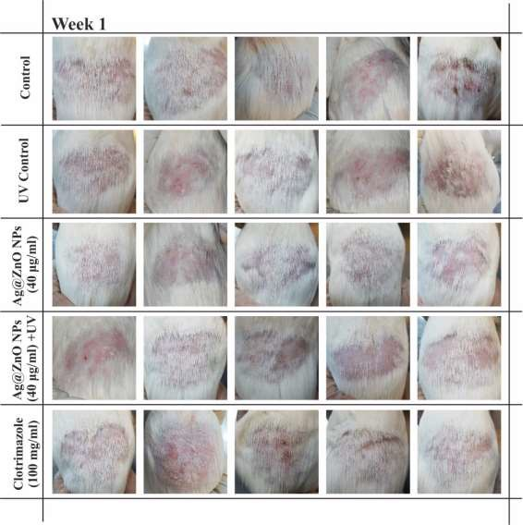

Figure S1. Optical Images of all guinea pigs in 5 groups, inoculated with T. Mentagrophytes, after 7 days (Week 1). The loss of hair in the infected area is noticeable.

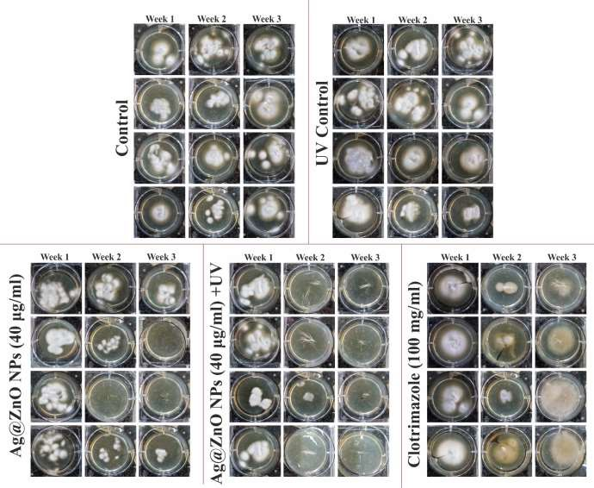

Figure S2. Culture results from all samples during three weeks of study. Hair and skin debris of infected area in guinea pigs were collected and cultured to monitor the infected area during three weeks' study.

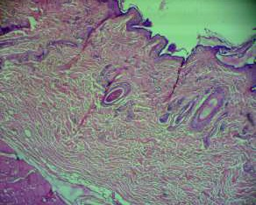
Control (Healthy)

Figure S3. Skin histopathology of healthy control group

Control (Un-Treated) | Ag@ZnO NPs-Treated | Clotrimazole-Treated
 |  | 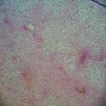
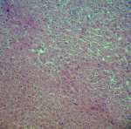 | 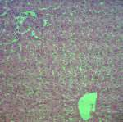 | 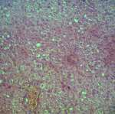
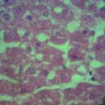 | 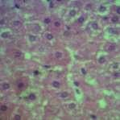 | 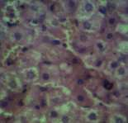

Figure S4. Liver histopathology with different magnification in un-treated control, Ag@ZnO NC- treated group vs. clotrimazole-treated group, the scale bar in first row is 200 µm and it is 100µm for second and third rows.

Control (Un-Treated) | Ag@ZnO NPs-Treated | Clotrimazole-Treated
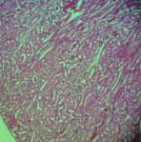 | 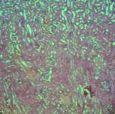 | 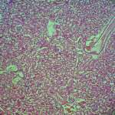
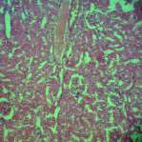 | 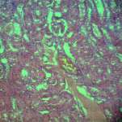 | 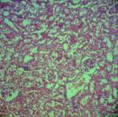
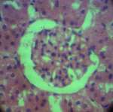 | 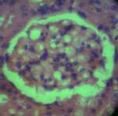 | 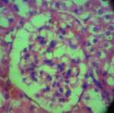

Figure S5. Different magnification of kidney histopathology in un-treated control, Ag@ZnO NC- treated group vs. clotrimazole-treated group. The scale bar in first row is 200 µm and it is 100µm for second and third rows

Author Current Affiliation: 1- The Russell H. Morgan Department of Radiology and Radiological Science, Division of MR Research, The Johns Hopkins University School of Medicine, Baltimore, MD, USA 2- Cellular Imaging Section and Vascular Biology Program, Institute for Cell Engineering, The Johns Hopkins University School of Medicine, Baltimore, MD, USA

