Supplementary appendix – Figures
Figure A: PRISMA flow diagram
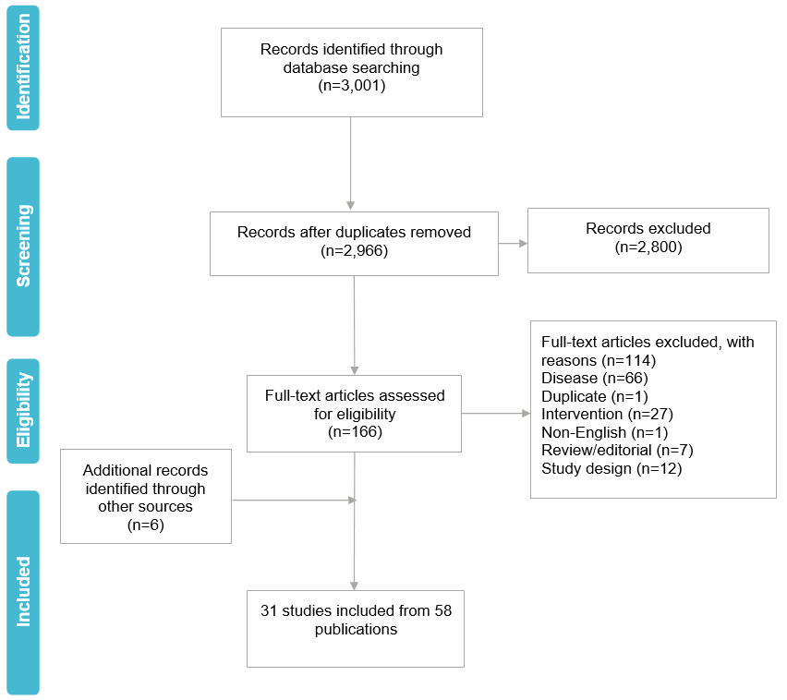

Key: PRISMA, Preferred Reporting Items for Systematic Reviews and Meta-Analyses.

Figure B: Subgroup analyses for pooled EXPLORER and PATHFINDER – overall survival in the RAC-RE population
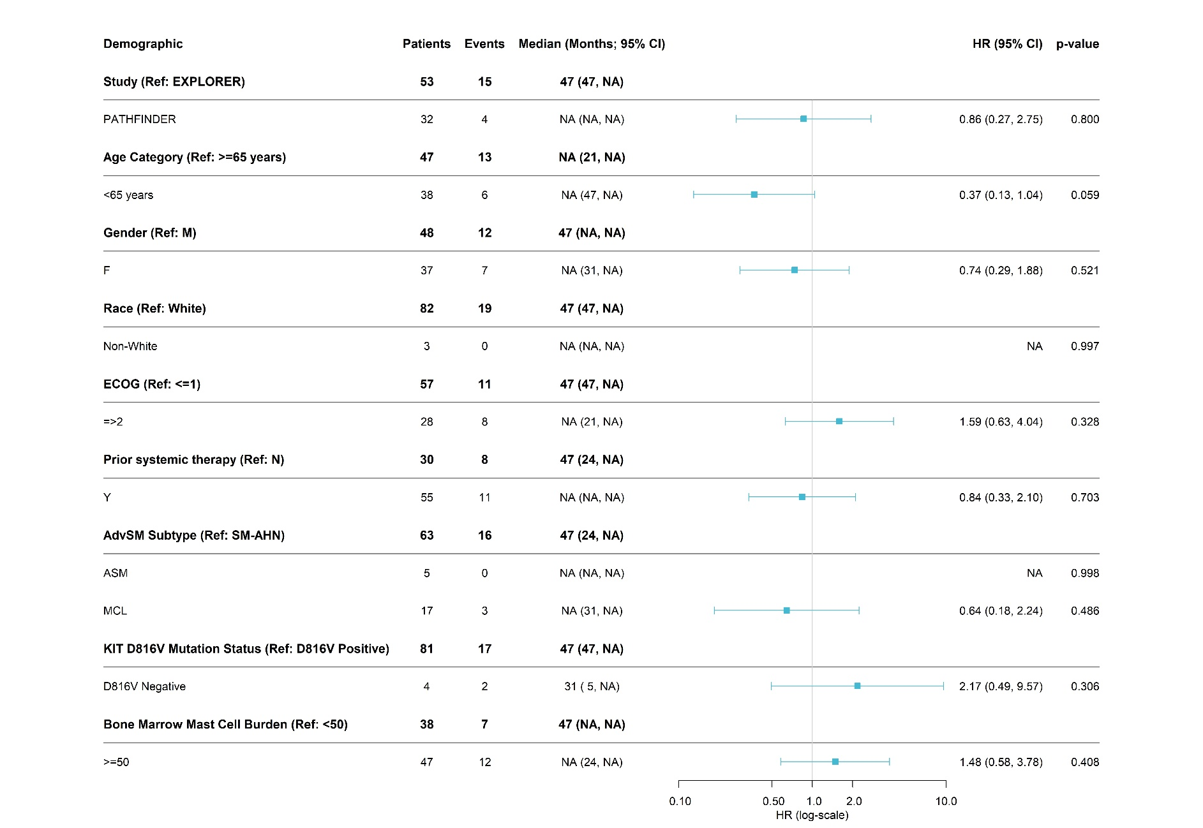
Key: AdvSM, advanced systemic mastocytosis; ASM, aggressive systemic mastocytosis; CI, confidence interval; ECOG, Eastern Cooperative Oncology Group; HR, hazard ratio; MCL, mast cell leukemia; NA, not applicable; RAC-RE, response assessment committee response-evaluable; SM-AHN, systemic mastocytosis with associated hematological neoplasm.

Figure C: Subgroup analyses for pooled EXPLORER and PATHFINDER – overall response rate in the RAC-RE population
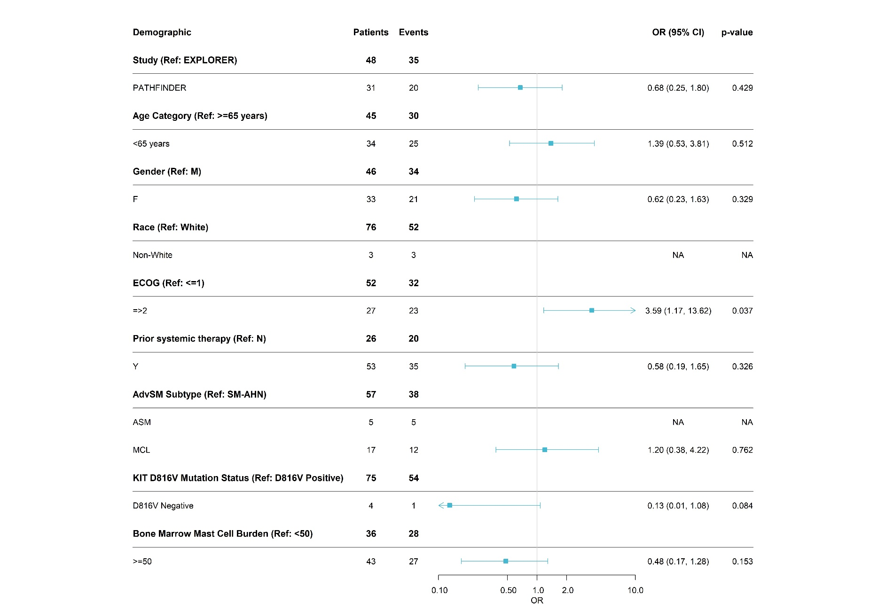

Key: AdvSM, advanced systemic mastocytosis; ASM, aggressive systemic mastocytosis; CI, confidence interval; ECOG, Eastern Cooperative Oncology Group; HR, hazard ratio; MCL, mast cell leukemia; NA, not applicable; OR, odds ratio; RAC-RE, response assessment committee response-evaluable; SM-AHN, systemic mastocytosis with associated hematological neoplasm.

Figure D: Subgroup analyses for pooled EXPLORER and PATHFINDER – complete remission rate in the RAC-RE population
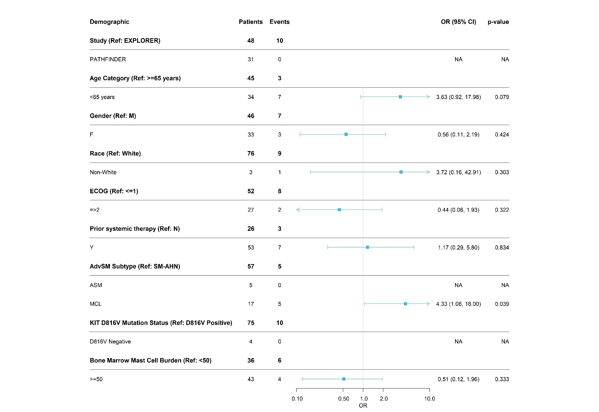

Key: AdvSM, advanced systemic mastocytosis; ASM, aggressive systemic mastocytosis; CI, confidence interval; ECOG, Eastern Cooperative Oncology Group; HR, hazard ratio; MCL, mast cell leukemia; NA, not applicable; OR, odds ratio; RAC-RE, response assessment committee response-evaluable; SM-AHN, systemic mastocytosis with associated hematological neoplasm.

Figure E: Kaplan–Meier of pooled avapritinib (safety) versus pooled midostaurin (FAS)
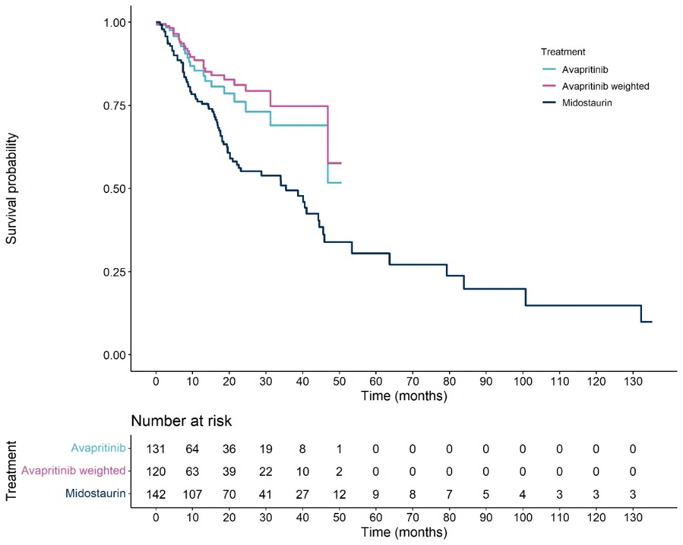
Key: FAS, full analysis set.

Figure F: Kaplan–Meier of PATHFINDER avapritinib (RAC-RE) versus pooled midostaurin (PEP)
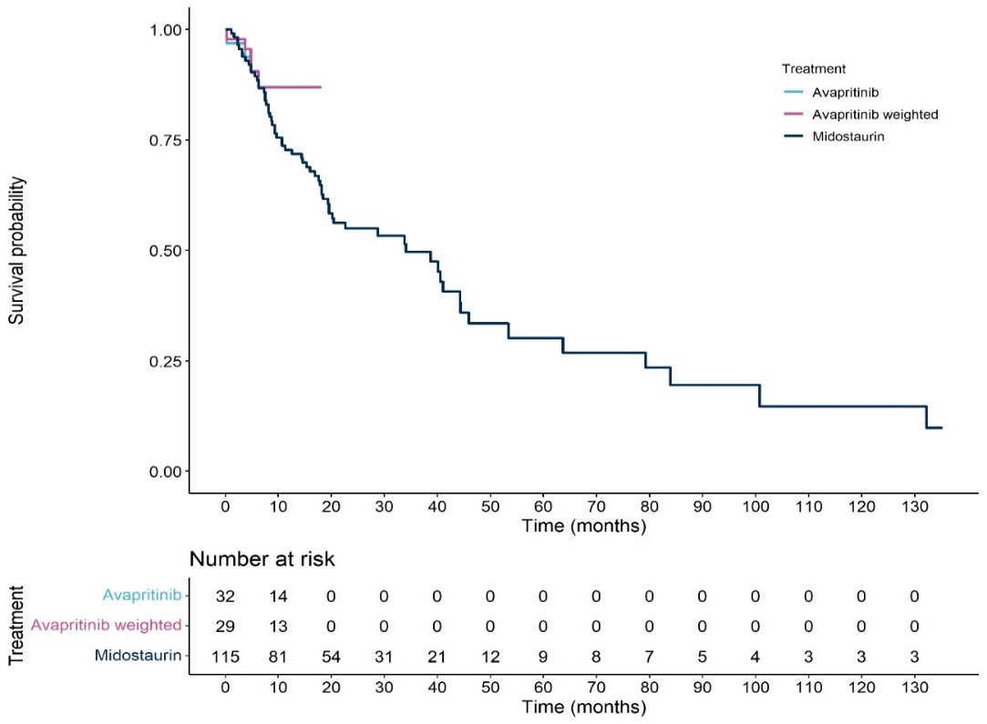

Key: PEP, primary efficacy population; RAC-RE, response assessment committee response-evaluable.

Figure G: Kaplan–Meier of pooled avapritinib (RAC-RE, midostaurin-naïve) versus pooled midostaurin (PEP)
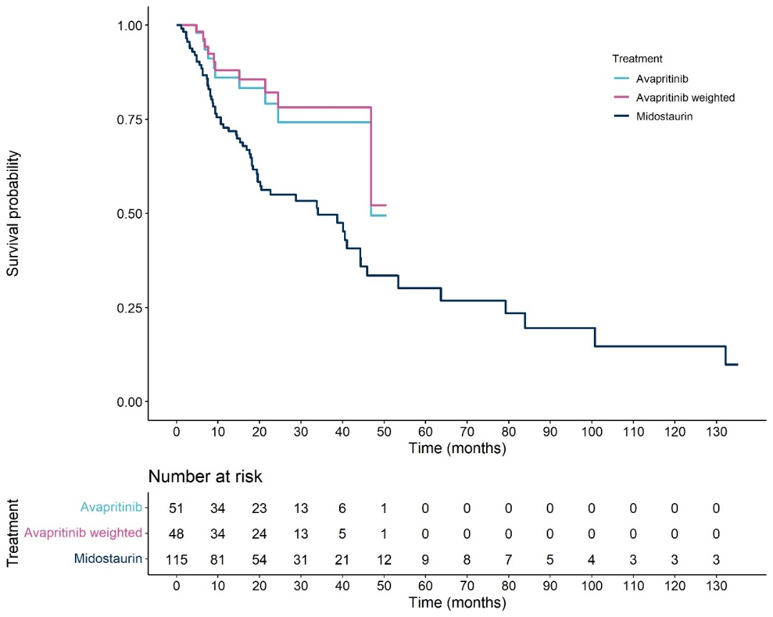

Key: PEP, primary efficacy population; RAC-RE, response assessment committee response-evaluable.

Figure H: Kaplan–Meier of pooled avapritinib (RAC-RE, 200 mg) versus pooled midostaurin (PEP)
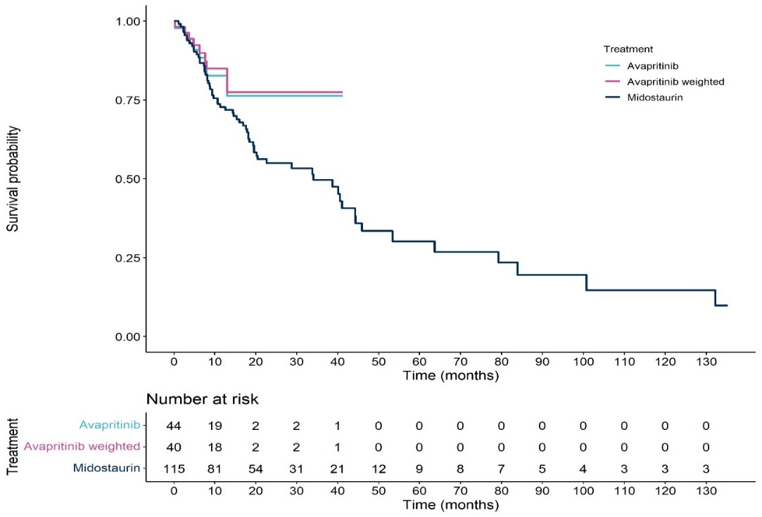

Key: PEP, primary efficacy population; RAC-RE, response assessment committee response-evaluable.
Figure I: Overall survival results when number of C-findings is included as a matching variable
Key: CI, confidence interval; HR, hazard ratio; ITC, indirect treatment comparison; MAIC, matching-adjusted indirect comparison; PEP, primary efficacy population; RAC-RE, response assessment committee response-evaluable.
Note: *, pooled EXPLORER and PATHFINDER population, **, pooled D2201 and A2213 population.

Figure J: Overall response rate and complete remission results when number of C-findings is included as a matching variable
Key: CI, confidence interval; CR, complete remission; ITC, indirect treatment comparison; MAIC, matching-adjusted indirect comparison; OR, odds ratio; ORR, overall response rate; PEP, primary efficacy population; RAC-RE, response assessment committee response-evaluable.
Note: *, pooled EXPLORER and PATHFINDER population.

