Supplementary material

Navigating the hydroxymethylome: some experimental biases and quality control tools for the tandem OxBS Illumina microarrays

Contents
Supplementary Table 1 Multivariable linear regression model outputs 3
Supplementary Table 2 Linear mixed effect model outputs 4
Supplementary Table 3. Pairwise Wilcoxon rank sum test p-values from comparing the internal normalization control probe (NORM_A/G/C/T) intensities in BS converted and oxBS converted ccRCC samples. 5
Supplementary Figure 1. The probe call rate difference across all data sets 6
Supplementary Figure 2. Principal component regression analysis of technical variables in ccRCC samples 7
Supplementary Figure 3. Coefficient of variation and ICC in replicate human fetal oligodendrocyte samples. 8
Supplementary Figure 4. The recommended 5hmC cut-off batch 1 samples batch 2 samples using oxBSQC … 9
Supplementary Figure 5. The distribution of 5hmC signal in low-quality probe vs high quality probe in batch 1 samples batch 2 samples using oxBSQC 10
Supplementary Figure 6. The CpG genomic location enrichment for low-quality probes in batch1 and batch2 using oxBSQC 11
Supplementary Figure 7. The distribution of internal normalization control probe (NORM_A/G/C/T) intensities in BS converted and oxBS converted ccRCC samples 12

Supplementary Table 1. Multivariable linear regression model outputs for comparing DNA extraction kit performance between BS and oxBS treated samples, with sample source adjusted.

 | Multivariable Linear Regression Model
 | Dependent variable:
 | Fraction of Low Quality Probes
 | Bisulfite Converted Samples | Oxidative Bisulfite Converted Samples
Kit:Tandem Nucleic Acid Extraction Kit | -0.365 | -19.464***
 | (-5.687, 4.956) | (-27.038, -11.890)
Study:ccRCC | -0.33 | 9.283**
 | (-5.679, 5.018) | (1.671, 16.895)
Study:DWB | 0.698 | 8.504***
 | (-1.767, 3.163) | (4.996, 12.013)
Study:GSE104273 | -18.581*** | -11.926***
 | (-20.886, -16.276) | (-15.206, -8.646)
Study:GSE105109 | -7.965*** | -8.719***
 | (-9.734, -6.196) | (-11.236, -6.202)
Study:GSE116402 | -17.796*** | 6.403
 | (-24.102, -11.491) | (-2.571, 15.377)
Study:GSE133062 | -19.630*** | 4.204
 | (-25.344, -13.916) | (-3.928, 12.337)
Study:GSE63179 | -4.437** | -0.608
 | (-8.404, -0.471) | (-6.253, 5.038)
Study:GSE71328 | -15.211*** | -5.409***
 | (-18.041, -12.381) | (-9.437, -1.381)
Study:GSE71719 | -9.190*** | -6.231***
 | (-11.448, -6.932) | (-9.445, -3.017)
Study:GSE73895 | -6.518*** | 5.291***
 | (-8.657, -4.379) | (2.247, 8.336)
Study:PedCNS | -0.471 | 4.289***
 | (-2.508, 1.566) | (1.390, 7.187)
Constant | 98.192*** | 83.051***
 | (96.500, 99.883) | (80.644, 85.458)
Observations | 417 | 417
R2 | 0.728 | 0.627
Adjusted R2 | 0.72 | 0.616
Residual Std. Error (df = 404) | 3.661 | 5.21
F Statistic (df = 12; 404) | 90.091*** | 56.671***
Note: *p<0.1; **p<0.05; ***p<0.01

Supplementary Table 2. Linear mixed effect model outputs for comparing DNA extraction kit performance between BS and oxBS treated samples, with sample source included as a random intercept.

 | Linear Mixed Effect Model
 | Dependent variable:
 | Fraction of Low Quality Probes
 | Bisulfite Converted Samples | Oxidative Bisulfite Converted Samples
Kit:Tandem Nucleic Acid Extraction Kit | -1.704 | -15.935***
 | (-6.435, 3.026) | (-21.708, -10.162)
Constant | 90.240*** | 82.599***
 | (85.753, 94.727) | (78.610, 86.589)
Observations | 417 | 417
Log Likelihood | -1,155.39 | -1,296.61
Akaike Inf. Crit. | 2,318.77 | 2,601.22
Bayesian Inf. Crit. | 2,334.89 | 2,617.33
Note: *p<0.1; **p<0.05; ***p<0.01

Supplementary Table 3. Pairwise Wilcoxon rank sum test p-values from comparing the internal normalization control probe (NORM_A/G/C/T) intensities in BS converted and oxBS converted ccRCC samples.
ID | Norm_A Red P-value | Norm_C Green P-value | Norm_G Green P-value | Norm_T Red P-value
RCD002 | 7.45E-09 | 1.90E-11 | 7.45E-09 | 2.00E-11
RCD003 | 7.45E-09 | 1.90E-11 | 7.45E-09 | 3.03E-11
RCD005 | 7.45E-09 | 1.90E-11 | 7.45E-09 | 3.36E-11
RCD007 | 7.45E-09 | 1.80E-11 | 7.45E-09 | 1.90E-11
RCD008 | 3.73E-08 | 2.22E-11 | 1.49E-08 | 4.35E-11
RCD013 | 3.73E-08 | 2.59E-11 | 2.24E-08 | 5.34E-11
RCD047 | 7.45E-09 | 1.90E-11 | 7.45E-09 | 2.22E-11
RCD058 | 7.45E-09 | 1.90E-11 | 7.45E-09 | 2.46E-11
RCD060 | 7.45E-09 | 1.90E-11 | 7.45E-09 | 1.90E-11
RCD062 | 7.45E-09 | 1.80E-11 | 7.45E-09 | 1.90E-11
RCD072 | 0.012269832 | 0.003780043 | 0.052813068 | 0.000622078
RCD074 | 1.42E-07 | 5.62E-11 | 4.10E-07 | 8.43E-11
RCD078 | 7.45E-09 | 1.90E-11 | 7.45E-09 | 2.00E-11
RCD080 | 7.45E-09 | 2.00E-11 | 7.45E-09 | 3.03E-11
RRC165 | 7.45E-09 | 1.90E-11 | 7.45E-09 | 3.19E-11
RRC172 | 7.45E-09 | 3.03E-11 | 7.45E-09 | 6.22E-11
RRC228 | 7.45E-09 | 1.90E-11 | 7.45E-09 | 2.59E-11
RRC231 | 7.45E-09 | 1.90E-11 | 7.45E-09 | 1.90E-11
RRC678 | 7.45E-09 | 2.11E-11 | 7.45E-09 | 6.22E-11
RRC691 | 1.49E-08 | 1.90E-11 | 2.24E-08 | 2.73E-11
RRC725 | 7.45E-09 | 1.90E-11 | 7.45E-09 | 2.00E-11
RRC755 | 7.45E-09 | 1.90E-11 | 7.45E-09 | 2.34E-11

Supplementary Figure 1. The probe call rate difference across all data sets

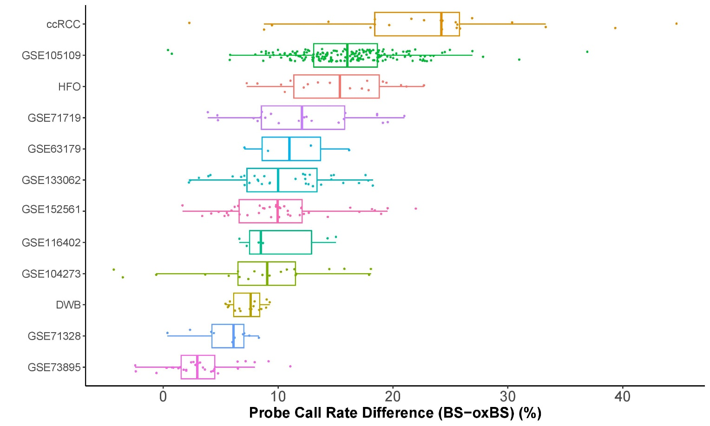

Supplementary Figure 2. Principal component regression analysis of technical variables in ccRCC samples

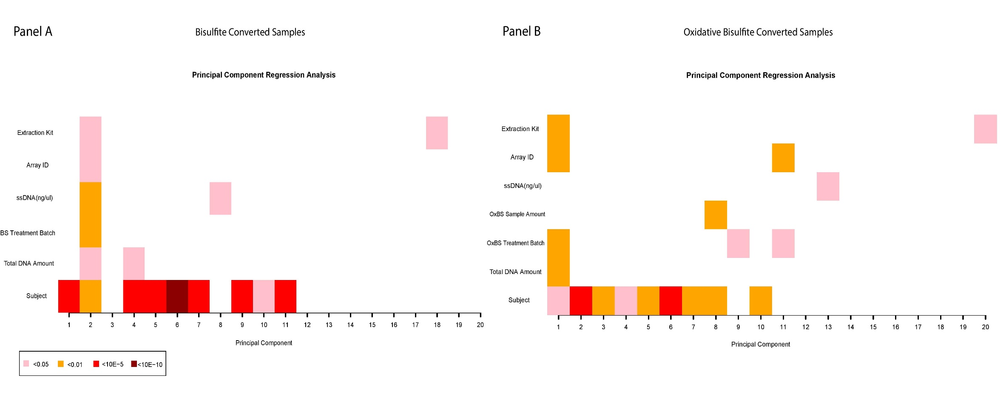

Supplementary Figure 3. Coefficient of variation and ICC in replicate human fetal oligodendrocyte samples.
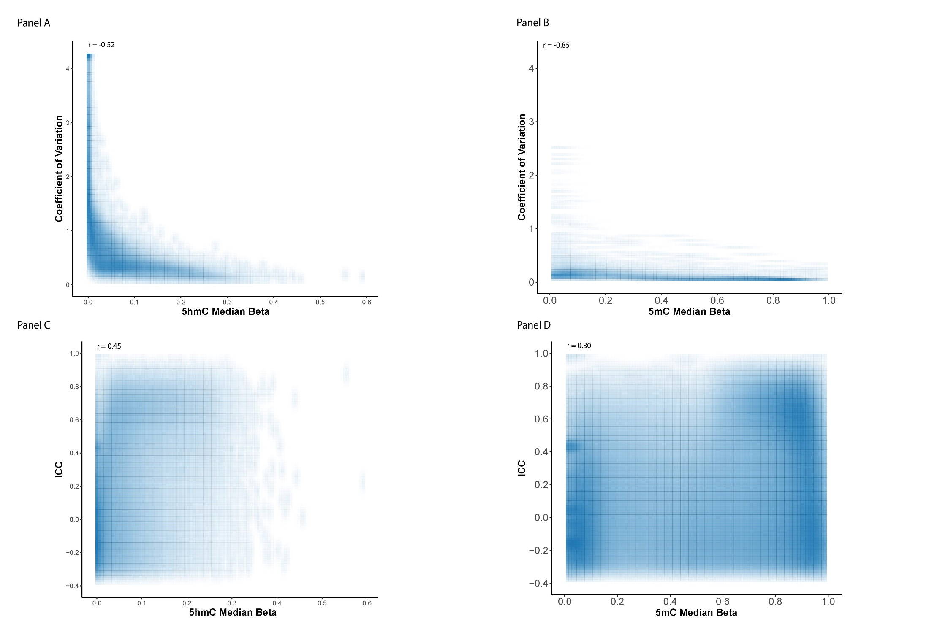

Supplementary Figure 4. The recommended 5hmC cut-off batch 1 samples batch 2 samples using oxBSQC.
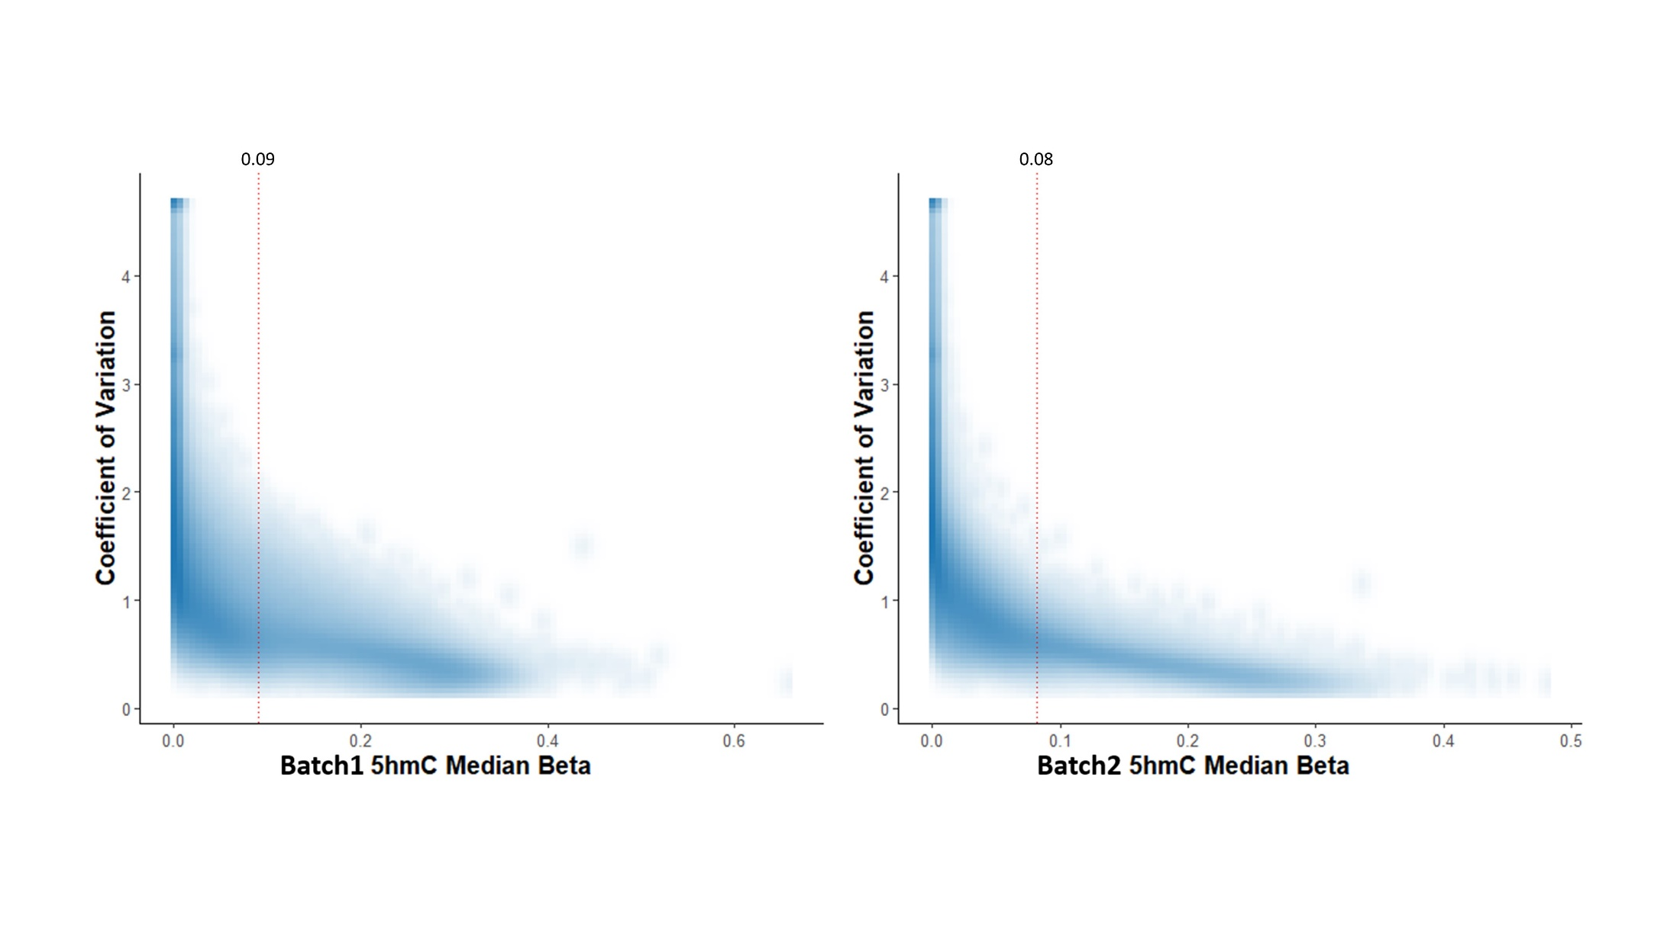

Supplementary Figure 5. The distribution of 5hmC signal in low-quality probe vs high quality probe in batch 1 samples batch 2 samples using oxBSQC.
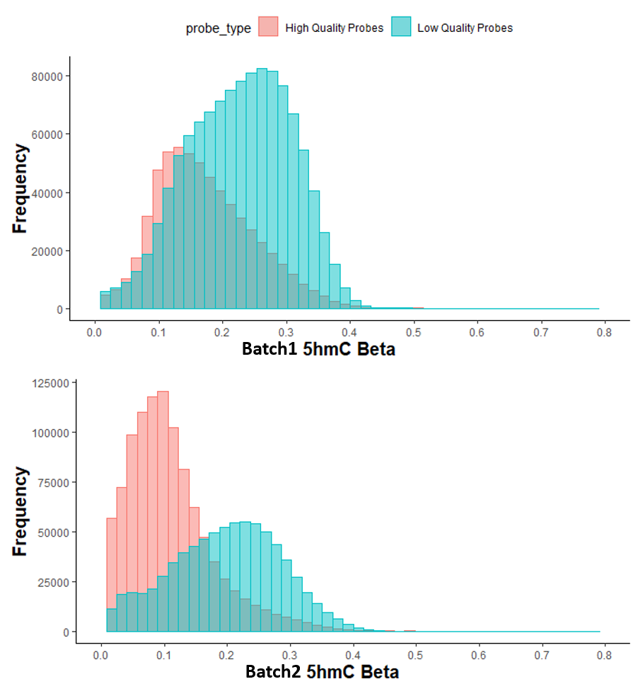

Supplementary Figure 6. The CpG genomic location enrichment for low-quality probes in batch1 and batch2 using oxBSQC.

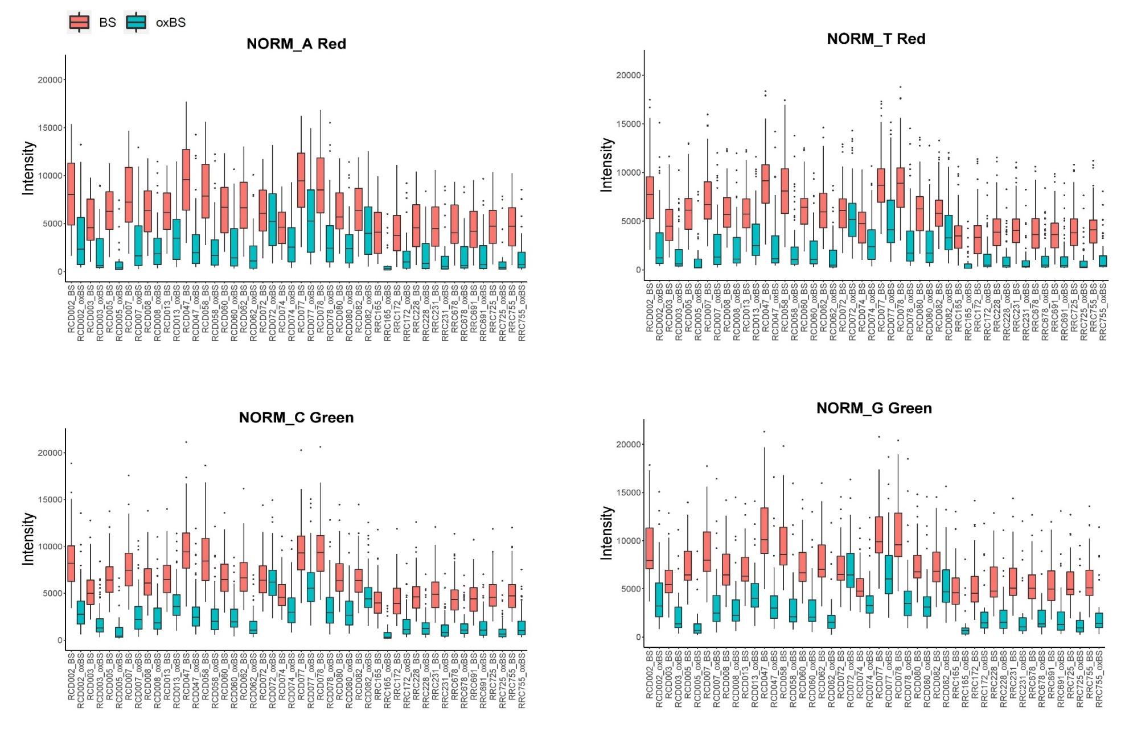
Supplementary Figure 7. The distribution of internal normalization control probe (NORM_A/G/C/T) intensities in BS converted and oxBS converted ccRCC samples.

