Supplementary Materials:
Figure S1: Analysis of the physicochemical profile of the gp46 protein. The analysis suggests that the L55P mutation may generate an important change in hydrophilicity, hydropathy, antigenicity, accessibility, and membrane buried-helix.
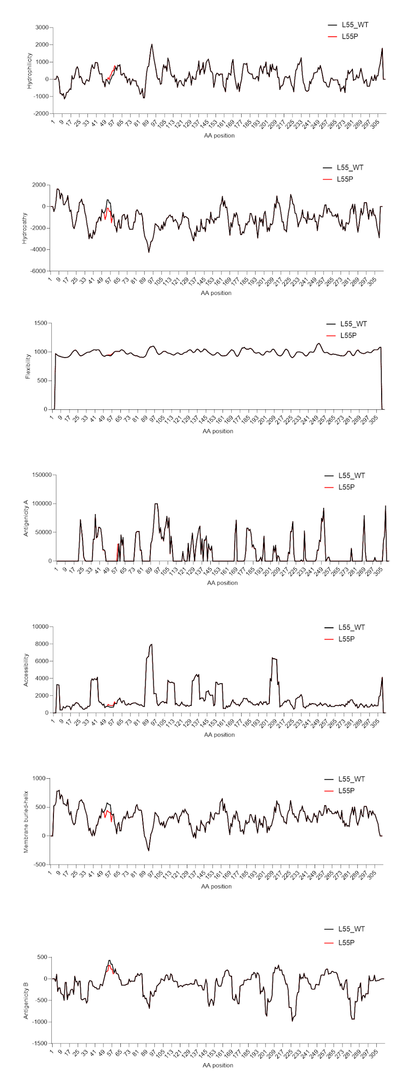
Figure S2: Analysis of the physicochemical profile of the gp46 protein. The analysis suggests that the Q64H and S72G mutations may generate an important change in antigenicity, accessibility, and membrane buried-helix. It also suggests that the V247I mutation may generate an important change in antigenicity.
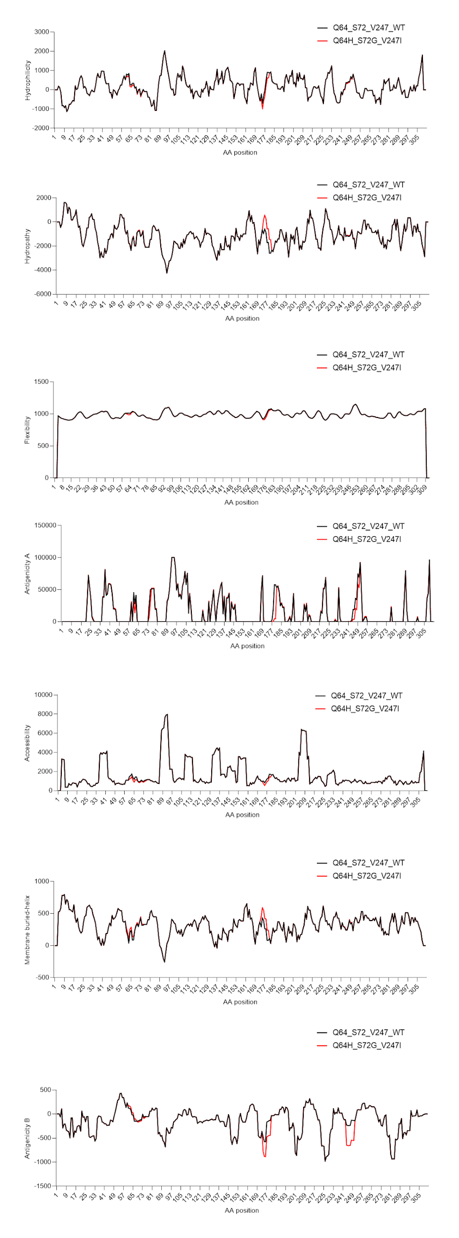
Figure S3: Analysis of the physicochemical profile of the HBZ protein. The analysis suggests that the G90R mutation may generate an important change in hydrophilicity, hydropathy, antigenicity, accessibility, and membrane buried-helix. It also suggests that the K169R mutation may alter accessibility.

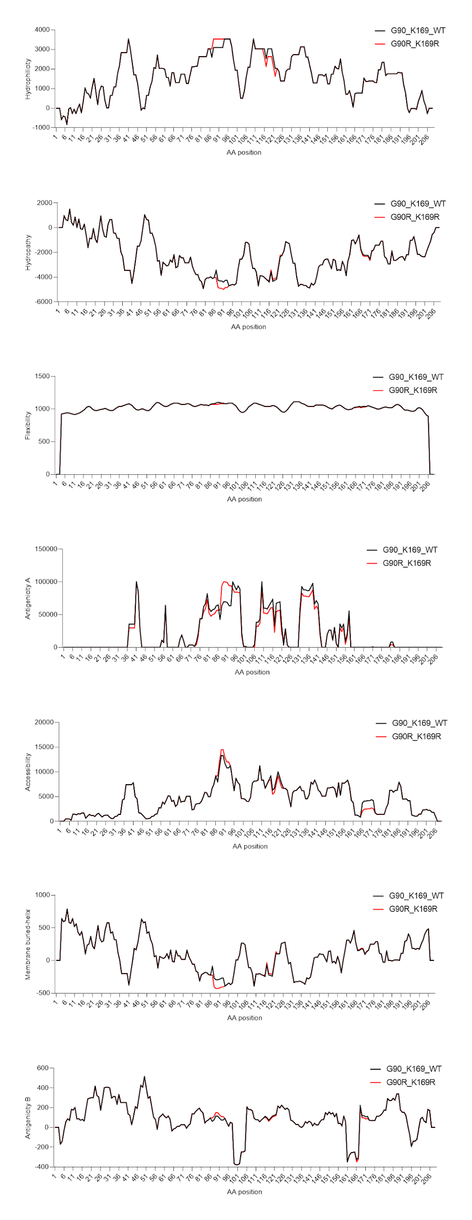
Figure S4: Analysis of the physicochemical profile of the p14 protein. The analysis suggests that the G244D mutation may generate an important change in hydrophilicity, hydropathy, antigenicity, accessibility, and membrane buried-helix.
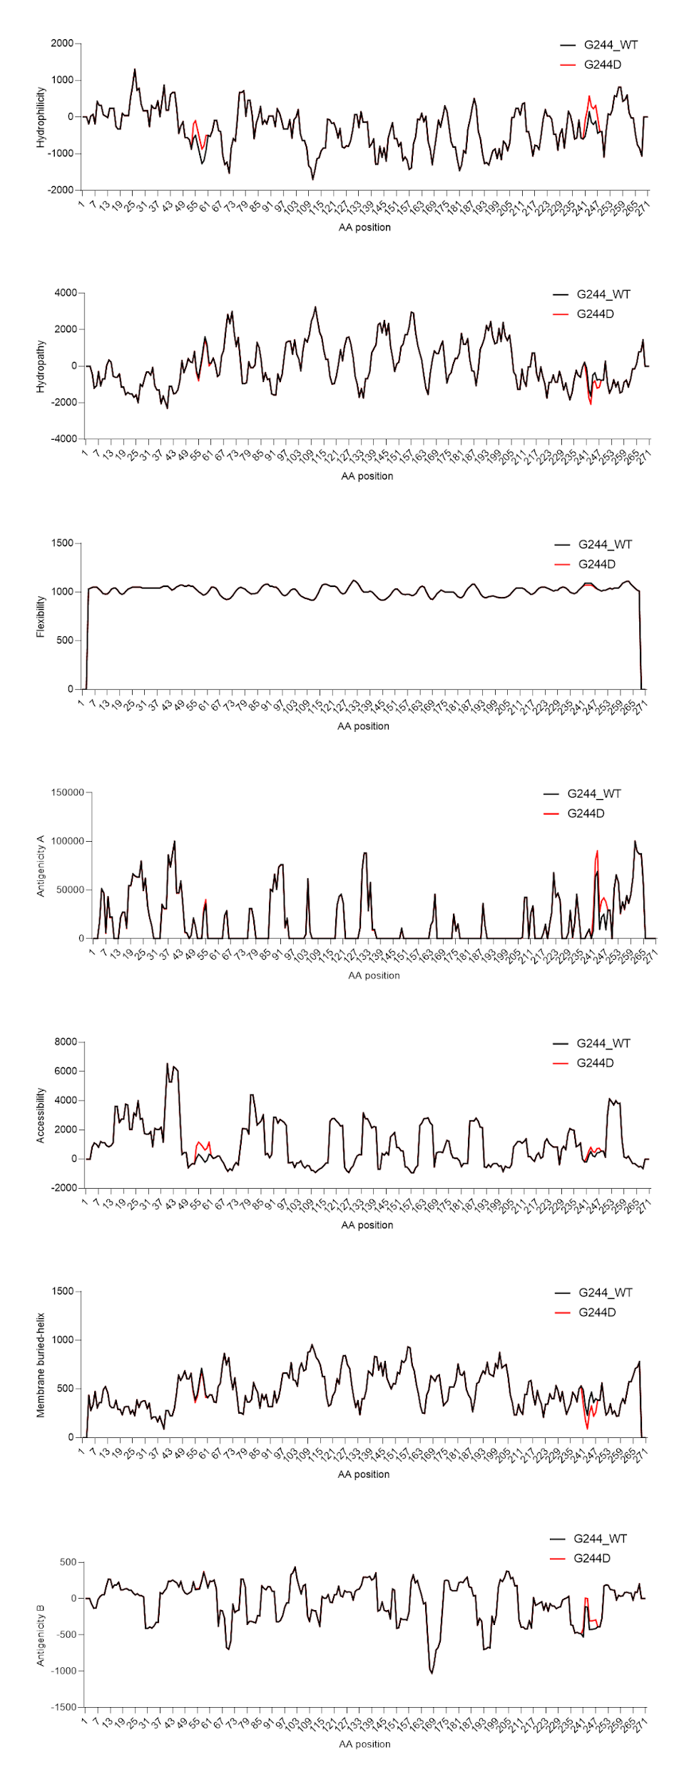
Figure S5: Analysis of the physicochemical profile of the p15 protein. The analysis suggests that the Q3P mutation may generate an important change in hydropathy, antigenicity, and accessibility.

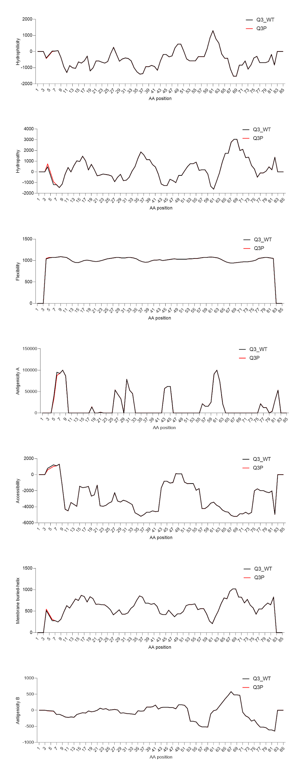
Figure S6: Analysis of the physicochemical profile of the p30 protein. The analysis suggests that the R37C mutation may generate an important change in hydrophilicity, hydropathy, accessibility, and membrane buried-helix.

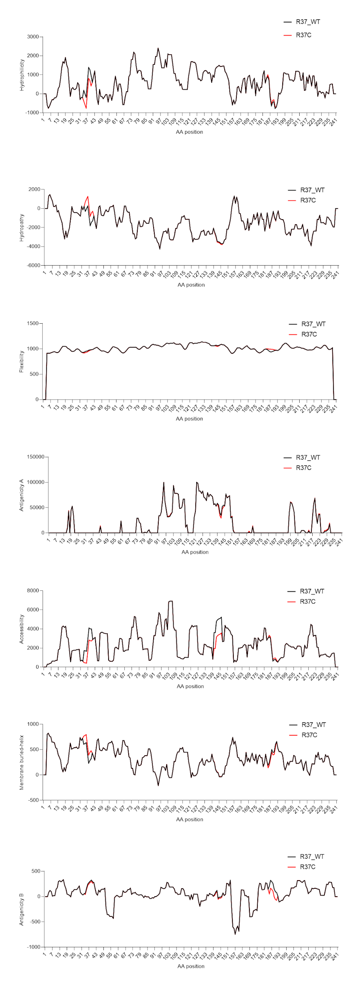
Figure S7: Analysis of the physicochemical profile of the p40 protein. The analysis suggests that the P136S mutation may generate an important change in membrane buried-helix.

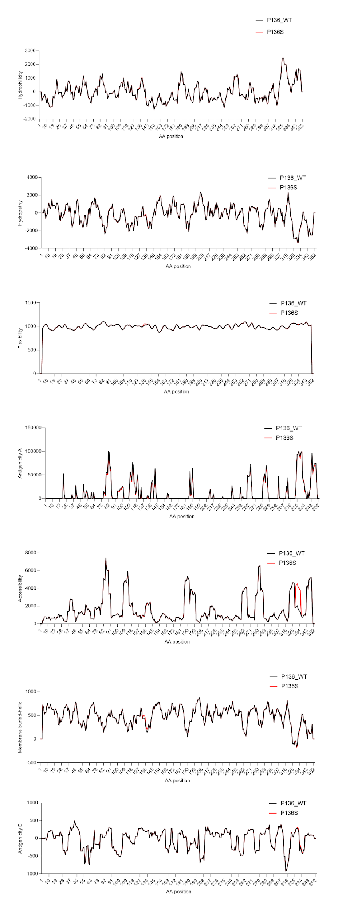
Figure S8: Analysis of the physicochemical profile of the p12 protein. The analysis suggests that the P34L mutation may generate an important change in hydrophilicity, hydropathy, antigenicity, flexibility, accessibility, and membrane buried-helix.
