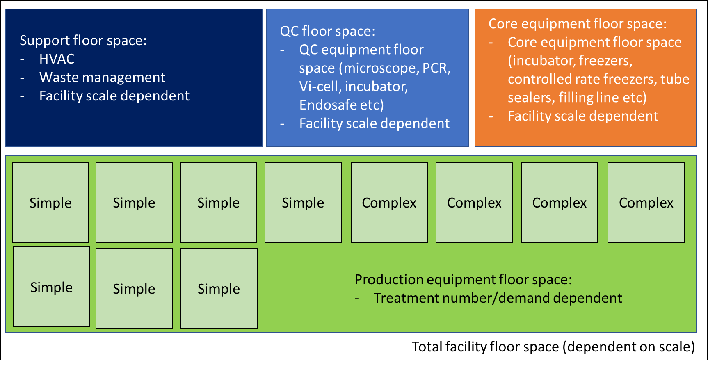
Supplementary Material 2 Facility floor plan schematic

