Supplemental Figure S1. CD19+ B-cell count over time following treatment with RTX-PF, RTX-EU, and RTX-US in patients with RA [1].
(© 2016 Pfizer Inc. British J of Clinical Pharmacol., published by John Wiley & Sons on behalf of British Pharmacological Society).
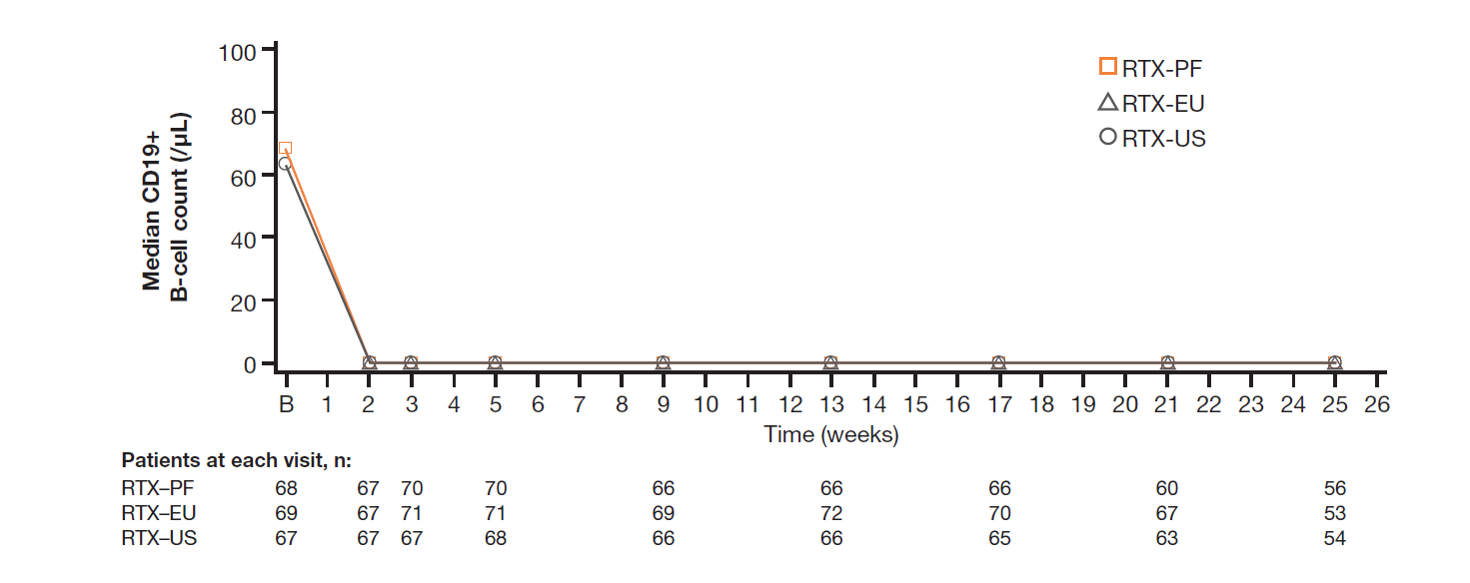
RA: rheumatoid arthritis; RTX-EU: rituximab reference product (MabThera®) sourced from the European Union; RTX-PF: PF-05280586; RTX-US: rituximab reference product (Rituxan®) sourced from the United States.

Supplemental Figure S2. Study design (REFLECTIONS B328-06) [2]. (© The Author(s). https://creativecommons.org/licenses/by-nc/4.0/)

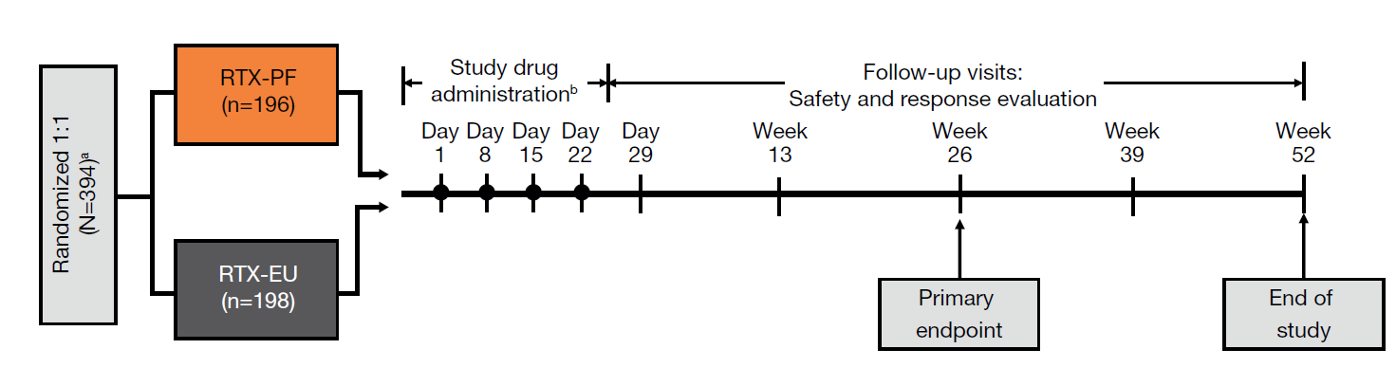
ªSubjects were stratified at randomization (1:1) using the FLIPI2 classification and had an ECOG performance status of 0–1. ^{b}PF-05280586 or rituximab-EU (375 mg/m² intravenously [once weekly for 4 weeks at days 1, 8, 15, and 22]).
ECOG Eastern Cooperative Oncology Group: FLIPI2 Follicular Lymphoma International Prognostic Index 2: RTX-EU: rituximab reference product (MabThera®) sourced from the European Union; RTX-PF: PF-05280586.

Supplemental Figure S3. Incidence of anti-drug antibodies (safety population). Created using data from [2].
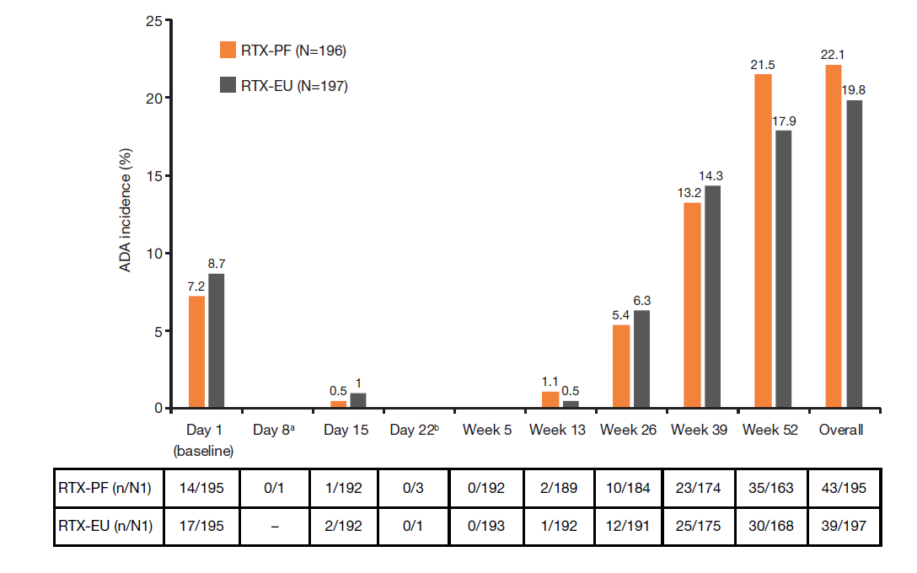
For the Overall row the denominator (N1) was the number of subjects tested who had at least one observed post-dose result, and a positive subject was defined as a subject with at least one post-dose sample that tested positive.
ªDay 8 was an unplanned visit.
^{b}Sample collected before protocol amendment 1.
n: number of subjects; N: total number of subjects receiving treatment in each group; N1: number of subjects tested who had an observed result at the specified visit; rituximab-EU: rituximab reference product (MabThera®) sourced from the European Union; RTX-PF: PF-05280586.

References
1. Cohen S, Emery P, Greenwald M et al. A phase I pharmacokinetics trial comparing PF-05280586 (a potential biosimilar) and rituximab in patients with active rheumatoid arthritis. Br. J. Clin. Pharmacol. 82(1), 129-138 (2016).
2. Sharman JP, Liberati AM, Ishizawa K et al. A randomized, double-blind, efficacy and safety study of PF-05280586 (a rituximab biosimilar) compared with rituximab reference product (MabThera®) in subjects with previously untreated CD20-positive, low-tumor-burden follicular lymphoma (LTB-FL). Biodrugs 34(2), 171-181 (2020).

