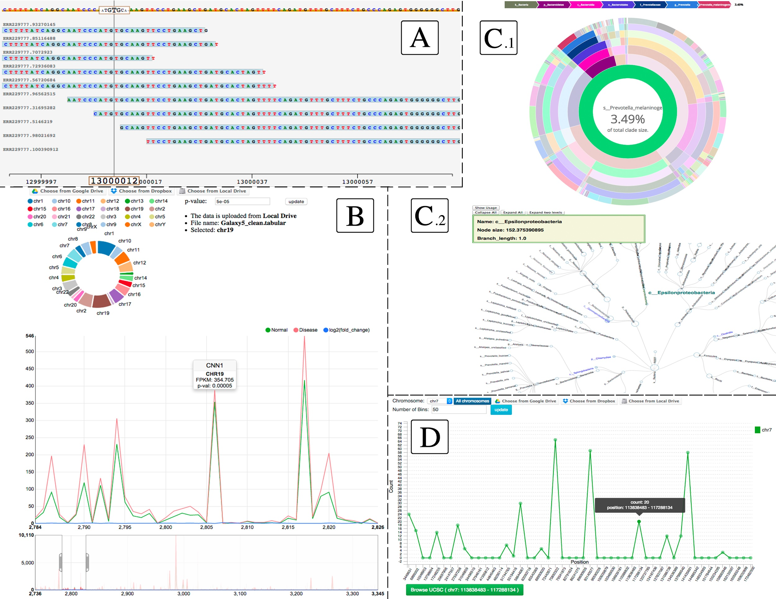

Figure 1. Examples of Visual Omics Explorer (VOE) data visualizations, which are intuitive for researchers without prior bioinformatics expertise and cover both the primary analysis of the NGS data, in addition to exploratory data mining of the bioinformatics algorithms output. (A). NGS read alignments and gene variants; (B). differential gene expression along a chromosomal region as computed by RNA-seq analysis; (C₁,C₂). Phylogenetic trees constructed from analysis of 16s metagenomic datasets and; (D). Binned CHIP-Seq peaks across a genomic region (similar visualization is used for binning gene variants to explore mutational load across different regions of a chromosome).

