Supplementary materials
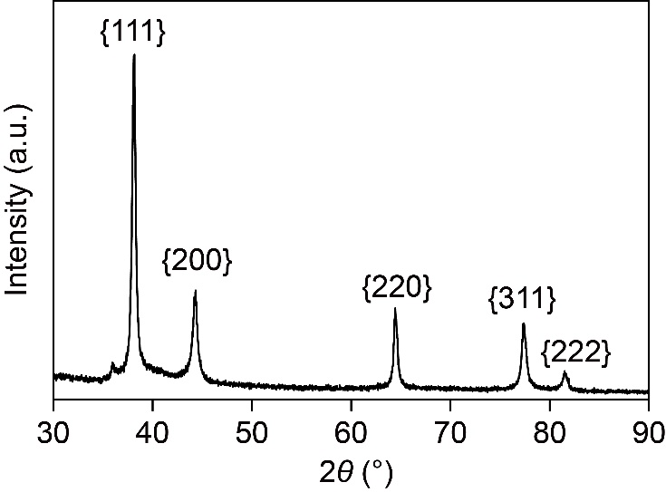
Figure 1. XRD pattern of AgNTs.
XRD: X-ray diffraction; AgNTs: silver nanotriangles.

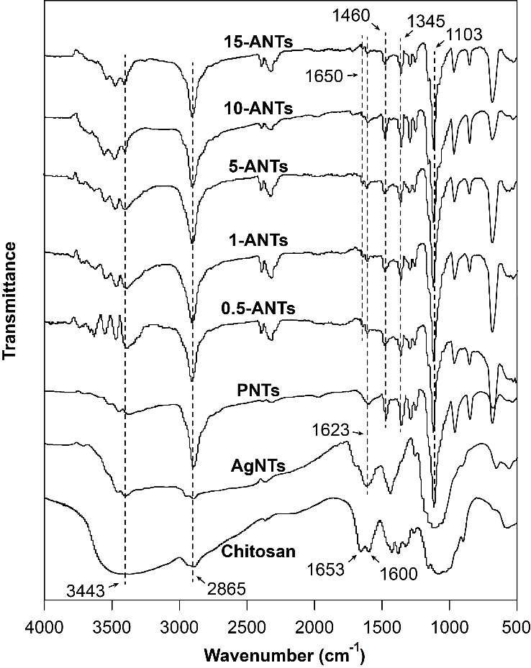
Figure 2. FTIR spectra of Chitosan, AgNTs, PNTs, 0.5-ANTs, 1-ANTs, 5-ANTs, 10-ANTs and 15-ANTs.
FTIR: Fourier transform infrared. AgNTs: silver nanotriangles; PNTs: PEGylated silver nanotriangles; 0.5-ANTs: PEGylated silver nanotriangles modified with AS1411 density of 0.5%; 1-ANTs: PEGylated silver nanotriangles modified with AS1411 density of 1%; 5-ANTs: PEGylated silver nanotriangles modified with AS1411 density of 5%; 10-ANTs: PEGylated silver nanotriangles modified with AS1411 density of 10%; 15-ANTs: PEGylated silver nanotriangles modified with AS1411 density of 15%.

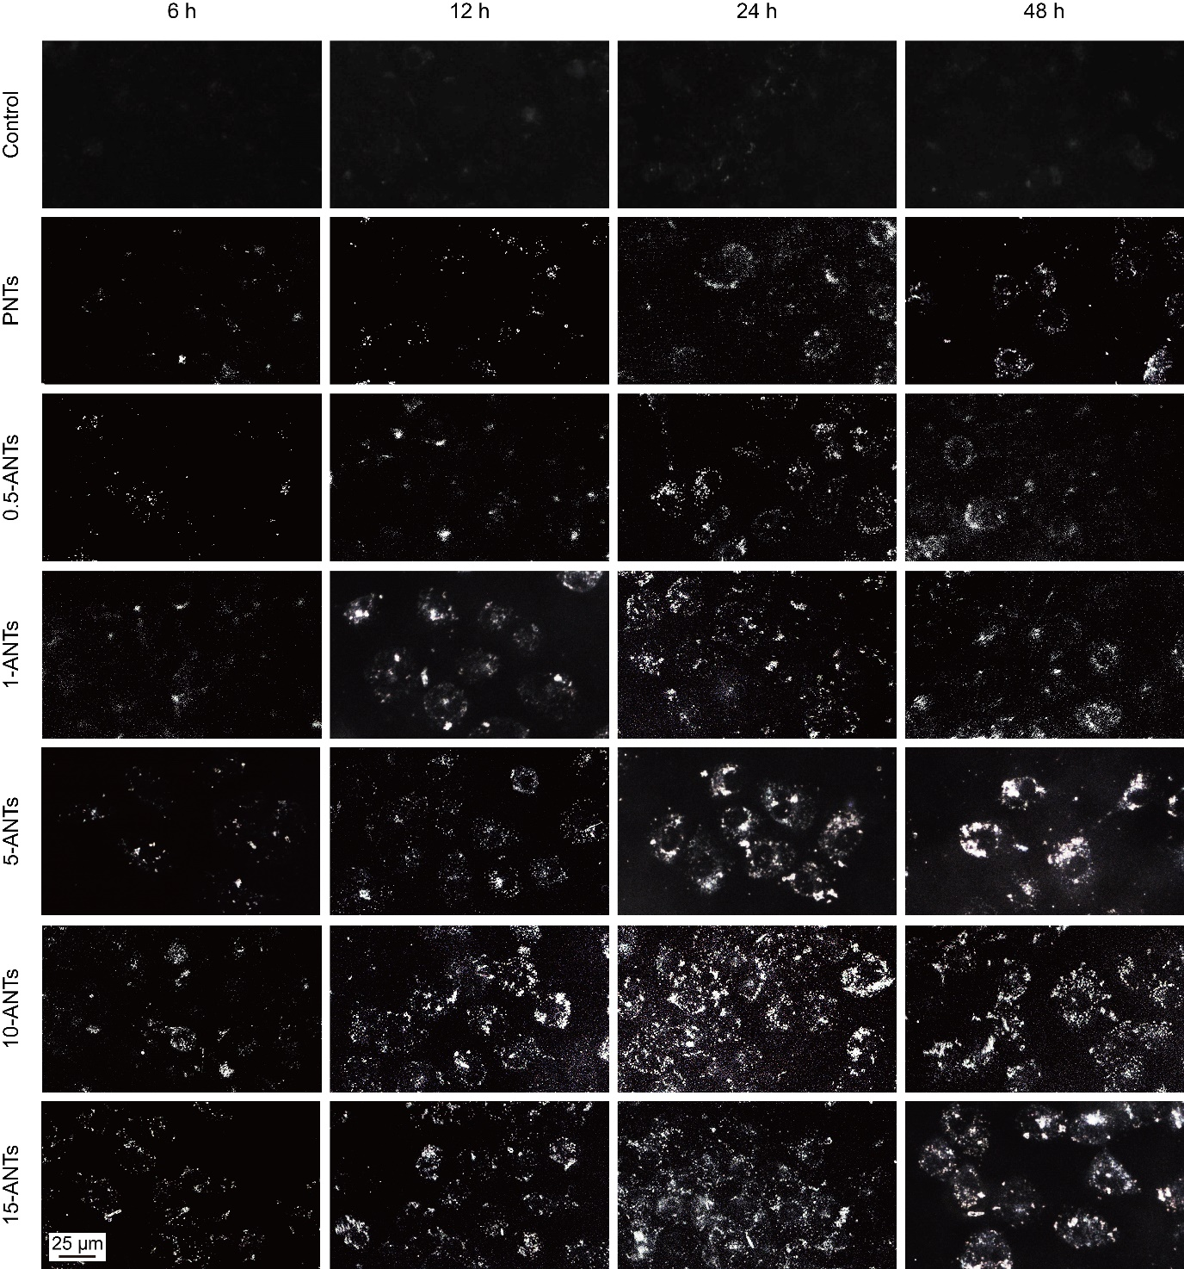
Figure 3. Cellular uptake of PNTs and ANTs with different AS1411 densities. Dark-field microscopy images of MDA-MB-231 cells treated with PNTs, 0.5-ANTs, 1-ANTs, 5-ANTs, 10-ANTs or 15-ANTs (2 μg/mL) for 6, 12, 24 or 48 h.
PNTs: PEGylated silver nanotriangles; 0.5-ANTs: PEGylated silver nanotriangles modified with AS1411 density of 0.5%; 1-ANTs: PEGylated silver nanotriangles modified with AS1411 density of 1%; 5-ANTs: PEGylated silver nanotriangles modified with AS1411 density of 5%; 10-ANTs: PEGylated silver nanotriangles modified with AS1411 density of 10%; 15-ANTs: PEGylated silver nanotriangles modified with AS1411 density of 15%.

