**Supplementary Documents**

**Efficient Synthesis of Glyco Disulphide Capped Gold Nanoparticles: Cytotoxicity Studies, and Effects on Lung Cancer A549 Cells**

Christian K. Adokoh‡[1]Ψ,Franklin K. Keter†#, Collins Obuah§, Henok H. Kinfe‡, Robert Tshikhudo† and James Darkwa‡

‡*Department of Chemical Sciences, University of Johannesburg, P. O. Box 524, Auckland Park, 2006, South Africa*

†*Nanotechnology Innovation Center, Advanced Materials Division, Mintek, 200 Malibongwe Drive, Randburg, 2125, South Africa*

§Department of Chemistry, University of Ghana, Legon, Ghana.

*ΨCurrent Address: Department of Forensic Sciences, University of Cape Coast, College of Agriculture and Natural Sciences, School of Biological Sciences.*

#*Current Address: Clinton Health Access Initiative, P. O. Box 2011-00100, Nairobi, Kenya*

**Direct Method of Synthesis of Glyco Disulfide AuNPs**

The UV-vis data of AuNPs G**D2** showed sharp intense peaks between 529-538 nm at high pH and broad peaks 536-554 nm at low pH (Figure S1a-b) indicating aggregation of particles.



b.

a.

Figure S1: UV-vis spectrometer of **GD2** AuNP (a) Low pH 8.9-9.2 (b) High pH (12.4-12.5)

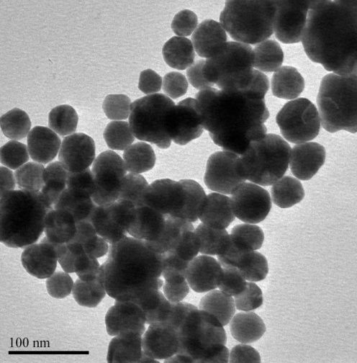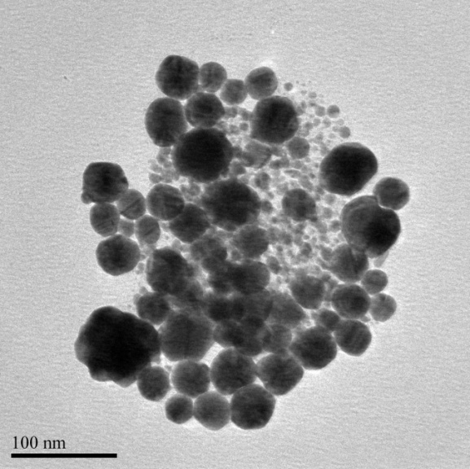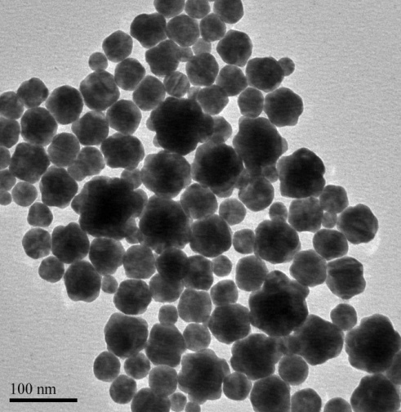

**d**

**e**

**f**

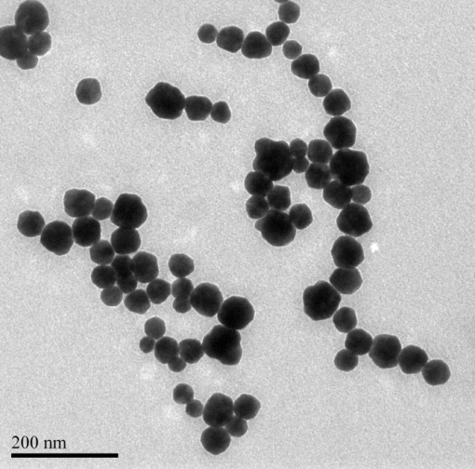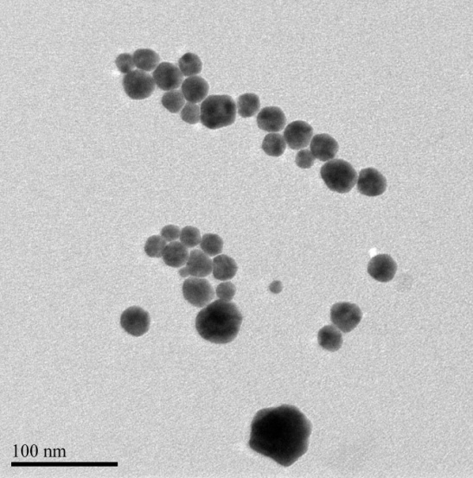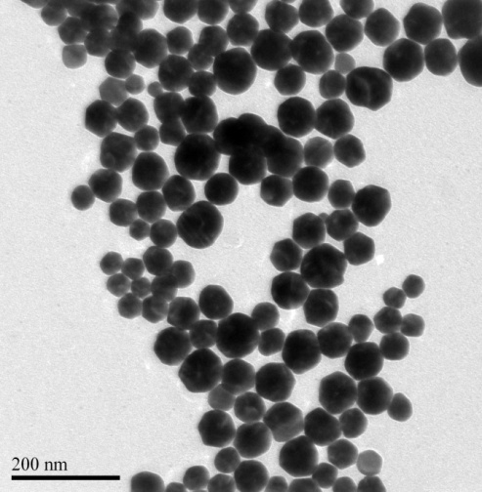

**e′**

**f′**

**d′**

Figure S2: (d-f) TEM micrograph of AuNP **GD2** with Au:L2 ratio of 1: 0.5, 1:1 and 1: 1.5 respectively at various ligand pHs. Note: d´-f´ are TEM micrograph of a-c at pH ~12 respectively

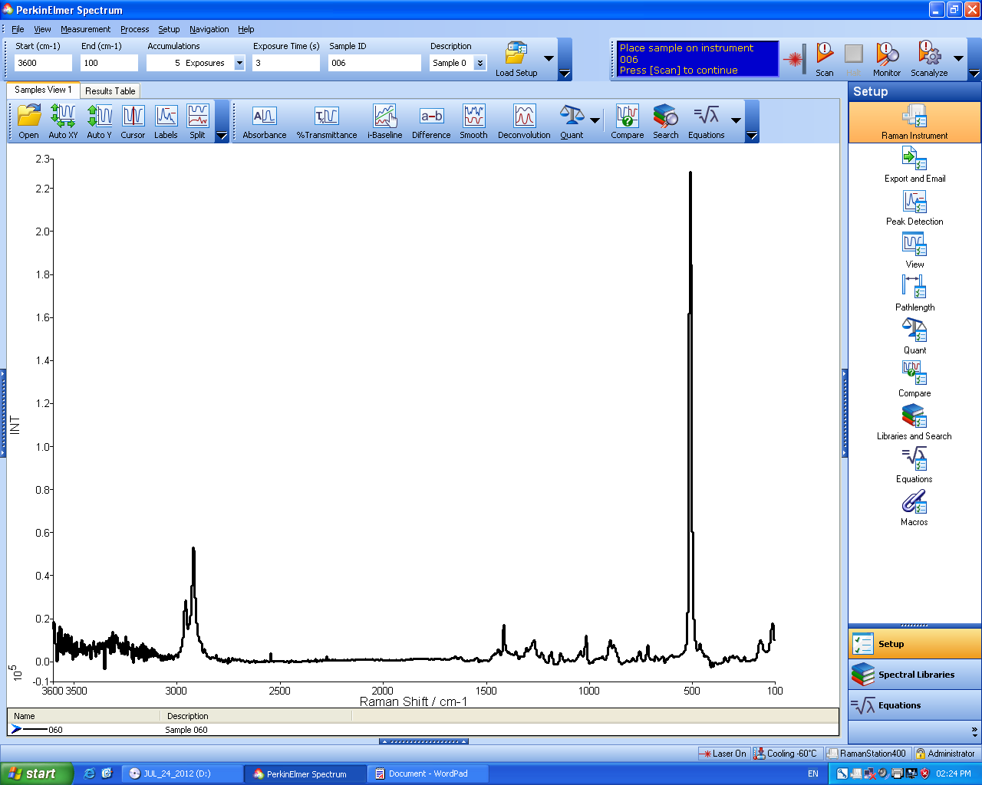

S-S

Figure S3a: Raman spectrum of gluconamidoethyl disulfide (**L1**)

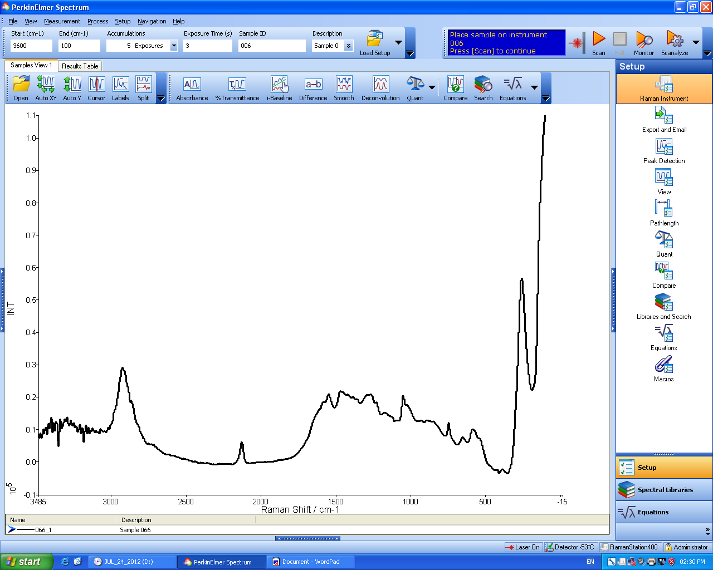

Au-S bond

Up field shift of S-S bond

Figure S3b: Raman spectrum of gluconamidoethyl disulfide AuNP via direct method

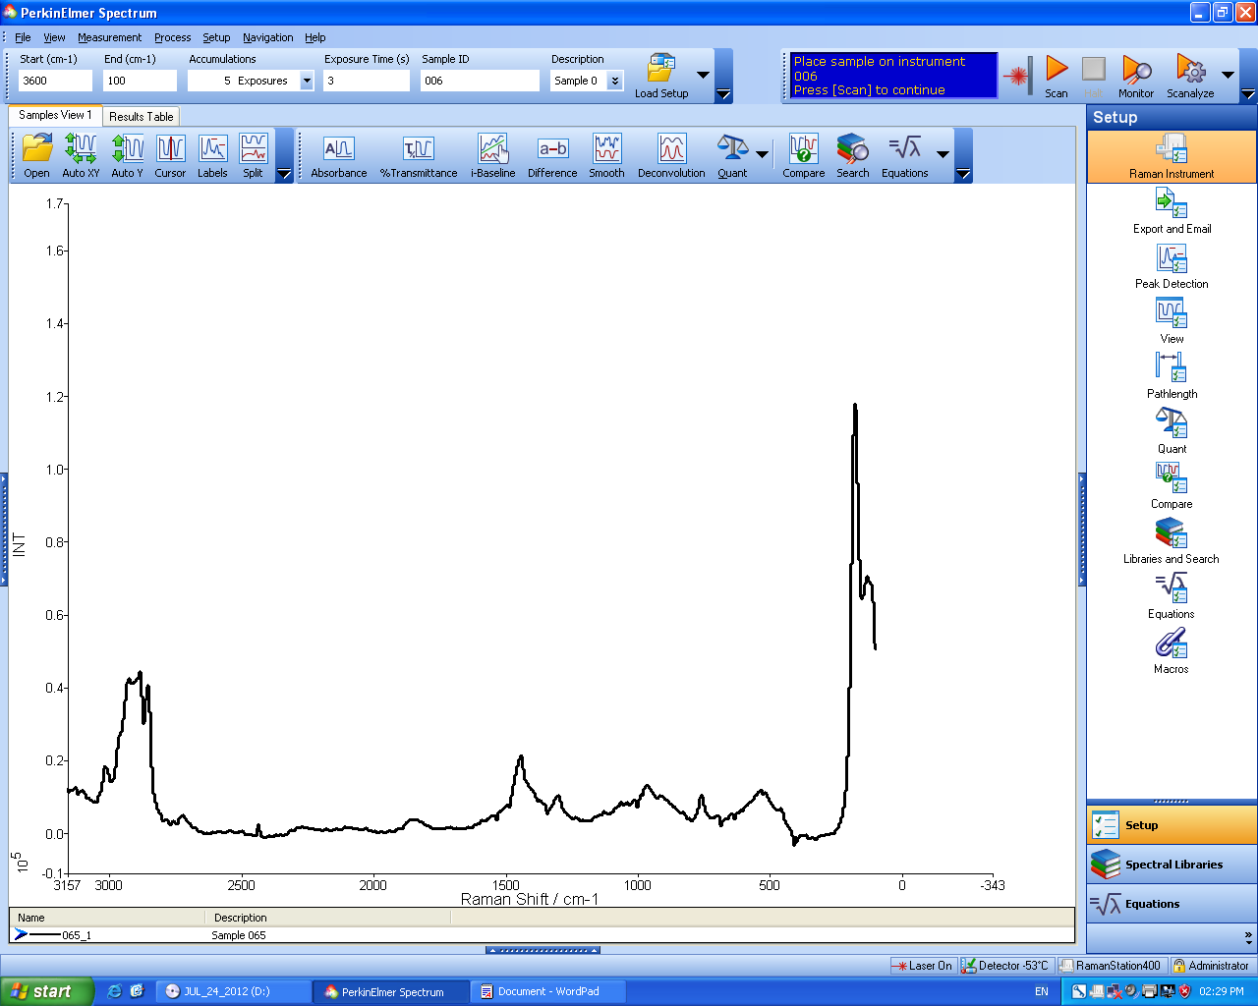

Au-S bond

Up field shift of S-S bond

Figure S3c: Raman spectrum of gluconamidoethyl disulfide AuNP via ligand exchange



Figure S4: UV-vis spectrum of GD1 AuNP at different pHs.

*Synthesis of Non-acetylated and Acetylated Disulfide Gluconamidoalkyl AuNPs (***GD4-9***) via Substitution Method*



Figure S5: General representation of substitution gold nanoparticles synthesis.

**Photochemical Irradiation Synthesis of Gluconamidoalkyl Disulfide Gold Nanoparticles (GD10-16)**

The monodispersed cationic glyconanoparticle was synthesized *in situ* *via* photochemical irradiation method using photoinitiator Irgacure 2959 (Figure S6). The gold nanoparticles were prepared in double distilled water with ratios of HAuCl4: IRGC: gluconamidoalkyl disulfides (**L1-L3**) (1:3:1 and 1:3:1.5).

.

Figure S6: Preparation of glyco disulfide gold nanoparticles *via* photochemical irradiation method.

TEM image of the following photoirradiation of various ratios of ligands to gold are presented in the figure S7 below.

H:\07-12 AuNP\08\01.tifC:\Users\Kweku\Desktop\TEM 1\photochemical TEM\07-12 AuNP\08\09\02.tifC:\Users\Kweku\Desktop\TEM 1\photochemical TEM\07-12 AuNP\08\09\10\11\01.tifH:\07-12 AuNP\03.tifC:\Users\Kweku\Desktop\TEM 1\photochemical TEM\2\02.tif

**d**

**c**

**a**

**b**

C:\Users\Kweku\Desktop\TEM 1\photochemical TEM\2\04.tif

**e**

**f**

Figure S7: TEM image of GNP of (a) aggregated GD14 (b) aggregated GD15 (c) GD11 (d) GD12 (e, f) GD13.

***In vitro* anticancer screening of gold disulfide glyconanoparticles**

Two cell lines: Human normal peripheral blood mononuclear cells (PBMCs) and Human lung adenocarcinoma epithelial cell line (A549) were used to study the cytotoxicity activities of selected disulfide gold glyconanoparticles (**GD1**- **GD3**, **GD4**, **GD6** and **GD7).** The figurebelow demonstrates *g*rowth inhibition profile of A549 cancer cells of the AuNPs **GD1.**

0.0

0.8

1.6

0.5

1.0

1.5

2.0

Abs (450/800 nm)

Log(Compound conc.) (µg/mL)

Figure S8. Growth inhibition profile of A549 cancer cells by AuNPs **GD1**

1. Ψ*corresponding author’s address:Current Address: Department of Forensic Sciences, University of Cape Coast, College of Agriculture and Natural Sciences, School of Biological Sciences (Email:* [*cadokoh@ucc.edu.gh*](mailto:cadokoh@ucc.edu.gh)*) Tel. +233264769777*

   ‡*Department of Chemistry, University of Johannesburg, P. O. Box 524, Auckland Park, 2006, South Africa. (Email:* [*jdarkwa@gmail.com*](mailto:jdarkwa@gmail.com)*) Tel. +27728524639, +23326772816153* 