**Survival Analyses**

**Figure 3**. Funnel Plot of the Overall Survival (OS) in male patients (immunotherapy versus chemotherapy).

**Figure 2**. Funnel Plot of the Overall Survival (OS) in patients ≥ 65 years (immunotherapy versus chemotherapy).

**Figure 1**. Funnel Plot of the Overall Survival (OS) in patients with ECOG-PS 1 or more (immunotherapy versus chemotherapy).

**Figure 4**. Funnel Plot of the Overall Survival (OS) in female patients (immunotherapy versus chemotherapy).

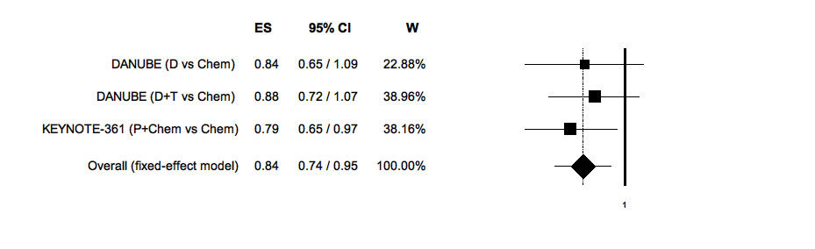

**Figure 6**. Funnel Plot of the Overall Survival (OS) in patients with transitional urothelial histology (immunotherapy versus chemotherapy).

**Figure 5**. Funnel Plot of the Overall Survival (OS) in patients with no liver metastases (immunotherapy versus chemotherapy).

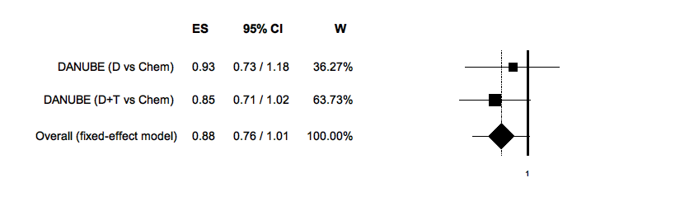

**Figure 7**. Funnel Plot of the Overall Survival (OS) in patients with mixed histology (immunotherapy versus chemotherapy).

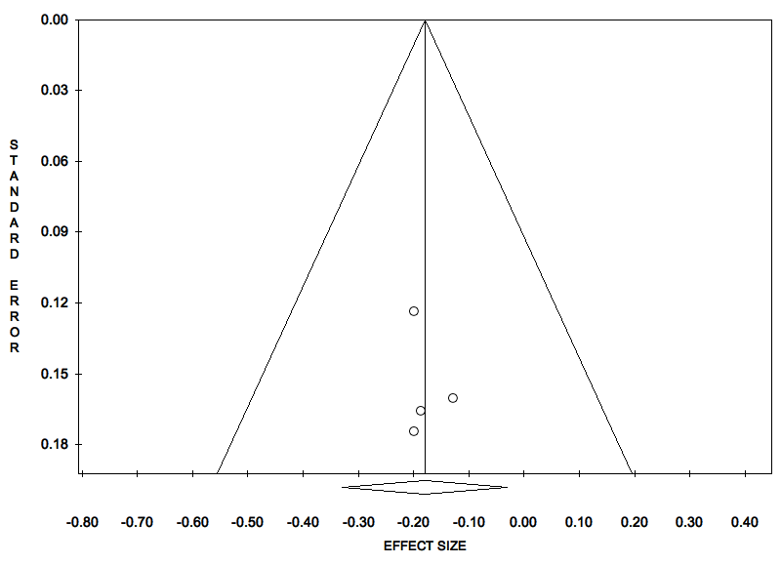

**Figure 8**. Funnel Plot of the Overall Survival (OS) in patients with ECOG-PS 0 (immunotherapy versus chemotherapy).

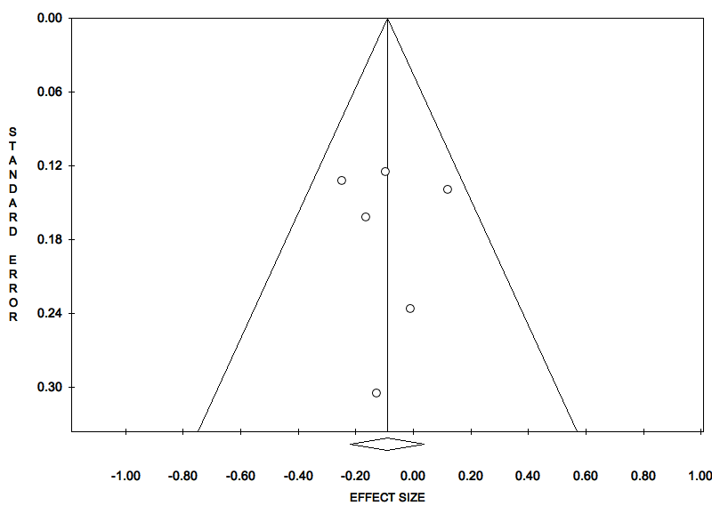

**Figure 9**. Funnel Plot of the Overall Survival (OS) in patients with ECOG-PS 1 or more (immunotherapy versus chemotherapy).

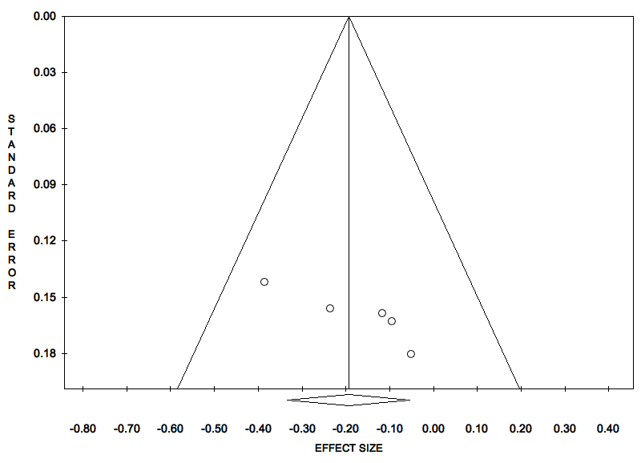

**Figure 10**. Funnel Plot of the Overall Survival (OS) in patients < 65 years old (immunotherapy versus chemotherapy).

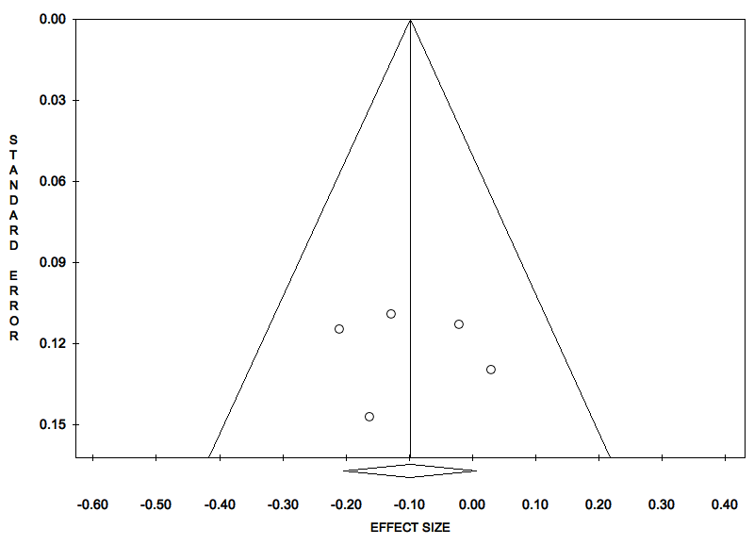

**Figure 11**. Funnel Plot of the Overall Survival (OS) in patients ≥ 65 years old (immunotherapy versus chemotherapy).

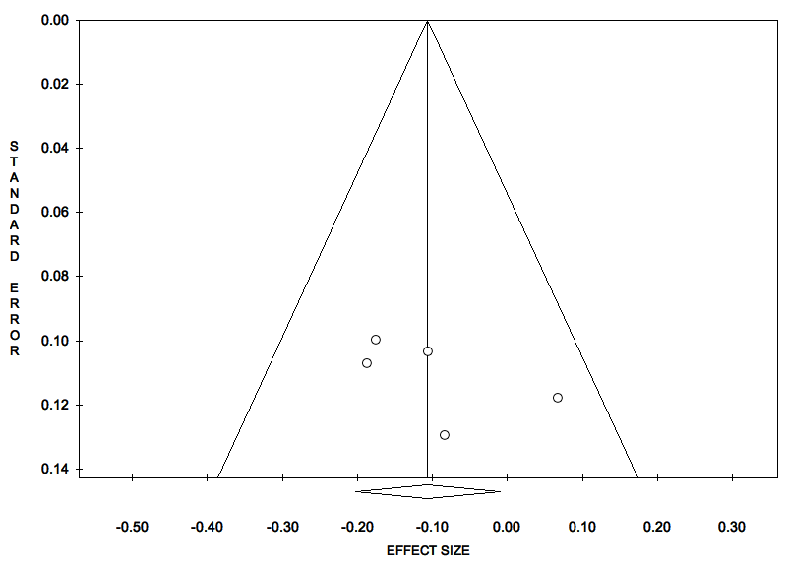

**Figure 12**. Funnel Plot of the Overall Survival (OS) in male patients (immunotherapy versus chemotherapy).



**Figure 13**. Funnel Plot of the Overall Survival (OS) in female patients (immunotherapy versus chemotherapy).

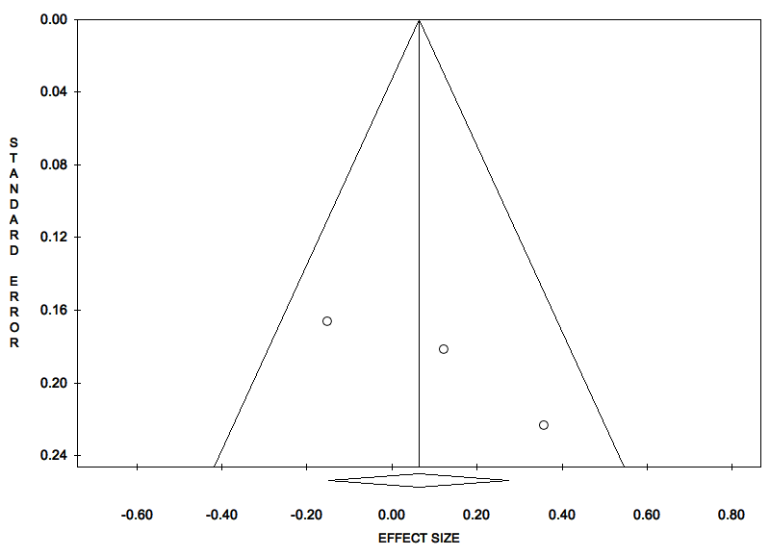

**Figure 14**. Funnel Plot of the Overall Survival (OS) in patients with liver metastases (immunotherapy versus chemotherapy).

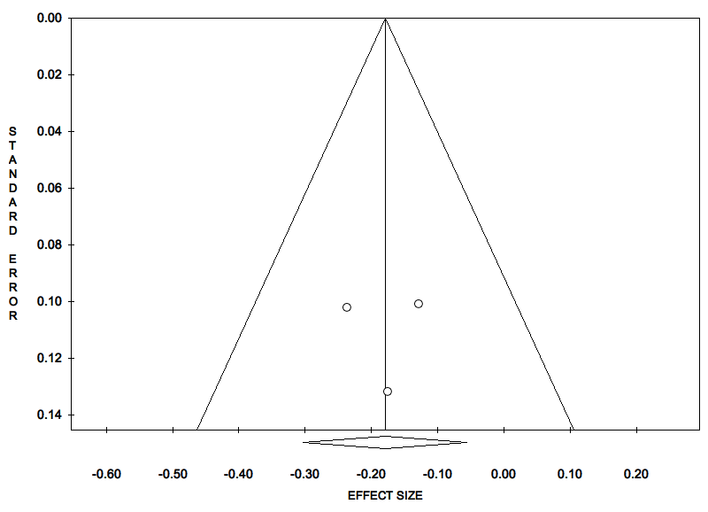

**Figure 15**. Funnel Plot of the Overall Survival (OS) in patients with no liver metastases (immunotherapy versus chemotherapy).