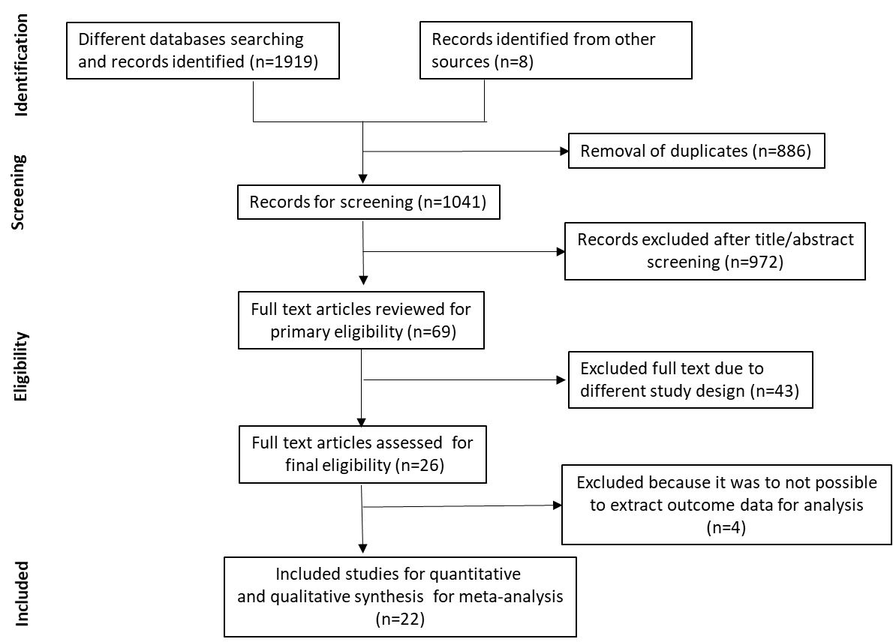

Supplementary Figure 1. Flow chart for identification of included studies by following PRISMA guidelines.

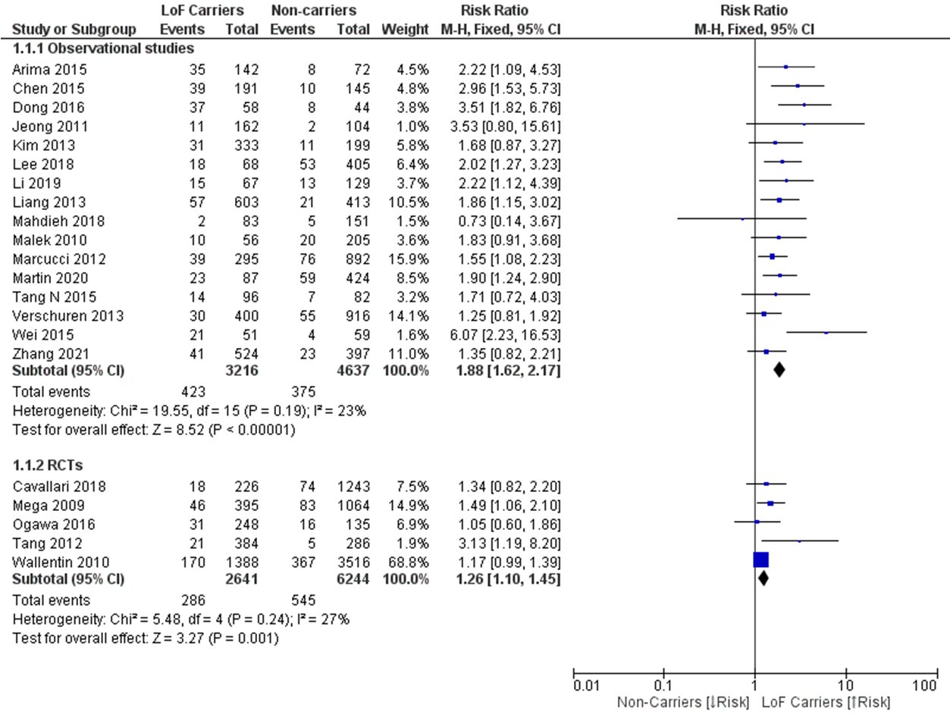
Supplementary Figure 2. Forest plot of the effect of study design on MACE for ACS patients undergoing PCI treated with clopidogrel. Risk of MACE of observational studies for patients carried CYP2C19 LoF alleles vs Non-carriers (Fig. A) and risk of MACE of RCTs for patients carried CYP2C19 LoF alleles vs Non-carriers (Fig. B). Here, MACE=Major adverse cardiovascular events, ACS=Acute coronary syndrome, PCI=Percutaneous coronary intervention, LoF=Loss-of-function, RCTs=Randomized clinical trials.

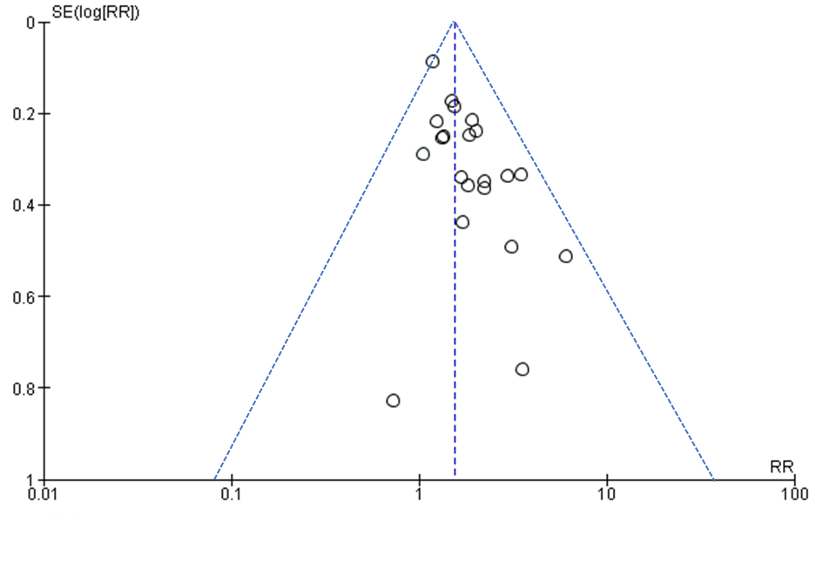
Supplementary Figure 3. Funnel plot of the MACE for ACS patients undergoing PCI carrying CYP2C19 LoF alleles vs CYP2C19 Non-LoF alleles treated with clopidogrel. Here, MACE=Major adverse cardiovascular events, ACS=Acute coronary syndrome, PCI=Percutaneous coronary intervention, LoF=Loss-of-function.

